Eiffel Graph Library

Jimmy J. Johnson

June 2009

Table of Contents
1. Introduction 1
1.1. Goals 1
1.2. Theory Review 1
2. Providing the Structure 2
2.1. GRAPH 2
2.2. NODE 3
2.3. EDGE 3
2.4. Contracts 4
2.5. Trees 7
3. Beyond Structure 9
3.1. GRAPH_ITERATOR 9
3.2. Other Traversal Settings 10
3.3. PATH 11
3.4. Moving Back and Forth With Iterators 12
3.5. Mode Changes During Graph Traversals 13
3.6. Node and Edge Ordering in a Graph 13
3.7. The Big Picture (…so far) 14
4. The Rest of the Story 14
4.1. Containers, Finally 15
4.2. The Big Picture 16
4.3. Covariance and Catcalls 17
5. Performance 18
5.1. VALUED_GRAPH vrs. LINKED_LIST 19
5.2. B_TREE vrs. SORTED_TWO_WAY_LIST 19
5.3. INDEX_B_TREE vrs. HASH_TABLE 19
6. Conclude Me 19
7. Notes on Implementation 19
7.1. feature “<” in node and edge 19
7.2. JJ_ARRAYs 19
7.3. Covariant Redefinitions With “Anchors” 20
7.4. Assertion Checking 21
7.5. B_TREE 22
7.6. INDEXED_B_TREE 23
8. To Be Done 24
8.1. This File 24
8.2. All classes 24
8.3. Test Classes 24
8.4. GRAPH 24
8.5. GRAPH_ITERATOR 25
8.6. B_TREE 25
8.7. NODE 26
8.8. VALUED_NODE 26
8.9. B_TREE_NODE 26
8.10. WEIGHTED_PATH 26
8.11. EDGE 26
8.12. WEIGHTED_EDGE 26
8.13. LABELED_NODE 26
9. Last Check 27

Introduction
Graph theory is useful and indispensable for solving problems in many diverse areas. Besides its purely theoretical and mathematical applications, graph theory has been used to model systems from computer networks to road maps. It is used in chemistry, physics, and sociology. The list is seemingly endless and has potential to grow. The Eiffel Graph Library attempts to provide a powerful and easy to use tool encapsulating many concepts of graph theory. The library has features for solving many of the common problems in graph theory and is flexible enough to be extended or used for many others.

Goals
The first rule followed in the development of this library was to try to “get it right first, make it fast later.” The main goal was to produce a correct, robust, library which followed graph theory as closely as possible in the functionality and naming of the classes and features. It had to be practical, easy to use, and extendable.
Once the library is stable and proven it should be reviewed to make it as fast and efficient as possible.

Theory Review
From [4], [7], and [8], here are the definitions of some of the terms applicable to this library.
Intuitively, a graph is a set of nodes (sometimes points or vertices) and a set of edges (sometimes lines or arcs), where each edge joins one node to another. The order of a graph is the number of nodes it contains and the size is the number of edges. A simple graph has nodes that are connected by at most one edge. A graph that is not a simple graph is called a multigraph. A labeled graph has a label or value associated with each node.
The number of edges leaving a node is called its out-degree and the number of edges coming into a node is the node’s in-degree; the sum of the two is the degree of the node. A labeled, or colored edge, has a label associated with it. A weighted edge has a numeric value, usually a real, associated with the edge and is sometimes called the cost of traversing that edge.
An edge that connects a node to itself is called a loop. An edge is directed if it can be traversed, or walked, in only one direction; it is undirected if it can be traversed in either direction. A graph is directed if it contains directed edges.
A path, or walk, is a sequence of one or more edges from one node leading to another node. The length of a path is the number of edges comprising the path. The cost of traversing a path is the sum of the costs of traversing each edge in the path. A cycle is a path that returns to the node from which it started. A graph with no cycles is said to by acyclic.

Providing the Structure
The library models the containers (e.g. graphs, weighted graphs, and b-trees) around the basic concept of a graph as a collection of nodes which are connected by edges. The three main classes in the library which provide and maintain the structure of a graph are GRAPH, NODE, and EDGE. Class GRAPH and its descendents are intended to be used directly. Classes NODE and EDGE and their descendents are relegated to more of a support role.

GRAPH
Class GRAPH is the top of the container hierarchy. Features default_create and make_with_order are the creation features. Feature default_create creates a graph whose nodes can have multiple incoming and multiple outgoing edges. Each node when created by the graph will initially have enough room to hold the Default_order number of edges. Feature make_with_order allows the nodes to be created with enough room for the number of edges as given in the argument to the feature. In either case, though, the number of edges a node can contain can grow beyond what was initially set.
A graph can be queried with node_count and edge_count to determine the number of nodes or edges, respectfully, that are in the graph. Features has_node and has_edge are boolean queries for testing whether a node or an edge is in the graph.
Nodes are added to the graph using feature connect_nodes which takes two nodes as arguments and creates a connection (i.e. an EDGE) between them. One of the preconditions, is_connection_allowed ensures the two nodes are in states that allow a connection between them. Feature connect_nodes_directed also creates an edge between the two nodes; the difference is that the new edge is a directed connection from the first node to the second node. The newly created edge can be obtained with last_new_edge.
Nodes and edges can also be added to a graph without creating a new edge using features extend_node and extend_edge. These features can be used to make a node or edge “visible” to the graph. Feature prune_node conversely removes a node and all its edges from the graph making them no longer “visible” to this graph; that is, they are no long “in” the graph. The nodes and/or edges are not themselves changed; a node still has all its edges and the edges still connect the correct nodes. This allows a node having many edges to be “in” a graph, but perhaps some or all of its edges are not themselves in the graph. A node could also be in, and therefore manipulated by, more than one graph without harming its connections or the connections of other nodes. Similarly, feature prune_edge will remove an edge from the graph without disconnecting the edge.
In some cases a graph really does mean to remove a connection between two nodes by disconnecting the edge between them. Feature disconnect_nodes will do that assuming both nodes are in the graph; a graph should not disconnect nodes which it does not own.
Of course there are query features to determine if a node or an edge is in the graph, features has_node and has_edge. Feature is_reachable determines if a node is somehow connected through any combination of edges to the current graph, which is a node, and feature is_traversable determines if an edge can somehow be traversed through any combination of movements from one node to another. If there is a node that cannot be reached from any other node in the graph, the graph is_disconnected. Feature is_cyclic determines if it is possible to start on one node and traverse the graph in such a way as to visit that same node again. Feature is_acyclic is provided for convenience.
Finally, feature is_empty is there for consistency with the kernel container classes and returns True if the graph contains no nodes or edges. Because a graph “is a” (inherits from) NODE, a graph can but is not required to contain itself. In other words, as a NODE, a graph can be one of the nodes in itself.
These few features provide much of the interface for a graph. (There is one more very important feature applicable to all objects of type graph and several other features that apply to special types of graphs. The discussion of these features will be postponed until later.) So how can GRAPH provide any real functionality with so few features? The answer is the real work is done in an ancestor class and, as was just hinted above, that ancestor is NODE.

NODE
Node is the most complex of the top structure-providing classes in the library. Besides providing GRAPH with the creation features, default_create and make_with_order, it provides the mechanics for creating and storing the edges to be seen by a graph. Feature adopt, taking one NODE as an argument, adds a child node by creating a new edge and connecting that edge from the current node to the argument node. Feature disown, again with one NODE as an argument, removes that child node by disconnecting any edges from the current node to the child. Complementary features embrace and spurn allow a node to take on a parent node (by creating an edge from the parent to the current node) or to remove a parent node, again by disconnecting the appropriate edge(s). There are also “deep” versions of these features.
The edges stored in a node can be accessed through features such as i_th_edge, connections, connections_from, connections_to, children, parents, relations, ancestors, and descendants. The number of edges in a node is obtained through features count, child_count, in_count, and out_count. Feature order, not to be confused with count, gives the number of edges the node is capable of containing (the capacity) at this moment.
Status features and their setters control the behavior of a node. If a node can_adopt then it is allowed to have out-going edges (i.e. to obtain children.) It is set by allow_adopting and forbid_adopting. If a node can_embrace then it is able to obtain an incoming edge (i.e. to obtain a parent.) If a node can_embrace_multiple then it is allowed to have more than one incoming edge (i.e. to have more than one parent.) The setter features are named similarly as above with the forbid and adopt prefix added to the feature name.
Other CONTAINER-type queries such as is_empty, has_edge, has_node, etc are also available.

EDGE
EDGE is the last of the three top-level, structural classes. Simply put, an edge is a connection between two nodes, a node_from and a node_to. If one of the nodes to which the edge connects is known, the other node can be accessed by feature other_node, taking as argument a reference to the known node.
Even though the feature names node_from and node_to imply the edge goes in one direction, that is not the intent. The names, chosen to distinguish the two nodes, simply seemed a better choice than names such as “node_1” and “node_2”. If a directed edge is desired then give direction to an edge using feature set_directed. Feature set_undirected will return the edge to a directionless state. This status is reported by is_directed.
Three other status-reporting features, is_connected, is_disconnected, and is_unstable deserve attention. After creation an edge can be in one of three states. The first, is_connected, is the state normally expected where there is a node at both ends of the edge. Feature connect, which is also a creation feature, ensures the edge connects the two nodes passed as arguments. The other creation feature default_create will create an edge that is not connected to any nodes. While this might seem to be an odd state for an edge, it is in fact necessary, for example, when removing a child node from a parent node. (Remember that a child node is removed by calling disconnect on the appropriate edge.) The third state an edge might find itself in is when there is an edge at one end but not the other. This does not make sense in the context of graphs, but will develop as an intermediate state as one node and then the other is connected or disconnected from the edge. Feature is_unstable is used by the class invariant to distinguish this state, allowing the object to momentarily exist in this “semi-invalid” state. The invariant, though, ensures the edge ends up in one of the two stable states.

Contracts
Contracts, as in any good library, play a very important role. They are used extensively in this one. Of particular interest is the way referential integrity is maintained between the two nodes in an edge and the edges contained in a node. Each node at the ends of an edge must contain that edge; if a node contains an edge then the node must be one of the nodes of that edge. In NODE the invariant calls has_proper_connections which checks all the edges contained in the node to ensure each edge has_connection to the current node. Also, the invariant in EDGE ensures that both nodes has_connection to the current edge. The two invariants are show in Figure 1.
In addition the features for adding nodes to a graph (and connecting edges) are armed with many preconditions and postconditions. Recall that feature connect_nodes from GRAPH, shown in Figure 2, is used to add nodes to a graph by having the first node adopt the second node. Feature extend_edge is called near the end; it ensures that the last_new_edge, and hence the two nodes at the end of that edge, are added to and therefore in the graph. The pre- and post-conditions of connect_nodes illustrates some of the extensive use of contracts in this library.
-- from EDGE
symetrical_connections: is_connected implies
(node_from.has_edge (Current) and node_to.has_edge (Current))
-- from NODE
has_proper_connections: not is_unstable implies has_proper_connections
Figure 1 – Referential Intergety Invariants from NODE and EDGE
connect_nodes (a_node, a_other_node: like node_anchor) is
-- Make a connection between the two nodes, ensuring both nodes
-- are visible to (i.e. "in") the graph. The newly created edge
-- connecting the two nodes can be accessed through `last_new_edge'.
-- Side effect: if Current `is_ordered' then the two nodes will be
-- ordered after this call, perhaps rearranging their edges.
require
node_exists: a_node /= Void
other_exists: a_other_node /= Void
node_can_adopt_child: a_node.can_adopt
other_node_is_adoptable: a_other_node.is_adoptable
other_node_is_adoptable: a_other_node.is_adoptable
can_add_node: is_extendable_node (a_node)
can_add_other_node: is_extendable_node (a_other_node)
allowable_connection: is_connection_allowed (a_node, a_other_node)
do
a_node.adopt (a_other_node)
if is_ordered then
if not a_node.is_ordered then
a_node.set_ordered
end
if a_other_node.is_ordered then
a_other_node.set_ordered
end
end
extend_edge (last_new_edge)
ensure
node_inserted: has_node (a_node)
other_node_inserted: has_node (a_other_node)
new_edge_in_graph: has_edge (last_new_edge)
proper_from_connection_made: last_new_edge.originates_at (a_node)
proper_to_connection_made: last_new_edge.terminates_at (a_other_node)
end
Figure 2 – Feature connect_nodes from GRAPH
Figure 3 shows the implementation of feature adopt, from NODE, giving another example of a very heavily contracted feature. While not a true measure of the quality of the software, the number of lines dedicated to the contracts is much higher than the number of lines in the body.
adopt (a_child: like node_anchor)
-- Add a connection (EDGE) from Current to `a_child'.
require
can_adopt_children: can_adopt
child_exists: a_child /= Void
child_is_adoptable: a_child.is_adoptable
local
e: like edge_anchor
do
e := new_edge
e.connect (Current, a_child)
ensure
connection_exists: has_node (a_child)
connection_to_exists: has_edge_to (a_child)
count_increased: edge_count = old edge_count + 1
out_count_increased: out_count = old out_count + 1
in_count_unchanged: in_count = old in_count
last_edge_originates_at_current: last_new_edge.originates_at Current)
last_edge_terminates_at_a_child: last_new_edge.terminates_at (a_child)
end
Figure 3 – Feature adopt from NODE
Features in the library rely very heavily on such contracts of these. Another example is in feature disconnect_nodes from GRAPH which requires that the two nodes being disconnected are contained in the graph; a graph should not change nodes it does not own. This check could have been done in the body and then no action taken if one or both of the nodes was not in the graph, but that would have required the graph to search [twice] just to determine if it should take action. Removing the burden from the feature bodies allows a finalized system to run much faster than if the same check was performed in the body. This heavy use of contracts will, of course, slow the execution of a system during testing when all checking is turned on.
One of the preconditions to connect_nodes from GRAPH deserves a closer look. Feature is_extendable_node is called for each node passed to connect_nodes to ensure the nodes which the graph is being asked to connect can be added to the graph. Feature is_extendable_node, shown in Figure 4, first checks to make sure the node is non-void. Then, if the graph is acting as a tree it verifies that the node can have at most one parent. The assertions in these examples give a sampling of how extensively contracts are used in this library. The last one alludes to the use of contracts as they apply to trees.
is_extendable_node (a_node: like node_anchor): BOOLEAN is
-- Can `a_node' be put into and manipulated by Current?
-- If `is_tree_mode' then Current can only manipulate nodes which
-- have or can have only one parent.
-- If Current is not acting as a tree it can take any non-void node
-- and change the node. This could violate the invariant of another
-- graph if that other graph contains `a_node' and is acting as a
-- tree; Current could ask a singly-parentable node to take on a
-- second parent.
do
Result := a_node /= Void and then
((not is_tree_mode) or else
(is_tree_mode and then a_node.can_embrace_multiple)) end
Figure 4 – Feature is_extendable_node from GRAPH

Trees
Graph, node, and edge are the top nodes in the library’s hierarchy and provide the features for creating and maintaining the structure of a graph. One would expect a library such as this to contain a tree class, since a tree also imposes further “structure” onto a graph. For starters, a tree must be a connected and acyclic graph. This could have been obtained by the addition of a tree class, but for various reasons this class was not included.
As Meyer wrote in the first edition of Object Oriented Software Construction [Error: Reference source not found], “finding the classes” is not always easy. It would seem as if a tree class would naturally follow from the definitions in graph theory because a tree “is a” graph with special properties. But, carrying this logic to the absurd, one would end up not just with a tree class but with classes for directed graphs, undirected graphs, multigraphs, colored graphs, weighted graphs, disconnected graphs, cyclic and acyclic graphs and a cornucopia of other classes in a combinatorial explosion when these properties must be combined. Instead of providing separate classes for all these combinations, this library uses the status features in class GRAPH to provide some of the desired properties.
Feature is_cyclic was discussed above. In addition feature is_tree_mode is true if a graph is behaving as a tree. If a graph is_acyclic and is not is_disconnected, then the graph can be considered a tree and can be forced into a “tree mode” with a call to set_tree_mode. This will ensure that future additions to the graph comply with the rules for a tree. In addition this property can be set at creation time by using one of the creation features make_singly_parentable or make_singly_parentable_with_order, inherited from class NODE, to make a graph whose nodes can have at most one parent. These features set can_embrace_multiple to false and ensure all nodes added have that property as well. (Remember that is_extendable_node from GRAPH only allows nodes which, themselves can have at most one parent if the graph can only have one parent.)
If is_tree_mode is true for a graph then the root_node attribute becomes available. Remember that a GRAPH object, in this case a tree, is itself one of the nodes in the tree. Depending on the order of connections, the tree could grow up by adding new parents, moving the root up, or down by adding children, leaving the root where it was. So, the root_node is not necessarily, and most likely is not, the GRAPH object. The feature will continue up the parent_edge (from NODE) until there is not a parent. That node then is the root of the tree.
If is_tree_mode is true for a graph then other measurement features become available. Feature height gives the length, in number of edges, of the longest path from the root_node down to a leaf node; feature weight gives the number of leaf nodes in the graph; feature breadth gives the number of nodes at a particular level in the graph; and feature node_depth gives the distance, again in number of edges, that a particular node is from the root_node.
The invariants of class GRAPH, shown in Figure 5, ensure a graph maintains tree properties if it was asked to by a call to set_tree_mode. In order to maintain tree properties during node additions to a graph for which is_tree_mode is true the preconditions to the connection features must also be “modified”.
invariant

tree_mode_implication: is_tree_mode implies is_tree
is_tree_implication: is_tree implies (is_asyclic and then
not is_disconnected and then
not has_multi_parented_node)
Figure 5 – Invariant from GRAPH
Referring back to Figure 2, in the preconditions of connect_nodes from GRAPH we see a call to feature is_connection_allowed, shown in Figure 6, which forces the caller to guarantee that nodes being connected in [a graph behaving as] a tree meet tree-node conditions. First the nodes must both be extendable into the graph as seen earlier with is_extendable_node for a graph. The first node must be able to adopt a child node and the second node must be able to accept a parent. This ensures the node properties. Finally, if is_tree_mode, at least one of the two nodes must already be in the graph in order to maintain the not is_disconnected invariant. A graph that is a tree, then, will be a connected-acyclic graph whose nodes have at most one parent and which restricts the types of nodes added so they also comply with tree properties.
is_connection_allowed (a_node, a_other_node: like node_anchor): BOOLEAN is
-- Is Current allowed to make a connection between the two nodes?
-- If `is_tree_mode' then one of the nodes must already be in the graph.
-- (Remember, Current is always "in the graph" so we can start by
-- adding connections to Current.)
do
if is_extendable_node (a_node) and then is_extendable_node (a_other_node) and then
a_node.can_adopt and then a_other_node.is_adoptable then
if is_tree_mode then
Result := (has_node (a_node) or else has_node (a_other_node))
-- no need to check for induced cycle because the only way to
-- get a cycle is to allow nodes to obtain more than one parent;
-- this is prevented by `is_extendable_node' which makes sure a
-- node can not embace multiple parents.
else
Result := True
end
end
end
Figure 6 – Feature is_connection_allowed from GRAPH
So, having explored some of the features and contracts of NODE, EDGE, and most of the features of GRAPH, it is time to cover, as promised earlier, the one other important feature of GRAPH.

Beyond Structure
At this point we have seen how to build a graph using feature connect_nodes from GRAPH and adopt from NODE, but there has been no discussion about how individual nodes or edges in the graph can be accessed beyond maintaining a reference to the nodes as they are passed into the graph. The individual nodes and edges in the graph can be reached by using an iterator. Feature iterator in class GRAPH makes a new object of type GRAPH_ITERATOR, an external iterator allowing several types of traversals over a graph with the ability to get the currently pointed-to node or edge.

GRAPH_ITERATOR
An iterator for a graph is created with feature make, taking an object of type GRAPH and the start point for the traversal is set in make or later by a call to set_root_node whose argument node must be in the graph for which the iterator was created. The creation feature calls set_breadth_first (Figure 7) allowing the graph to be traversed by visiting each of the nodes in “breadth-first” order using the normal start, forth, back, is_after, etc. pattern. The different traversal methods can be set by calls to features shown in the figures below.
set_breadth_first is
-- Make Current traverse the graph in breadth-first order.
-- Begin at the root node and explore all the neighboring nodes. Then for each of
-- those nearest nodes, it explores their unexplored neighbor nodes, and so on.
-- 1
-- / | \
-- 2 3 4
-- / | | \
-- 5 6 7 8
-- / | | \
-- 9 10 11 12
Figure 7 – Comment for set_breadth_first from GRAPH_ITERATOR
set_depth_first is
-- Make Current traverse the graph in depth-first order. Start at the root
-- and explore as far as possible along each branch before backtracking.
-- (http://en.wikipedia.org/wiki/Depth-first_search)
-- 1
-- / | \
-- 2 7 8
-- / | | \
-- 3 6 9 12
-- / | | \
-- 4 5 10 11
Figure 8 – Comment for set_depth_first from GRAPH_ITERATOR
set_post_order is
-- Make next `sort' be in post-order (i.e. visit all children then the parent)
-- 12
-- / | \
-- 5 6 11
-- / | | \
-- 3 4 9 10
-- / | | \
-- 1 2 7 8
Figure 9 – Comment for set_post_ordert from GRAPH_ITERATOR
set_in_order is
-- Make Current traverse the tree in `in_order' fashion. Traverse the left
-- subtree, visit the root, traverse the right subtree, etc. This will visit the
-- lowest leaf, parent, remaining leaves, parent, etc.
-- 6
-- / | \
-- 4 7 11
-- / | | \
-- 2 5 9 12
-- / | | \
-- 1 3 8 10
Figure 10 – Comment for set_in_order from GRAPH_ITERATOR
Figure 11 shows two other traversal methods not usually encountered in the literature on graphs but may be useful in some applications. The first is a bottom-up traversal which visits nodes furthest away from the root_node first, then visits the nodes one level closer to the root, and so on. The second is a leaf-first traversal which visits nodes by moving down the branches in order until reaching a leaf.
set_bottom_up  -- 12  -- / | \  -- 9 10 11  -- / | | \  -- 5 6 7 8  -- / | | \  -- 1 2 3 4 | set_leaf_first  -- 12  -- / | \  -- 9 4 11  -- / | | \  -- 8 3 10 7  -- / | | \  -- 1 2 5 6
Figure 11 – Traversal Order for set_bottom_up and set_leaf_first

Other Traversal Settings
So far in the discussion of class GRAPH and the description of possible traversal methods provided by GRAPH_ITERATOR there was an assumption that each node to be visited was “in” the graph; that is not always required in this library. There has been no mention of a class encompassing the concept of directedness (i.e. a “directed graph” class) as found in most graph-theory literature and other graph libraries; the descusion below will show how directedness can be added to a graph. Finally, the traversal policies, from breadth-first traversal to leaf-first traversal, have assumed the object of the traversal was to visit each node in a graph with no mention of the edge traversed or path explored; this class allows these other traversal policies.
Normally an iterator is created from a graph and the iterator is used to visit nodes that are “in” the graph starting at a root_node that is also “in” the graph. In this case feature is_seeing_reachables is in its default state of false. To change this, use feature see_reachables which allows nodes connected to an arbitrary node to be visited without first putting all the nodes into a graph. This allows the iterator to “see” nodes that are connected to the root_node but may not be “in” the graph. This need could arise if one wishes to visit all nodes connected to a node that is in two graphs with some of its descendents in one graph and other descendants in another graph. Feature see_visibles returns the iterator to the default state.
Directedness was touched briefly in the discussion of feature connect_nodes_directed from class GRAPH and in the discussion of class EDGE and its features set_directed, set_undirected, and is_directed. This library does not contain a class which models a directed graph; this “directedness” is delegated to each edge in the graph, allowing the user to mix directed and undirected edges in one graph. An example application would be the modeling of a map of city streets containing both two-way and one-way streets. The traversal features check is_directed for each edge as it is encountered to determine if a traversal down that edge from the current node to the node at the other end of the edge is allowed. If a truly directed graph is desired then inspect_children will cause the traversal to proceed only from the node_from of each edge to the node_to of each edge; inspect_parents will cause the traversals to go the other way. The default setting for a graph is to inspect_relations which causes the traversal to treat the two nodes of an edge equally, giving the traversal the opportunity to move in either direction down the edge. Nevertheless, an edge which is_directed can be traversed in only one direction.
But this directedness is not the only factor used by the traversals to determine whether or not to visit a node. So far the policy has been to visit_nodes, stepping to each node reachable by the chosen traversal method until all nodes have been visited and visiting a node no more than once. But some applications require not only each node to be visited but also requires each edge in the graph to be traversed which may lead to nodes being visited multiple times. Other applications may require each possible path (or walk) to be explored, allowing multiple visits to nodes and repeated traversals of edges. Class Graph_iterator exports status-setting features which will modify whatever traversal method is in use at the time (e.g. breadth-first, depth-first, etc.) to accommodate these needs. Feature traverse_edges causes the traversal to continue until all reachable edges have been traversed and explore_paths allows the traversal to continue until all reachable paths have been explored.

PATH
The concept of a path is encapsulated in the final support class called, predictably enough, PATH. A path begins at the first_node, set by the creation feature make, and proceeds down a list of edges to the last_edge and last_node. The cost of a path is simply the number of edges in the path (the number of edges to traverse along this path to travel from the first_node to the last_node.) Edges are added to a path with extend. Because a path is an unbroken list of edges from one node to another, any new edge to be added “should” have one node in common with the last_node. A precondition that the edge has_connection_to or has_connection_from the last_node would be desirable, but this is not possible as that would require a strengthening of the precondition to extend which hales from COLLECTION. So, to check if a new edge is valid, a check statement is added in the version of extend redefined here in PATH.
The discussion of class PATH gives some insight into the implementation of the traversal methods of an iterator. As the iterator moves forward to the next edge (in order to obtain the next node) a new path is built and added to a list of paths already explored. The current edge and node is obtained by accessing the last_edge and last_node of the last path added to the list. In other words, each path in the internal list gives one trail of edges that were traversed in order to get from the root_node of the iterator to the last_node of that path, with the last path in the list pointing to the current trail of edges. This “current” path is access using feature path.

Moving Back and Forth With Iterators
It is easy to see, then, that moving the iterator backwards is simply a matter of getting the previous path from the internal list. Or is it? If the graph has changed between the last call to forth and this call to back, the path now referenced may be invalid; that is, one of the nodes visited or edges traversed along the path may no longer be in the graph. Figure 12 shows a simple graph and paths explored during a breadth-first traversal. Remember that a PATH is a start_node followed by a list of edges. In the figure, path references an object with start_node “a” and a list containing an edge from “a” to “b” and an edge from “b” to “e”. The iterator has visited the nodes in the order “a-b-c-d-e”, so the “current” node would be node “e”, the last node of the path. Calling back would move the path cursor back to path “abd”, causing the iterator to return node “d” on a call to node. But if node “b” was deleted prior to the call to back, to which path should the path cursor be moved and which node should be the current one?
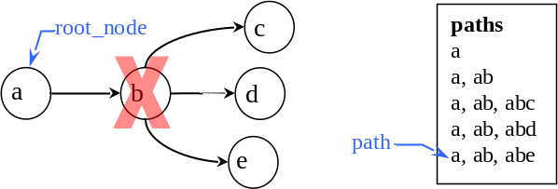
Figure 12 – Node Deletion Affects Cursor Movement
Class GRAPH_ITERATOR and its descendents implement feature back so that invalid paths are ignored. In the example any path going through node “b” (paths “abd”, “abc”, and “ab”) are no longer valid, so a call to back would move the path cursor back to path “a”. Feature node would then return the same node as feature root_node.
This example illustrates a problem with using an external iterator instead of an internal one as used in class LINKED_LIST and others from the base library. The structure [of the graph] could change and the iterator would not know it. In fact, this problem arises not just for feature back but all features of class GRAPH_ITERATOR that rely on the current position. Feature node, edge, and path are three of these. To prevent an iterator from returning a value that is invalid, such as a node that is no longer in the graph, an edge that is not connected to two nodes, or a path containing a disconnected edge, the iterator can check the validity of the current path and keep searching until it finds a valid path.
This path validity checking can slow the iteration immensely, so this checking is turned off by default; it is assumed that most iterations go from start until is_after with no mid-iteration changes to the graph. This status is queried with feature is_validate_mode and is turned on and off with features set_validate_mode and set_unsafe_mode. When is_validate_mode is true the path validity checking will be done.
The use of external iterators may have made the implementation of the iterator classes more difficult, but it simplified the development of the structural classes because those classes do not have to worry about maintaining a “cursor” as the structure changes. In addition, it allows a graph to be traversed in various ways by multiple iterators at the same time and allows the traversal method to be changed in mid-course.

Mode Changes During Graph Traversals
Setting the traversal method of an iterator using features such as set_breadth_first, set_depth_first, and so on as described in sections 3.1 and 3.2 does not lock the iterator forever in that mode. Figure 13 depicts a graph and the list of paths created when the graph was traversed from beginning to end, but with a change mid-course in the traversal method. The graph was traversed in order from the root node through nodes “e” and “b” to node “f” via paths “abe”, “ab”, and then “abf”. At that point the traversal method was changed to breadth-first by calling set_breadth_first. Since breadth_first_forth looks for the children of the first “queued” node, the children of “a” are visited next, producing paths “ac” and “ad”, but node “b” is not visited again. Next in breadth-first order are the children of “b”. Nodes “e” and “f” have already been visited, so they are not visited again. It looks at this point as if node “g” should be next. It is not so obvious, though, that node “b” has two unvisited children. Remember that if the graph is_visiting_relations, which is the default setting, the direction of the edges is ignored meaning that node “a” is also an unvisited child of node “b”. If nodes “a” and “b” were connected before nodes “b” and “g” then node “a” would normally be visited first, then, as the last child of node “b”, node “g” would be visited. The breadth-first traversal of the remaining nodes is straight forward. Node “c” has no children so the one child of node “d” is visited to complete the traversal.
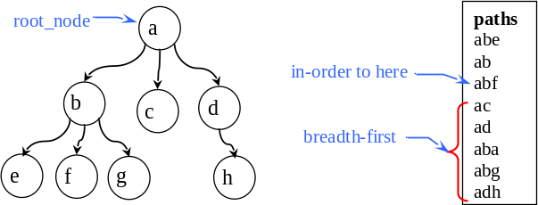
Figure 13 – Changing Traversal Method

Node and Edge Ordering in a Graph
In the example traversal of the graph in Figure 13 above, the order in which node “a” and node “g” was visited depended on the order in which they were connected to node “b”. The default setting for graphs is to place the edges into the nodes in the order they are connected to that node (i.e. the edges are added at the end of the list of edges.) Sometimes a sorted order is desired where the children of a node should be in alphabetical order. Other graphs may require the edges to be ordered with the shortest edges first. To build a graph with this ordering use feature set_ordered which sorts any edges already in the graph and places new edges in their proper sequence. Feature sort is also available to order edges already in the graph, but subsequent edge additions will be placed at the end of the edge list in the nodes.
This ordering ability implies that there is a comparison operation going on between nodes and edges. Both classes, NODE and EDGE, inherit from COMPARABLE and redefine feature “<”. At this level in the hierarchy an edge is less than another edge if the node from which it originates (node_from) is less than the other’s originating node. If the originating nodes are equal then the terminating nodes (node_to) are compared.
This begs the question, “How are nodes compared?” A node is less than another node if the number of edges in the node is greater than the number of edges in the other node. This places nodes with the most children first. If the number of edges in the nodes is the same then each edge in the node is compared to the corresponding edge in the other node using the edge comparison described above. These comparison operations become more straight forward further down in the class hierarchy where edges have costs and nodes can take on values; these costs and values can be compared. But before seeing these descendent classes, let us look at the hierarchy of the classes described up to this point.

The Big Picture (…so far)
Figure 14 depicts the library as described so far showing the structural class GRAPH and its support classes NODE, EDGE, PATH, and GRAPH_ITERATOR.
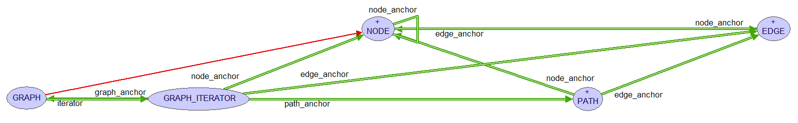
Figure 14 – Upper-level Classes
None of these classes are deferred; each is fully usable as is. However, a graph with simple nodes and edges while interesting to theorists is not of much practical use in programs. So now it is time to reveal the rest of the library.

The Rest of the Story
The classes seen so far allow a user to build a graph complete with nodes and edges, and the iterator classes, along with the path classes, allow various traversals of the graph. But missing is the ability to put data or items into a graph and use the graph’s structure to organize the data. One approach could be to inherit from NODE and/or EDGE which would allow the objects, which now conform, to be manipulated by an object of type GRAPH. But, this approach puts a heavy burden on the developer. An easier way, similar to the use of the base container classes, such as LINKED_LIST and ARRAY, would be to use this library’s generic container classes—the descendents of GRAPH.

Containers, Finally
The generic descendent classes of GRAPH are parameterized around the way data can be stored in a graph. Data can be held in the nodes or on the edges. The data on the edges is either simply that, information, thought of as a label or name for the edge, or it is a numerical value representing the cost of traversing that edge. The generic parameters N, E, and C are used to differentiate these three ways of looking at the data. N is used for the Node-data to be stored in the nodes, E is used for Edge-labels, and C stands for the Cost of traversing an edge.
Figure 15 shows all the container classes along with their generic parameters. Below GRAPH is class VALUED_GRAPH [N]. This would be for a graph holding nodes containing data of type N. For example, the diagram in Figure 15 could be modeled as VALUED_GRAPH [CLASS_NAMES]. Class LABELED_GRAPH [E] is for a graph where the edges contain some type of data but there is no real “cost” to traverse the edges. (Exploring a path, of course, has a cost which is predicated on the number of edges in the path; the longer the path the higher the cost of walking it.) A VALUED_GRAPH [COLOR] might be used in a map coloring problem. Class WEIGHTED_GRAPH [C] is for graphs which have a traversal cost associated with each edge.
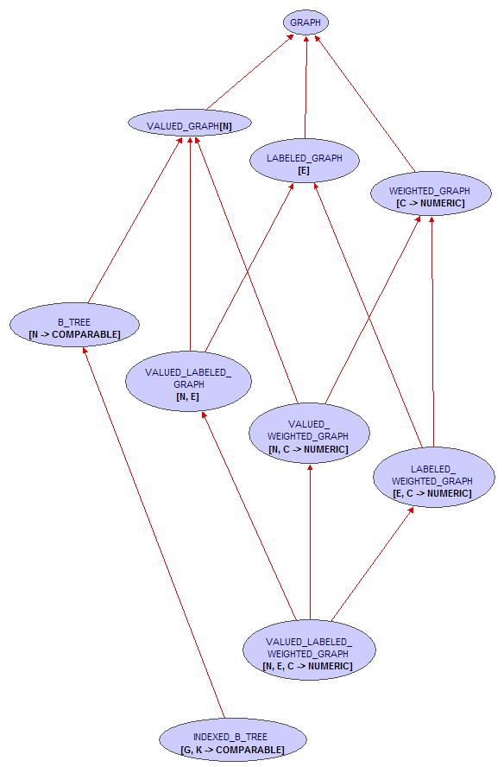
Figure 15 – Containers
Class B_TREE [N ->COMPARABLE] models a b-tree whose values of type N are stored in order. The creation procedures for class B_TREE sets the graph to tree mode as discussed above. Class INDEXED_B_TREE [G, K -> COMPARABLE] stores items of type G indexed by a key of type K. This class is analogous to a HASH_TABLE [G, K -> HASHABLE] except the keys do not have to be hashable.
A Note about b-trees

If items already in a b-tree are changed the tree may not then be ordered correctly. If an item must be changed it may be better to first remove it from the tree, change it, then insert it back into the tree. This will ensure it ends up in the correct spot. Another alternative is to set_validate_mode. This will make the tree ensure the items are in the correct order and if not it will reorganize the tree. If the tree is large this could take a long time to complete.
Two of these data typing properties are combined in the descendents at the second level in the hierarchy in classes VALUED_LABELED_GRAPH [N, E], VALUE_WEIGHTED_GRAPH [N, C] and LABELED_WEIGHTED_GRAPH [E, C].
All three come together in class VALUED_LABELED_WEIGHTED_GRAPH [N, E, C]. This bottom-most class could be used to model a highway system where N, the node-data type, could be a CITY; E, the edge-label type, a STREET; and C, the edge-cost type, a REAL. The declaration for this hypothetical class would be MAP [CITY, STREET, REAL_32]. The last parameter, the REAL32 value, might represent the “difficulty of driving a particular street” and could be computed from information such as the length between two cities, the road condition, or the number of lanes which would be stored in each street. The corresponding support classes for the node, edge, and path-types would automatically follow. Figure 16 shows sample code for this example.
local
New_york: CITY
map: VALUED_LABELED_WEIGHTED_GRAPH [CITY, STREET, REAL_32]
iterator: GRAPH_ITERATOR
route: PATH
travel_difficulty: REAL_32
do
…
-- Assume all objects have been created and items added to the graph
iterator := map.iterator
iterator.set_start_node (New_york)
-- Move forth until finding the destination city.
…
route := iterator.path
travel_difficulty := route.cost
end
Figure 16 – Example Libray Usage
Near the end of the code the “travel_difficulty” entity is assigned the cost of exploring (or walking) the selected route. As stated this cost could be calculated from the street objects stored in the map. This is achieved by using feature set_cost_agent from …
Path or weighted path?
Fix me!!

The Big Picture
Figure 17 depicts the hierarchy with the container classes on the left and two support classes NODE and EDGE with their descendents at the middle and right. Classes PATH and GRAPH_ITERATOR and their descendants are not shown in order to avoid clutter.
All the container classes have an iterator anchored to a path as shown for the upper-level classes in Figure 14.
The green client relation links, named xxx_anchor, between the node classes and the edge classes are features that are not exported and should not be called even by the enclosing class; they were used to ease development of the library. The features are covariantly redefined in descendents so all features taking, in this case, arguments of type NODE or EDGE will follow the redefinition of the class. For example, feature connect_nodes from GRAPH takes two nodes as arguments. The arguments are defined to be of type like node_anchor. So if feature connect_nodes is called on an object of type VALUED_GRAPH [STRING], it would expect the two arguments to be of type VALUED_NODE [STRING], and the edge eventually created between the two nodes will be of type VALUED_EDGE [STRING].

Covariance and Catcalls
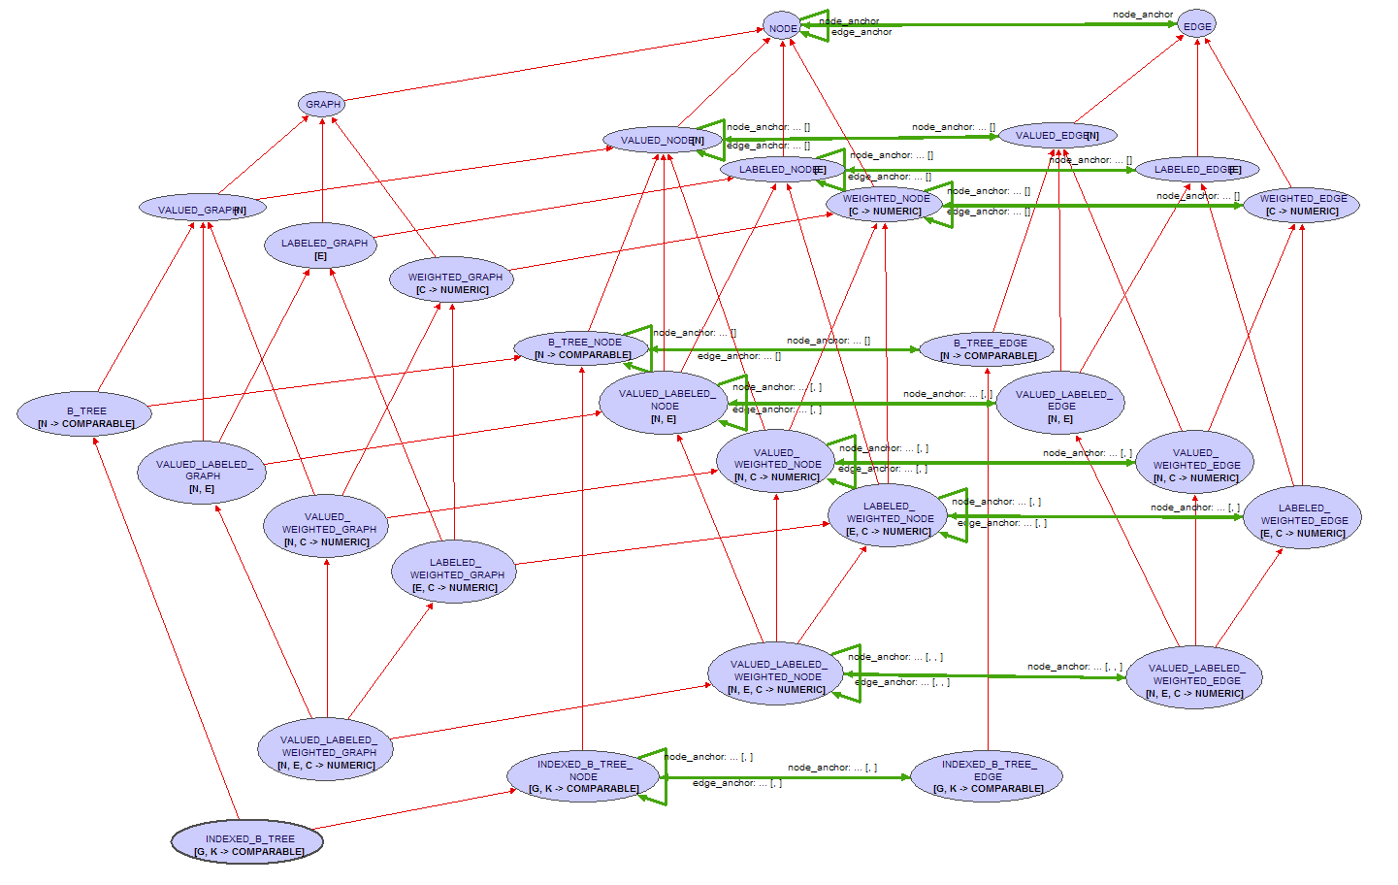
Figure 17 – The Graph Library
The flexibility gained by this covariant redefinition greatly simplified the development of the library but, as described in [3], this can lead to the “risk of run-time type failures known as catcalls.” Figure 18 shows code illustrating this problem. Entity integer_node conforms to NODE so it can be passed as a parameter in a call to connect_nodes on target g, because g, as a GRAPH simply expects objects of type NODE as arguments. The problem though, is that g is attached to a VALUED_GRAPH [STRING] object which expects two VALUED_NODE [STRING] arguments. The compiler will not catch this and this will most likely lead to a segmentation violation error.
cause_cat_call is
-- Attempt to produce a cat call on the covariantly redfined classes
local
string_node: VALUED_NODE [STRING]
integer_node: VALUED_NODE [INTEGER]
string_graph: VALUED_GRAPH [STRING]
g: GRAPH
do
create graph.make_with_value (“the graph”)
create string_node.make_with_value (“a node”)
create integer_node.make_with_value (123)
g.connect_nodes (graph, string_node) -- okay
g := string_graph
g.connect_nodes (graph, integer_node) -- produces a catcal
end
Figure 18 – Catcall Illustration
Class B_TREE is even more problematic in respect to catcalls because it changes the export status of many features. For example, a b-tree cannot call connect_nodes, because as items are added to the tree, the tree itself is responsible for creating the nodes in which items will be placed. So, a polymorphic assignment could not only pass in the wrong type of nodes but could also call features that should not be allowed for that target.
If possible avoid the type of polymorphic assignments depicted in Figure 18. For example, when accessing a node from an object of type B_TREE [STRING] assign the node to an entity of type B_TREE_NODE [STRING] not an entity of type NODE.
Section 3.2 said that an object of type GRAPH_ITERATOR could be created which is not associated with a particular graph. That could also lead to Catcalls. If an object of type GRAPH_ITERATOR was created to explore descendants of an object of type B_TREE_NODE, then the nodes obtained from the iterator may appear as simply a NODE type and not as a B_TREE_NODE, giving entities access to improper features.
This shows that care should be exercised when using the library. The intent of the library is for the descendent classes of graph to be used as containers to hold the real objects of interest. The support classes such as NODE, EDGE, and PATH and their descendents are to be used only in rare cases. Also, while some polymorphic assignments should work in some cases, try to match the container types to the support types as closely as possible.

Performance
If this catcall situation is avoided and this library is used as described, systems requiring graphs or trees could be easily modeled. But how do these classes fair in the performance arena? To answer this question the classes were compared to comparable classes in the elks structures cluster.

VALUED_GRAPH vrs. LINKED_LIST

B_TREE vrs. SORTED_TWO_WAY_LIST

INDEX_B_TREE vrs. HASH_TABLE

Conclude Me
…it adds much flexibility to the development of new systems and provides functionality not found in the Eiffel libraries up to now. The library is a practical implementation of …

Notes on Implementation

feature “<” in node and edge
When thinking of a node as containing a value it is easy to envision that the comparison of two nodes would be done by comparing the value in the two nodes. Or, with an edge containing a cost or a “value on the edge”, comparisons would be done based on the costs in the two edges. So, in the first approximation of this library I attempted to defer feature infix “<” in the support classes, NODE, EDGE, and PATH.
But, I wanted all the classes to be effected. Finish this section……

JJ_ARRAYs
This library relies on container classes from another cluster called “jj_support”. These classes are all descended from ARRAYED_LIST because arrays may tend to be faster in the b-tree classes than a linked structure. Class JJ_ARRAYED_LIST changes feature prune to remove the first occurrence of an item starting at the beginning of the list, not from the current position. I felt that was more intuitive and prevented having to call start every time an item needed deleting. The class keeps the one-argument feature replace (renamed), but adds a two-argument replace. Instead of replacing the “current” item, it goes to the position of an item and then replaces the item with the new one. Again, this seemed more intuitive for the situations called for in this library.
I also wanted the ability to optionally store the nodes and edges in a sorted order. Class JJ_SORTABLE_ARRAY provides a sort feature and features for inserting in order is desired. Feature item_position for finding an item in an array or for finding the position where a new item should go was indispensable for JJ_B_TREE.
Finally, class JJ_ARRAYED_STACK behaves just like its ancestor, the base class ARRAYED_STACK, but allows items other than the top one to be inspected. This was needed for class PATH which needs to move through or access each edge in the path but must only add or delete edges from one end.
Iteration through these arrays was performed using an integer counter with feature i_th. I found that using start, item, forth would sometimes violate contracts because an invariant or other called feature would iterate over the same structure that was currently being iterated over.

Covariant Redefinitions With “Anchors”
I wanted to avoid the proliferation of classes seen in other attempts at a graph library. Sometimes there are classes for acyclic graphs, directed graphs, undirected graphs, disconnected and connected graphs, and so on. This “class explosion” occurred to some extent in this library because a particular node, edge, and path type had to be matched to the graph type, but through the use of the “anchor features” the library structure remained overall simple and the redefinitions were brainless (except for INDEXED_B_TREE which became quite complicated.)
To ease development “anchor features” were used in all the classes to provide types for the nodes, edges, paths, and graphs. For example, class EDGE has nodes at each end, node_from and node_to, which are defined as “like node_anchor” shown in Figure 19. In B_TREE_EDGE feature node_anchor is redefined as in Figure 20 to be of type B_TREE_NODE so that an edge in a b-tree will connect only b-tree nodes.
All the anchor features have the form shown in Figure 19 and are redefined in descendant classes similarly to that shown in Figure 20.
feature {NONE} -- Anchors (for covariant redefinitions)

node_anchor: JJ_NODE is
-- Anchor for features using nodes.
-- Not to be called; just used to anchor types.
-- Declared as a feature to avoid adding an attribute.
do
check
do_not_call: False
-- Because give no info; simply used as anchor.
end
ensure then
void_result: Result = Void
end
Figure 19 – Example of an “Anchor feature”
feature {NONE} -- Anchors (for covariant redefinitions)

node_anchor: JJ_B_TREE_NODE [N] is
-- Anchor for features using nodes.
-- Not to be called; just used to anchor types.
-- Declared as a feature to avoid adding an attribute.
do
check
do_not_call: False
-- Because give no info; simply used as anchor.
end
ensure then
void_result: Result = Void
end
Figure 20 – An “Anchor feature” redefined

Assertion Checking
Eiffel allows an object to violate invariants during features as long as it is restored on exit. Nevertheless, great effort was put into maintaining the invariants for each object at all times. Unavoidably however, there were places in the code where assertion checking had to be turned off. This was generally in features which are selectively exported. For example, in B_TREE during the splitting or combining of nodes the number of edges in a node and the number of items in a node could violate one or more of the invariants. As items are being shifted from one node to another there are times when the number of items falls below the minimum number of items per node as required by the b-tree’s order. Also, since the edges and items must be shifted one at a time, the number of edges versus the number of items breaks the invariant that says the number of edges for non-leaf nodes is always one more than the number of items. Turning assertion checking off during development was not an option, so these “questionable” sections of code were bracketed with calls to check_assert from ISE_RUNTIME as shown in Figure 21 in the if statement. The second call to check_assert restores the assertion checking to what it was before the feature turned it off.
feature {B_TREE} -- Implementation (Insertion/deletion features)

prune_value (a_node: like node_anchor; a_value: like item_anchor)
-- Remove `a_value' from `a_node'.
require
node_exists: a_node /= Void
value_exists: a_value /= Void
node_has_value: a_node.has_item (a_value)
local
b: BOOLEAN
n: like node_anchor
v: like item_anchor
do
if a_node.is_leaf then
b := {ISE_RUNTIME}.check_assert (False)
a_node.value.prune (a_value)
if a_node.item_count < minimum_item_count and then not a_node.is_root then
restore_node_count (a_node)
end
b := {ISE_RUNTIME}.check_assert (b)
else
n := a_node.successor_node (a_value)
v := n.i_th (1)
a_node.value.replace (a_value, v)
prune_value (n, v)
end
ensure
enough_items: a_node.is_root or else a_node.item_count >= minimum_item_count
end
Figure 21 – Feature with Assertion Checking Disabled
In feature prune_value in Figure 21, for the nested if statement beginning, “if a_node.item_count < minimum_item_count …” to be true, by definition the invariant for a b-tree node would be violated; the number of items in the node has fallen below the minimum number required. But the point of this part of the feature is to restore that count when it is too low. The only way to check it is to turn the assertion checking off. Once restore_node_count has done its job, assertion checking can be turned back on.
Also, during a node deletion from a graph, the edges are disconnected. One of these disconnected edges could be in a path stored in an iterator. When a feature of that path is called, and it will be in GRAPH_ITERATOR, the invariant from PATH which says the path is made of an unbroken chain of edges will be violated. So, the section of code in the GRAPH_ITERATOR class that checks the list of paths for validity must also be bracketed with check_assert as described above.

B_TREE
In order to follow the normal graph theory classification where a tree “is-a” graph, class B_TREE inherits from GRAPH indirectly through VALUED_GRAPH [N]. It inherits from VALUED_GRAPH in such a way that it makes the value in each node be an array instead of a single value. Specifically a JJ_SORTABLE_FIXED_ARRAY [N] is used as the generic parameter to VALUED_GRAPH [N] as shown in Figure 22.
class
B_TREE [N -> COMPARABLE]
inherit
B_TREE_NODE [N]
VALUED_GRAPH [JJ_SORTABLE_FIXED_ARRAY [N]]
Figure 22 –Inheritance for B_TREE
The corresponding node and edge classes and the anchor features, shown in Figure 23, are redefined similarly to the other container and support classes.
class
B_TREE_NODE [N -> COMPARABLE]
inherit
VALUED_NODE [JJ_SORTABLE_FIXED_ARRAY [N]]
feature {NONE} -- Anchors (for covariant redefinitions)
node_anchor: B_TREE_NODE [N]
edge_anchor: B_TREE_EDGE [N]
value_anchor: JJ_SORTABLE_FIXED_ARRAY [N]
item_anchor: N
Figure 23 –Inheritance for B_TREE_NODE
As with all the node classes the node_anchor is the same type as the class. The value in the node is now an array as defined by feature value_anchor. A new feature, item_anchor, is defined in order to type each item in the array. This fixes the number of items in each node at creation time. The edge_set is still there from NODE but the number of edges is restricted by the invariant to always be one more than the number of items in the node.
Figure 24 shows the structure of an example b-tree of integers. Each node contains an array with order-1 items and a list of order number of edges pointing to the child nodes.
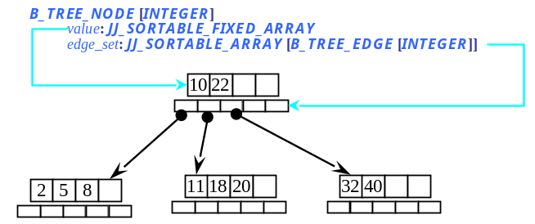
Figure 24 – B_TREE_NODE Structure

INDEXED_B_TREE
An INDEXED_B_TREE is built from a B_TREE whose items are of type B_TREE_CELL. The items of interest in the tree are contained in the cell and indexed by a key value. An item can be accessed with feature item or one of its aliases.
class
INDEXED_B_TREE [G, K -> COMPARABLE]
inherit
INDEXED_B_TREE_NODE [G, K]
B_TREE [B_TREE_CELL [G, K]]
Figure 25 –Inheritance for INDEXED_B_TREE
class
INDEXED_B_TREE_NODE [G, K -> COMPARABLE]
inherit
B_TREE_NODE [B_TREE_CELL [G, K]]
Figure 26 –Inheritance for INDEXED_B_TREE_NODE
Error: Reference source not found shows the structure of a single node in an indexed b-tree holding string values which are indexed by integer keys.
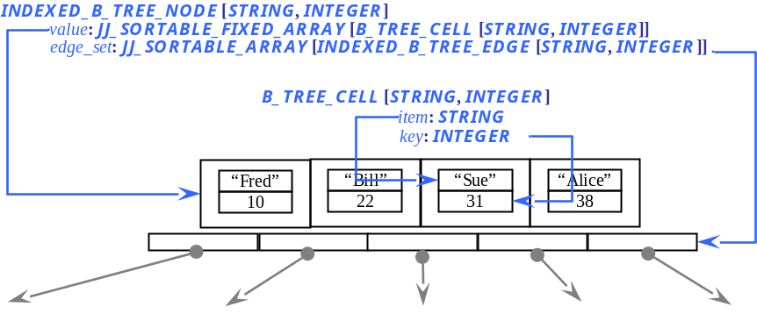
Figure 27 – INDEXED_B_TREE_NODE

Iterators
As an iterator progresses, it needs to mark node as visited, edges as traversed, and paths as explored. At first the visited_nodes feature was implemented as a list into which nodes were inserted. A node was considered visited if it was in visited_nodes. To determine if a node had been visited required a traversal of this set. For efficiency, instead of letting the GRAPH_ITERATOR keep track of visitations, this was delegated to NODE (and EDGE). When a node is visited, it is marked as was_visited_by (an_iterator). Instead of an iterator keeping track of the nodes it has visited, a node keeps track of the iterators which have visited it. Determination of node visitation should be faster this way; the number of

To Be Done

This File
- Fix diagrams so they don’t cover a footnote.

All classes
- Remove all “is” keywords from features.
- Make void-safe and remove all “require /= Void” preconditions, etc.
- Fix all class names in comments to have braces around them.
- Make NODE, EDGE, and PATH (?) export modification features to GRAPH and GRAPH_ITERATOR only and add status feature is_locked (and corresponding setters) to GRAPH_ITERATOR to prevent changes to a graph during iteration. This would allow an iterator to assume the graph has not changed and therefore no need to check if a path is valid. No because one iterator may lock it but another could unlock, invalidating the assumption.

Test Classes
- Make a graphical display to show a graph and let the user dynamically create a graph.
- Make a test suite to check all traversals, moving forward and backwards while the graph is changing. Change traversal modes in the middle of a traversal to see what happens.
- Test the speed of insertions, deletion, access, and traversals on a B_TREE against a SORTED_TWO_WAY_LIST. Test INDEXED_B_TREE against a HASH_TABLE.

GRAPH
- Should I change N, E, and C (Node-data, Edge-label, and edge-Cost) to V, L, and W (node-Value, edge-Label, and edge-Weight)? Or maybe use V, L, and C because the “weight” of a graph is the sum of the costs of all the edges. But “weighted graph” is the term used for graphs having costs in the edges. ???
- Ensure the graph will create nodes that have the same properties as the graph. Added nodes do not necessarily require this but when the graph makes the nodes they should. Tree nodes will have more restrictive properties.
- Allow root_node to not be in graph (perhaps due to a deletion by the graph) which would invalidate all paths and the iterator would be is_before(?) or is_after
- Add minimal_spanning_tree etc. – should this return copies or references? A minimal spanning tree of a graph returns a similar graph, not a tree, in order to keep the types correct. Minimal spanning “tree” will be a misnomer for this feature; it really returns a graph with the minimal number (or shortest) edges.
- Should GRAPH always contain itself? In minimal_spanning_graph I need a list of graphs as containers and putting the current graph into itself means each graph has an extra node. Think about this.
- Add shortest_path between two nodes? Or should this be in NODE?
- Revisit set_alphabetical – does this make sense? Yes, sort the `nodes’ and `edges’ sets.
- Feature root_node – what happens if it is deleted from the graph? What to use for root node then?
- Add feature distance (a_node, a_other_node) to GRAPH?

GRAPH_ITERATOR
- Finish minimal_spanning_graph for directed situations.
- Ensure all traversals keep track of queue_index? Why not use pending_paths in place of queue_index for all traversals?
- Fix back to call breadth_first_back when traversing that way.
- Fix breadth_first_back. Decrementing the queue_index_position every time is wrong!
- Fix breadth_first_back so it updates visited_nodes, and traversed_edges.
- Fix visited_nodes and traversed_paths to account for is_shortest_first traversals. The nodes and edges may be in the paths but not yet visited or traversed. A node is not “visited” until all its edges have been traversed.
- Fix comment in shortest_first_forth.
- Implement shortest_first_back and call it from back.
- Feature in_order_start – should it set the queue_index_position? What do I do with queue_index_position for the traversal methods that don’t use this index? What should it be when traversal method changes to one that does?
- Implement visit_longest for use by bottom_up_start and bottom_up_forth.
- Implement unreachable_nodes.

B_TREE
- In split I create new nodes and then check the status of is_comparing_objects. Why not create a new_node and then call copy_status on that node? I would need a feature new_valued_node to accommodate a VALUED_GRAPH.
- Revisit is_in_order – export it? Rename is_sorted? What happens if an item changes? Provide sort feature? Provide feature is_allowing_changes? If true then must sort else assume checked in precondition.
- Should any traversal methods other than the set_in_order be exported? How do you traverse a b-tree breadth-first, etc?

NODE
- Fix invariants. I think the can_embrace_multiple implications are wrong.
- Be consistent with feature naming; sometimes I use “connections” and sometimes the word “edges”. Pick one.

VALUED_NODE
- Add replace_value? Why do this?

B_TREE_NODE
- In features successor_node and predecessor_node the post-condition, “result_is_descendent_of_Current” should be true but something is wrong, perhaps with descendants.

WEIGHTED_PATH
- Add (agent?) to get the cost associated with an edge, such as in EDGE [STREET] where street has feature that determines the length, in miles, of the street and that agent is passed to WEIGHTED_PATH in a feature like set_cost_agent. [Or can this go in PATH?]

EDGE
- Implement feature set_cost_agent to allow a user to provide a method for calculating the cost. However, this conflicts with the current concept of the generic parameter E; in WEIGHTED_EDGE [E] feature cost returns E. A change here would also affect feature “<” or check_edges.
- Features node_from and node_to could be given names more in line with graph theory, such as “head/tail” (refers more to the edge not the nodes) or “direct successor/predecessor” (a “successor/predecessor” refer to any node reachable from a node--what I called ancestors/descendents).

WEIGHTED_EDGE
- Feature check_nodes looks to see if the cost in each edge is an object of type COMPARABLE. But an object of type NUMERIC is NOT comparable. How will this affect a graph of integers? [Answer: it will not; INTEGER inherits from COMPARABLE.] There is a similar comparison in LABELED_EDGE but that seems okay.

LABELED_NODE
- Fix post-conditions to deep_adopt_labeled.
- Fix pre- and post-condition for all features.
- Fix the features to account for is_tree_mode. Connecting and disconnecting edges is not so simple any more.

Last Check
- Ensure all the class names, feature names, code segments, and figures agree with the actual code.
- Update all field codes for the figure and footnote numbering and the cross references.
References
- Bertrand Meyer: Object Oriented Software Construction, 1988.
- Bertrand Meyer: Eiffel: The Language, third edition, work in progress at www.inf.ethz.ch/~meyer/ongoing/etl/, user name Talkitover, password etl3, consulted October 2007.
- Mark Howard, et. al.: Type-safe Covariance: Competent Compilers Can Catch All Catcalls, Draft — Version of 27 April 2003.
- Mary E. S. Loomis: Data Management and File Processing, 1983, ….fix me
- Reinhard Diestel: Graph Theory, Electronic Edition 2000, Springer-Verlag New York 1997, 2000.
- Olivier Jeger: Extending the Eiffel Library for Data Structures and Algorithms: EiffelBase, Masters Thesis, ETH Zurich, October 2004.
- Weisstein, Eric W. “Graph.” From MathWorld—A Wolfram Web Resource. http://mathworld.wolfram.com/Graph.html.
- http://en.wikipedia.org/wiki/Glossary_of_graph_theory.

Conversion to void-safe code would elliminate the need for this and many other checks.
Development of this library went through a version which did have a tree class, but when generic containers were added the number of classes and therefore the complexity of the interface grew disproportionally to the benefit gained. Renaming of the creation procedures and changes in feature exports were also overly complicated. The current implementation of class GRAPH which must acount for tree properties is more complex but the interface is simplified.
Describing the order in which the nodes are traversed naturally produces a tree-like representation, however the traversals do not produce trees just a list of paths.
This is analogous the backward traversal of a LINKED_LIST where a previously accessed item may no longer be in the list, so moving backwards would give a different “previous” item or may even go off the front of the list.
A different implementation for preventing invalid cursor movement through a changing graph was considered. A proposal to allow a graph to know [i.e. keep a reference to] each iterator created for that graph was discarded because every change to the graph would require reshufling of each iterator referenced which was deemed to place too much overhead on a graph.
These features do have the side affect of changing each node that is in the graph; the original edge ordering in the nodes is lost.
The “anchor” attributes, depicted in Figure 14 as client links, are covariantly redefined features to which other featuers and result types are anchored. The use of these anchor features simplified development and will be discussed later.
In hindsight, feature prune_value may not need to be exported to B_TREE so the invariants of B_TREE which check each node in the tree for compliance with b-tree properties would not be called; however the qualified call “a_node.item_count” would still check the invariants required for a B_TREE_NODE.
The figure shows all the nodes containing an array of references to child nodes. In actuality, the edge_set of nodes in a b-tree are actually Void until the first child edge is added to the node. So, the edge_set of leaf nodes will always be Void.
For simplicity the figure shows the strings as values stored with the keys in the cells; however, the cells really contain a reference to an object of type STRING. Child nodes are not shown.

