**Toggle.sh**

1. min = -200mV, max = 3.30V
2. period = 236.51ms
3. The value is over 100% the expected value
4. The period is longer than the expected because on top of the sleep for the period the code will take time to execute the rest of the commands
5. 3.2% CPU usage
6. Table below

|  |  |  |
| --- | --- | --- |
| input | period | cpu |
| .9 | 1.8366 s | .7% |
| .01 | 56.08 ms | 14.3% |
| .001 | 38.40 ms | 19.0% |
| .0001 | 36.7 ms | 21.4% |
| .00001 | approx the same as before | 20.8% |

1. the period is not stable – it varies from approx 37 to approx 70
2. now the period is very stable – it varies by less than 1 ms
3. the period becomes more stable
4. the period becomes much shorter
5. 26.93 ms with using sh and removing the extra lines of code

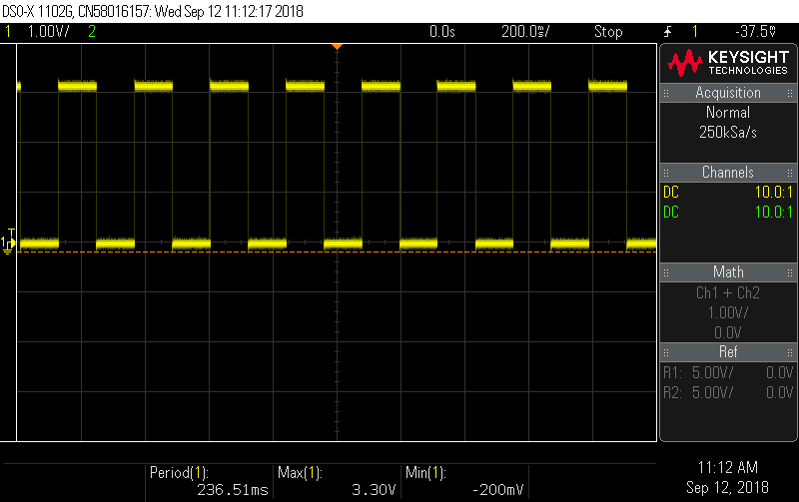

**Toggle.c**

1. min = -360mV, max = 3.46V
2. period = 398.9us
3. The value is over 100% the expected value
4. The period is longer than the expected because on top of the sleep for the period the code will take time to decode and execute the rest of the commands
5. 52.8% CPU usage
6. Table below

|  |  |  |
| --- | --- | --- |
| input | period | cpu |
| .01 | 401us | 40.1% |
| .0001 | approx the same as before | “” |
| .000001 | approx the same as before | “” |

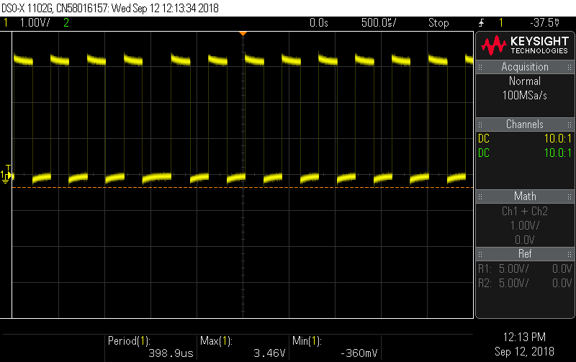

**Toggle.py**

1. min = -240mV, max = 3.34V
2. period = 200.53ms
3. The value is over 100% the expected value
4. The period is longer than the expected because on top of the sleep for the period the code will take time to decode and execute the rest of the commands
5. .7% CPU usage
6. Table below

|  |  |  |
| --- | --- | --- |
| input | period | cpu |
| .0001 | 560 us | 38.6% |
| .00001 | 370 us | 59.8% |
| .000001 | 351 us | 100% |
| .0000001 | 167 us | 96.2% |
| .00000001 | approx the same as before | “” |

