# Convert NextSeq basecall to fastq

First, put a “SampleSheet.csv” in the top directory. E.g.

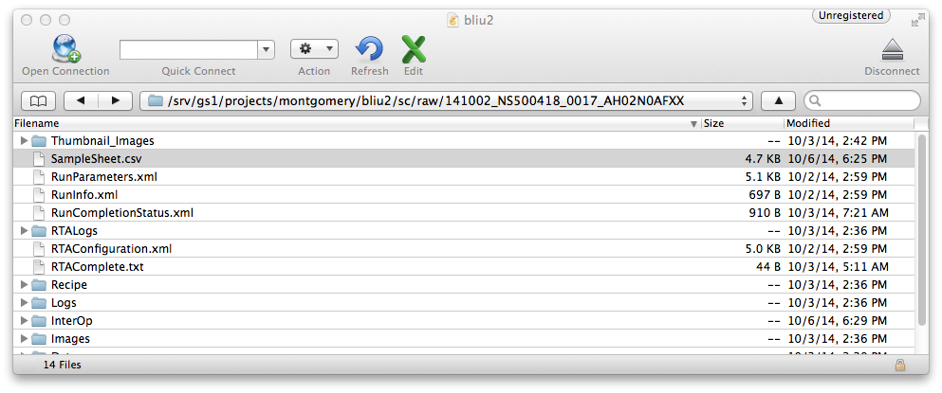

Sample sheet templates:

* **NextSeq500_SampleSheet_DualIndex.csv:** template for dual index
* **NextSeq_SampleSheet_SingleIndex.csv:** template for single index

To convert NextSeq bcl files to fastq format, use **run_bcl2fastq2.sh**