# Creating a git repository

To be a successful bioinformatician, the first thing you need to do is to create a git repository to store your scripts.

First, let us create a git remote repo on github. If you don’t have a github account, you should really create one on <https://www.github.com>. After you have a personal account, clikc on the ‘plus’ button on the topright corner to create a new repository. You will see the following page.

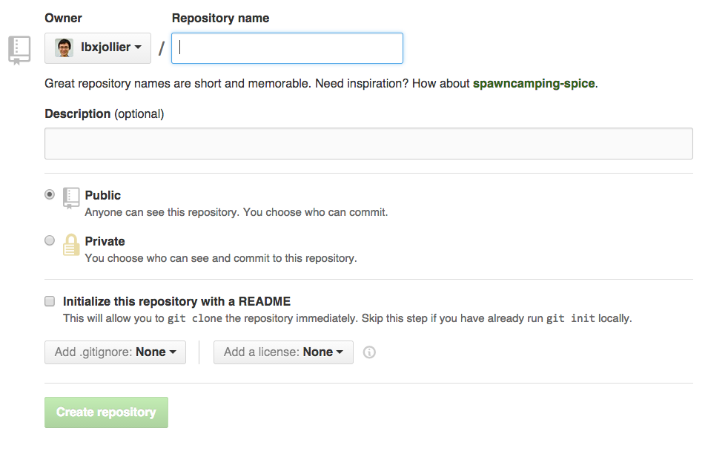

Enter repository name, and click on ‘Create repository’.

Now clone this repository to your local machine:

*$ git clone git@github.com:lbxjollier/bioinformatics_toolbox.git*

# If you encounter the following error, follow this [link](https://help.github.com/articles/generating-ssh-keys/) to generate a public ssh key.

*Permission denied (publickey).*

*fatal: The remote end hung up unexpectedly*

This command will create a directory named “bioinformatics_toolbox”. Add some files into this directory, and type:

$$\$ git add*$$

Let usdo our first commit:

*$ git commit –m ‘initial commit’*

This command tells git to keep a permanent copy of the current files. To check whether a desired files have been committed, use:

*$ git status*

You will see: 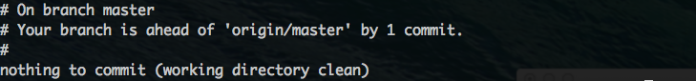

This reflects that we have committed the newly added files locally, but have not ‘pushed’ the local file to our remove repo on github. To push, use:

*$ git push origin master*

To exclude a file, first create a .gitignore file:

$ touch .gitignore

Then add files you don’t want to include. For example:

$ echo '.nfs0000000006ee455100000edb' >> .gitignore