

Documentation for Version 1.0
Last revision: 25/12/2021
Introduction
Pelion is a two-dimensional game framework written in
C++. This document contains a tutorial on how to install Pelion and get started with it. It also describes all of the supported features in Pelion.

Pelion is an open source project. You can contribute to this project on GitHub: https://github.com/boxofbytes/Pelion

Installing Pelion
Installing Pelion is generally a quick and simple process. The installation process varies from one platform to another.

Installing on Linux
Before installing Pelion, make sure you have GLFW and GLM installed.

Inside the Pelion “bin” folder you should find the necessary files for installation. Copy the “libPelion.so” file to your /usr/lib/ folder and the “Pelion.hpp” file to your /usr/include/ folder. Then, link Pelion with OpenGL and GLFW in your IDE or compiler.

Afterwards, you should have a fully functional Pelion installation ready to be used.

Installing on Windows and macOS
Installing on Windows and macOS currently isn’t possible. There are plans, however, on making it possible in the next versions of Pelion.
Getting Started
In this section, we will show you how to get started by making your own Pelion project. We are going to make a small tech demo to show what you can do in Pelion.

Before doing anything, let’s first make a blank .cpp file with a main function and include the "Pelion.hpp" header that should be in your device's include folder if you have installed Pelion.
It should look something like the code below.

#include <Pelion.hpp>

int main() {

return 0;
}

Now that that’s set up, we will move on to the next step – rendering.

If we want to render anything in Pelion, we will need a window. A window is the core of your project, it’s the area of your screen that you will be rendering things onto and it should be the first thing that you create and initialize. To do that, we should first create a Window object. In this tutorial, we will call it “my_window”.

Pelion::Window my_window;

The 4 basic elements of a Window are its width, height, color and title. There are other properties of a Window like its resizability, but we will stick to the default values for now.

We will create a function called “window_create” that changes the properties of our window object and also calls the Window.Init() function which initializes and creates the window with the properties that it was given. This will be the first function that we call in our main function.

void window_create() {
my_window.Width = 800;
my_window.Height = 450;
my_window.Title = "Hello world!";
my_window.Color = {255, 255, 255};
my_window.Init();
}

int main() {
window_create();
return 0;
}

But after we create our window, the main function will end - effectively terminating our program. To solve this, we will create a render loop - a while loop that renders objects while the window is open.

We will create this loop in a new function called “draw_loop”.

To check if the Window is open, we can call the Window.Open() function that returns true if it is open and false if it isn’t. We will call this function in our main one after window_create.

In the loop, we will also call the Window.Render() function which will swap the framebuffers of our window and do some other minor stuff like detect when the user wants to close the window.
When the user wants to close the window by doing an action like pressing the close button, Window.Open() will return false, which means our loop will end. After that happens, we will call Window.Cleanup() to close the window and clean up its resources.

void draw_loop() {
while(my_window.Open()) {
my_window.Render();
}
my_window.Cleanup();
}

int main() {
// ...
draw_loop();
return 0;
}

You can now compile your program and if everything goes well, you will get a nice white 800x450 window.

Remember, you must link your program with Pelion using your IDE/compiler otherwise your program won’t work.

Having a blank window is, however, very boring. What if we wanted to add a shape of some sort? Well, we can do that with Objects.

Objects are structures that represent an object with a color, shape, size, position...
You can create them by constructing them and if you want to render them you can call the Object.Draw() function. They wont render if their visibility is set to false, but by default it is true.

Pelion::Object main_object;

// ...

void draw_loop() {
while(my_window.Open()) {
// ...
main_object.Draw();
}
}

By default, the color, size and position of our Object is 0. Because the position of the object is the distance in pixels from the center of the window, if the position of the Object is 0 the Object is at the center of the screen.

Let’s change some properties, as shown in the next example.

int main() {
main_object.Size = {200, 200};
main_object.Shape = Pelion::PELION_TRIANGLE;
main_object.Angle = 45;
main_object.Color = {0, 128, 255};
// ...
}

You should now get a slightly tilted blue triangle. You can change the properties of the object in the render loop to create some cool effects.

Let’s include the cmath library and make the triangle's angle the time that has passed since the Window has been created wrapped in a sine function. This will make the triangle rotate smoothly over time. To get the time that has passed since the window has been created, we will call the Window.Time() function.

#include <cmath>

// ...
void draw_loop() {
while(my_window.Open()) {
// ...
main_object.Angle = sin(my_window.Time()) * 360;
main_object.Draw();
}
}

We can also make the Object's shape change if we press a certain key.
To get the state of a key, call the Window.GetKeyState() function that takes a key enum as a parameter and returns a keystate enum.

Let’s make a process_input function, which will get called every frame if we put it in our draw loop.

void process_input() {

}

void draw_loop() {
while(my_window.Open()) {
// ...
process_input();
}
}

In it, we will get the key state of the enter key and if it is currently being held, we will make the Object's shape a rectangle, If not, it will make it a triangle.
void process_input() {
if(my_window.GetKeyState(Pelion::PELION_KEY_ENTER) == PELION::PELION_KEYSTATE_PRESSED) {
main_object.Shape = Pelion::PELION_RECTANGLE;
} else {
main_object.Shape = Pelion::PELION_TRIANGLE;
}
}

Now when you compile your program and press the enter key, you should see the object's shape change.

At the end, we made a nice and really simple demo that has a window with a spinning triangle/rectangle inside of it.
The final source code should look like this

#include <Pelion.hpp>
#include <cmath>

Pelion::Window my_window;
Pelion::Object main_object;

void window_create() {
my_window.Width = 800;
my_window.Height = 450;
my_window.Title = "Hello world!";
my_window.Color = {255, 255, 255};
my_window.Init();
}

void process_input() {
if(my_window.GetKeyState(Pelion::PELION_KEY_ENTER) == Pelion::PELION_KEYSTATE_PRESSED) {
main_object.Shape = Pelion::PELION_RECTANGLE;
} else {
main_object.Shape = Pelion::PELION_TRIANGLE;
}
}

void draw_loop() {
while(my_window.Open()) {
my_window.Render();
main_object.Angle = sin(my_window.Time()) * 360;
main_object.Draw();
process_input();
}
my_window.Cleanup();
}

int main() {
main_object.Size = {200, 200};
main_object.Shape = Pelion::PELION_TRIANGLE;
main_object.Angle = 45;
main_object.Color = {0, 128, 255};
window_create();
draw_loop();
return 0;
}

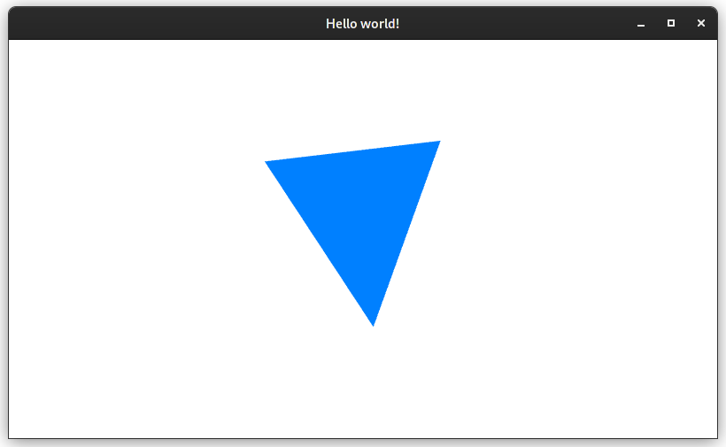
Feel free to experiment, add more objects, make more functions, maybe even make a small game. The only limit is your imagination! (...and the Pelion feature set but we won’t talk about that)
Window
Window is a class that is a window. Objects are rendered inside of it.

Properties
int32_t Width
Width of the Window in pixels.
int32_t Height
Height of the Window in pixels.
uint32_t MSAASamples
The amount of samples used for Multisample Anti-aliasing.
bool Resizable
Defines if the window is resizable or not.
string Title
Title of the Window.
RGB Color
Background color of the Window.

Functions
GetKeyState(Keys key)
Returns KeyStates enum
Returns the state of a key.
Init()
Initializes and creates the Window.
Cleanup()
Terminates the Window.
Render()
Swaps the Window’s buffers.
Open()
Returns bool value
Returns true if Window is open, and false if not.
Time()
Returns float value
Returns time that has passed since the Window has been created.
Object
Object is a structure that represents an object displayed within a window.

Properties
Shapes Shape
Shape of the Object.
RGB Color
Main color of the Object.
Vec2 Pivot
Position of the point around which the Object rotates.
Vec2 Size
Size of the Object in pixels.
Vec2 Position
Distance of the Object from the center of the screen.
float Angle
Angle at which the Object is tilted in degrees.
bool Visibility
Visibility of the Object. Blocks draw function if not set to true.

Functions
Draw()
Renders the Object

RGB
RGB is a structure consisting of the red, green and blue float values.

Properties
float R
Red value.
float G
Green value.
float B
Blue value.

Vec2
Vec2 (short for Vector2) is a structure consisting of the x and y float values.

Properties
float x
Horizontal position in the coordinate system.
float y
Vertical position in the coordinate system.

End of documentation
Thank you for using Pelion!

