1.
a). Thanks to dynamic typing, more generic code can be written:
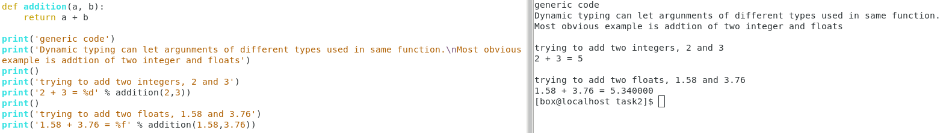
In the example, we can use the function “addition()” by passing both integer and floating point numbers. If we have to achieve same in statically typed language, we have to do (1)defining another function of corresponding type, or (2)casting the type before we have to make the variable work, achieving the same purpose.
Therefore the good in dynamic typing can see here: writing concise code with maximum coverage of usage.

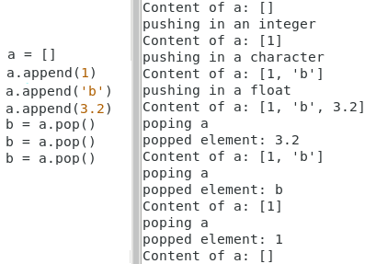
b) Dynamic typing also enables mixed type data type:
In the example, we use the list in python to model the behavior of a stack. Since it is a dynamic typing language, it does not have restriction on what is put inside the list. So we could put either integers, characters and floating points into it.

It is useful when a stack has to be maintained with holding of different objects, e.g. holding different class, and it can be easily achieved with the property of dynamic typing.

2.
a) Python is better than java while implementing array initialization:
Python’s initialization of 2D array could made into 1 line, making it more like a “common variable declaration” which is simple assignment statement, whereas Java uses a nested for-loop, which is no differ from other for-loop logic component.

b)Python is better than java in view of implementing the Object-Oriented structure:
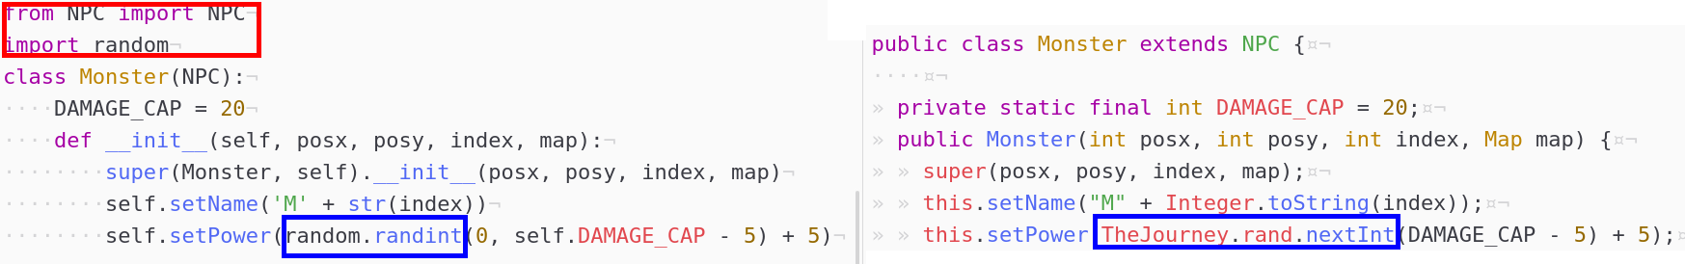
When it is to calling to extend parent class, Python has to import that file while Java doesn’t need. In my personal feeling, python gives me better readability on “which modules are we going to use in the following code”, for example, just by reading the Java code I cannot know is NPC class located in library or in user-created file.
Also, Python makes the Object more independent because it has less linkage with the other class. All calls and libraries has to be imported in the beginning, so it can be easily taken out for another game. Such as if I have another game called “Fighting Jimmy”, the NPC and Monster python file is readily avaliable, while I have to add together with “TheJourney” Java file if I am to use the java code.

3.
First example is another illustration on calling function using different types:
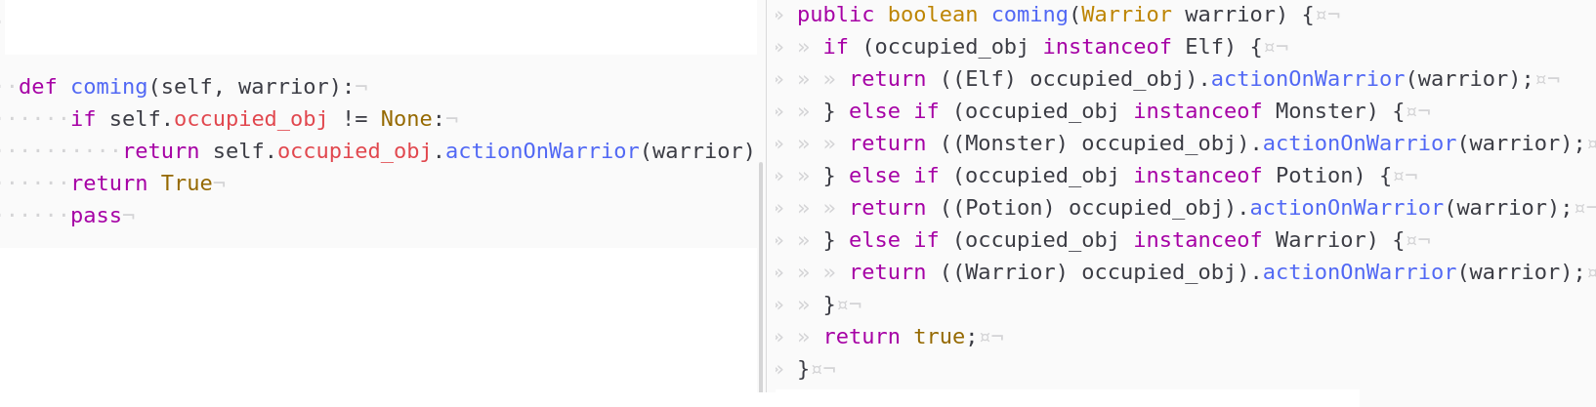
When we need to call the common function shared by several objects of different instances, we have to use variable casting if it is of different type in static typed language, even we know that they have the function provided. Same situation does not apply in dynamic typed language, which make duck typing happens, that the code could run as long as it has the function “actionOnWarrior()”. This shows that dynamic typing has itself a advantage of giving clean and less verbose code.

Another example is in the same code fragment. Note that the parent of Elf, Monster, Potion is NPC while Warrior itself is a root class. So when I modified the code to add “Potion” and “Warrior” into the function, hardly do I need to modify anything in Python code whereas I have to add two casting else-if in Java. This enhances the scalability and modularization of program, which when I add code, even object of new instance into the program and it could still run thanks to Duck typing that they can all “actionOnWarrior()”. This makes the program more robust indeed.

