Colman Traditions

LANTERNS
Overview: Campers who are on their 5th year at Colman and beyond attend a ceremony after evening program. We think Thursday would be the best night for Lanterns with our current schedule, because Wednesday night has Polar Bear in the morning. At the Lantern Ceremony, which takes place at the Chapel, campers receive face paint one-by-one that symbolizes their years at Colman. We start with the previous Lanterns and initiate the new Lanterns last. The only staff members at the Lantern ceremony should be Lanterns themselves - which means Ivy, Ice Pop, and Robbie are the only staff members who will be facilitating the ceremony (only one of us could do it a week too based on availability). After receiving their face paint, Lanterns will participate in an Embers that will replace their cabin Embers for that night. As they exit, they will write down their first and last name and their number of years at camp so we can add them to the lodge wall if they are not already on it.

After evening program, we can make an announcement: “If this is your fifth summer at Colman or you have been at Colman for longer than five summers, please do not leave with your cabin when they are dismissed.” We will then walk those campers up to the Chapel.

The face paint is a black box on the right cheek with one red dot in the middle for five years. Every year after five will be another dot on the left cheek. If a camper has ten years, the dot will be an X, with years after ten as dots on the left cheek. The face paint is an important part of the old ceremony - campers will often leave their face paint on for the rest of the session.

The Embers is more of a conversational one - campers can share out about why they keep going to camp, what camp means to them, etc.

We will walk the cabin loop after the ceremony and drop campers off with their counselors.

BEADS
Overview: Campers receive beads every week to represent the number of years they have been coming to camp, the cabin they were in, and other achievements like participating in the polar bear plunge, whale swim, or earning value awards. The beads will be put on bracelets or necklaces and presented to the campers to take home.

POSTCARDS
Overview: Counselors write postcards for each camper to be sent to them on their birthdays. The messages include happy birthday wishes and reminders of the fun stuff they did at camp. This is a great way to keep kids connected to camp during the year and remind parents about camp as well. We’ve included a good format for your letters below. We want to make sure the letters are personalized to the camper, so include notable (and positive) things about their personalities and something they did at camp (preferably with the cabin) that they really enjoyed. Please also take a few seconds to decorate your cards.

We want to refrain from including inside jokes that could concern parents. We also don’t want to say “looking forward to seeing you,” because that camper may not be able to return to camp for a plethora of reasons. Make sure to say “we hope” when talking about that camper returning. And include both counselor names on the signature.

EXAMPLE
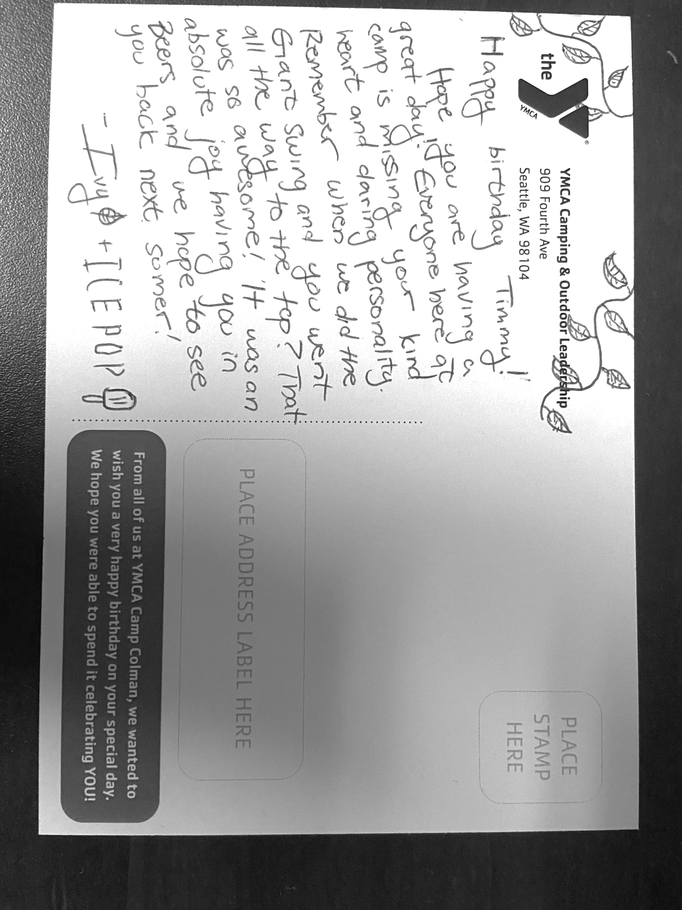
TAKE CARE TO NOTE WHEN THE CAMPERS BIRTHDAY IS. If their birthday is after December, you should write THIS summer. Or they will know you didn’t write it right before their birthday.

VALUE AWARDS
Overview: Campers who exemplify the Y core values of respect, responsibility, honesty, caring, and passion for excellence, have the opportunity to receive awards. The recipients of the awards are voted on by their cabin mates, however, counselors still have the final say. Counselors should make sure the voting is not a popularity contest, and make changes to the winners if deemed necessary.

CABIN CALLS
Overview: During meal lineups as well as other times when the camp comes together, we will need to take a roll call to make sure all the cabins are present. This is a fun opportunity for counselors and their campers to do a fun and creative call besides simply “here”. This is a great way for cabins to show their camp spirit as well as compete with each other for the best cabin call. Cabin calls should be SHORT, less than 30 seconds (unless you’re Ivy and you write a 2 minute CA rap to the tune of Super Bass by Nicki Minaj. Thank you!) or it will take forever. It is important for other counselors as well as leadership to be supportive and encouraging of all cabin calls. Sometimes they can fall flat when a cabin is unprepared and having counselors cheer regardless can prevent campers from feeling embarrassed.

GOOP HOOPS
Overview: Goop hoops is a basketball tournament hosted by Connie and the kitchen staff towards the end of the summer. Everyone is welcome to participate. Teams have 5 members, 3 players and 2 alternates. Start forming teams early. There will be a large meal afterwards with great food but everyone needs to pitch in if they want to eat! You will be facing off against other teams of counselors, leadership, the kitchen staff, and even the teens.

TELL ME WHY
Overview: Our Colman song that we sing right before we dismiss cabins after campfire. We would like to implement singing Tell Me Why after every evening program. When cabins meet back up at the campfire pit, we can give night messages, then sing, then dismiss cabins one-by-one for meds. This would also help getting campers to begin to settle down for Embers and bedtime. Furthermore, campers and staff would be able to actually learn the song!

Logistics: To sing Tell Me Why, everyone should stand and cross their right arm over their left arm, and hold hands with the people next to them. Be sure to let campers know that they do not have to hold if they are uncomfortable doing so. At the end of the song, we will turn to the right without letting go, so our arms uncross themselves as we turn around. Then the camp will be standing facing away from the stage. We take this time as a moment of silence before dismissal. Whoever is dismissing cabins should do so by who is respecting the silence the best. Please let camp know that after we finish singing we expect silence.

**We highly encourage all staff to learn this song. It’s incredibly important to long-time returners and the heart of Colman. Please also model respectful participation in Tell Me Why. There was a serious problem last year with counselors laughing and not taking it seriously. That behavior means our campers won’t take it seriously either, and it’s disrespectful to everyone else.

