

HL7 Implementation Guide: XML Implementation for Virtual Medical Record, Release 1

Project Coordinator and Document Editor

Kensaku Kawamoto, MD, PhD, University of Utah

Collaborators

David Shields, University of Utah

Andrew K. McIntyre, FRACP, MBBS, Medical-Objects

Yongjian Bao, PhD, GE Healthcare

Howard R. Strasberg, MD, MS, Wolters Kluwer Health

Peter R. Tattam, Tattam Software Enterprises Pty Ltd

Scott Bolte, MS, GE Healthcare

Peter Scott, MBBS, Medical-Objects

Keith Boone, GE Healthcare

Zhijing Liu, PhD, Siemens Healthcare

Chris Melo, Philips Healthcare

Nathan Hulse, PhD, Intermountain Healthcare

Jim Basilakis, MBBS, MS, University of Western Sydney

Robert Worden, Open Mapping Software, Limited

Daryl Chertcoff, HLN Consulting

Clayton Curtis, MD, PhD, U.S. Veterans Health Administration

Guilherme Del Fiol, MD, PhD, University of Utah

Emory Fry, MD, Uniformed Service University Health Sciences

Jean-Charles Dufour, MD, PhD, Université Aix-Marseille

Laurent CHARLOIS, Université de la Méditerranée

Project Sponsor

HL7 Clinical Decision Support

HL7 Project #184

Informative Specification

September 2011

Table of Contents

Table of Contents 2

1 Executive Summary 3

2 XML implementation Guide for VMR 4

2.1 Overview 4

2.2 datatypes.xsd 4

2.3 vmr.xsd 4

2.4 cdsInput.xsd 5

2.5 cdsInputSpecification.xsd 6

2.6 cdsOutput.xsd 12

2.7 Examples 13

# Executive Summary

A Virtual Medical Record (vMR) for Clinical Decision Support (CDS) is a data model for representing clinical information *inputs* and *outputs* that can be used by CDS engines and local clinical information systems, through mechanisms such as CDS services, or execution of standardised clinical support logic such as a GELLO execution engine. The vMR encompasses data about a patient's demographics and clinical history, as well as CDS inferences about the patient (e.g., recommended clinical interventions). A vMR for CDS is needed to enable the design and development of scalable CDS resources that can be used across multiple healthcare institutions and health information systems. Existing clinical data, from any source, is virtualised to present a façade compliant with the vMR class model. Clinical logic can then be executed against the data represented in the vMR model.

The objective of the HL7 CDS Work Group’s vMR XML Implementation Guide is to define a set of schemas for the serialization and exchange of vMR-compliant clinical data between parties. This guide lists the proposed set of schemas that make up the vMR Release 1 Specification. This is the first DSTU ballot for this material. Input is sought on the format rather than the content, as a normative vMR model will be defined elsewhere. It is envisaged that all elements of the final vMR, when this is finalised, will be represented in both UML (.xmi files), class diagrams, and in a set of XSD representations.

Note that the proposed XML schemas shall be considered *normative* while all accompanying examples will be considered *informative*.

# XML implementation Guide for VMR

## Overview

The vMR XML specification consists of 5 XSD schema files which follow a similar conceptual categorization than that defined in the vMR domain analysis model:

1. datatypes.xsd
2. vmr.xsd
3. cdsInput.xsd
4. cdsInputSpecification.xsd
5. cdsOutput.xsd

Diagrams have been added for illustrative purposes only. Please note, however, that it is the schemas and not these diagrams that represent the actual specification and source of truth.

## datatypes.xsd

This schema defines the base vMR data types which consist of a simplified/constrained subset of ISO 21090 data types. This implementation is based on the abstract HL7 version 3 data types specification, release 2 and derives directly from its corresponding XSD representation. They were originally imported from the ISO21090 xml schema file (source: <http://gforge.hl7.org/svn/hl7v3/trunk/dt/iso/iso-21090-datatypes.xsd>). For a list of the ISO 21090 data types represented in this schema, please refer to the documentation for vMR DAM, Release 1. Note that the HL7 V3 Release 2 data type specification is abstract and cannot be used directly. The ISO21090 xml schema files define content, but not operations.

This schema is imported by all other schemas.

## vmr.xsd

This schema specifies information about a patient relevant for CDS. It has been enhanced in several ways compared to the vMR UML Domain Analysis Model (DAM), Release 1. These enhancements are as follows: (1) Made bodySiteCode within BodySite attributes optional rather than mandatory. This change was made because a specific body site may be implied by the type of procedure, problem, etc., such that only the laterality is of interest (e.g., bilateral laterality for a mastectomy). (2) ClinicalStatementEntityInRoleRelationship.role was renamed to ClinicalStatementEntityInRoleRelationship.targetRole to be consistent with the naming structure for Entity; (3) ClinicalStatementEntityInRoleRelationship.relationshipTimeInterval was added; (4) relatedEntityInRole was renamed to relatedEntity, and RelatedClinicalStatementToEntityInRole was deleted. These changes (changes 2-4) were made because they enable the same structure to be used for representing related entities, regardless of the source of the relationship (entity vs. clinical statement).

This schema is imported by both the cdsInput.xsd and cdsOutput.xsd schemas. The main components of the vmr.xsd schema are shown below. Please refer to the schema for the actual specification.

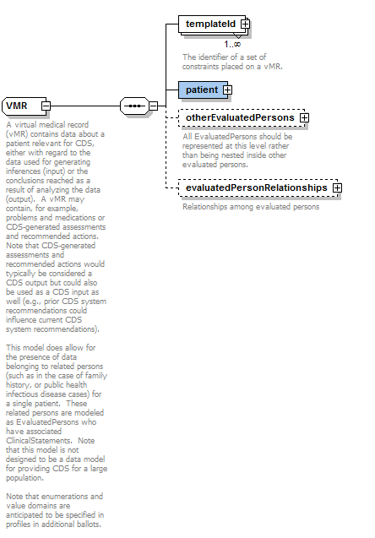

Figure 1 - The VMR complex type

## cdsInput.xsd

The cdsInput.xsd schema represents input data used by a CDS system. The main components of the cdsInput.xsd schema are shown below. Please refer to the schema for the actual specification.

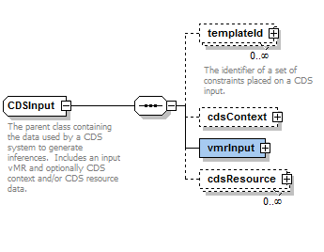

## cdsInputSpecification.xsd

This schema specifies the specific CDS input data required for a specific CDS use case. The main components of the cdsInputSpecification.xsd schema are shown below. Please refer to the schema for the actual specification.

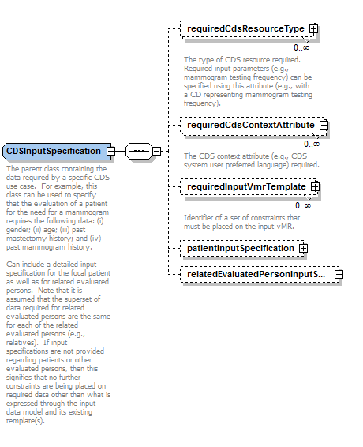

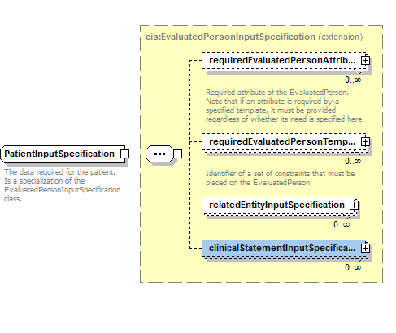

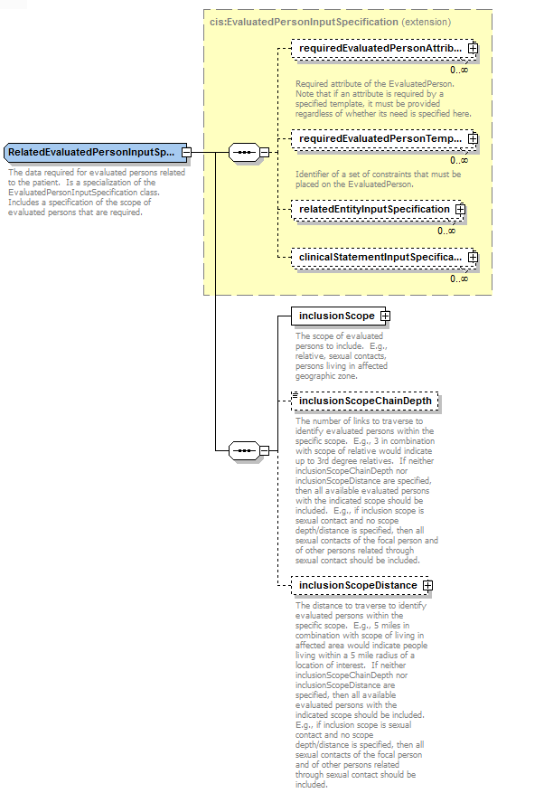

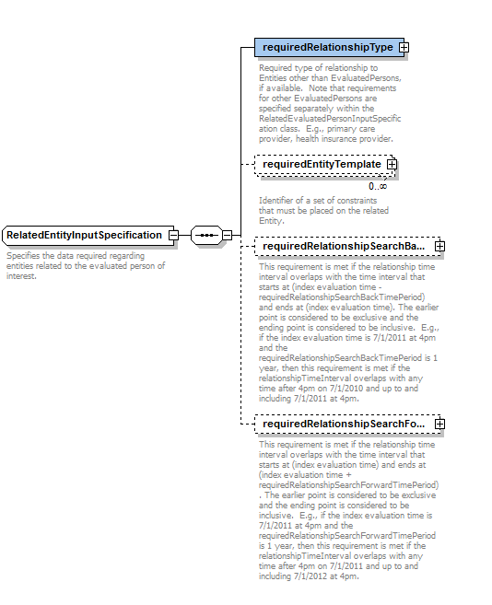

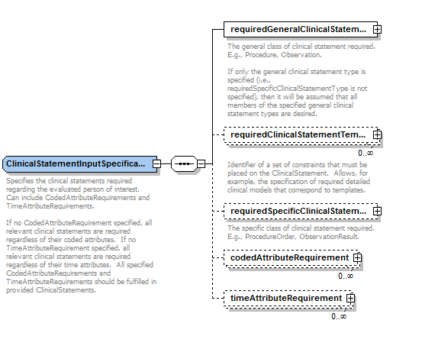

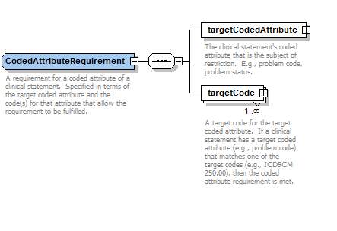

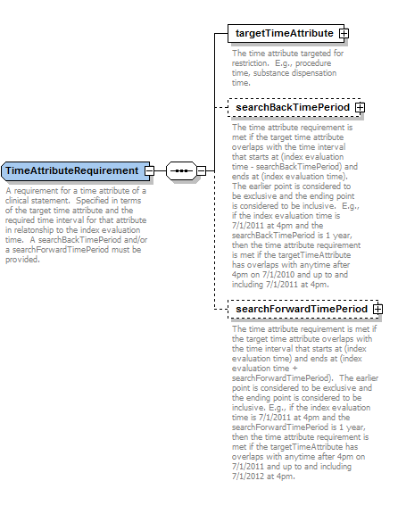

## cdsOutput.xsd

This schema specifies output data generated by CDS systems. The main components of the cdsOutput.xsd schema are shown below. Please refer to the schema for the actual specification.

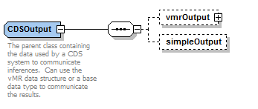

## Examples

Seven *informative* examples are provided with this normative specification to illustrate various aspects of vMR serialization:

1. SampleCdsInput_drugAllergyInteractionScreeningRequestContent.xml
2. SampleCdsInput_drugConditionInteractionScreeningRequestContent.xml
3. SampleCdsInput_drugDrugInteractionScreeningRequestContent.xml
4. SampleCdsInput_labResults.xml
5. SampleCdsInput_vaccinations.xml
6. SampleCdsInputSpecification.xml
7. SampleCdsOutput.xml

## 