**INTERNATIONAL ORGANIZATION FOR STANDARDIZATION**

**ORGANISATION INTERNATIONALE DE NORMALISATION**

**ISO/IEC JTC1/SC29/WG11**

**CODING OF MOVING PICTURES AND AUDIO**

**ISO/IEC JTC1/SC29/WG11 MPEG2017/m41889**

**October 20th, Macau, CN**

**Source Unified Streaming Platform, Media Excel, Level 3**

**Title [NBMP] Live Encoder Ingest Standardization**

**Authors** Rufael Mekuria, Dirk Griffioen, Arjen Wagenaar, Kevin Johns (Level 3), Nikos Kyriopoulos (Media Excel)

## Use Case on Live Media Ingest

This document proposes initiation of standardization of a live encoder ingest format and protocol. Live encoders in the cloud or on premise typically send their content to the media processing entity as soon as it becomes available. While the format typically follows formats like MPEG-2 TS or ISO Base Media, the transmission method (push based manner (e.g. via the HTTP POST protocol), auxiliary information and file format flavor often differ. Figure 1 shows the workflow of pushing content from a live encoder to a media service and the identified interop item for standardization. An example specification of an encoder ingest is specified by Microsoft azure: the azure media ingest specification [1] superseding the ingest part of the smooth streaming protocol [2]. Yet this specification is insufficient as many industry requirements are missing (explicit HEVC support, timed meta-data etc) and it is a specification proprietary to Microsoft Azure Cloud, hampering widescale deployment. In this interop part the ingest of the media and timed meta-data are both critical.

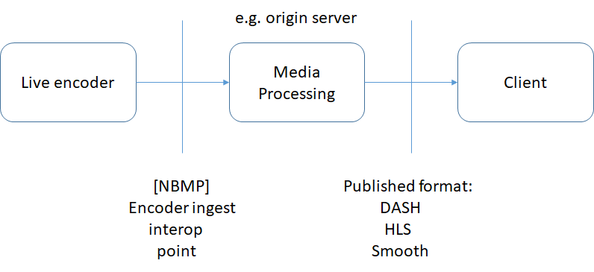

Figure 1 Encoder ingest interop point

## Relevance and Industry Impact

Currently there is no standard specification for live encoder ingest into media processing entities like origin servers, content delivery networks etc. In current practice live encoders may post encoded media data to this source in a different manner. Differences in the format and codec flavor and different transmission methods often require large scale interop when changing live encoder or maintaining workflows with multiple live encoders. For this reason, many media services cannot switch between encoder vendors easily as they need to do months of interop testing to get live services to work.

Further meta-data ingest from the broadcast stream such as markers (ID3, SCTE-35) are extremely important in industry practice, so a possible spec shall also cover the ingest of these types of content. Further, best practice for service and encoder failover, clock synchronization will be a possible part of the specification.

The industry would benefit immensely from a standardized live encoder ingest specification. The DASH [2] standard defines manifest formats and recommendations for formatting media fragments. However DASH targets communication between a server and a client, with the client requesting fragments from the server. In the case of a live encoder, the encoder needs to push content to the server as soon as it becomes available, a push based method is called for such as using HTTP POST as defined in [1]. This is outside the scope of DASH and other protocols that specify a format between a client and a server.

Standardization of this work item will improve industry interoperability and help providers of large scale live media services and other media processing services in the cloud. Also, this standardization work will establish a best practice for ingesting media and meta-data content from encoder making improving industry practice. With the increasing media cloud activity and more complex cloud based services and application and more standardized cloud solutions, standardization of encoder ingest is critical. Further, many media services have multiple brands of encoders, when using different brands of encoders for redundancy, in case of failover, different specs of the encoder give an interop problem. Such workflows require an interop matrix of supporting multiple encoder ingest protocols to keep the live streaming running.

## Definitions

**Live stream event:** live broadcast from a live encoder

**Timed meta-data:** meta-data in the live encoder broadcast or a secondary source embedded in the bit-stream for content insertion and other functionalities. Examples include ID-3 tags and SCTE 35 markers which are widely adopted in the industry.

**UTC**: Universal time code

**SCTE-35:** video streaming markers developed by the society of cable telecommunications engineers that is widely adopted for signaling splash points in transport streams that can be used for content insertion [4].

**ISOBMFF:** ISO base media file format [4]

## Requirements

1. NBMP shall standardize a transport protocol for live encoder ingest
2. The ingest format shall support push based transmission of live stream events
3. The ingest format shall support timed meta data such as based on ID3 and SCTE-35
4. The ingest specification shall support ingest of MPEG-H and MPEG-4 media including HEVC, AVC, AAC, MPEG-H audio and other media formats
5. Media ingest shall be in fragments (moof box and mdat) as specified by ISOBMFF
6. The ingest specification stream shall use clock synchronization between streams, preferably on UTC timestamps form the original (SDI) signal
7. The ingest specification shall be based on MPEG technologies and container formats
8. The ingest spec shall specify failover and restart procedures to gracefully restart in case of failovers
9. The ingest spec document shall specify best practices for encoder redundancy and service redundancy (i.e. continuation of the live event after failure of encoder or service node)
10. The ingest specification shall support graceful teardown of ingest of live stream events

## Industry Support

This document was contributed by Unified Streaming, however there is significant industry support for this, e.g. Broadcasters, Encoder vendors or CDNs which we will involve with the work.

## Recommendation

MPEG NBMP should encourage industry standardization of live encoder ingest specification, possibly on a fast track. This is missing in the digital ecosystem today making interop in live streaming services difficult. The standard shall have strong industry support and follow current industry practice. While the specification fits in the NBMP framework, we recommend an earlier CfP response date to feed the industry need for standardized ingest of media and meta-data content. We suggest the following:

* Prepare a call for proposals targeting live encoder ingest specification inviting major cloud media service providers, live encoder vendors and broadcasters for standardization in the NBMP framework
* If needed establish an Ad Hoc group mandate to target achieving the encoder ingest standard that focuses only on this matter to collect the full industry requirements from interested parties.

# References

x

|  |  |
| --- | --- |
| [1] | Microsoft. Smooth Streaming Transport Protocol. [Online]. <https://www.iis.net/learn/media/smooth-streaming/smooth-streaming-transport-protocol> |
| [2] | ISO/IEC JCT1/SC29 MPEG, "ISO/IEC 23009-1:2014: Dynamic adaptive streaming over HTTP (DASH) -- Part 1: Media presentation description and segment formats," 2014. |
| [3] | Microsoft. (2017, July) Azure Media ingest specification. [Online]. Azure spec (https://docs.microsoft.com/en-us/azure/media-services/media-services-fmp4-live-ingest-overview), |

x