**IM3080 Design and Innovation Project (AY20xx/xx Semester x)**

**Individual Report**

**Name:** Chen Wei Xuan

**Group No:** 3

**Project Title:** *JIO*

**Contributions to the Project** (1-2 page)

I mainly contributed to the project in designing. I was first assigned to the designing of our cats’ characters at the start of the project and moved on to the UIUX team for buttons thereafter. After some trial and error and drafts drawing for the characters, a round body fitting cat was then decided. For UIUX, I designed some relevant icons and one of which was the hourglass. For this, 10 different frames were hand drawn for the animation. All designs were drawn from scratch by the team using **PIXELART** animator tool.

I also drew the icons for the in-app notification message box, as well as some other small buttons. A variety of buttons were made by the design team and then a few were then picked to be used for the app. These are just some examples. Colors were also based to match the map’s color palette.

Jiggly Cat was one of the 4 main cat characters done by me. Inspiration came from Jiggly Puff character in Pokémon. Based on reference from Pusheen, these cats had 4 different directions, left facing in both front and back as well as right facing respectively. Fishing scenes also had to be made separately as the facial expression changes according to a successful catch. Color shades were chosen carefully for it to look as natural as possible, keeping in mind the look they would be carrying in the actual app.

I also drew the design of the moon scene for the day-night cycle environment where the background transits from daytime to nighttime when the timer is due. This is how the environment looks like after integration.

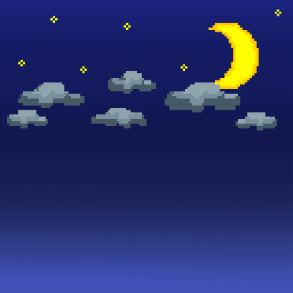

These are some pull requests containing files that were pushed to GitHub for the coding team to integrate in.

**Reflection on Learning Outcome Attainment**

**Reflect on your experience during your project and the achievements you have relating to at least two of the points below:**

1. Engineering knowledge
2. Problem Analysis
3. Investigation
4. Design/Development of Solutions
5. Modern Tool Usage
6. The Engineer and Society
7. Environment and Sustainability
8. Ethics
9. Individual and Teamwork
10. Communication
11. Project Management and Finance
12. Lifelong Learning

**Point 1: Communication**

**State the area: When discussing and collaborating with group members**

Communication was a key factor throughout the entire project. The entire DIP team consisted of 10 people, and it was my first time carrying out a project with such a large group. I had to adapt and learn to communicate effectively. During discussions and meetings, I observed that everyone’s opinions were well-respected and that new ideas were encouraged by all. Team members were also cooperative and participated actively for every meeting, leading our productivity in the group to be at its potential. Moreover, the team leaders for respective roles such as Coding Head and Art Head were very responsive and guided the team members on what they were supposed to do well. When tasks were delegated, the team leader also made sure everyone knew what they had to carry out and was okay with the assignments. This shows effective communication as there were no hiccups when respective tasks were due. I feel that the overall experience was very pleasant with the team and through the 13 weeks, the group was understanding to each other when some tasks were not able to be completed on time due to tight schedule. I would say an achievement was being able to adapt to a new environment fast and no issues arose while carrying out my specific role in the team.

All in all, communication aspect throughout the team has been smooth and I am very appreciative of my team members.

**Point 2: Design**

**State the area: First time opportunity to design for a project**

Being in an engineering discipline since my poly days, I have never had the chance to be part of a design team for a project. Being mainly in the design team has allowed me to expand my creativity while drawing and coming up with features based on what I think fit the app and characters. As I was given the opportunity to draw our cats’ characters, I was able to explore and do some drafts for fitting based on online references. I also helped in drawing icons used for the app’s interface. All designs implemented were hand drawn using **PIXELART** online animator tool as our app held a pixel theme for both the User Interface (UI) and font.

I was also able to help my teammates with any additional editing required to lighten their workload. Even though it might not seem much, my achievement was seeing the completed designs being integrated and displayed into the app and it made me feel proud of the whole team’s work.