**Block Chain-Powered Cloud Health Vault**

Zameer Gulzar1, Pinreddy Susritha2, Ramya Sri Kasagoni3, Gudipati Siddartha4, Kodimala Akhila5, Boyapati Praveen6

1Assistant professor, Department of computer science, SR University, Warangal, Telangana, India.

2 Department of computer science, SR University, Warangal, Telangana, India. 3 Department of computer science, SR University, Warangal, Telangana, India. 4 Department of computer science, SR University, Warangal, Telangana, India. 5 Department of computer science, SR University, Warangal, Telangana, India. 6 Department of computer science, SR University, Warangal, Telangana, India.

***Abstract-*** An electronic health record (EHR) is a technology that lets in you to keep song of your health facts. It keeps computerized records of several healthcare corporations. Records are exchanged through organization-wide data systems in addition to different networking technology and exchanges. Patients these days count on immediate get right of entry to their fitness records. However, the fitness zone comes with immediate get entry to records, and there are issues about the privacy and protection of scientific records of patients. As a result, a blockchain-primarily based answer can help in resolving this issue. The blockchain has the capability to conquer the traditional centralized device, which suffers from an excessive lack of accessibility. This is a decentralized generation that has recently been offered to provide a new standpoint on facts protection and device efficiency. This paper provides a blockchain-based machine that enables the patient’s information be managed and secured right into a single document held with the aid of the patient. This machine become advanced the usage of the Ethereum community the use of Ganache, as well as programming languages, gear, and techniques together with Solidity and web3.Js. The measured approach recommended in this paper uses this platform to save sufferers’ facts and execute functions in a decentralized system using blockchain clever contracts. Transactions are communicated via the smart agreement as soon as it has been released, presenting security and privacy capabilities. Furthermore, the transaction’s preferred changes can be demonstrated and

transmitted to the whole allotted network. There is also a cryptocurrency pockets (MetaMask) that holds a centrally

managed, non-public information device in which information may be speedy accessed and secured through authorities. Doctors and sufferers can get admission to the device through the pockets. Moreover, all the facts of the medical doctor and patient could be secured and controlled through this gadget. This proposed device is aimed toward doing matters together with the following: blockchain technology permits users to obtain the identical facts at the equal time, growing efficiency, growing credibility, and lowering boundaries. It enables the steady garage of facts via putting unique get right of entry to for users. Additionally, this proposed machine enables the steady

transfer of patient clinical information. Finally, this paper describes a health-document system and a brand-new protocol which can be short and steady to apply. It lets in greater openness and ownership of touchy records to be recorded and secured and also promotes the healthcare area with blockchain.

***Index Terms-*** Ethereum, blockchain, EHR

1. **INTRODUCTION**

A blockchain is a decentralized community that uses peer-to-peer (p2p) era to track all transactions. It lacks a

centralized authority or a single point of touch. Rather, it

is a set of nodes that maintain the gadget functioning [1].

Each transaction is extraordinarily safe because of the network’s nodes. Encryption presents an extra level of security to the connection. The virtual document is duplicated at each

node inside the gadget [2]. Each node needs to confirm the reality of a transaction earlier than adding it lower back. A range of blocks make up a digital ledger. Each block gives a detailed report of every transaction [3]. Education, production, and the healthcare industry is just a few of the domain names where in blockchain has piqued hobby. It contributes to the health area in a number of methods because it's far a dispensed and decentralized era [4]. The Ethereum blockchain is

powered by way of ETH, Ethereum’s local cryptocurrency. Ethereum is a decentralized blockchain generation that creates a peer-to-peer community for securely executing and verifying a smart agreement code. It permits developers to construct new types of ETH-based tokens which can be used to power decentralized apps (dapps) thru clever contracts. Participants can transact with one another without relying on a trusted valuable creatority. A smart agreement differs from blockchain era in that it is a laptop mechanism that operates routinely whilst precise instances are met. From a blockchain

point of view, it brings good judgment to the blockchain. Smart contracts are identification contracts that consist of a peer-to-peer agreement’s phrases of carrier [5]. It is a collection of code and records discovered at a particular function at the Ethereum blockchain. Smart contracts are utilized in our recommended method to switch information, grant access to hospital treatment specialists to look customer

facts, or limit get right of entry to to hospital treatment personnel [6].

In the healthcare enterprise, there are various boundaries, which include preserving song of the massive volumes of statistics created by way of hospitals. Patient statistics might be enormously stable with the implementation of smart contracts in clinical associations. It will restrict the variety of information leaks as a result of hackers [7].

Decentralization, security, privateness, and resilience

via cryptographic algorithms are all factors of block-

chain which has the ability to address the prevailing difficulties in the healthcare industry. The digital healthcare services plays a crucial position in retaining and storing information. However, it has a large trouble with patient facts leaking out. The present healthcare machine is insecure among several clinical services due to information availability delays and the hazard of records robbery. Hospital data may be archived without the affected person’s knowledge. Due to several demanding situations, which include security and accessibility of information, there was no exploration or experimentation inside the healthcare enterprise. In today’s healthcare zone, securely accessing data within the network is a top recognition of the proposed device. The blockchain-primarily based machine can generate fantastic outcomes in many methods if used as it should be. It is a good and effective manner to stable authentic statistics. The information is maintained as a ledger characteristic in blockchain technology with the smart contract, controlling the affected person’s get right of entry to clinical information. It ensures security, ease of get right of entry to, and different manufacturing factors of administration, as well as privacy, validity, and authentication for this gadget. In the close to term, there could be a focal point on constructing a helpful internet site based totally on blockchain technology with a view to stable

all data collected with the aid of doctors and sufferers. However, numerous studies articles at the machine of blockchain in healthcare had been posted, with some of the most notable works protected under. Rathee et al. [8] defined their utility of IoT in healthcare. Their invented software lets in for garage, processing, and transmission of patient records in some of formats consisting of photographs, textual content, and voice over the internet, utilizing quite a number smart gadget. However, many intruders can cause a whole lot of dangers to IoT gadgets. For this purpose, they

presented a security architecture for healthcare multimedia

facts using the blockchain approach on this e-book. Sharma et al. [9] tested several instructions that decentralization and smart contracts will take the Internet of Things in e healthcare. They also offer a brand-new structure and talk the benefits, problems, and destiny tendencies of mixing all

three. When compared to traditional techniques, their suggested structure beats them in phrases of the average packet shipping ratio, common latency, and common energy financial savings. Poorni et al. [10] addressed a blockchain-based totally certificates idea for more authentication. It uses the blockchain’s integrity, so the serial numbers of certificate are stored on the blockchain in preference to at the unique certificates. The layout contains alpha-mixing of unique impressions to save you similarly counterfeiting. Agbo et al. [11] finished an evaluation of the modern blockchain improvement within the healthcare industry. According to their findings, blockchain will be a viable solution for more than a few healthcare applications along with remedy management, biological research, and digital fitness document management. Sharma et al. [12] counseled a cyber-physical gadget for e-healthcare information transmission offerings that is each electricity and carrier-level settlement (SLA) efficient. Through tendencies inside the advert hoc on-call for distance vector (AODV) protocol, the suggested phenomena can be upgraded to guarantee security viaidentifying and deleting undesirable gadgets/nodes participating during the communication procedure. The framework targets two security concerns which have a sizeable impact on network services: gray and black holes. Pariselvam and Swarnamukhi [13] discussed the troubles and various protective strategies for securing the privacy of fitness information within the cloud. A new cloud-primarily based method for defensive affected person records primarily based on problems and ranging protection has been proposed. This method provides for the encryption of strong and steady signs the use of separate cryptographic keys, as well as the merging of included information from many resources inside the cloud without the content material being recognized.

It additionally gives dependable information access, permitting customers to ship a person information request to the cloud earlier than understanding what it will reply to. The principal goal of this counseled gadget is to safely shop all scientific records inside the cloud. It also assures the safe upkeep of statistics and makes it to be had for docs and patients. Another element to be showed is the Ethereum control framework’s potential to exactly put in force complicated laptop models, which are required for the implementation of proper smart contracts inside the healthcare industry.

1. **RELATED WORKS**

Blockchain is a shared database storage technology also

called Distributed Ledger Technology (DLT). Data is

recorded in the sort of manner that guarantees the safety, security and veracity and immutability over time of that data, together with the whole recording of modifications, edits and deletions. This manner that authentic statistics ‘blocks’ within the blockchain remain intact and verifiable, and the blockchain additionally acts as an unchangeable complete journal or log of information updates become independent from the unique access. The beginnings of blockchain generation have been in 2008, with the presentation of Satoshi Nakamoto(seemingly an alias, but beside the point to the dialogue) in a seminal paper regarding the cryptocurrency Bitcoin in whichultra-steady information storage is imperative [6]. In that paper, the author provided the idea of creating a platform which could secure the exchange of cryptocurrency of Bitcoin the usage of the

principle of Cryptography and Distributed Computing. Since its inception in 2008, blockchain era has been of first-rate hobby to developers and researchers for use in numerous fields, of which medical systems and associated health-associated systems are examples [7]. MEDShare [8] was

advanced to shield the privacy of sufferers and reduce the

threat of misuse of patient medical information. The builders

of MEDshare applied blockchain-based statistics garage for the manipulate and auditing of shared scientific records in the Cloud. MED share statistics all operations and facts within the system in a tamper-proof way and can screen the entities that get admission to records from their records custodian system. A cloud garage gadget, mentioned in [9], proposed patient privacy safety for digital patient statistics with the aid of distributing partial components of digital patient data among numerous cloud servers and an green technique for reconstruction of those information. This novel cloud storage device completely ensured data privateness. By way of employing the Shamir’s Secret Sharing set of rules, that is an algorithm in cryptography created by using Adi Shamir [10]. Another layout of a cloud-based Electronic Health Record (EHR) system turned into proposed via Xhafa et al. [11] which protected attribute-primarily based encryption. The gadget enabled the combining of the separated components of the information from each far-off cloud server for smooth access and viewing by means of a health practitioner, preserving the privacy of the patient

statistics the use of characteristic-based encryption. The system shape included components for Physician Authorization and Access and Patient Health Record Storage and Access which allowed patient health information to be shared among physicians.

An Internet of Things (IoT) primarily based gadget proposed via [12], which the researchers termed HealthChain, turned into an application of IoT generation for faraway patient information monitoring. However, it turned into diagnosed that the statistics retrieved from the

IoT tool and stored in a centralized records shop became not

guaranteed to be steady and therefore there has been the opportunity of leakage of patient facts and lack of patients’ privateness. As nicely, there was always the opportunity of the irretrievin a position lack of affected person data within the occasion of a server failure. These researchers overcame those troubles by means of gathering affected person health records the usage of the blockchain, consequently the call Health Chain. In the Health Chain system, connections among the blockchain and IoT gadgets were designed to save you statistics deletion or correction in an effort to prevent clinical

disputes. This is, of path, the number one feature of blockchain generation: the immutable aspect of information once inside the blockchain so the stored statistics is in no way changed, but changes to the records are blanketed inside the blockchain as a file or log of modifications which, themselves, are immutable. As reported in [13], health records-sharing on the permissioned blockchain from HyperLedger Fabric became proposed and advanced, together with a cell software that

enabled the information proprietors to govern get entry to from other health-care companies and medical insurance companies. Wearable devices were also included with the machine to accumulate person’s health statistics. The health records might be synced to the cloud server and changed into processed before storing it on the blockchain. Due to the dimensions of the health statistics collected from wearable gadgets, the Merkle tree changed into adopted to shop only the Merkle

root on a blockchain transaction to ensure the scalability and

performance of the gadget. (A Merkle root is a easy mathe-

matical way to verify the information on a Merkle tree and are used in cryptocurrency make sure that the information blocks handed between friends on a peer-to-peer community are whole, undamaged, and unaltered. They are relevant to the computation required to hold cryptocurrencies like Bitcoin and Ethereum). The blockchain also saved medical treatment records, insurance claims, and other activities which includes records requests, and so forth. Channeling was additionally proposed with the scheme to make sure privacy protection.

Cloud-assisted EHR consortium blockchain became proposed

in [14]. The blockchain become advanced at the Ethereum

platform with Proof-of-Authorization because the consensus mechanism. They proposed searchable encryption and proxy

re-encryption for the security of data. The device enabled the storage of encrypted patient EHR at the cloud server. The

shared EHR must be legal by using their records owner first.

If the permission became granted, the records could be encrypted once more the usage of the statistics proprietor’s re-encrypted key before sending it to the facts requester which will be a central authority department, health center,

laboratory, health center, and many others. The scheme performed protection desires and had excessive computational efficiency.

1. **METHODS**

### Problem Identification

### Inefficient, insecure, and fragmented medical record management compromises patient care.  Traditional methods, paper-based or digital, lack data integrity, security, and accessibility.

**Figure1:**



Health Reports

### Proposed Method

# Collect detailed requirements from stakeholders, including patients, doctors, and healthcare institutions. Design the system architecture, considering scalability, data security, and performance. Develop the Patient and Doctor Portals with a user-friendly interface. Perform unit testing, integration testing, and system testing to ensure the application functions as intended. Implement robust security measures, including data encryption, secure communication, and access control.

# Deploy the application to a secure server or cloud environment. Allow selected users (e.g., beta testers) to perform final testing and provide feedback. Implement regular updates to add new features and improve security.

# Figure2:

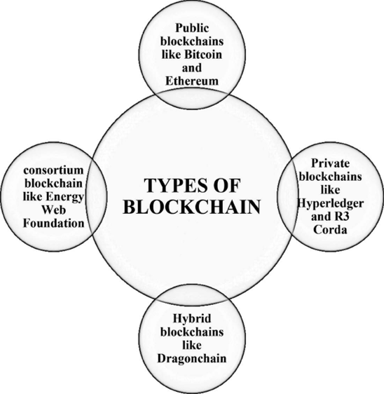

BlockChain

### Implementation

Patient Portal:

* + Frontend: HTML, CSS, JavaScript (React for a dynamic interface)
  + Backend: Node.js, Express.js
  + Authentication: OAuth2, JWT

Doctor Portal:

* + Frontend: HTML, CSS, JavaScript (React)
  + Backend: Node.js, Express.js
  + Authentication: OAuth2, JWT

User Database:

* + Database: PostgreSQL or MongoDB for user profiles and authentication data
  + Encryption: SSL/TLS for data in transit.

Blockchain:

* + Blockchain: Ethereum (for smart contracts) with Solidity for contract development.
  + Distributed File Storage: IPFS for securely storing and retrieving medical records.

***Figure5:***

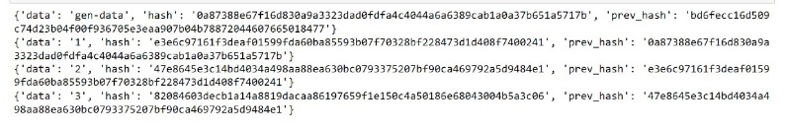

Blockchain(data stored in blocks)

### Consortium Blockchain

A consortium blockchain is a type of blockchain where multiple organizations or entities come together to form a network, and each participant has a role in verifying and recording transactions on the network. This differs from private blockchains where a single entity controls the network and from public blockchains where anyone can join the network. A private blockchain is a decentralized ledger that is only accessible to a select group of individuals or organizations. It has a single operator or entity that who can access the network, view information, and create data on the blockchain.

***Figure3:***

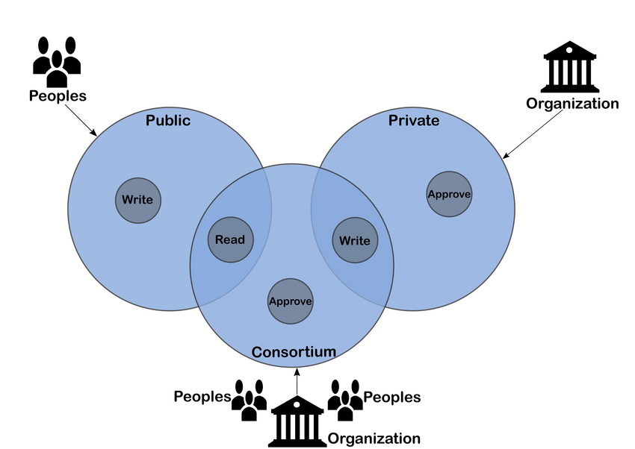

Consortium Block Chain

# RESULTS

**RESULTS**

PATIENTS INTERFACE

Initially account type need to be selected and Upon the patient's first visit, they must log in; if not, they need to sign up.

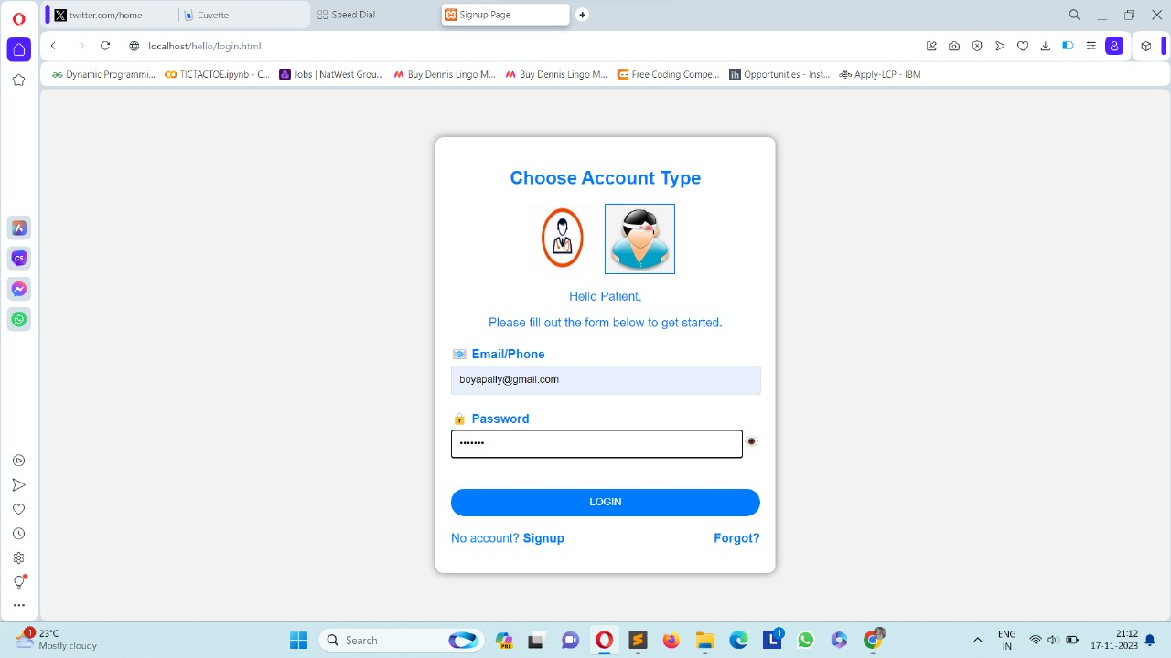

The patient's Home page will feature various options. Additionally, patients can input new health records by providing specific details such as the doctor's name, hospital name, and prescription into text fields, and then add the document or record. These documents are stored and can be accessed at any time the patient updates them, making them visible on the doctor's interface.

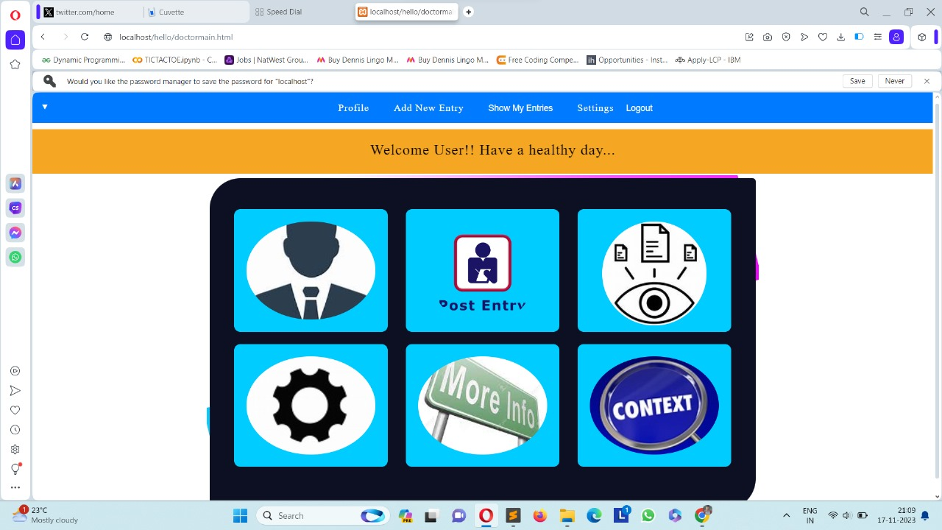

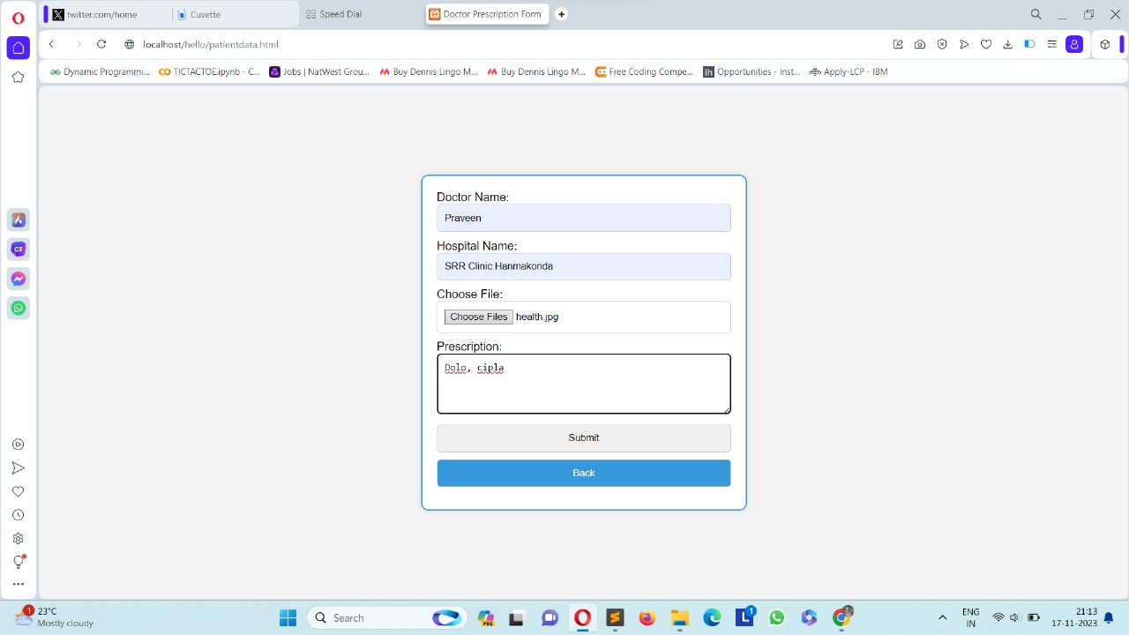

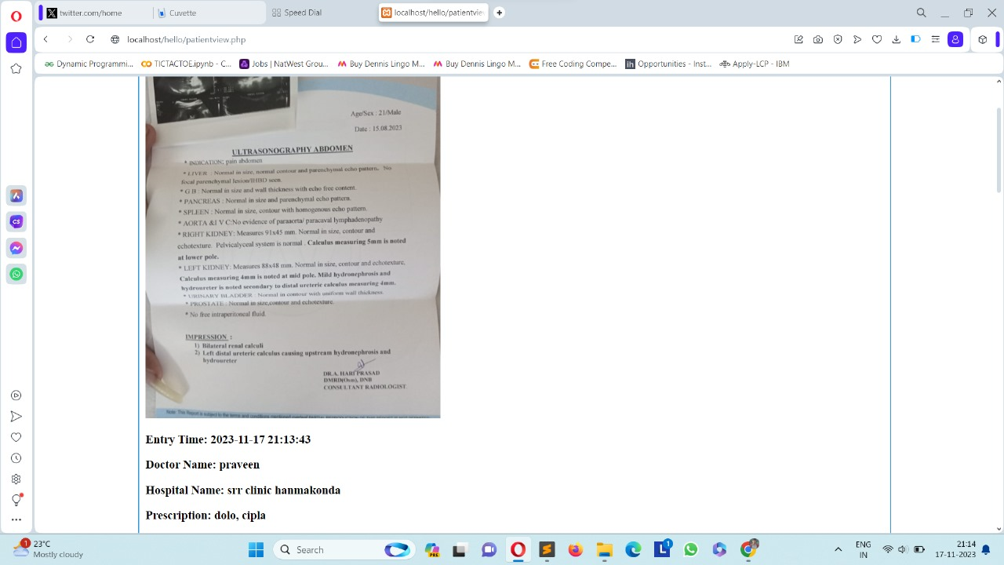

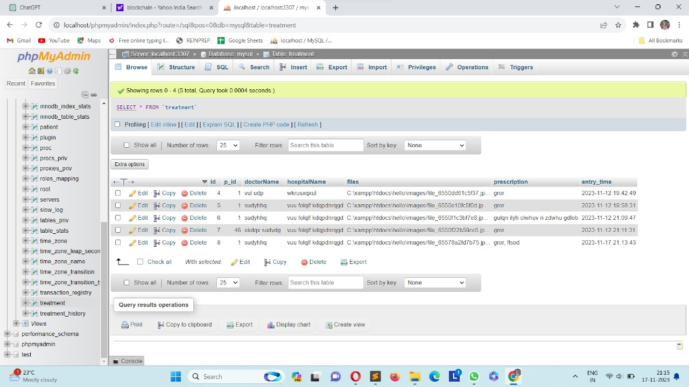

DOCTOR’S INTERFACE

The patient's Home page will feature various options. Additionally, patients can input new health records by providing specific details such as the doctor's name, hospital name, and prescription into text fields, and then add the document or record. These documents are stored and can be accessed at any time the patient updates them, making them visible on the doctor's interface.

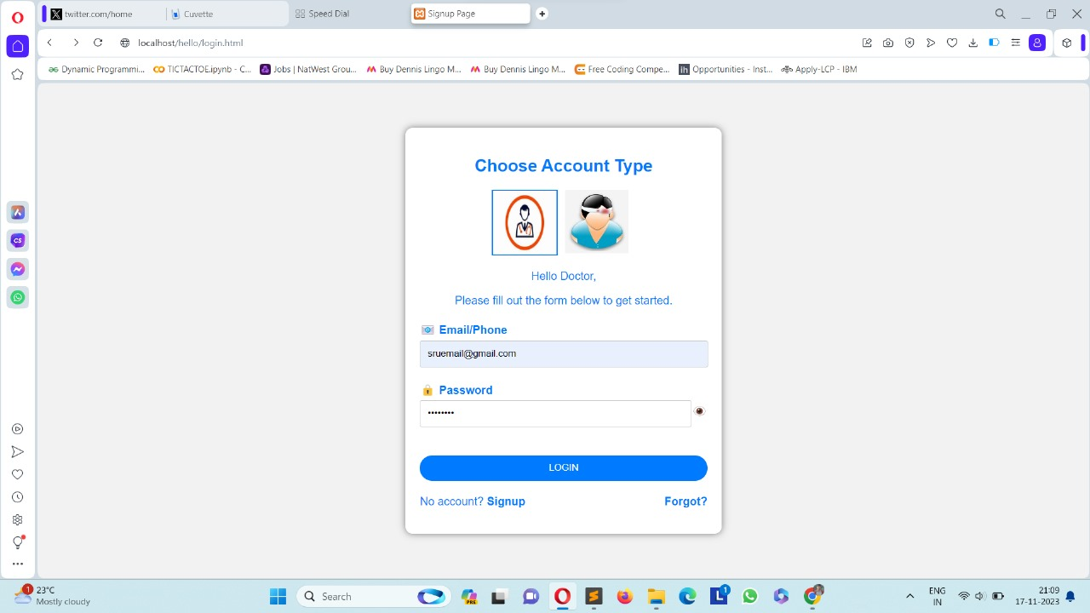



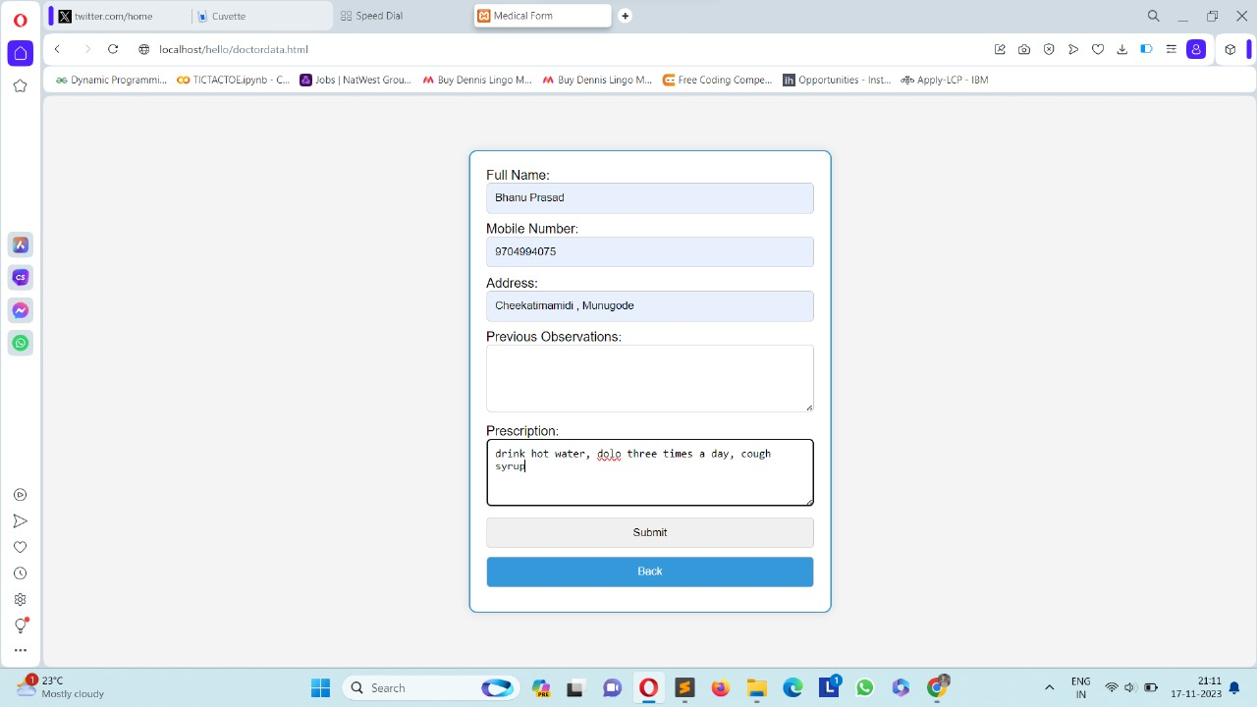

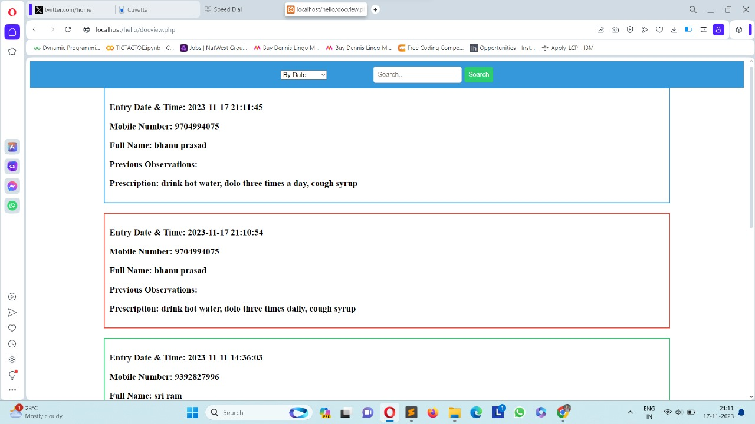

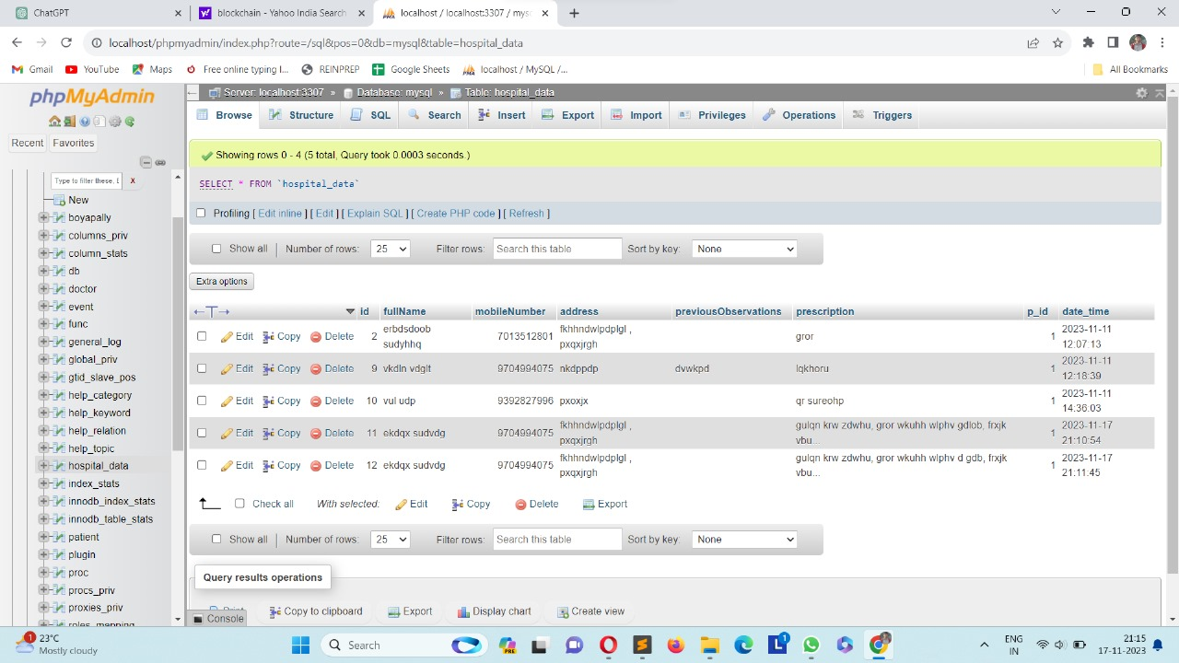

# CONCLUSION

The standard medical record-keeping method is inefficient, and it necessitates a tremendous amount of storage space to retain the results of all medical tests for all patients. The data in prior systems was unstructured, making it impossible to transmit information. Because of the massive volume of data produced by the healthcare industry, we need to start thinking about improving our data management methods without risking the data's security and privacy. Because of the confidentiality data, there will be additional changes. This change brings many issues that need to be addressed, and blockchain successfully addresses the funda- mental issues.

This system allows the patient to grant and withdraw any record-specific authorization to the authorities with a single tap. This automation has been made much easier to deploy due to Ethereum and smart contracts. The suggested wallet serves as a bridge for providing secure and convenient access to the blockchain, as well as hassle-free secret key maintenance. It can also act as a link for patients who are uncertain about migrating their information to electronic health records (EHRS). The system's cryptographic encryption methods, which are difficult and impossible to crack, will offer security and dependability. It has been determined that this system has achieved the majority of the project's objectives, namely, authentication data exchange of medical reports utilizing blockchain security, and it is expected that the project's implementation will meet the users' needs. As a result, the authentication, data exchange, and security of medical reports have already been completed successfully utilizing blockchain. The system also deals with the problems caused by direct disease transmission in hospitals, like the ongoing COVID-19 situation, mainly through physical copies of medical records and the increased risk associated with additional human chain contamination.

### FUTURE ENHANCEMENT:

A blockchain, wherein facts are maintained in a related

collection of blocks, has made it feasible to create and deploy new packages based on a distributed and decentralized ideology in place of traditional cloud-primarily based apps. The present clever settlement might be extended to enhance the research and offer the advanced functions required by way of an EHR adminis-

tration device. Future development ought to maximum possibly aim at presenting a actual-time video convention communication feature. In this COVID-19 outbreak, it is pretty advocated. Another possibility is that the charge module will ultimately be incorporated into the present structure. This may be executed through a decentralized architecture primarily based on blockchain generation, where in an affected person pays for a specialist’s consultation with a credit score or debit card. In the event

of verification, the NID quantity may be included. With the creation of Ganache, we now have the opportunity to test with a comparable technique making use of a private blockchain. It will involve improving lookup and assisting the greater talents required by way of an HER management solution. In addition, there may be an evaluation of gift and destiny methodologies.

***Acknowledgement***

We are thankful for **Dr.M.Sheshikala,** Head of CS&AI dept**, Mr.Sallauddin Md,** Assistant Professor, Dept of Computer science at **SR University** for giving us the chance to work on this project. Our gratitude extends to our project guide, **Mr. Zameer Gulzar**, Assistant Professor in the CSE department, for his unwavering support and for providing the essential direction needed to finish this project. Finally, we’d like thank our friends for their support in completing the project successfully.

## REFERENCES

[1] K. Tiwari, S. Kumar, and R. K. Tiwari, “SURAKSHIT: a block-

chain enabled healthcare model for privacy assurance and data security,” Journal of Critical Reviews, vol. 7, no. 13, pp. 2493– 2511, 2020.

[2] L. Academy, “Consensus protocols,” 2019

[3] J. Yli-Huumo, D. Ko, S. Choi, S. Park, and K. Smolander, “Where is current research on blockchain technology-a systematic review,” Plos One, vol. 11, no. 10, 2016.

[4] P. A. Laplante, M. Kassab, N. L. Laplante, and J. M. Voas, “Building caring healthcare systems in the Internet of Things,” Systems Journal, vol. 12, no. 3, pp. 3030–3037, 2018.

[5] A. Gharat, P. Aher, P. Chaudhari, and B. Alte, “A framework for secure storage and sharing of electronic health records using blockchain technology,” ITM Web of Conferences, vol. 40, article 03037, 2021.

[6] R. Sreeraj, A. Singh, and V. Anbarasu, “Preserving EMR records using blockchain,” Annals of Romanian Society for cell Biology, vol. 25, no. 6, pp. 5344–5350, 2021.

[7] R. Harika and B. ThirumalaRao, “Survey on smart healthcare using blockchain,” Journal of Critical Reviews, vol. 7, no. 14, pp. 615–621, 2020.

[8] G. Rathee, A. Sharma, H. Saini, R. Kumar, and R. Iqbal, “A hybrid framework for multimedia data processing in IoT- healthcare using blockchain technology,” Multimedia Tools and Applications, vol. 79, no. 15-16, pp. 9711–9733, 2020.

[9] A. Sharma, Sarishma, R. Tomar, N. Chilamkurti, and B. G. Kim, “Blockchain based smart contracts for internet of medical things in e-Healthcare,” Electronics, vol. 9, no. 10, p. 1609, 2020.

[10] R. Poorni, M. Lakshmanan, and S. Bhuvaneswari,

“DIGICERT: a secured digital certificate application using block-chain through smart contracts,” in 2019 International Conference on Communication and Electronics Systems (ICCES), pp. 215–219, Coimbatore, India, 2019.

[11] C. C. Agbo, Q. H. Mahmoud, and J. M. Eklund,

“Blockchain technology in healthcare: a systematic review, ” Multidisciplin-

ary Digital Publishing Institute, In Healthcare, vol. 7, no. 2, p. 56, 2019.

[12] A. Sharma, G. Rathee, R. Kumar et al.,

“A secure, energy- and SLA-efficient (SESE) E-healthcare framework for quickest data transmission using cyber-physical system, ” Sensors, vol. 19, no. 9, p. 2119, 2019.

[13] S. Pariselvam and M. Swarnamukhi,

“Encrypted cloud based

personal health record management using DES scheme,

” in IEEE International Conference on System, Computation, Automation and Networking (ICSCAN), pp. 1–6, Pondicherry, India, 2019.

[14] A. Sharma and R. Kumar,

“Service level agreement and energy

cooperative cyber physical system for quickest healthcare services,” Journal of Intelligent & Fuzzy System, vol. 36, no. 5, pp. 40774089, 2019.

.