Name : BoyapatiNandini Course : Software Engineering
Reg No : 192525137

Experiment – 3

Question : The stakeholders have conflicting views on the user interface design for an E-Commerce mobile app. Create a prototype using Figma tool to discuss with the stakeholders to get their feedback and approval.
Link : https://www.figma.com/design/d0plixcT4vSrfcVRNKBaw9/Untitled?node-id=0-1&p=f&t=mb6S47MfkTtA2qs8-0

Step 1: Open Figma
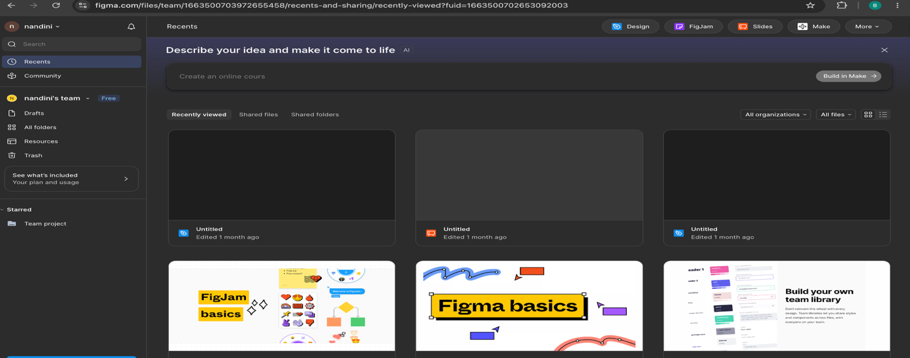

Step 2: Create the Project 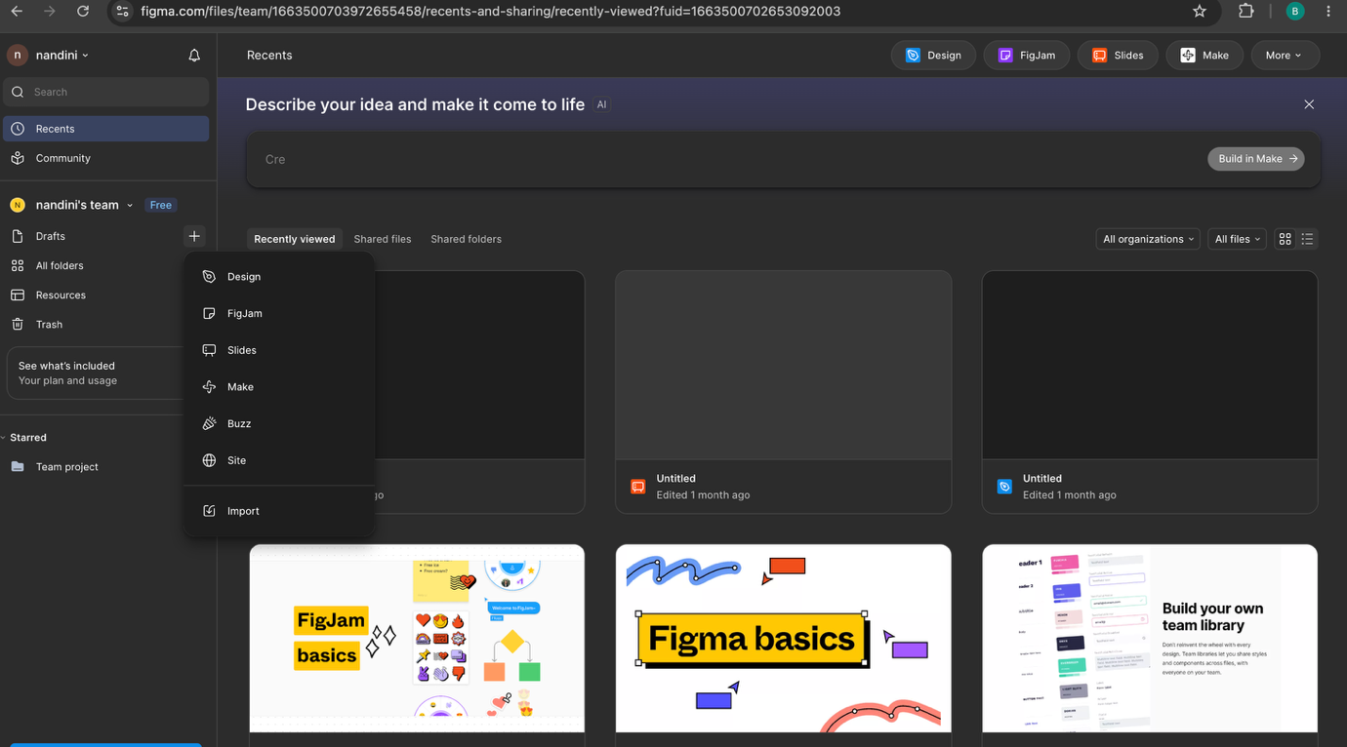

Step 3: Design the Login / Sign-Up Screen

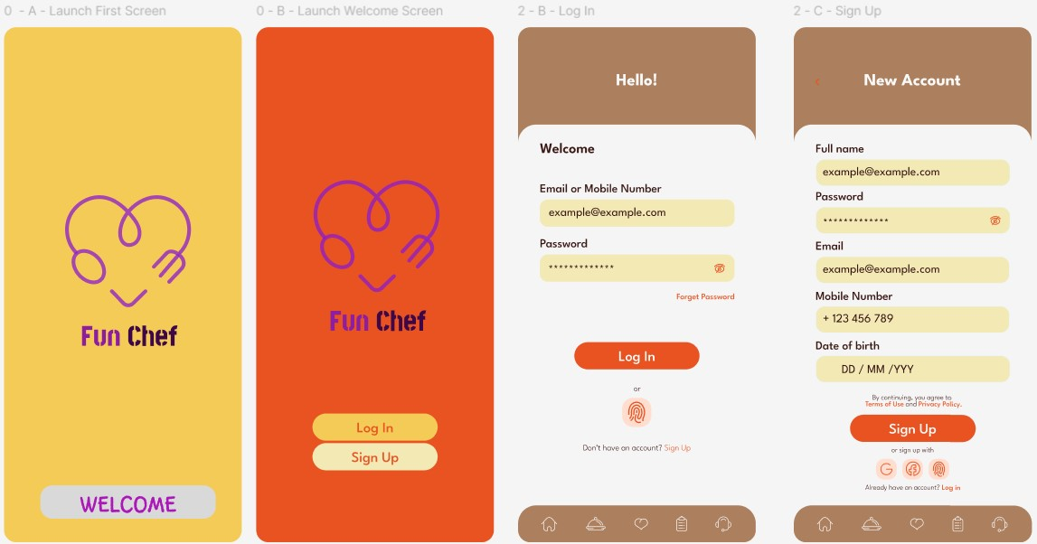

Step 4: Design the Home Page


Step 5: Design the Product Listing Page
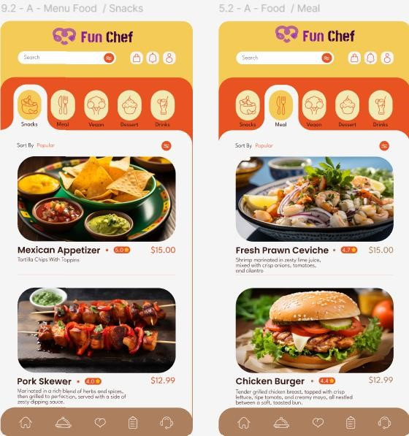

Step 6: Design the Product Details Page
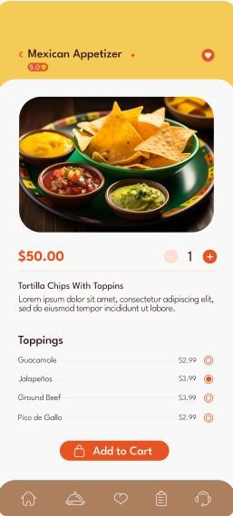

Step 7: Design the Shopping Cart Page
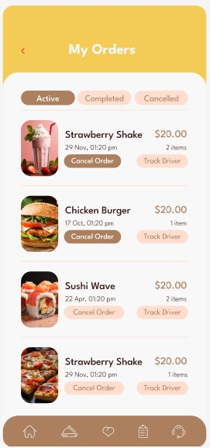

Step 8: Design the Order Confirmation Page
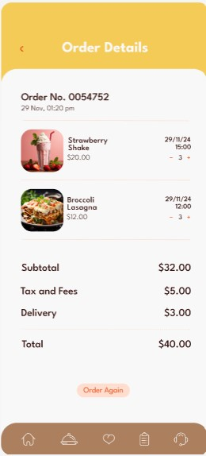

Step 9: Connect the Screens

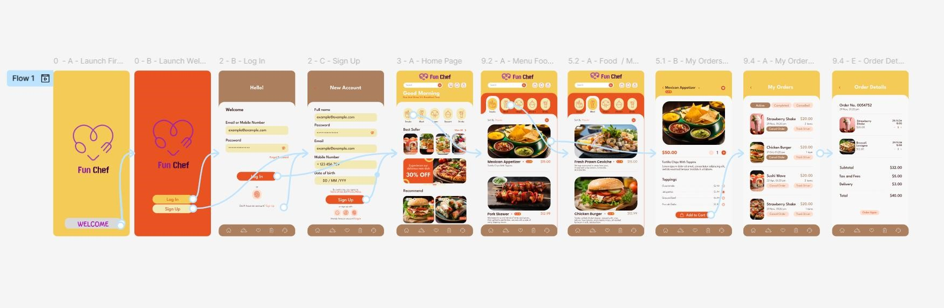

Step 10 : Present the Prototype to Stakeholders

