SIMATS ENGINEERING
ASSESSMENT TOOL 1-Pseudocode Writing Task (Algorithm Design)

COURSE NAME: Data Structures COURSE CODE: CSA03

COURSE OUTCOME COVERED

CO: Construct MST using shortest path algorithms and traverse the graph to model and analyse real-world problem. (Bloom Level -BL4, BL6)

Assessment Tool Weightage: 35%

QUESTIONS: EACH QUESTION CARRIES: 10 MARKS DURATION : 1 HOUR
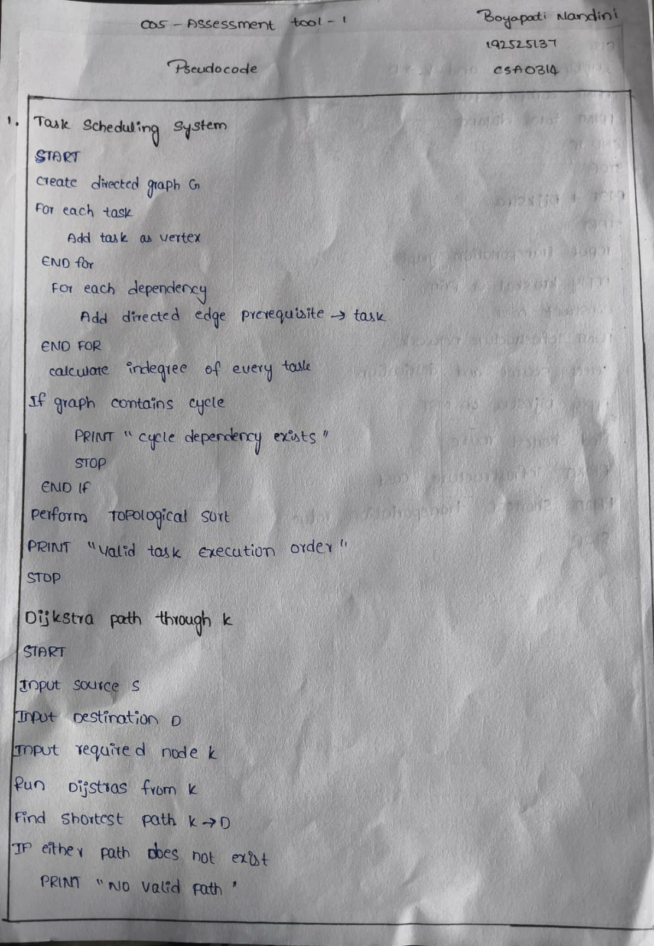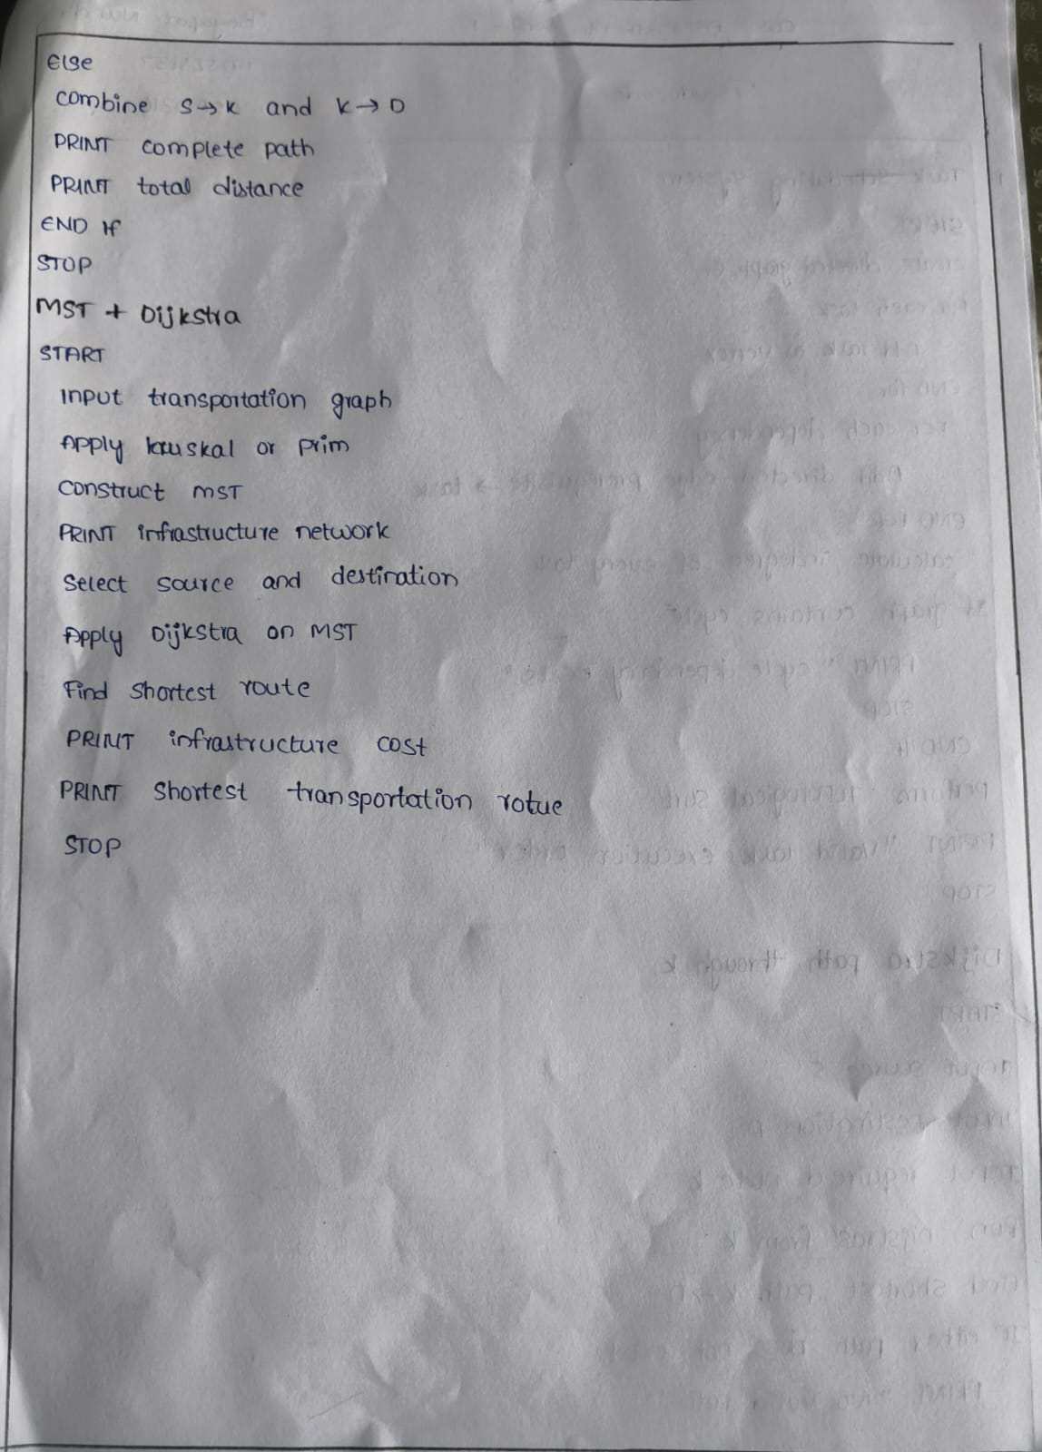

Code of Conduct:

I B . Nandini (Name / Reg No) certify that this submission is my original work and that I have adhered to the guidelines specified for this assessment.
I understand that any violation of academic integrity rules will result in disciplinary action.

Signature of the student: B.Nandini
Criteria | Weightage | Level 4 – Exemplary | Level 3 – Proficient | Level 2 – Developing | Level 1 – Beginning
Problem Understanding | 20% | Identifies all inputs, outputs, constraints accurately | Minor missing elements | Partial understanding | Incorrect interpretation
Algorithm Design | 30% | Complete, correct, and logically sound solution | Minor logical gaps | Partially correct logic | Incorrect approach
Use of Control Structures | 20% | Efficient and appropriate use of loops, conditions, functions/modules | Minor inefficiencies | Limited or basic usage | Incorrect or missing constructs
Pseudocode Structure | 10% | Well-structured, clear, consistent format, easy to follow | Mostly clear with minor issues | Difficult to follow in parts | Poorly structured and unclear
Completeness | 20% | Handles all cases; optimized approach | Handles most cases; reasonable efficiency | Handles basic cases only | Incomplete or inefficient

