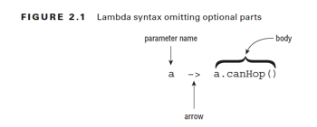

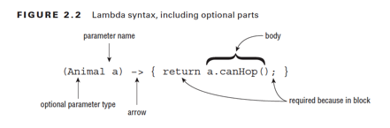

**Source**

* Stream<String> empty = Stream.empty();
* Stream<Integer> singleElement = Stream.of(1);
* Stream<Integer> fromArray = Stream.of(1, 2, 3);
* List<String> list = Arrays.asList("a", "b", "c");

Stream<String> fromList = list.stream();

* Stream<Double> randoms = Stream.generate(Math::random);
* Stream<Integer> oddNumbers = Stream.iterate(1, n -> n + 2);

**Intermediate**

* filter(p -> p.isEmpty())
* limit(3)
* skip(2)
* map(x -> x.size())
* distinct()
* sorted()
* sorted((a,b) -> a.compareTo(b))
* peek(x -> System.out.println(x))

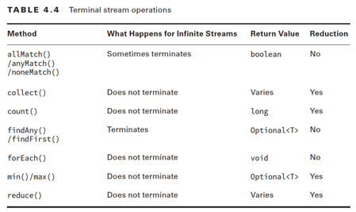

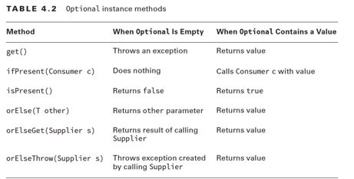

**Collectors**

* collect(Collectors.toList())
* collect(Collectors.toSet())
* collect(Collectors.toMap(keyFunction, valueFunction))
* collect(Collectors.groupingBy(func))
* collect(Collectors.partitioningBy(func))
* collect(Collectors.joining())
* collect(Collectors.joining(”, "))