

Universidad De Manila

Former City College of Manila

659-A Cecilia Muñoz St, Ermita, Manila, 1000 Metro Manila

“InfoQuest: Barangay System Information and Request”

By: IT-22

Cyrus Angelo C. Brutas

Allen R. Alonzo

Alessandra Marie C. Coronel

Aldrich Dale D. Hellera

Carl Joshua Opinaldo

Ghianne P. Sayana



**Table of Contents**

Chapter I:

Introduction-------------------------------------------------------------------------------------------------

Conceptual Framework---------------------------------------------------------------------------------

Background of the Study-------------------------------------------------------------------------------

Objectives

General Objectives---------------------------------------------------------------------------------------

Specific Objectives---------------------------------------------------------------------------------------

Statement of the Problem----------------------------------------------------------------------------

Scope and Delimitation--------------------------------------------------------------------------------

Significance Study--------------------------------------------------------------------------------------

Sitemap------------------------------------------------------------------------------------------------------

Definition of Terms-------------------------------------------------------------------------------------

**Introduction:**

A population census is a total process of collecting, compiling, evaluating, analyzing, and publishing or otherwise disseminating demographic, economic, and social data pertaining, at a specified time, to all persons in a country or in a well-delimited part of a country (United Nations (2008)).

Barangay governance has an important role in the establishment of the local government units in the country. The barangay serves as the principal planning and executing unit of government programs, basic services, projects, and activities. It also acts as a platform through which the community's collective ideas may be articulated and taken into consideration.

Our system, called InfoQuest, is a system, that allows the barangay staff to input, modify, and store the information of their residents, at the same time, it also allows the residents to request the documents that they want, enter their personal details, and then the barangay will provide an update to their query in their given time or through the announcement page. Which where the people could also leave a message that is regarded to the barangay.

**Conceptual Framework:**

**Output**

**Process**

**Input**

Program now will Store, Update, and Make Request that needed to be done by Barangay Personnel

User inputs data, to store, Comply, Update, and Request

Program return result where Personnel could check the Stored, Change, and the Request form that the Program Takes

**Background of the Study:**

In Pre-Hispanic Times, A Barangay was a sailboat that carried early settlers and traders to the Philippine Archipelago from Indonesia and Borneo. They were Simple Communities that have been tied with a Head Man or a Group of Families, The Barangay is sociospatial. Barangay governance has an important role in the establishment of the local government units in the country. The barangay serves as the principal planning and executing unit of government programs, basic services, projects, and activities. It also acts as a platform through which the community's collective ideas may be articulated and taken into consideration. A Barangay is a Small Division That has been administered in the Philippines and which is native to every Filipino. Along with the Chairman, 7 Other Barangay Kagawad or Councilor and an SK Chairman or the "Sangguniang Kabataan Chairman. In the midst of World Evolution as years, and decades have passed Technology Rises to its prime, Many Scientist invents Things that Normal People cannot explain on how it works and One of them Is Programming, which is a series of codes that when it’s done it can make a whole system that is capable of doing a specific task that has been Program to it. Barangay System is a way of keeping the records of residents in the jurisdiction of the Barangay. A System is Capable of executing Specific tasks here in the Barangay system it is capable of recording Bulk Information and storing it for a long period of time completely safely. It is also the most important file of Records that the barangay holds since Records are information of all the people who live in the barangay it is highly prioritized since it is a piece of important information that not only the barangay need but the government also. Proposing a System where The Records can be Stored, Kept, and Search along with Requesting Files that the Barangay provides for its Citizens is A better option than keeping them on Paper alongside an Envelope that can easily be destroyed by means of Other humans or Nature, Not only It can Store and Request Having this kind of System will give the barangay the power to improve their work since having these kinds of information can only not delay their works but also accurately provides by the use of this System. InfoQuest is A System that we proposed it has the capabilities of the things such as Storing, Keeping, and Requesting. It is not only used by these means to help the Information to be safe but also helps the Barangay officials since Authorized personnel can only access this system also to help them lessen the burden of Bulk Request that the residents need for School purposes, Work Purposes, Medical Purposes, and ETC... InfoQuest is a Digital Processing Program that The User or the Authorized Personnel can be dependable on this program. Having InfoQuest Updating Data can also be viable since it is a program that stores information. InfoQuest also has the capability of Document issuance that can generate Clearance, Residents Clearance, and Certificate of Indigency in a matter of minutes which can greatly affect the time consumption of the normal issuance of these Documents. InfoQuest reaches for the Barangay 13 zone 2 District 1 and also its Chairman, Capt. Mario Macapagal to us be able to present this program.

**Objectives:**

**General Objectives:**

This system would have its homepage, which will serve as the announcement page would display the barangay announcement and advisory, a suggestion message box where the users can put their collective thoughts, a page that contains all the information of the residents, which only the staffs can access, and a request page, which would appear like a form the allows the user to enter their details such as name, address and the document they need.

**Specific Objectives:**

1. To improve the Data Storing System of the barangay by providing an automated system where they can store and retrieve records that they possess in an orderly and systematic manner.

2. To allow residents to view announcements and inquire about barangay certificates digitally.

3. To quickly access information about the people of the barangay.

4. To create a system that will aid the residents in processing documents they immediately need.

**Statement of the Problem:**

This system attempts to simplify the process of accessing the information of the citizens of the barangay, from both the barangay and the resident’s point of view. Furthermore, it seeks the answer to the following questions:

1. In terms of conveniences, how can the automated system affect the speed of the process of getting the documents the residents needed?
2. How does having an announcement or bulletin page affect the dissemination of the barangay advisories?
3. How the system will lessen the human error of using pen and paper approach in recording in doing of transactions?
4. How efficient is this system in technological era, especially to residents who are older and not knowledgeable enough in modern technology?
5. What is the importance of digitalizing information that the barangay holds in order to keep them secured and up to date?

**Significance of the Study:**

To The Students:

This Program will help them to understand how important Programming is and how it can help in the Daily works of Officials not only on Work but almost everything

To The Barangay

This Program will help The Barangay to fully understand how we pick this kind of System to help our chosen Barangay and to enlighten them on Possibilities that having this kind of Program in Barangay is a Success

To The Researchers:

This Program is for Researchers who want to be enlightened on how to use Programming to help the Barangay

To The Future Researchers:

This program can serve as a study that they can use in order for them to come up with a better plan for the Barangay Future

To The System

This Program will help in Storing Data, Keeping them, having Documents requesting, and Making Announcements which also lessen the Burden of work of Barangay officials

**Scope and Delimitation:**

**Scope**

This study focuses on Data Storing System.

This study will be conducted in Barangay 13, Zone 2.

**Delimitation**

-Only authorized personnel could access the system such as Barangay officials, maintain credibility, and protect the citizen’s private information.

-Only the citizens of the Barangay 13 can register.

-Only the selected barangay personnel are allowed to modify things in the information system.

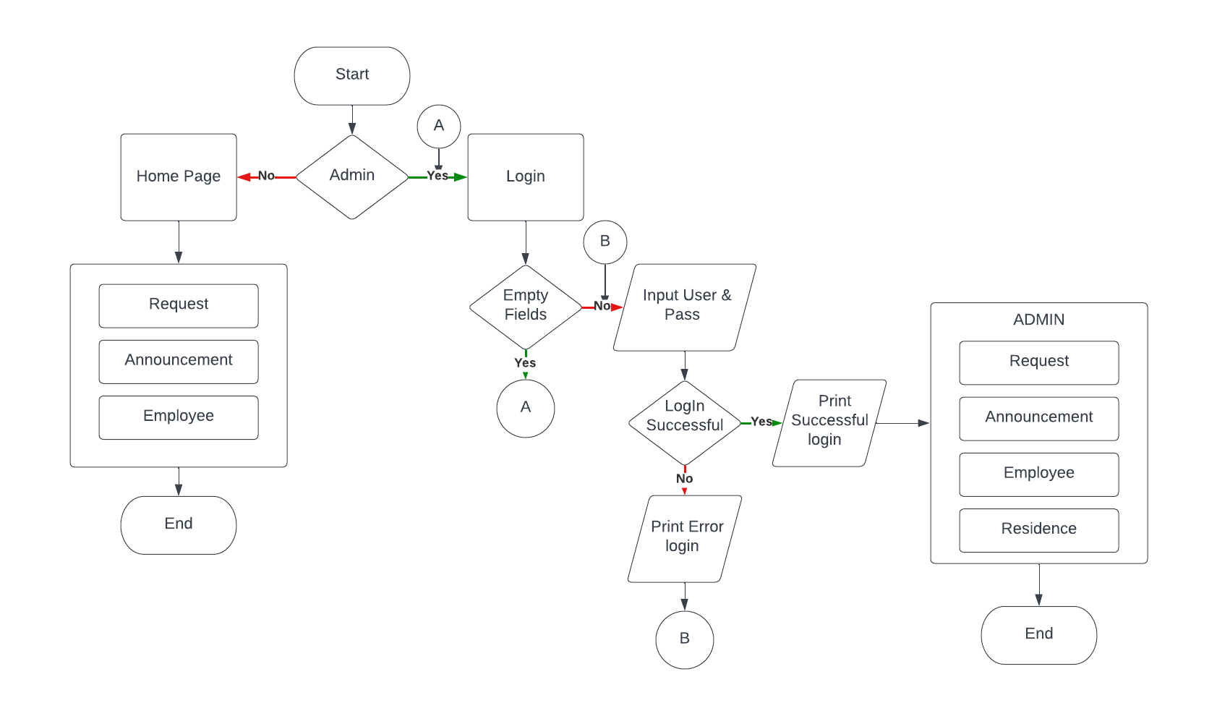**Sitemap:**

**Definition of Terms:**

Analyzing- examine methodically and in detail the constitution or structure of (something, especially information), typically for purposes of explanation and interpretation.

Articulated- to give clear and effective utterances to

Barangay- a unit of administration in Philippine society consisting of from 50 to 100 families under a headman

Barangay governance- the Barangay serves as the primary planning and implementing unit of government policies, plans, programs, projects, and activities in the community, and as a forum wherein the collective views of the people may be expressed, crystallized and considered, and where disputes may be amicably settled.

Census- is a regularly occurring and official inventory of the human population and housing units in the Philippines.

Chairman- acts as the presiding officer and chief executive officer of the commission.

Collecting- a group of objects or an amount of material accumulated in one location, especially for some purpose or as a result of some process

Community- a group of people living in the same place or having a particular characteristic in common.

Compiling- to collect information from different places and arrange it in a book, report, or list

Decades- a period of ten years.

Demographic- relating to the structure of populations.

Digital- describes electronic technology that generates, stores, and processes data in terms of two states: positive and non-positive

Disseminating- the act or process of disseminating or spreading something

Documents- a piece of written, printed, or electronic matter that provides information or evidence or that serves as an official record

Economic- study of scarcity and its implications for the use of resources, production of goods and services, growth of production and welfare over time, and a great variety of other complex issues of vital concern to society.

Establishment- the action of establishing something or being established.

Evaluating- form an idea of the amount, number, or value of assess.

Executing- carry out or put into effect

Infoquest- The name of Program Barangay System Information and Request

Information- facts provided or learned about something or someone.

Input- a place where, or a device through which, energy or information enters a system.

Jurisdiction of the barangay- The territorial jurisdiction of the new Barangay shall be properly identified by metes and bounds or by more or less permanent natural boundaries

Local government - the administration of a particular town, county, or district, with representatives elected by those who live there.

Modify- make partial or minor changes to (something), typically so as to improve it or to make it less extreme.

Program- series of coded software instructions to control the operation of a computer or other machine.

Programming- a technological process for telling a computer which tasks to perform in order to solve problems.

Publishing- the activity of making information, literature, music, software and other content available to the public for sale or for free

Request- to make a request to or of

Residents- a person who lives somewhere permanently or on a long-term basis.

Scientist- a person who is studying or has expert knowledge of one or more of the natural or physical sciences.

Social data- publicly available information shared by social media users, like their location, language, and content shared.

Sociospatial- Relating to sociological aspects of (mostly urban) spaces.

Store- a quantity or supply of something kept for use as needed.

System- a set of principles or procedures according to which something is done an organized framework or method.

Task- a piece of work to be done or undertaken.

Technology- the application of scientific knowledge for practical purposes, especially in industry.