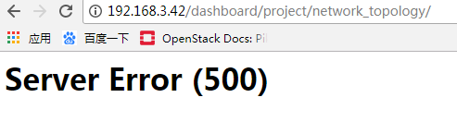

在controller节点重启HTTP

#systemctl restat httpd

