- 去http://download.redis.io/releases下载Redis-3.0.6包
- 通过filezilla上传到虚机 usr/local下
- 在 /usr/local/下 tar -zxvf redis-3.0.6.tar.gz
- cd redis-3.0.6 目录下
- yum install gcc gcc-c++ kernel-devel automake autoconf libtool make wget tcl vim ruby rubygems unzip git -y
- make MALLOC=libc
- make install
- Server1执行：mkdir -p /usr/local/cluster
mkdir 7000
mkdir 7001
mkdir 7002
Server2执行：mkdir -p /usr/local/cluster
mkdir 7003
mkdir 7004
mkdir 7005
- cp /usr/local/redis-3.0.6/redis.conf /usr/local/cluster/
- cd /usr/local/cluster
- vim redis.conf
修改以下内容
##注意每个实例的端口号不同
port 7000
daemonize yes
cluster-enabled yes
cluster-config-file nodes.conf
cluster-node-timeout 5000
- server1执行
cp /usr/local/cluster/redis.conf /usr/local/cluster/7000
cp /usr/local/cluster/redis.conf /usr/local/cluster/7001
cp /usr/local/cluster/redis.conf /usr/local/cluster/7002
server2执行
cp /usr/local/cluster/redis.conf /usr/local/cluster/7003
cp /usr/local/cluster/redis.conf /usr/local/cluster/7004
cp /usr/local/cluster/redis.conf /usr/local/cluster/7005
注意修改成对应的端口
- cd /usr/local/cluster/7000
redis-server redis.conf
cd /usr/local/cluster/7001
redis-server redis.conf
cd /usr/local/cluster/7002
redis-server redis.conf
Server2同上
之后ps -ef | grep redis查看状态
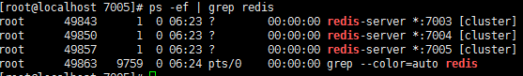
- gem install redis --version 3.0.6
- 执行redis的集群命令创建集群（注意ip地址和端口号）
cd /usr/local/redis-3.0.6/src
./redis-trib.rb create --replicas 1 192.168.199.242:7000 192.168.199.242:7001 192.168.199.242:7002 192.168.161.242:7003 192.168.161.242:7004 192.168.161.242:7005
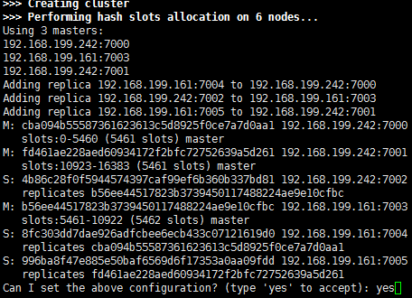
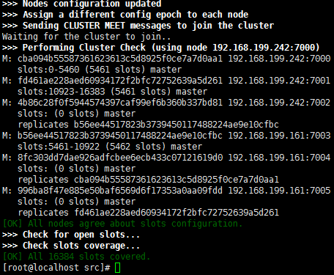
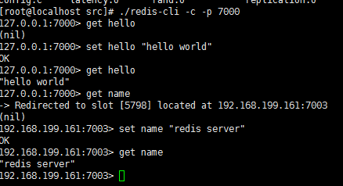
以上为测试集群，安exit退出

