# **MariaDB Galera Cluster 部署（如何快速部署MariaDB集群）**

**1.安装环境准备**

安装MariaDB集群至少需要3台服务器（如果只有两台的话需要特殊配置，请参照官方文档）

在这里，我列出试验机器的配置：

操作系统版本：[CentOS](http://www.linuxidc.com/topicnews.aspx?tid=14" \o "CentOS" \t "http://www.linuxidc.com/Linux/2015-07/_blank)7

node01:192.168.8.25

node02:192.168.8.26

node03:192.168.8.27

以第一行为例，node01为 hostname ，192.168.8.25为 ip ，在三台机器修改 /etc/hosts文件，我的文件如下：  
192.168.8.25 node01  
192.168.8.26 node02  
192.168.8.26 node03

为了保证节点间相互通信，需要禁用防火墙设置（如果需要防火墙，则参照官方网站增加防火墙信息设置）

在三个节点分别执行命令：  
systemctl stop firewalld

然后将/etc/sysconfig/selinux 的 selinux 设置成 disabled ,这样初始化环境就完成了。

配置yum源

#vim /etc/yum.repos.d/CentOS-MariaDB.repo

添加如下内容

[mariadb]

name = MariaDB

baseurl = http://yum.mariadb.org/10.0/centos7-amd64

gpgkey=https://yum.mariadb.org/RPM-GPG-KEY-MariaDB

gpgcheck=1

enabled=1  
2.安装 MariaDB Galera Cluster  
[root@node01 ~]# yum install -y Mariadb-Galera-server

[root@node02 ~]# yum install -y Mariadb-Galera-server

[root@node03 ~]# yum install -y Mariadb-Galera-server   
3.配置 MariaDB Galera Cluster

初始化数据库服务，只在一个节点进行  
[root@node01 mariadb]# /etc/init.d/mysql start

  
[root@node01 mariadb]# mysql_secure_installation

NOTE: RUNNING ALL PARTS OF THIS SCRIPT IS RECOMMENDED FOR ALL MariaDB  
      SERVERS IN PRODUCTION USE!  PLEASE READ EACH STEP CAREFULLY!

In order to log into MariaDB to secure it, we'll need the current  
password for the root user.  If you've just installed MariaDB, and  
you haven't set the root password yet, the password will be blank,  
so you should just press enter here.

Enter current password for root (enter for none):  
OK, successfully used password, moving on...

Setting the root password ensures that nobody can log into the MariaDB  
root user without the proper authorisation.

Set root password? [Y/n]  
New password:  
Re-enter new password:  
Password updated successfully!  
Reloading privilege tables..  
 ... Success!

By default, a MariaDB installation has an anonymous user, allowing anyone  
to log into MariaDB without having to have a user account created for  
them.  This is intended only for testing, and to make the installation  
go a bit smoother.  You should remove them before moving into a  
production environment.

Remove anonymous users? [Y/n] n  
 ... skipping.

Normally, root should only be allowed to connect from 'localhost'.  This  
ensures that someone cannot guess at the root password from the network.

Disallow root login remotely? [Y/n] y  
 ... Success!

By default, MariaDB comes with a database named 'test' that anyone can  
access.  This is also intended only for testing, and should be removed  
before moving into a production environment.

Remove test database and access to it? [Y/n] n  
 ... skipping.

Reloading the privilege tables will ensure that all changes made so far  
will take effect immediately.

Reload privilege tables now? [Y/n] y  
 ... Success!

Cleaning up...

All done!  If you've completed all of the above steps, your MariaDB  
installation should now be secure.

Thanks for using MariaDB!

关闭数据库，修改 /etc/my.cnf.d/galera.cnf  
[root@node01 mariadb]# /etc/init.d/mysql stop  
[root@node01 ~]# vim /etc/my.cnf.d/server.cnf  
修改以下内容：  
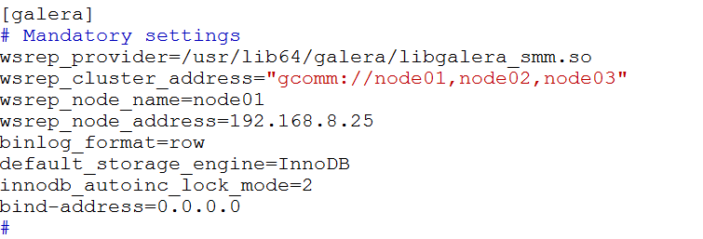

提示：如果不用ssl的方式认证的话，请把wsrep_provider_options 注释掉。

将此文件**复制到node02、node03，**注意要把 wsrep_node_name和 wsrep_node_address改成相应节点的 hostname和ip。  
   
4.启动 MariaDB Galera Cluster 服务  
[root@node01 ~]#/etc/rc.d/init.d/mysql bootstrap

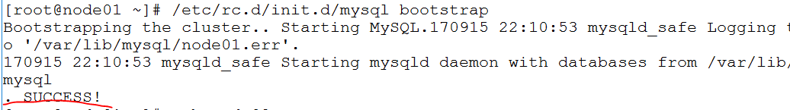

继续启动其他节点：  
[root@node02 ~]# /etc/init.d/mysql start  
[root@node03 ~]# /etc/init.d/mysql start

测试，在节点node01登录mariadb，创建数据库在node02，node03中等看到相同内容即可