**Data to Understanding: Enterprise Arrangements to Optimize Intelligence Production**

**Backgroud:** The growing ubiquity of collected and available data caused by advances in sensor technologies have presented the US Army with a unique challenge. No longer does the Army intelligence enterprise suffer from the lack of data, but rather now struggles to meet demands of the flood of data coming from this growing array and capabilities of collection platforms. Traditional architectures relied on large, forward-based processing, exploitation, and dissemination (PED) nodes to handle the large data created by the intelligence, surveillance, and reconnaissance (ISR) platforms. These systems, while mobile, are relatively large and take time to set-up and operate, making them prime targets for future enemies. In the words of the Army Chief of Staff “On the future battlefield, if you stay in one place longer than two or three hours, you will be dead.”**[1]**

Context: In context of the complex future operating environment, this represents a significant organizational challenge for the US Army. The Combined Joint Chiefs of Staff issued an ISR Joint Force 2020 white paper, stating the need for “work more aggressively to focus on PED... to develop more efficient PED processes... and include PED considerations within CCMD deliberate and crisis planning efforts.”[2] The vast collection of Army’s ISR data requires an extensive Army intelligence enterprise to PED the resultant information to support forward deployed forces at the leading edge of operations.[3] The traditional force structure and command, control, communications, computers, and intelligence (C4I) architectures must be rethought and reorganized in order to meet these challenges. Already, the Army has reorganized and established non-traditional units[4],[5] to support the ISR enterprise, little research has been done to assess the impact and efficiency of these reorganizations, with even less consideration given at individual level impact. Specifically, how the new organizational arrangement will change the individuals micro-decision making process and its overall affect on producing intelligence in support of theater intelligence customers.

**Purpose:**  Develop an exploratory enterprise “laboratory” to model and simulate different organizational arrangements based on intelligence and operational requirements.

To explore:

* What network organization arrangements are best able to deal with different time scaled requirements?
* Is there a critical point of interaction across the enterprise which produces shared understanding?
* Are there quantifiable efficiencies gained through consolidated, federated, or hybrid approaches to an Army PED enterprise?

**Model Design**:

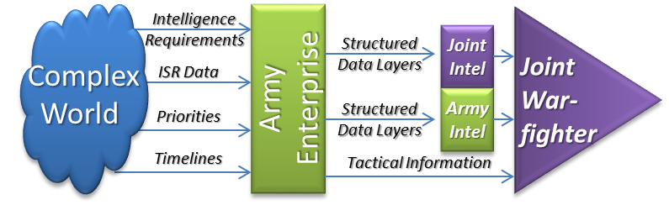The model will assess the Army Enterprise’s ability to support the Joint and Theater Army customer set, ranging from tactical forces engaged in operations to the joint theater and national-level intellingence consumers. The basic concept examines the flow of intelligence or information requirements, ISR data volumes, competing priorities, and information timelines (deadlines), all of which vary independently and randomly. The effectiveness of the enterprise is measured in its ability to manage these inputs and produce the required information to its various consumers. In a resource constrained environment, there will need to be limits on the resources available for the enterprise, so efficiencies and optimization will be key metrics. The “Mongolian Hoarde” approach of adding a plethora of contractors to meet demands is no longer a viable option.

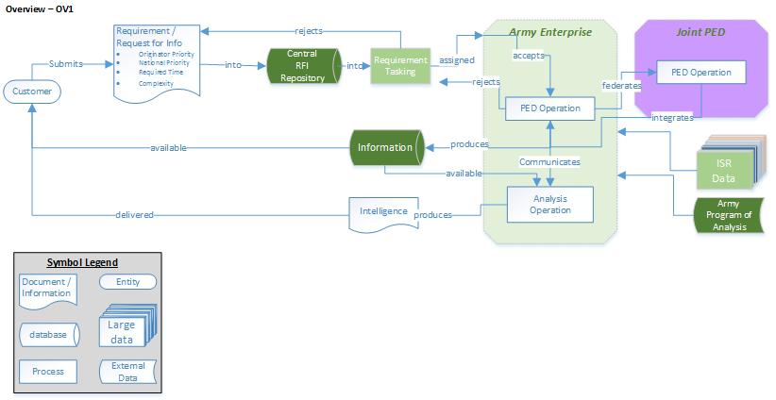

Overview (OV1) – There are multiple customers that submit multiple requirements or requests for information (RFI) into the RFI system. These requirements are defined as “PED UAV Line” or “Produce Intelligence”, which have priorities attached to them. There is a RFI management and tasking process that is either automated or “manned” by a node that monitors the RFI, adjusts priorities based on a formula, and polls the system for the correct node to assign the mission. The node can reject, accept, or request to federate out to another node. Each node has certain capabilities, capacities, efficiencies, and focuses/mission direction. Furthermore, some requirements require follow-on analysis, requiring further nodal interaction (or not) to combine PED outputs with other information. 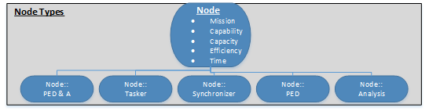

Can use talkspan to determine understanding between requestor and exploiter

* “energy” (shared understanding) should increase or decrease based on # of interactions and time between interactions - need reference and formula
* Recommend we scale down to GEOINT path through enterprise

Agents descprition:

Requestor: Quality of request based on experience and interaction with enterprise- recommend 3 kinds- immediate, deep, partial; key feature is “happiness with intelligence”

Collector: ?

Exploiter: understanding of request, level of effort to exploitation, randomized quality of work, feedback by boss (mix determine overall quality of product)

**Model Assessment**:

* Big metric: Quality of intelligence (determined by requestor agents aunderstanding) for different requirements
* Supporting metrics- where in structure breakdowns occur to reduce overall quality.

1. http://breakingdefense.com/2016/10/miserable-disobedient-victorious-gen-milleys-future-us-soldier/
2. http://www.dtic.mil/doctrine/concepts/white_papers/cjcs_wp_isr.pdf
3. http://www.afcea.org/events/armyintel/13/documents/LTG_Legere.pdf
4. https://www.inscom.army.mil/msc/116MIB.aspx
5. https://www.army.mil/article/158947