The Missing Total: What CMS’s Estimates Show for Medicaid Providers Under Two Proposed Rules
THEIA Services · Public note · September 6, 2026; revised [DATE]
Prepared by: Eric Boyda
Evidence tags: [E] stated in a cited public document; [I] arithmetic or a reading by THEIA Services; [C] depends on facts not yet public.

Executive summary
Under CMS’s central estimates, two proposed rules would leave providers about $488 billion to $753 billion worse off over 2026–2035, in 2026 dollars, net of lower provider taxes and, at the lower end, of the most that providers could stop paying to fund the cut payments. [I] The rules would carry out two sections of the One Big Beautiful Bill Act (OBBBA): Section 71115 limits the taxes states levy on providers to fund Medicaid, and Section 71116 caps state directed payments (SDPs), extra payments a state requires its Medicaid managed care plans to make to particular providers (sec. 1). [E] CMS measures its SDP and provider tax estimates against a projection of Medicaid without the OBBBA (sec. 3) [E], so they include the OBBBA’s own effect. [I] CMS publishes no hospital figure: it expects most of the SDP rule’s reductions to fall on hospitals but says it lacks the data to attribute them by provider type (sec. 3). [E]
THEIA Services found no published estimate of this combined net loss. [I] The outside estimates this note examines, from the Healthcare Financial Management Association (HFMA), KFF and POLITICO, each measure something narrower or on a different basis, and CMS’s own figures and an $891 billion HHS estimate measure different things again (sec. 5). [I] CMS itself says the two rules together would on net still cut provider payments significantly over time (sec. 4) [E], without giving a combined figure. [I]
The $753 billion ceiling is a combined $916.9 billion reduction in Medicaid payments to providers from the two sections, as the rules would implement them, less $163.7 billion in lower provider taxes. [I]
The $488 billion floor subtracts at most a further $264.7 billion: the state share of the SDP cut, which providers may partly stop funding through provider taxes and intergovernmental transfers (IGTs). [I] THEIA Services found no current public source showing how much of each state’s SDP funding comes from each source, or how states will fund SDPs going forward, so CMS’s data cannot narrow the range. [I]
Hospitals can still gauge their own exposure: a hospital’s SDP receipts and its provider tax and transfer payments allow a hospital-specific estimate (sec. 7), and state decisions make the result a range, not a single number. [I]
Both rules remain proposals that CMS can change before finalizing (sec. 1) [E], and THEIA Services takes no position on whether either is good policy.

1. The OBBBA and the two proposed rules
The OBBBA, formally Public Law 119-21 and called the Working Families Tax Cut legislation by CMS (91 FR 46562), sets two limits on how states fund Medicaid; CMS has proposed one rule for each, and both rules add provisions the OBBBA does not require. [E] A third, Section 71117, is carried out by a final rule (CMS-2448-F) that CMS’s provider tax estimates take into account and that CMS says does not significantly change them (91 FR 46590 n. 23, 46592; Appendix C). [E]

The SDP rule (CMS-2449-P)
SDPs are extra payments, most approved in advance by CMS, that a state requires its Medicaid managed care plans to make to particular providers (42 CFR 438.6(c)(1); 91 FR 30447). [E] Most go to hospitals: hospitals received 87.5 percent of the estimated $143.8 billion in SDPs that needed CMS’s written prior approval in the federal fiscal year ending September 30, 2025 (91 FR 30447). [E] That is a share of one year’s payments, not of the projected cuts. [I]
Required by the OBBBA (Section 71116) | Added by CMS in the proposed rule
Caps SDPs for inpatient hospital, outpatient hospital, nursing facility and academic medical center practitioner services at 100 percent of Medicare rates in states that expanded Medicaid to low-income adults (expansion states; Appendix B) and 110 percent elsewhere. | Extends the cap to SDPs for other services: CMS estimates −$5.34 billion in spending over 2029–2035 (91 FR 30453).
Lets SDPs approved, or sought through a documented good-faith effort, before May 1, 2025 (by July 4, 2025 for rural hospitals) continue above the cap, then cuts these grandfathered payments by 10 percentage points a year, starting with each state’s first managed care rating period (the period for which a state sets its plans’ payment rates) on or after January 1, 2028. | Limits fee-for-service payments that target particular practitioners: CMS estimates −$2.44 billion in spending over 2029–2035 (Table 27, 91 FR 30456).
Source: 91 FR 30400–30456. CMS’s additions include the two shown; THEIA Services did not confirm that no others exist. Both are federal plus state spending in 2026 dollars (91 FR 30453, 30456).

The provider tax rule (CMS-2452-P)
States tax hospitals, managed care plans, nursing facilities and other providers to fund part of their Medicaid share, collecting a projected $98.6 billion in calendar year 2026 (91 FR 46589). [E] Hospitals pay the largest share, $61.8 billion (Table 4, 91 FR 46589; Appendix B). [E]
Federal law bars states from promising providers their tax back, an arrangement called a hold harmless (Appendix B). [E] Under current rules a tax that raises more than a threshold share of taxed providers’ net patient revenue, at most 6 percent, is also an indirect hold harmless if, in the aggregate, 75 percent of taxpayers get back 75 percent or more of their tax (the 75/75 test; 91 FR 46564). [E] A failed tax costs the state federal matching funds on the revenue that does not qualify (42 CFR 433.70(b)) [E], so a lower threshold limits how much states can raise. [I]
Required by the OBBBA (Section 71115) | Added by CMS in the proposed rule
Freezes provider taxes in every state at July 4, 2025 levels: no new taxes, no rate increases. | Stops applying the 75/75 test from federal fiscal year 2027, making the threshold the most a tax can raise, whether or not providers get their tax back (91 FR 46562, 46581).
Lowers the threshold in expansion states on the schedule below; taxes on nursing facilities and on intermediate care facilities for people with intellectual disabilities are exempt from the lower threshold and stay at their July 4, 2025 level (P.L. 119-21, § 71115(a)(2); 91 FR 46565, 46576). | Adds a new permissible class: a category of health care items or services states may tax (91 FR 46562).
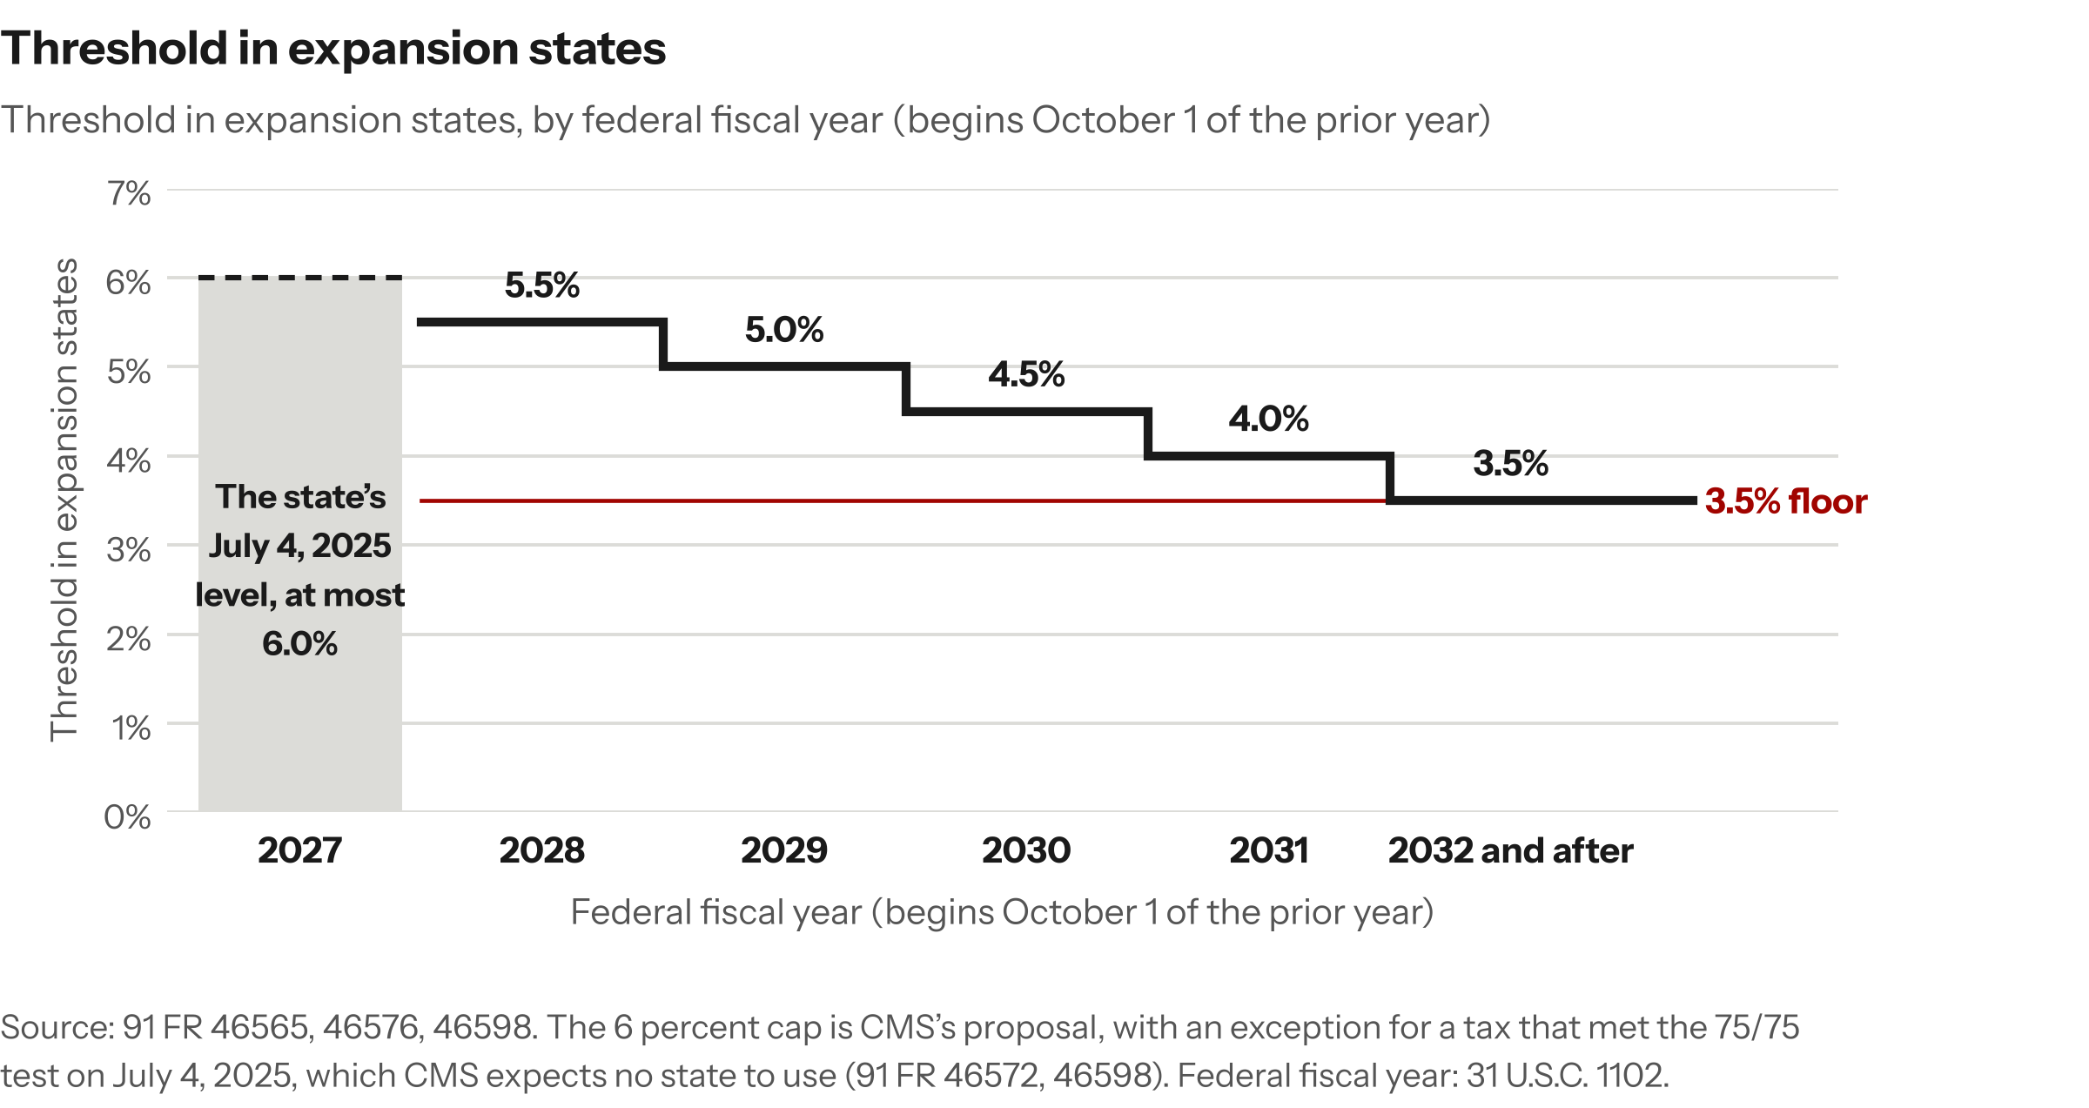
Figure 1. Federal fiscal year (begins October 1 of the prior year): Threshold in expansion states.
Source: 91 FR 46565, 46576, 46598. The 6 percent cap is CMS’s proposal, with an exception for a tax that met the 75/75 test on July 4, 2025, which CMS expects no state to use (91 FR 46572, 46598). Federal fiscal year: 31 U.S.C. 1102.

2. What links the two rules
States can fund their Medicaid share, which the federal government matches, from general revenue, provider taxes, or IGTs: funds that units of government within a state, such as public hospitals, transfer as the non-federal share (Appendix B). [E] Between 80 and 90 percent of SDPs relied entirely or partly on provider taxes or IGTs by the end of 2025, on CMS’s preprint data (91 FR 30452; Appendix C). [E] The Government Accountability Office’s state figures for SDPs approved as of August 26, 2022 combine provider taxes and IGTs in one amount, not dollars by source, and GAO says that amount is undercounted (GAO-24-106202, Table 4). [E]
The financing source decides which rule reaches an SDP: a tax-funded SDP is capped by the SDP rule, and the provider tax rule limits the taxes that fund it, while an SDP funded only by IGTs faces the cap alone. [I]
Because provider taxes fund many SDPs and both rules reach tax-funded SDPs, CMS’s estimates overlap. [I] Under CMS’s central estimate, the provider tax rule would cut provider payments by $384.0 billion alone but by only $142.1 billion more once the SDP rule’s cuts are counted, and CMS attributes the $241.9 billion difference ($154.9 billion federal, $87.0 billion state) to cuts already counted in the SDP rule (91 FR 46592). [E] Any total that adds the two estimates without removing the $241.9 billion overlap counts $241.9 billion twice. [I]
The $241.9 billion overlap rests on two central assumptions: that 65 percent of SDPs are tax-financed, within CMS’s 55 to 75 percent estimate (its high-savings and low-savings values) for the tax-financed share of SDP spending, and that states apply at most 80 percent of the reductions to SDPs (91 FR 46592). [E] CMS’s other estimates move these assumptions together, so its figures do not isolate the effect of any one (Appendix D). [I]
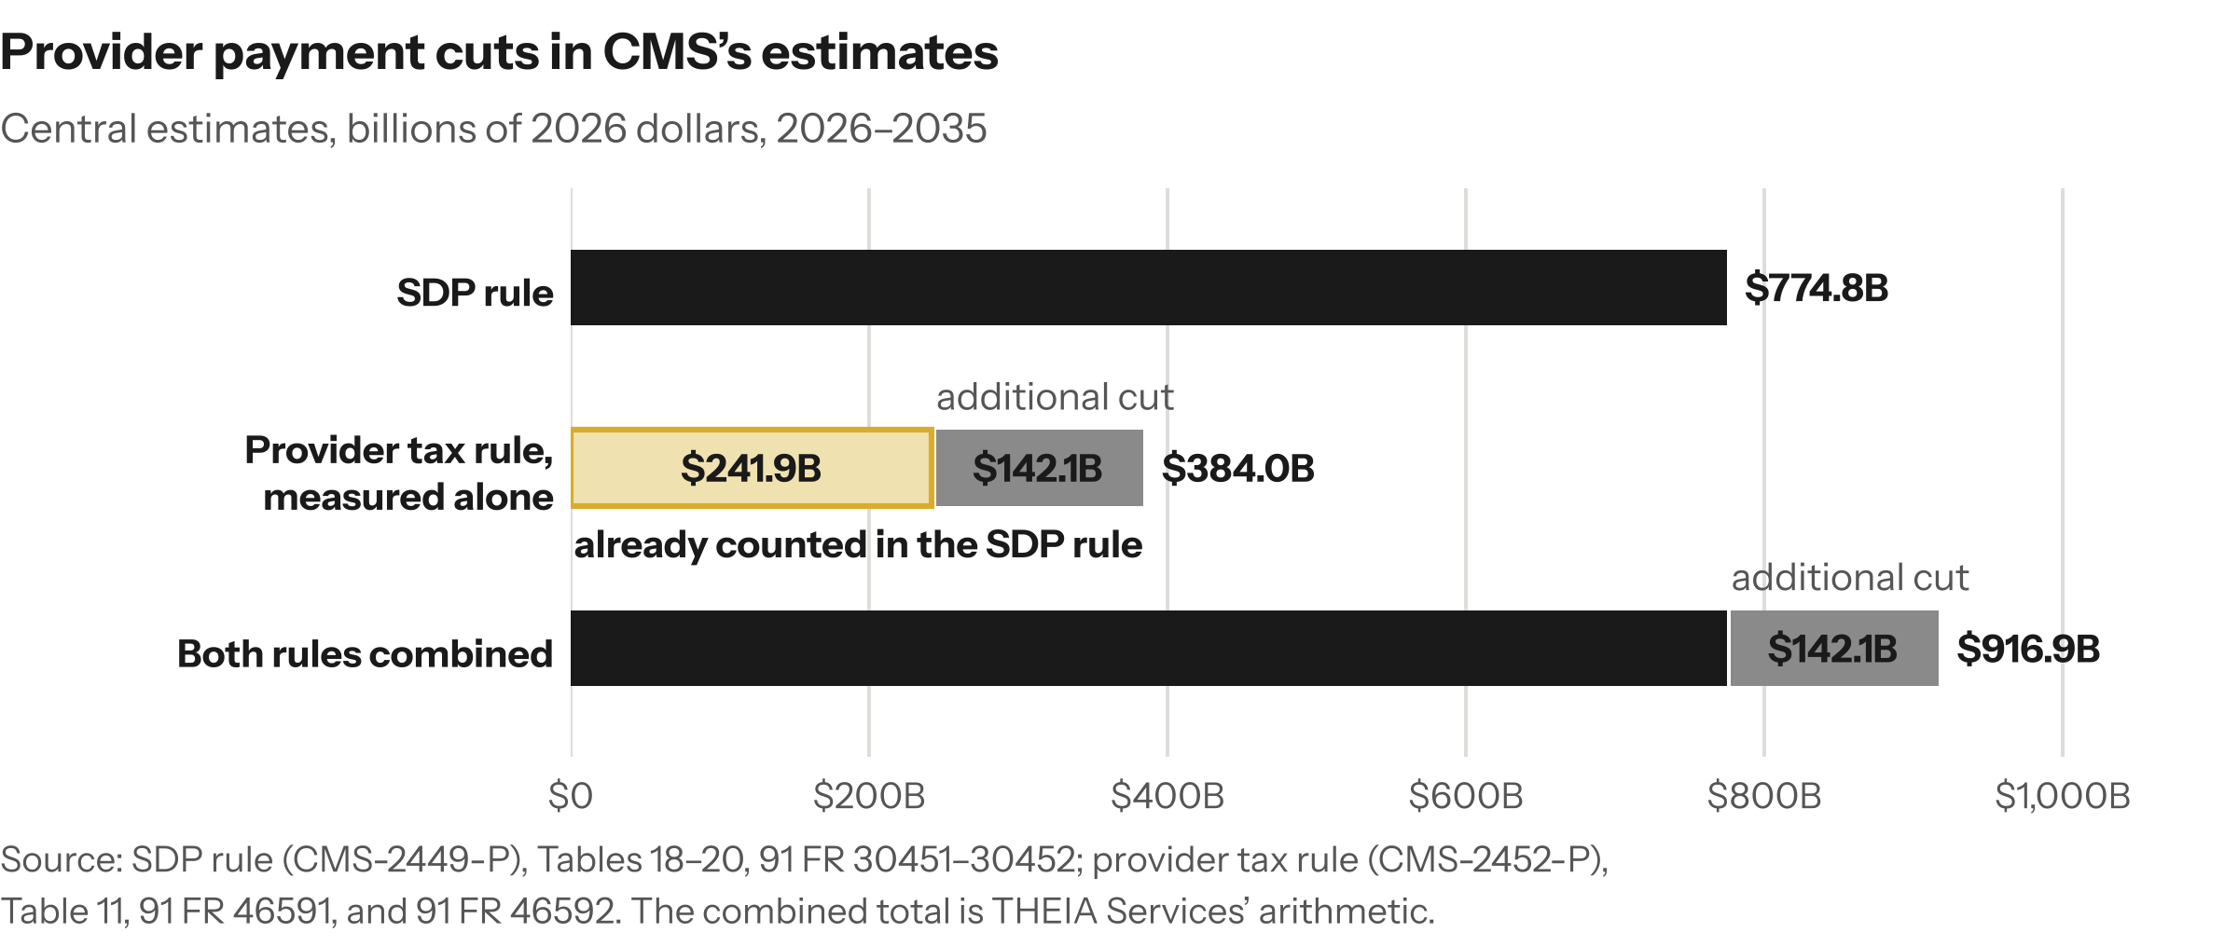
Figure 2. CMS counts $241.9 billion of the same payment cuts in both rules’ estimates.

3. CMS’s estimates for each rule
CMS estimates each rule in a Regulatory Impact Analysis measured against a projection of Medicaid without the OBBBA, for the SDP rule’s SDP estimates (91 FR 30447) and for the provider tax rule (91 FR 46589–46591) [E], so both include the OBBBA’s effect. [I] The SDP rule’s fee-for-service estimates state no baseline (91 FR 30455). [I] The SDP rule prices Section 71116 (Tables 18–20, 91 FR 30451–30452) and its extension to other services (91 FR 30453) separately [E]; THEIA Services found no separate estimate of what the provider tax rule adds to Section 71115. [I]
CMS publishes a central estimate (its primary scenario) and low-savings and high-savings estimates for each rule; for the SDP rule they vary the assumed gaps between commercial, Medicaid and Medicare rates (91 FR 30453–30454; Appendix D). [E] For the provider tax rule, besides the two assumptions behind the overlap (sec. 2), the central estimate assumes states offset 30 percent of the cut with other revenue; the other estimates change all three (91 FR 46591–46594). [E] CMS states the offset immediately before its $384.0 billion total, splits the $142.1 billion and $241.9 billion from that total and prints no total before the offset (91 FR 46591–46592) [E]; THEIA Services reads all three figures as net of the offset, which CMS does not say in words. [I]
CMS states each scenario’s assumptions as single values, not by state (91 FR 30453–30454, 46593–46594). [E] THEIA Services reads them as national, so the estimates express uncertainty about national averages; it found no basis for assigning any state to one scenario. [I]
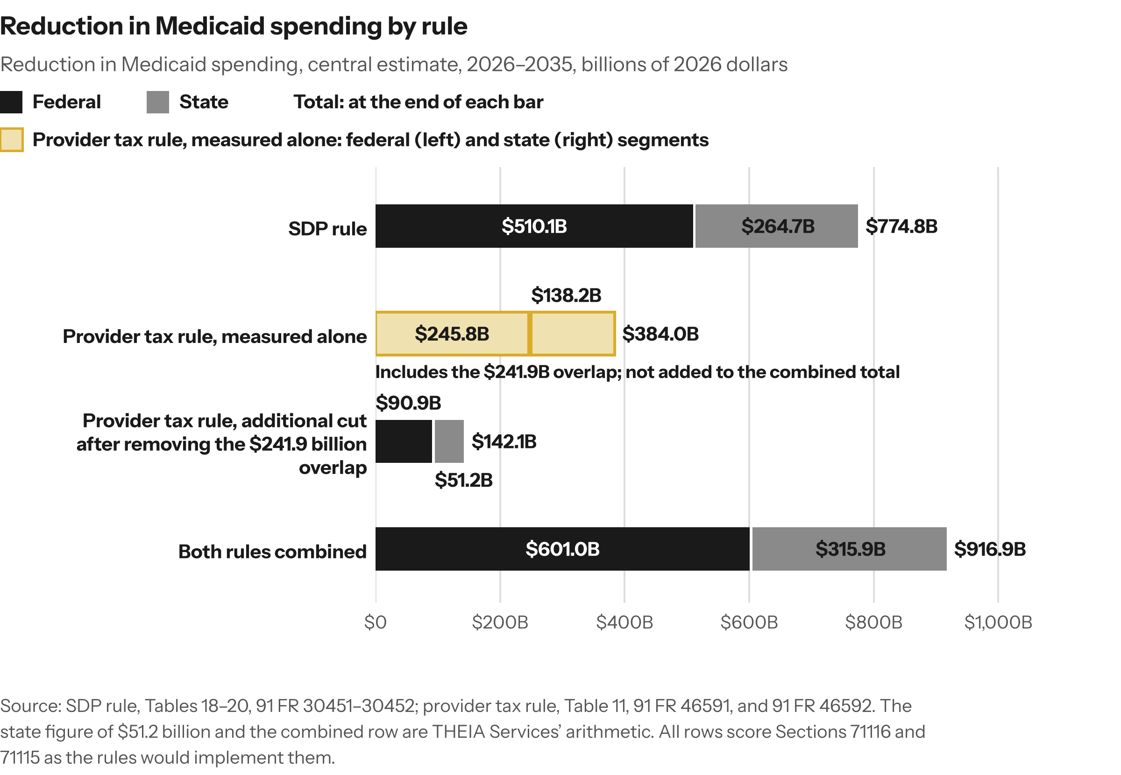
Figure 3. Reduction in Medicaid spending, central estimate, 2026–2035, billions of 2026 dollars: Federal; State; Total.
Source: SDP rule, Tables 18–20, 91 FR 30451–30452; provider tax rule, Table 11, 91 FR 46591, and 91 FR 46592. The state figure of $51.2 billion and the combined row are THEIA Services’ arithmetic. All rows score Sections 71116 and 71115 as the rules would implement them.
CMS labels the SDP rule’s years as fiscal years, federal or state unstated (91 FR 30451–30452), and gives a provider tax rule figure by calendar year (91 FR 46589) [E]; neither rule says whether the bases match, so the windows may be offset by a few months, and THEIA Services sums them as published (Appendix F). [I]
The federal and state reductions together equal the Medicaid payments each rule removes, so the totals are also payment cuts. [I] CMS describes the SDP rule’s reductions as falling on providers and other entities, such as local governments that reimburse providers for uncompensated care, and expects most of them to fall on hospitals; on the same page it says it lacks the data to attribute the impacts reliably to provider types, because SDPs are optional for states and their effects on providers are indirect (91 FR 30462). [E]
The provider tax rule also cuts state provider tax collections by $198.7 billion over 2026–2035 (Tables 6–8, 91 FR 46589–46590; Appendix B), of which CMS assigns $163.7 billion to providers and $35.0 billion to private payers, reasoning that providers pass part of their tax costs into commercial prices (Table 8). [E]
For the provider tax rule, lost tax revenue outweighs lower state spending: CMS shows states only as a net loss, $147.5 billion counting the SDP rule (CMS-2452-P Table 19, 91 FR 46596) and $60.5 billion for the rule alone (Table 12, 91 FR 46592) [E], each equal to the state reduction above, $51.2 billion or $138.2 billion, less the $198.7 billion. [I] The SDP rule’s state figure is a reduction in state spending measured before any change in the provider taxes and IGTs that fund the state share, so THEIA Services gives no state net for it (sec. 5). [I] This note uses Table 20’s sum, $264.7 billion, not the $264.4 billion in CMS’s text, because only the sum equals $774.8 billion less $510.1 billion (Appendix E). [I]

4. The net effect on providers
Right after its +$21.7 billion figure for the provider tax rule, CMS says that, taken together, the two proposed rules would on net still leave Medicaid paying providers significantly less over time (91 FR 46593). [E] The statement is qualitative and gives no combined figure. [I]
Combined, the two rules would leave providers about $488 billion to $753 billion worse off over 2026–2035 under CMS’s central estimates. [I] The gap between the two ends comes from step 3 alone: how much of the state share of SDPs providers fund themselves, which THEIA Services found in no public source. [I] Both ends rest on CMS’s central assumptions about how states respond (sec. 3; sec. 7, step 3). [I]
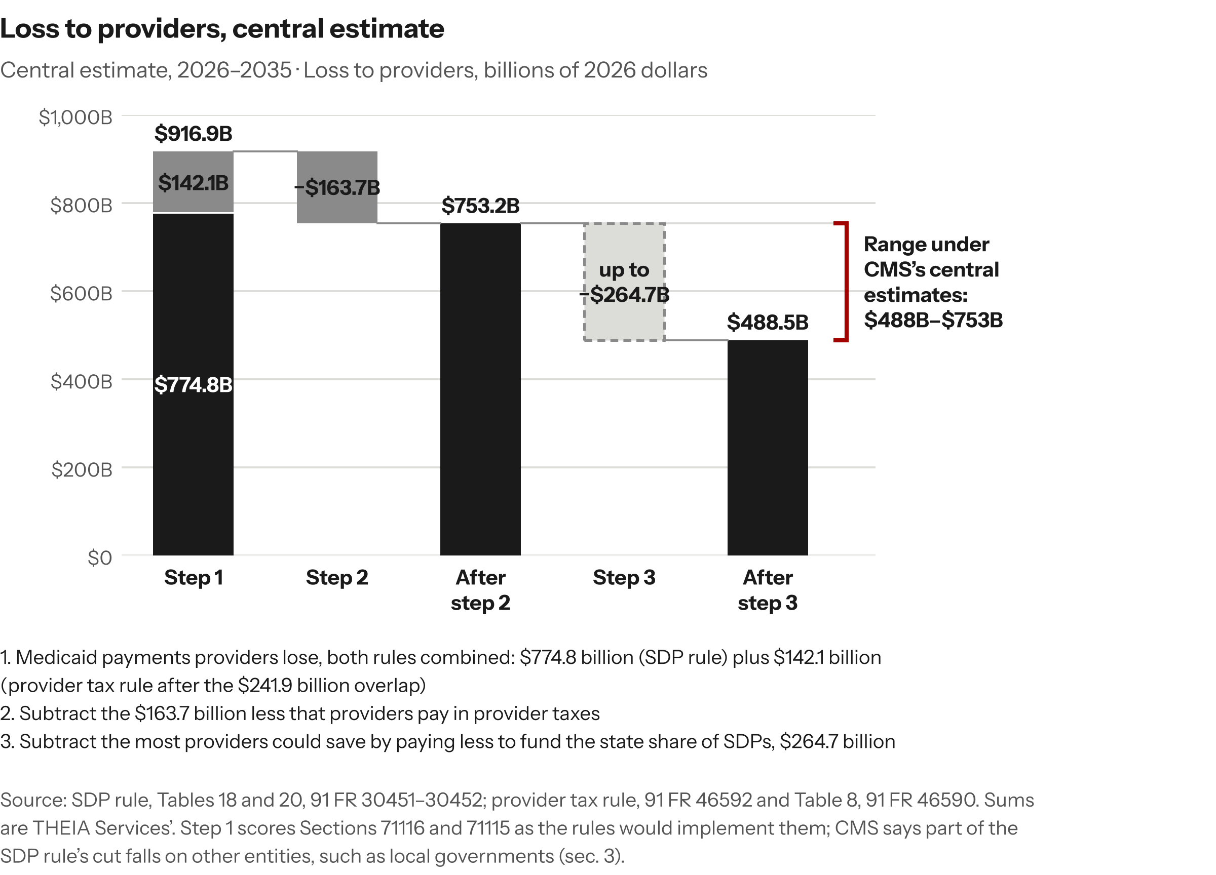
Figure 4. Central estimate, 2026–2035: Loss to providers, billions of 2026 dollars.
Source: SDP rule, Tables 18 and 20, 91 FR 30451–30452; provider tax rule, 91 FR 46592 and Table 8, 91 FR 46590. Sums are THEIA Services’. Step 1 scores Sections 71116 and 71115 as the rules would implement them; CMS says part of the SDP rule’s cut falls on other entities, such as local governments (sec. 3).
Step 3 rests on CMS’s caveat that, where providers pay the provider taxes or IGTs that fund the state share of SDPs, “the net change in provider revenue … could be significantly less,” though CMS is “unable to estimate the impacts on providers in more detail” (91 FR 30453). [E]
The $488 billion is a best case, since states fund part of the state share from general revenue and step 2’s $163.7 billion may already count part of what providers stop paying; CMS’s data support no closer estimate. [I] CMS’s low-savings and high-savings estimates, paired by THEIA Services, widen the range to about $122 billion (low-savings, after step 3) at one end and about $1,126 billion (high-savings, after step 2) at the other, in 2026 dollars over 2026–2035 (Appendix D). [I]
CMS’s figures cover all providers, with no separate hospital figure; for the SDP rule CMS says it cannot attribute the impacts by provider type (91 FR 30462), and for the provider tax rule it expects the largest decreases to fall on hospitals (91 FR 46591). [E] Hospitals are projected to pay $61.8 billion of the $98.6 billion in provider taxes in calendar year 2026 (Table 4, 91 FR 46589) [E]; if that one-year share held for the decade, hospitals would also receive most of step 2’s $163.7 billion in tax relief, an allocation that is THEIA Services’ assumption, not CMS’s. [I]

5. What the published figures measure
Each figure examined below measures something narrower than the combined net loss to providers or uses a different basis. [I]
CMS central estimates, 2026–2035 (billions of 2026 dollars) | SDP rule | Provider tax rule measured alone | Provider tax rule after counting the SDP rule’s cuts first | Both rules combined
Federal Medicaid spending reduction | 510.1 | 245.8 | 90.9 | 601.0
State Medicaid spending reduction, before lost provider tax revenue | 264.7 | 138.2 | 51.2 | 315.9
Payments providers lose | 774.8 | 384.0 | 142.1 | 916.9
Provider taxes states no longer collect | Not applicable | 198.7 (163.7 saved by providers; 35.0 by private payers) | 198.7 (same split) | 198.7 (same split)
Net for states | Not estimated here | Loss of 60.5 | Loss of 147.5 | Not estimated here
Net for providers | Not estimated by CMS | Loss of 220.3 | Gain of 21.7 | Loss of about 488 to 753
Source: CMS’s Regulatory Impact Analyses at the tables cited in secs. 3 and 4; net for states, CMS-2452-P Table 12 (91 FR 46592) and Table 19 (91 FR 46596). The combined column, which scores Sections 71116 and 71115 as the rules would implement them, the $51.2 billion and $315.9 billion state figures and the providers’ combined range are THEIA Services’ arithmetic; blank state nets: sec. 3.

The provider tax rule’s two figures for providers
CMS reports two net provider figures for the provider tax rule, neither covering both rules: net of the $163.7 billion in lower provider taxes, the $384.0 billion cut alone leaves providers $220.3 billion worse off (Table 12), and after the SDP rule’s cuts they are $21.7 billion better off (Table 14) (91 FR 46590–46593). [E] $163.7 billion less $142.1 billion is $21.6 billion; the difference is rounding in CMS’s components (Appendix E). [I] The −$220.3 billion thus already nets out the lower taxes [I], as the title of CMS’s Table 12, “Projected Net Changes Related to Changes in Provider Tax Revenues and Expenditures,” indicates (91 FR 46592). [E] The +$21.7 billion is the provider tax rule’s increment, not the two rules’ combined effect, which CMS itself calls a significant reduction (sec. 4). [I]
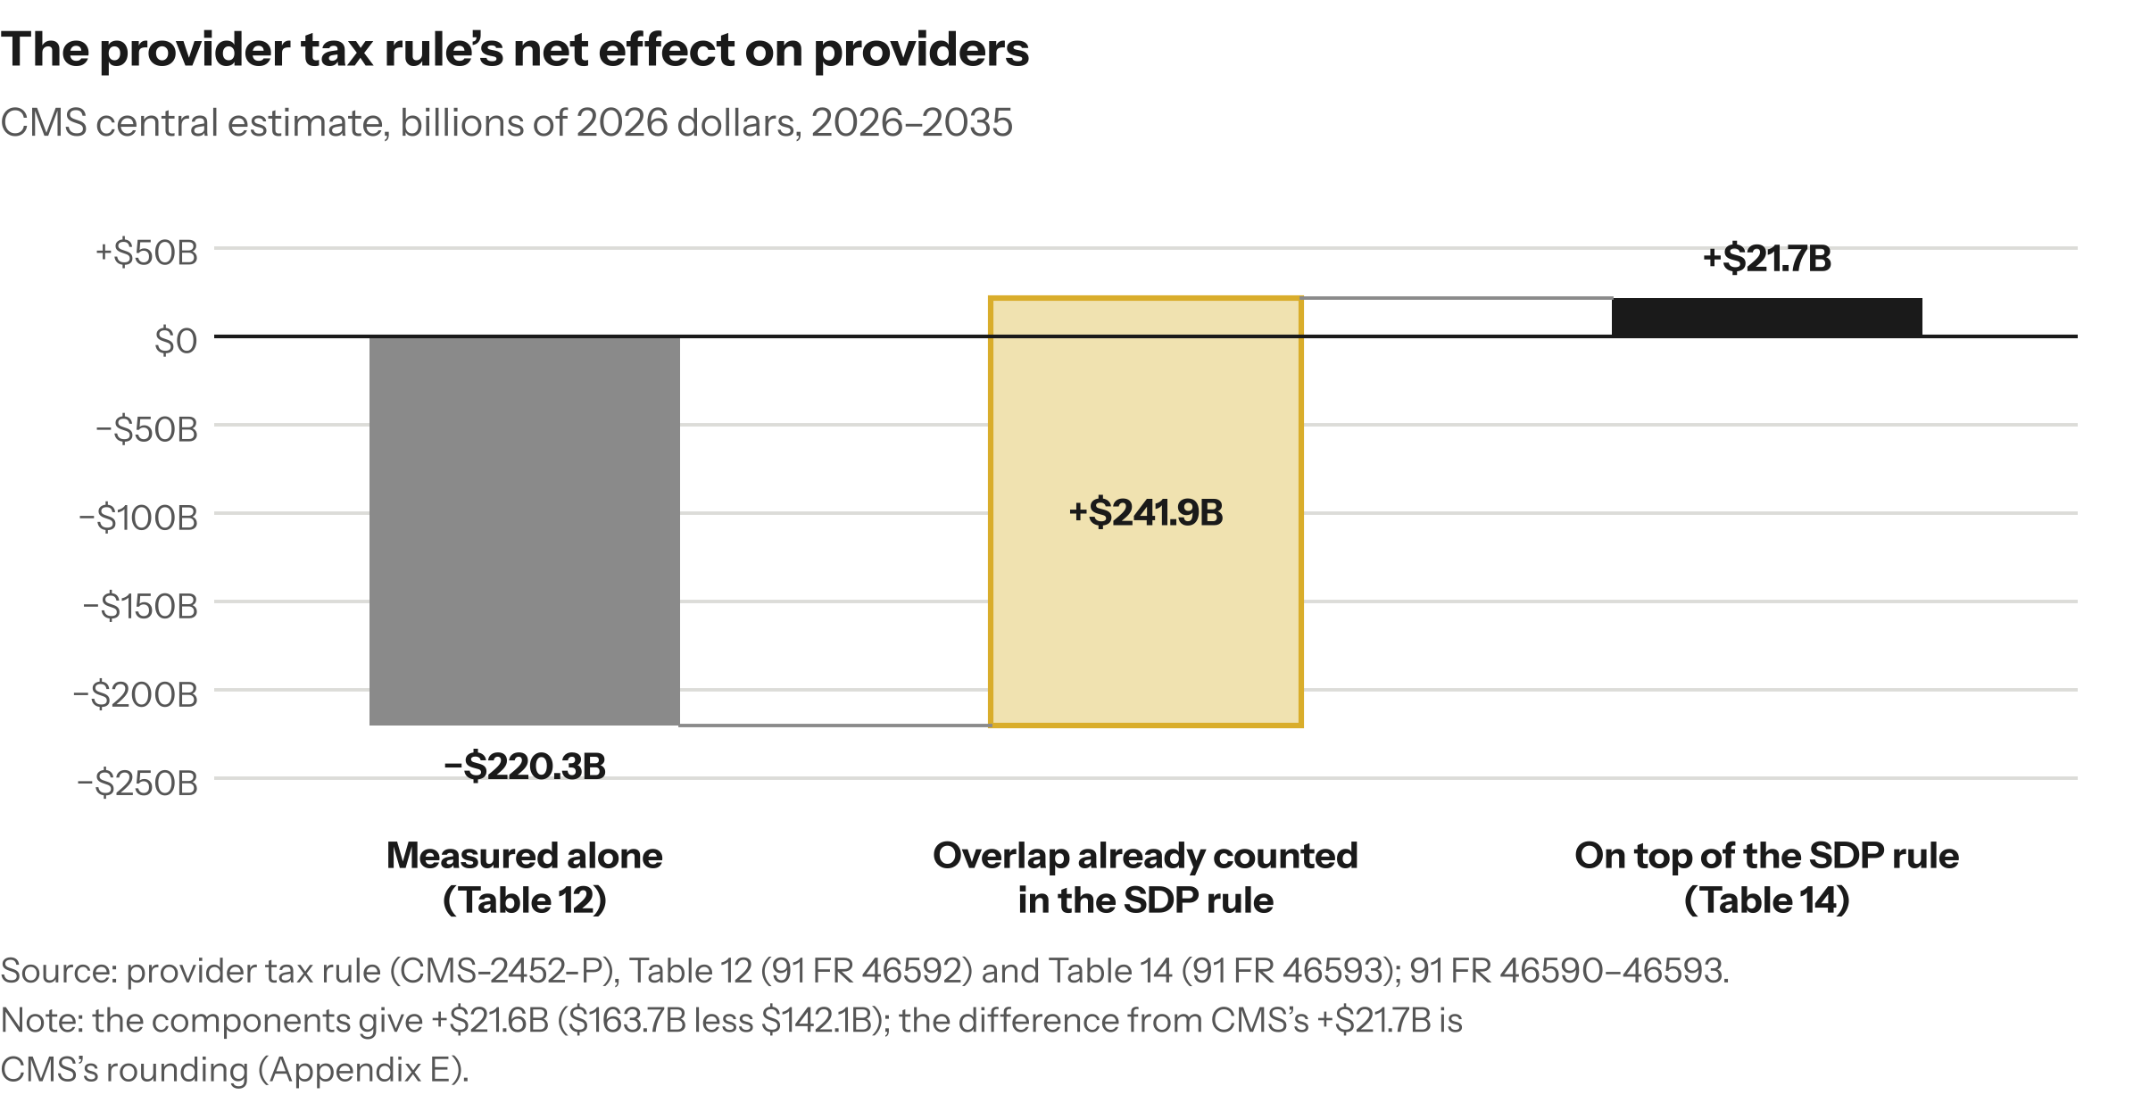
Figure 5. From −$220.3 billion to +$21.7 billion: the difference is the $241.9 billion overlap.

KFF’s $155 billion
KFF’s $155 billion, from its August 14, 2026 analysis of SDPs in 37 states, is the part of the SDP rule’s $510 billion federal cut that KFF reports is also counted in the provider tax rule. [E] That matches CMS’s $154.9 billion federal share of the $241.9 billion overlap (91 FR 46592). [I] KFF and CMS therefore report one finding, federal only versus federal plus state. [I]

HFMA’s $56.6 billion
HFMA’s $56.6 billion appears, on THEIA Services’ reading, to subtract the $163.7 billion in lower provider taxes twice. [I] HFMA’s July 22, 2026 article, which describes the same no-OBBBA comparison point as CMS, reported that provider payments would fall $220.3 billion over 10 years and providers would save $163.7 billion in taxes, “leaving a net decrease of $56.6 billion.” [E] But $220.3 billion matches the provider line of CMS’s Table 12, which already subtracts the $163.7 billion [I]; THEIA Services found $56.6 billion in neither rule [I], and if this reading is right, HFMA understates the provider tax rule’s standalone net effect, a $220.3 billion loss. [I]
CMS’s wording may explain the reading. [I] CMS describes the $384.0 billion payment cut as shown in Table 12 (91 FR 46592), although the $384.0 billion appears in Table 11 and Table 12 shows the net −$220.3 billion. [E] Of the five comments on the provider tax rule that cite $220.3 billion (five distinct texts, the same as filed and corrected), four describe it as a payment cut (comments CMS-2026-2476-0049, -0085, -0190 and -0201) and one as net of lower taxes (-0212); none arrives at $56.6 billion. [I] Georgetown University’s Center for Children and Families reported the same $220.3 billion on July 27, 2026 as already net of providers’ lower taxes [E], and HFMA had not replied to THEIA Services’ request for confirmation, sent September 28, 2026, as of [DATE]. [I]

POLITICO’s $681 billion and the Congressional Budget Office’s estimates
POLITICO’s $681 billion compares two estimates of the same OBBBA provisions on mismatched bases. [I] Its September 2, 2026 article reported that hospitals had expected to lose $340 billion through 2034 under the 2025 law, that the rules would produce about $756 billion in federal and $265 billion in state savings through 2035, and that, “as hospitals see it,” hospitals are losing $681 billion more than expected. [E]
The article names no source for the $340 billion. [I] The Congressional Budget Office (CBO) estimated that Section 71115 would reduce federal Medicaid outlays by $191.1 billion and Section 71116 by $149.4 billion over fiscal years 2025–2034 (July 21, 2025, Table 7, Title VII sheet; for Section 71116 also October 28, 2025, p. 5). [E] CBO reports interactions among the OBBBA’s Medicaid provisions separately (October 28, 2025, p. 6). [E] POLITICO’s $340 billion matches the sum of the two section figures, $340.5 billion, which CBO does not print. [I]
POLITICO’s CMS inputs mix scopes. [I] Its $756 billion equals both rules’ federal savings measured alone ($510.1 billion + $245.8 billion, 2026–2035, 2026 dollars). [I] Like CBO’s section figures, on THEIA Services’ reading of CBO’s tables, it leaves out the interaction between the two sections, but it covers other years, uses another baseline and may differ in dollar basis. [I] Read as the two rules’ combined cut, it counts the $154.9 billion federal overlap twice. [I] Its $265 billion is the SDP rule’s state spending reduction alone (sec. 3). [I] A gap between government savings estimates measures provider payments before tax relief, across all provider types, not a net hospital loss. [I]
On THEIA Services’ reading of CBO’s table layout (CBO does not say so in words), CBO’s section figures exclude the interaction between the sections. [I] The CMS figure treated the same way is its federal total without the interaction, $755.9 billion for 2026–2035; CMS’s $601.0 billion has no CBO counterpart (Appendix F). [I] Of the known differences, only CMS’s extra year lowers its figure, and removing the interaction raises it. [I] Without 2035, the $601.0 billion becomes $501.5 billion and the no-interaction total $630.9 billion (federal, 2026–2034), nine years against CBO’s ten. [I] Year bases may also differ (sec. 3). [I] Three other differences have no known direction: CMS’s 2026 dollars against CBO’s unstated dollar basis, what the provider tax rule adds to Section 71115, and the agencies’ comparison projections. [I] So the rest of the gap between these published estimates is unresolved. [I] THEIA Services found no independent derivation of $681 billion before September 2, 2026 [I]; one later comment restates it (comment CMS-2026-2476-0079; Appendix G). [E]

ASPE’s $891 billion
ASPE’s $891 billion, from an August 12, 2026 report by HHS’s Office of the Assistant Secretary for Planning and Evaluation (ASPE), is a combined federal and state Medicaid spending cut from the OBBBA’s provider tax and SDP provisions over 2025–2034, used to estimate benefits to other payers (p. 11) [E]; ASPE does not say whether it removes the overlap between the two provisions. [I]
ASPE estimates up to 3.5 percent lower non-Medicaid prices [E], the counterpart of the $35.0 billion in tax relief CMS assigns to private payers [I], and $502 billion to $875 billion in benefits to non-Medicaid payers over 2025–2034 (pp. 10–11). [E] ASPE scored the OBBBA’s provisions directly rather than as CMS’s proposed rules would implement them, over different years, so its $891 billion cannot be compared directly with THEIA Services’ combined $916.9 billion. [I]

6. Where exposure is concentrated
KFF’s August 14, 2026 analysis supplies the national picture: [E]
- Hospital SDPs in 37 states, including DC, likely exceed the new caps. [E]
- Excluding Minnesota and Missouri (no estimate), about $60 billion of one year’s federal hospital SDP spending is above the caps, out of about $78 billion in federal hospital SDP spending and about $93 billion in all federal SDP spending. [E]
- 31 expansion states have a non-exempt provider tax above 3.5 percent: 28 with hospital taxes, 10 with ambulance taxes and 6 with managed care organization taxes. [E]
KFF cautions that dollars above the caps may not show which states could face the largest proportional effects, and finds that states with most SDP spending above the caps already have base rates at or near the caps, while low base rates leave more SDP spending under them. [E]
Group | States | Federal hospital SDPs above the caps, one year | Parts of the two rules that reach the group
A. Both rules | 24 expansion states with hospital SDPs above the caps and a hospital tax above 3.5% | About $45.4B | The 100% cap and grandfathered phase-down; the provider tax freeze and lower threshold
B. Cap plus lower threshold on non-hospital taxes | 2 (WA, WV) | About $2.0B | The same, but the lower threshold reaches ambulance or other taxes, not hospital taxes
C. Cap only | 3 (DC, DE, HI) | About $0.8B | The 100% cap and phase-down; no tax above 3.5% identified other than nursing or intermediate care facility taxes
D. Non-expansion states with SDPs above the caps | 8 (FL, GA, KS, MS, SC, TN, TX, WI) | About $11.9B | The 110% cap, phase-down and provider tax freeze; no lower threshold
E. No identified hospital SDPs above the caps | 14 | $0 (excludes Colorado’s SDP; see text) | The provider tax freeze where a tax exists; the lower threshold in Arkansas, Colorado, Connecticut, Indiana and Vermont
Source: THEIA Services’ grouping from KFF’s August 2026 state file and Medicaid expansion tracker; KFF does not use these groups. The dollar column sums KFF’s estimates for each group.
The freeze limits every state’s ability to replace lost payments with new or higher provider taxes. [I]
Group E is not exposure-free: the lower threshold reaches Arkansas (an ambulance tax) and Colorado, Connecticut, Indiana and Vermont (hospital taxes), and KFF’s figures leave out a Colorado SDP above the new limits whose preprint CMS posted after July 20, 2026 (KFF, August 14 and 20, 2026). [E] Alabama and Wyoming have no Medicaid managed care (KFF, August 14, 2026) [E], so they have no SDPs. [I]
Of the Group D states, KFF imputed missing payment rates for three, Georgia, Texas and Wisconsin (KFF, August 14, 2026) [E], so their figures rest partly on imputation. [I] KFF counts taxes above 3.5 percent only in expansion states, which the lower threshold reaches, and Florida, Kansas and Mississippi did not answer KFF’s 2025 survey (KFF, August 20, 2026) [E]; neither shows that no Group D tax exceeds 3.5 percent. [I]
Minnesota and Missouri belong in Group A but have no KFF estimate [E], and no group separates tax-funded SDPs from SDPs funded only by IGTs, which the lower threshold does not reach. [I]
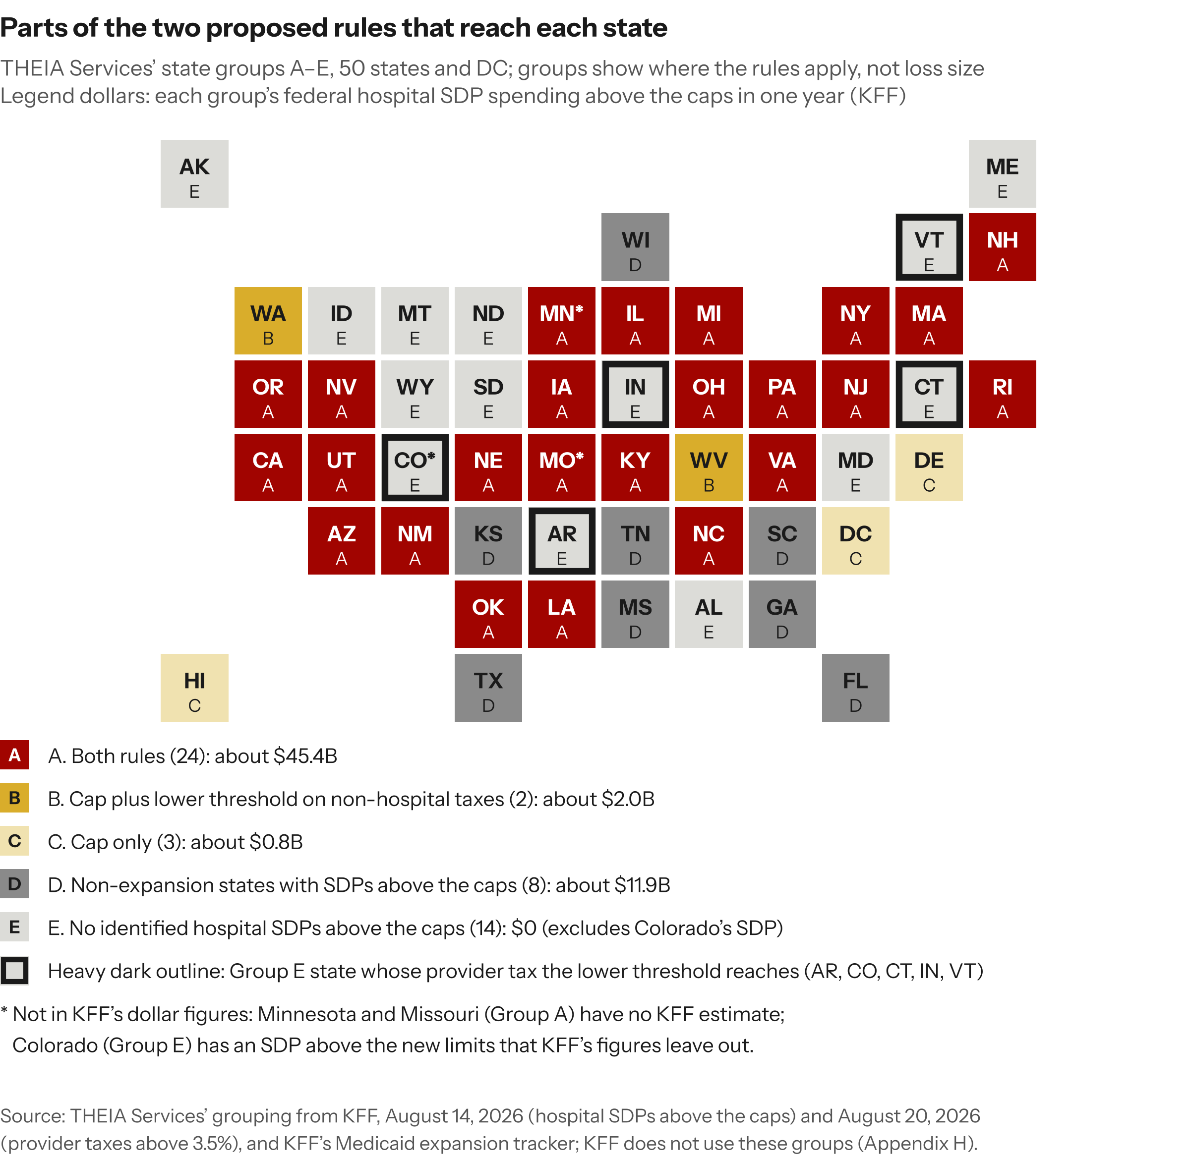
Figure 6. Which parts of the two proposed rules reach each state. The map shows where the rules apply, not where losses would be largest. In Group E the lower threshold reaches Arkansas, Colorado, Connecticut, Indiana and Vermont; the $0 omits a Colorado SDP above the limits.

7. Estimating one hospital’s position
A hospital can estimate its own position with the same three steps, because its own records hold the two figures public data lack: its SDP receipts and its provider tax and IGT payments. [I]

Step 1. SDP revenue at risk
For each SDP program, the hospital adds its base managed care payment and its SDP for each service, compares the total with the cap (100 percent of Medicare in expansion states, 110 percent elsewhere), and treats the SDP amount above the cap as at risk. [I] Grandfathered programs fall by 10 percentage points of Medicare a year until they reach the cap, starting with the state’s first managed care rating period on or after January 1, 2028, while other programs get no phase-down (Section 71116; sec. 1). [E] The hospital’s own records and the state’s documents supply the inputs (Appendix C). [I] Step 1 covers only SDP amounts above the cap; it leaves out cuts that follow lost provider tax revenue, including the share of the provider tax rule’s cut that falls outside SDPs (at least 20 percent under CMS’s 80 percent ceiling; sec. 2), which a hospital should treat as a separate exposure. [I]

Step 2. Lower provider taxes
Step 2 is the drop in the hospital’s own provider tax bill. [I] It is usually zero in non-expansion states, though a tax enacted or raised after July 4, 2025 may fall [I]: CMS says new taxes would in some cases be ineligible to remain in place beyond October 1, 2026 (91 FR 46589). [E] Step 2 is zero for a tax already at or below the threshold. [I] In expansion states, the hospital estimates its bill at each step of the lower threshold, 5.5 percent in federal fiscal year 2028 down to 3.5 percent from 2032, assuming the state lowers the tax to comply; the threshold limits a tax class’s revenue as a share of the class’s net patient revenue, not the hospital’s own rate, so the state’s plan for the tax decides the bill. [I] Until CMS provides each class’s new threshold, which it intends to do by September 30, 2028 (91 FR 46574) [E], the state’s current tax is the starting point. [I] Step 2 is not directly comparable with the national $163.7 billion over 2026–2035, which is measured against a projection without the OBBBA, comes from $198.7 billion in lower collections that include $51.0 billion of tax increases avoided under the freeze, and is what remains after the $35.0 billion CMS assigns to private payers (sec. 3). [I]

Step 3. Less money paid to fund SDPs
Step 3 is the money the hospital might stop paying to fund the state share of SDPs. [I] That money flows through provider taxes or through IGTs a public hospital or its owning local government makes. [I] It depends on a decision the state has not made, so the hospital models three cases: [I]
- The state lowers the tax or transfer as SDPs shrink, maximizing the hospital’s step 3 saving.
- The state keeps collecting the tax for other Medicaid costs, leaving no step 3 saving.
- The state replaces part of the lost SDPs with general revenue or other payment programs, shrinking the step 1 loss. CMS’s 30 percent offset covers only the provider tax rule’s cuts (sec. 3): replacing those cuts beyond 30 percent departs from CMS’s assumption, while replacing SDP payments lost to the cap is relief the national range does not include. [I]
Step 3 must not count a tax cut already counted in step 2. [I] A state’s preprint, the form it submits for CMS’s approval of an SDP, lists funding sources by type and reports IGT dollars by transferring entity but no provider tax dollars (SDP preprint, Section VI). [E] A state hospital association that works with the state on its provider tax program may hold member-level models of the tax and its payment pool. [I]

Questions to ask the state Medicaid agency
- Which SDP programs does the state treat as grandfathered, when does its first managed care rating period on or after January 1, 2028 begin, and how will it calculate each program’s Medicare-rate cap?
- Which provider taxes and IGTs fund each program, and in what amounts?
- Will the state lower provider tax rates as SDPs shrink, keep collecting the taxes for other Medicaid costs, or replace lost SDPs from other sources?
- Will the state redesign or resubmit any program before the cap applies?
The three steps cover only the two rules, leaving out managed care contracting, commercial price changes and the OBBBA’s other Medicaid provisions, including eligibility changes that affect how many Medicaid patients a hospital treats. [I]

8. Services already under strain
Obstetric, pediatric and inpatient psychiatric services were shrinking or shifting before either rule was proposed (studies below) [E], and the rules’ effect on them cannot be predicted from public data because it depends on state budgets, managed care contracts and each hospital’s finances. [I] THEIA Services makes no prediction about closures or service cuts.
- Obstetrics. GAO reported research showing that the number of rural hospitals providing obstetric services fell from 2004 through 2018, and that by 2018 more than half of rural counties had no hospital offering them (GAO-23-105515, October 2022). [E]
- Pediatrics. A national study found that pediatric inpatient units fell 29.9 percent and pediatric beds 19.5 percent from 2008 to 2022, against a 4.4 percent decline in adult units (Michelson et al., December 2024). [E]
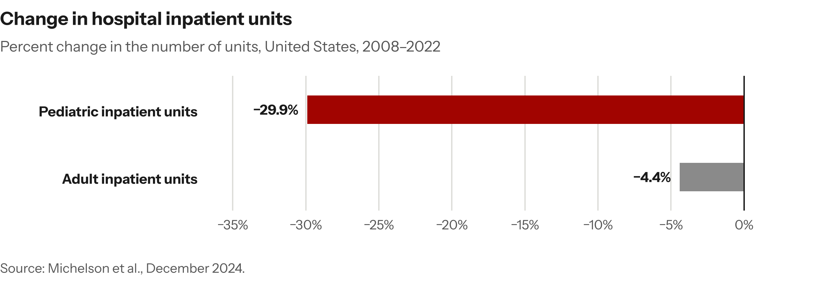
Figure 7. Pediatric inpatient units fell faster than adult units from 2008 to 2022, in one national study.
- Inpatient psychiatry. Psychiatric beds per 100,000 people fell from 11.3 to 9.06 in short-term acute care hospitals and rose from 16.8 to 19.5 in freestanding psychiatric hospitals between 2011 and 2023; the total stayed about flat at 28.1 and 28.4 (Lindenfeld et al., PLoS Medicine, July 2025). [E] The average annual percent change was not significant for any type of bed, although the authors’ regression models show a significant yearly decline in general hospitals’ psychiatric beds. [E]
The direction of the psychiatric estimates matters for adult Medicaid patients, because a freestanding psychiatric hospital with more than 16 beds meets the definition of an institution for mental diseases (IMD; Appendix B). [I] Federal Medicaid payment for IMD patients aged 21 to 64 is restricted by Social Security Act § 1905(a), with an exception for managed care (42 CFR 438.6(e)); the restriction long predates both rules. [E] Where hospitals run obstetric, pediatric or psychiatric services below cost and cover the loss from other revenue, lower SDPs are a plausible pressure point. [C]
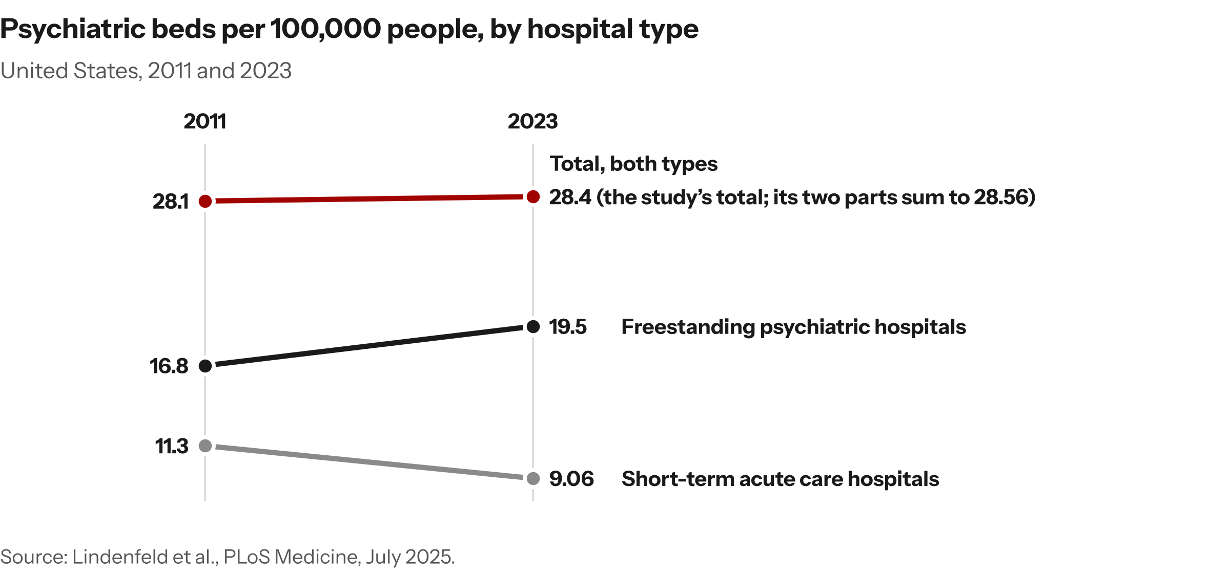
Figure 8. Psychiatric beds per 100,000 people by hospital type, 2011–2023. The combined total was about flat, and the average annual percent change was not significant for any type of bed.

Rural hospitals: a later grandfathering date
The OBBBA gives rural hospitals, as it defines them (Appendix B), until July 4, 2025, rather than May 1, for SDPs approved or sought through a documented good-faith effort, but their grandfathered payments still phase down from 2028 like other hospitals’ (Section 71116; sec. 1). [E]
For critical access, freestanding children’s and certain cancer hospitals, CMS proposes to set the SDP limit from each hospital’s most recent Medicare cost report; a default to the state plan rate was an alternative it did not propose (91 FR 30414). [E] Virginia’s Medicaid agency urged CMS not to default payment limits to state plan rates for services without a Medicare equivalent (comment CMS-2026-1916-0755, p. 3). [E] THEIA Services does not assess whether rural hospitals are less able to absorb these changes; the studies cited track services, not hospital finances. [I]

9. What to watch

Events that would change CMS’s estimates or the rules
- A final rule with a revised Regulatory Impact Analysis, especially any change to CMS’s 65 percent tax-financed assumption, which sets the size of the overlap between the rules, or to its assumed price ratios. [I]
- CMS’s analysis of how the two rules interact, which the SDP rule defers to future rulemaking (91 FR 30453) [E] and the provider tax rule partly supplies. [I]
- Either rule’s arrival for White House review, shown on reginfo.gov [E], which signals that a final rule is near. [I]
- Publication of CMS-2450, a separate proposed rule under White House review since May 12, 2026, whose agenda entry states an intent to revise or rescind parts of CMS’s 2024 managed care rule, including SDP requirements. [E]
- CMS approvals or renewals of individual SDPs under current rules, which can bring financing effects forward before either rule is final: in September 2026, one state’s SDP programs lapsed at the start of its fiscal year during a dispute over its provider tax calculation, and CMS authorized them about two weeks later (Texas Tribune, September 17, 2026). [E]
- Further rulings in Texas v. CMS, 805 F. Supp. 3d 734 (E.D. Tex. 2025), which the Children’s Hospital Association of Texas describes as a permanent injunction against CMS’s hold harmless test for Texas’s local provider participation funds (comment CMS-2026-2476-0114, pp. 13–14); the association says CMS has appealed (p. 14). [E]
- Lawsuits or congressional action: as of [DATE], THEIA Services located no lawsuit challenging either rule [I], and two July 2025 bills to repeal the underlying provisions had not advanced beyond committee referral (Appendix I). [E]

Events that would show who bears the cuts
- Interim provider tax data for the state fiscal year that contains July 4, 2025, which states would file by December 31, 2026 and from which CMS would calculate an interim threshold for state planning (91 FR 46583). [E] Final data are due June 30, 2028, and CMS intends to give states each permissible class’s new threshold no later than September 30, 2028 (91 FR 46574). [E]
- Any published analysis linking SDPs to the hospitals that receive them; THEIA Services located no nationally standardized public dataset that makes that link (Appendix C). [I]
- Any multi-state estimate that subtracts lower provider taxes from payment cuts for both rules over the same years; at least one state hospital association has published paired gross and net figures (Appendix F) [E], but THEIA Services found no multi-state version. [I]
- State legislative and budget decisions on the lower threshold, which decide whether states absorb the cuts, replace the lost money or pass the cuts on to providers. [C]

Appendix

A. How to read this note
Evidence tags. Each claim carries one tag. [E] means the claim is stated in a cited public document. [I] means it is THEIA Services’ arithmetic or reading, including the results of its own searches (“THEIA Services found no …”). [C] means it depends on facts not yet public.
Citations. “91 FR” pages are Federal Register pages. The SDP rule, CMS-2449-P, runs from 91 FR 30400 to 30466; the provider tax rule, CMS-2452-P, from 91 FR 46562 to 46599. Each rule numbers its own tables, so this note names the rule wherever two tables share a number (Appendix E). Comment IDs beginning CMS-2026-1916 are comments on the SDP rule; those beginning CMS-2026-2476 are comments on the provider tax rule. Comment counts give both docket views (Appendix I). Quotations are verbatim, 24 words or fewer, and at most one per source.
Evidence ledger. THEIA Services keeps an evidence ledger that records each claim, its source and pinpoint, and whether the source was re-read. Its flagged rows were checked against their primary sources on October 13 and 14, 2026. Where a source could not be found, this note either says so or leaves the claim out.

B. Terms
State directed payments (SDPs). Extra payments a state requires its Medicaid managed care plans to make to particular providers (42 CFR 438.6(c)(1)). [E] A state asks CMS to approve an SDP on a form called a preprint, and a rating period is the period for which a state sets its plans’ payment rates. [I] A grandfathered SDP is one approved, or sought through a documented good-faith effort, before May 1, 2025 (by July 4, 2025 for rural hospitals); it may stay above the cap until it is phased down (sec. 1). [E]
Expansion states. States that cover low-income adults under Social Security Act § 1902(a)(10)(A)(i)(VIII). [E]
Intergovernmental transfers (IGTs). Funds transferred from or certified by units of government within a state as the non-federal share of Medicaid spending (Social Security Act § 1903(w)(6)(A)). [E]
Provider taxes. Taxes states levy on providers to fund part of their Medicaid share. CMS projects $98.6 billion in calendar year 2026, about 26 percent of the roughly $376 billion states will spend on Medicaid medical assistance: hospitals $61.8 billion, managed care organizations $28.1 billion, nursing and intermediate care facilities $7.3 billion, and all other providers $1.4 billion (Table 4, 91 FR 46589). [E] Of the $198.7 billion fall in collections over 2026–2035, $51.0 billion comes from the freeze and $147.7 billion from the lower threshold (Tables 6–8, 91 FR 46589–46590). [E] A permissible class is a category of items or services a state may tax, and CMS intends to give each state a threshold for each class (91 FR 46574). [E]
Hold harmless and the 75/75 test. Federal law bars a state from guaranteeing to hold taxpayers harmless for their tax (Social Security Act § 1903(w)(4)(C)(i); 42 CFR 433.68(f)(3)). [E] Under the 75/75 test, a tax above the threshold is also a hold harmless if, in the aggregate, 75 percent of taxpayers get back 75 percent or more of their tax in enhanced Medicaid payments or other state payments (91 FR 46564). [E] A tax that fails costs the state federal matching funds, because CMS deducts the non-qualifying revenue from the state’s Medicaid spending before it calculates the federal match (42 CFR 433.70(b)). [E]
Threshold and freeze. The threshold is the most a tax may raise as a share of the taxed class’s net patient revenue; the OBBBA lowers it in expansion states from federal fiscal year 2028, and the freeze holds provider taxes in every state at their July 4, 2025 levels (sec. 1). [E] Taxes on nursing facilities and on intermediate care facilities for people with intellectual disabilities are exempt from the lower threshold (P.L. 119-21, § 71115(a)(2), 139 Stat. 302). [E]
Central, low-savings and high-savings estimates. CMS’s primary scenario and its two alternative scenarios for each rule (sec. 3; Appendix D). [E] The overlap is the part of the provider tax rule’s cut that CMS counts in the SDP rule’s estimate, $241.9 billion in the central estimate (91 FR 46592). [E] This note calls CMS’s adjustment for that overlap the interaction. [I]
Federal fiscal year. October 1 to September 30, named for the year in which it ends (31 U.S.C. 1102). [E]
Institutions for mental diseases (IMDs). Facilities of more than 16 beds primarily engaged in caring for people with mental diseases (Social Security Act § 1905(i)). [E] Federal Medicaid payment for IMD patients aged 21 to 64 is restricted by § 1905(a), which reaches patients under 65 but excepts inpatient psychiatric care for those under 21 (§ 1905(a)(16)). [E] The managed care exception for enrollees aged 21–64 is at 42 CFR 438.6(e), and section 1115 demonstrations for substance use disorder treatment provide a further exception (81 FR 27562). [E] THEIA Services found no source for the share of freestanding psychiatric hospitals that are IMDs, so sec. 8 relies on the definition alone. [I]
Rural hospitals. For the later grandfathering date, the OBBBA counts rural acute care hospitals paid under Medicare’s inpatient prospective payment system, and critical access, sole community, Medicare-dependent small rural, low-volume and rural emergency hospitals (P.L. 119-21, § 71116(d)(2), 139 Stat. 304). [E]

C. Limits of the analysis and the five data gaps
Five gaps in public data stand between a state’s exposure and a hospital’s loss. [I]
- Which hospitals receive which SDPs. THEIA Services located no nationally standardized public dataset that links SDPs to the facilities that receive them. [I] This is the facility-level limit: national and state figures cannot be divided among hospitals. [I]
- What each hospital pays in provider taxes and IGTs. Neither Regulatory Impact Analysis, nor the CMS-64 and MACPAC materials THEIA Services reviewed, publishes provider tax payments by facility. [I] The net provider figure is a payment cut less a tax cut, and neither part can be observed hospital by hospital. [I]
- How states fund SDPs, in dollars. THEIA Services located no current public source giving SDP financing in dollars by source and by state. [I] The Government Accountability Office’s state figures for SDPs approved as of August 26, 2022 give provider taxes and IGTs as one combined amount, because states do not report the amount from each source, and GAO says the amount is undercounted (GAO-24-106202, December 2023, app. III, Table 4, pp. 44–46). [E] For SDPs projected above 100 percent of Medicare, CMS reports that 39.8 percent were funded partly or wholly by IGTs but not provider taxes, 26.9 percent by provider taxes but not IGTs, and 14.2 percent by both, based on its June 2025 analysis of 402 SDPs it approved from 2022 through 2024 (91 FR 30410 and footnote 40). [E] CMS does not say whether these shares count SDPs or dollars. [I] The SDP preprint’s financing section asks states to check off funding sources and to report IGT dollars by transferring entity, but asks for no provider tax dollars (CMS, 42 CFR 438.6(c) preprint, January 2021, Section VI, questions 34–36). [E] This gap is why the headline is a range (sec. 4). [I]
- Each state’s binding threshold. States would file interim provider tax data by December 31, 2026, from which CMS would calculate an interim threshold for planning (91 FR 46583), and CMS intends to provide each state’s threshold for each permissible class no later than September 30, 2028 (91 FR 46574). [E] Until then the threshold that binds a given state and class is not public. [I]
- CMS’s price ratios. THEIA Services did not check CMS’s commercial-to-Medicare and Medicaid-to-Medicare ratios, which the SDP rule varies across scenarios that run from $408.4 billion to $989.7 billion (Appendix D). [I] Public commercial price sources exist, notably hospital price transparency files and RAND’s studies of employer-plan hospital prices, and were not searched. [I]
Other limits. The note gives no nominal-dollar or annual view of CMS’s figures and no estimate of effects on commercial prices or uncompensated care. [I] CMS’s figures are in 2026 dollars, and CMS assigns $35.0 billion of the lower provider taxes to private payers (Table 8, 91 FR 46590). [E] The provider tax rule’s full posted comment record was read for the figures and claims in sec. 5 (Appendix I). [I]
Section 71117. This section adds a statutory test of when a tax that a waiver exempts from the uniformity or broad-based requirement is not generally redistributive, and the final rule CMS-2448-F implements it (91 FR 4794, 4800, 4808). [E] CMS lists it as an interaction its provider tax estimates take into account (91 FR 46590 n. 23, 46592). [E]
Inputs for a hospital’s estimate (sec. 7). Managed care remittances show what the hospital receives. [I] The state’s approved preprint shows each program’s design and funding sources, and the state’s managed care contracts show when rating periods begin. [I]

D. Scenario detail
Parameters. The provider tax rule’s low-savings estimate assumes 75 percent of SDPs are tax-financed, up to 90 percent of the cut falls on SDPs and states offset 40 percent of the cut (91 FR 46594). [E] The high-savings estimate assumes 55 percent, up to 70 percent and 20 percent (91 FR 46593). [E] Each scenario also changes the share of provider taxes Medicaid pays (91 FR 46593–46594). [E] Other things equal, a higher tax-financed share means more overlap and a lower share less, but because the scenarios move all three assumptions together, CMS’s figures do not isolate the effect of any one. [I] CMS draws its range from preprint data: about 38 percent of SDPs financed with provider taxes and a further 37 percent financed with provider taxes and at least one other source (91 FR 46592). [E] The 75 percent upper end is 38 plus 37; CMS does not explain the 55 percent lower end or the 65 percent central value. [I]
For the SDP rule, commercial insurers pay 1.89 times Medicare for inpatient care in the central estimate, 1.37 times in the low-savings estimate and 2.55 times in the high-savings estimate (Tables 14–16, 91 FR 30449–30450). [E] The SDP rule’s low-savings and high-savings totals are $408.4 billion and $989.7 billion (91 FR 30453–30454). [E] CMS says the high-savings total includes the additional services the rule would limit (91 FR 30454), while its central tables cover Section 71116 (91 FR 30451–30452). [E] THEIA Services has not confirmed that the scenarios’ scopes match. [I]
The provider tax rule’s net provider figures. Measured alone, CMS’s net figures for providers are −$135.0 billion (low-savings), −$220.3 billion (central) and −$316.5 billion (high-savings); after the SDP rule’s cuts, they are +$149.6 billion, +$21.7 billion and −$136.1 billion (91 FR 46592–46594). [E] Differencing these series gives overlaps of about $285 billion in the low-savings estimate and about $180 billion in the high-savings estimate, against CMS’s $241.9 billion in the central estimate; CMS prints no overlap for the other scenarios. [I] The central +$21.7 billion is front-loaded: about +$24.3 billion over 2026–2031 and −$2.7 billion over 2032–2035 (Table 14, 91 FR 46593). [I]
The range under the other estimates. Cells are CMS’s [E]; sums are THEIA Services’ [I].
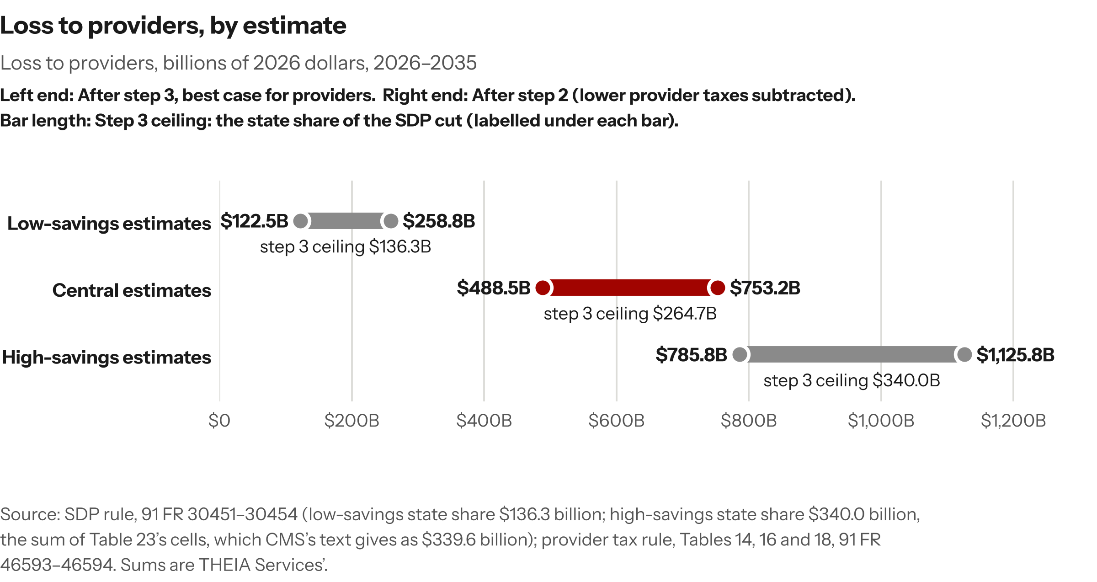
Figure 9. Loss to providers, billions of 2026 dollars, 2026–2035: Low-savings estimates; Central estimates; High-savings estimates.
Source: SDP rule, 91 FR 30451–30454 (low-savings state share $136.3 billion; high-savings state share $340.0 billion, the sum of Table 23’s cells, which CMS’s text gives as $339.6 billion); provider tax rule, Tables 14, 16 and 18, 91 FR 46593–46594. Sums are THEIA Services’.
CMS does not say how the two rules’ estimates pair; pairing low with low and high with high is THEIA Services’ choice. [I]
How readers restate the 65 percent. One commenter describes it as a share of SDP spending (comment CMS-2026-2476-0204, p. 10). [E] CMS states the 65 percent as a share of SDPs and its 55 to 75 percent range as a share of SDP spending (91 FR 46592). [E]

E. CMS printing errors, citation traps and rounding
Text against tables. The SDP rule’s text gives the central state reduction as $264.4 billion, while Table 20’s annual figures sum to $264.7 billion (91 FR 30452); its text gives the high-savings state reduction as $339.6 billion, while Table 23’s cells sum to $340.0 billion. [E] Where CMS’s text and tables differ, this note uses the table sums. [I] Some commenters repeat the $264.4 billion (comments CMS-2026-1916-0417, p. 6; -0509, p. 38; -0648, p. 3). [E]
Rounding. CMS reports +$21.7 billion for the provider tax rule after the SDP rule’s cuts (Table 14, 91 FR 46593). [E] $163.7 billion less $142.1 billion is $21.6 billion; the difference is rounding in CMS’s components. [I]
Two Tables 19. CMS-2449-P’s Table 19 (91 FR 30452) gives the SDP rule’s annual federal figures; CMS-2452-P’s Table 19 (91 FR 46596) is the provider tax rule’s accounting statement. [E]
Other printing errors. The provider tax rule misprints the SDP rule’s docket number as CMS-2249-P in footnote 27 (91 FR 46592), and its Table 5 caption transposes two letters of the WFTC acronym (91 FR 46589). [E]
The four-party Tables 12 and 14. Each table shows the provider tax rule’s effect on four parties: the federal government, states, providers and private payers. [E] Measured alone (Table 12): federal +$245.8 billion, states −$60.5 billion, providers −$220.3 billion, private payers +$35.0 billion. [E] After the SDP rule’s cuts (Table 14): +$90.9 billion, −$147.5 billion, +$21.7 billion and +$35.0 billion (91 FR 46592–46593). [E] Each table’s rows sum to about zero, because the effects are transfers among the four parties. [I]
How commenters read these figures. Some present CMS’s figures after counting the SDP rule first as the provider tax rule’s own effect, such as $90.9 billion in federal spending and, from the high-savings estimate, a $136.1 billion provider loss (comments CMS-2026-2476-0145, pp. 3–4; -0093, p. 8). [E] One national payer group appears to describe the $154.9 billion federal overlap as the reduction left after the SDP rule (comment CMS-2026-2476-0101, p. 1), and another gives CMS’s federal range without its high-savings estimate (comment CMS-2026-2476-0091, p. 27). [I]

F. Congressional Budget Office and CMS comparison detail
CBO’s two measures. CBO’s outlay estimates are in its July 21, 2025 Table 7 (Title VII sheet), by fiscal year, 2025–2034: Section 71115, $191.1 billion; Section 71116, $149.4 billion. [E] Their sum, $340.5 billion, is THEIA Services’ arithmetic; CBO does not print it. [I] CBO’s October 28, 2025 estimate gives Section 71115 on the deficit measure instead: $182.7 billion, which equals its outlay reduction less an $8.4 billion revenue loss (October 28, 2025, p. 5; Table 7). [E] CBO prints Section 71116 only as an outlay figure, and Table 7 lists no revenue effect for it. [E] Adding Section 71115’s $182.7 billion deficit figure to Section 71116’s $149.4 billion outlay figure gives $332.1 billion, a total CBO does not print. [I] This note compares outlays only and never sets one measure against the other. [I] Neither CBO file states a dollar year for these figures. [I]
How CBO handles interactions. CBO reports Sections 71115 and 71116 one at a time (October 28, 2025, pp. 4–5) and puts the remaining Medicaid policies and all interactions among the chapter’s policies in one separate line (p. 6); Table 7 shows interactions for the health subtitle as their own row and prints no figure for the interaction between the two sections. [E] CBO does not say in words that each section figure excludes that interaction; the reading rests on the layout. [I]
The federal reconciliation on CMS’s tables. All [I]:
CMS federal figure | 2026–2035 | 2026–2034 (2035 dropped)
Without the interaction: $510.1B (91 FR 30451) + $245.8B (Table 11, 91 FR 46591) | $755.9B | $630.9B (less $80.6B, CMS-2449-P Table 19, and $44.4B, CMS-2452-P Table 11)
With the interaction: $510.1B + $90.9B (Table 14, 91 FR 46593) | $601.0B | $501.5B (less $80.6B and $18.9B)
The $630.9 billion is the total without the interaction after dropping 2035. [I] Both columns are set against the $340.5 billion sum of CBO’s two section figures for 2025–2034; the with-interaction figures have no CBO counterpart. [I] Table 11’s annual federal row sums to $245.9 billion against CMS’s stated $245.8 billion. [I] CMS states its figures in 2026 dollars and gives no conversion (91 FR 30451, 46591). [E] CBO’s tables state no dollar year, so the direction of the dollar-basis difference is not established. [I]
Year basis. CMS does not say whether its 2026–2035 are federal fiscal years, state fiscal years or calendar years. [I] The SDP rule labels its year columns in Tables 18–20 as fiscal years without saying federal or state (91 FR 30451–30452), and its one-year base is federal fiscal year 2025 (91 FR 30447); the provider tax rule gives its $98.6 billion for calendar year 2026 and says its freeze, which begins October 1, 2026, reduces projected revenue in 2026 (91 FR 46589). [E] A freeze starting October 1, 2026 could not reduce revenue in federal fiscal year 2026, so the provider tax rule’s 2026 is probably not a federal fiscal year. [I] Neither rule says whether the two bases match, so the windows THEIA Services adds may be offset by a few months, and CBO’s are federal fiscal years. [I]
Coverage. CBO expects Section 71115 to add 1.1 million people to the uninsured in 2034 and Section 71116 to add none (October 28, 2025, p. 5), while CMS assumes the provider tax rule has no effect on enrollment (91 FR 46590). [E] The sources do not show which way this difference moves the comparison, so the note does not list it as a cause. [I]
CBPP’s comparison. The Center on Budget and Policy Priorities, which opposes the provider tax rule, compared CMS’s $601 billion with $341 billion (comment CMS-2026-2476-0033, p. 9, footnote 23). [E] The $341 billion matches the $340.5 billion sum of CBO’s two section figures, rounded. [I] CBPP reasoned that adjusting for the interaction and the dollar basis would raise CMS’s figure, so a large gap would remain, and gave no adjusted figures (same footnote). [E]
How commenters cite CBO. Commenters cite CBO’s Section 71115 estimate on both measures, $191.1 billion in outlays and about $183 billion, under different labels, and one state agency gives the two as a range (comments CMS-2026-2476-0201, p. 1; -0029, p. 1; -0097, -0187 and -0195, one campaign; -0126; -0089). [E] The $183 billion matches CBO’s $182.7 billion deficit figure. [I] In the SDP rule’s docket, about 120 comments (about 90 distinct texts) cite CMS’s $510 billion and about 90 (about 60 distinct texts) cite CBO’s $149.4 billion, often side by side, in both docket views (keyword counts; for example, comments CMS-2026-1916-0902, -0128 and -0756). [I] A group supporting the provider tax rule likewise carries ASPE’s statute-level estimates into that rule’s record (comment CMS-2026-2476-0130, p. 2). [E]
ASPE and CMS’s actuaries. ASPE notes that its federal savings estimate for the combined effect of the provider tax and SDP provisions is about the size of the SDP effect alone, $510 billion, as estimated by CMS’s Office of the Actuary (ASPE, August 12, 2026, p. 11). [E]
Who nets provider taxes. CMS’s provider tax rule nets tax relief against payment cuts, and the Texas Hospital Association published paired gross and net figures in April 2025. [E] The cap test compares an SDP’s total payment rate, base payment plus SDP, with the Medicare-based cap (sec. 7, step 1); netting provider taxes there changes the rate tested, not the net provider loss this note computes. [I] The Federation of American Hospitals asked CMS to count the provider taxes that partly fund SDPs when it calculates that rate (comment CMS-2026-1916-0676, p. 2), as did the American Hospital Association, South Carolina’s Medicaid agency and several template letters (about 12 comments, about 9 distinct texts, in both docket views, keyword count; comments CMS-2026-1916-0928, p. 11; -0923, p. 3; templates including -0369, -0476, -0808, -0437, -0424 and -0787). [I]

G. Sources searched for the $681 billion figure
Before September 22, 2026. THEIA Services searched the public records of the American Hospital Association, the Federation of American Hospitals, America’s Essential Hospitals, the Association of American Medical Colleges and the Children’s Hospital Association; the July 21, 2026 comment letters of eight named organizations on the SDP rule; and publications after August 15, 2026 from Manatt, Sellers Dorsey, Wakely, Health Management Associates and Milliman. [I] It found no independent derivation of $681 billion before September 2, 2026. [I] It did not search member-only or subscription publications. [I]
The comment records. The full text of every comment posted on regulations.gov for both rules as of October 7, 2026, attachments and scanned text included, holds one use of $681 billion, an individual’s, which restates POLITICO’s figure as a hospital loss with no source or derivation (comment CMS-2026-2476-0079; one comment, one distinct text, in both docket views). [I] Five letters for the September 21, 2026 deadline that THEIA Services had looked for on submitters’ sites are now posted (comments CMS-2026-2476-0148, -0116, -0109, -0057 and -0173). [E] It had not located the first four, from the Children’s Hospital Association, the National Association of Medicaid Directors, the Texas Hospital Association and the California Hospital Association; it had read MACPAC’s on MACPAC’s site. [I] THEIA Services found the figure in none of them. [I] The Illinois Attorney General, whose letter it had also looked for, co-signed a multistate attorneys general letter posted with a blank organization field (comment CMS-2026-2476-0140, p. 10) [E], which does not contain the figure either. [I] Matching by organization name, THEIA Services found no letter from the Illinois Health and Hospital Association in the posted docket. [I]
Limits. The comment record is a snapshot. [I] Text search of scanned pages can miss figures printed as images. [I] Letters published only on submitters’ sites are not in the docket, and letters were matched by organization name, so a letter filed with a blank organization field could be missed. [I]

H. State group definitions and KFF data
The groups. THEIA Services sorts the 50 states and DC by expansion status (KFF’s expansion tracker), by whether KFF finds hospital SDPs above the new caps (KFF, August 14, 2026) and by whether KFF finds a non-exempt provider tax above 3.5 percent (KFF, August 20, 2026). [I]
- A. Expansion states with hospital SDPs above the caps and a hospital tax above 3.5 percent: 24 states, about $45.4 billion of one year’s federal hospital SDP spending above the caps. [I] Minnesota and Missouri belong here but have no KFF estimate. [I]
- B. Expansion states with hospital SDPs above the caps and a non-exempt tax above 3.5 percent on ambulances or another non-hospital class, but no hospital tax above it: Washington and West Virginia, about $2.0 billion. [I]
- C. Expansion states with hospital SDPs above the caps and no non-exempt tax above 3.5 percent: DC, Delaware and Hawaii, about $0.8 billion. [I]
- D. Non-expansion states with hospital SDPs above the caps: Florida, Georgia, Kansas, Mississippi, South Carolina, Tennessee, Texas and Wisconsin, about $11.9 billion. [I]
- E. The 14 other states, with no hospital SDPs above the caps in KFF’s figures. [I] Five are expansion states the lower threshold reaches: Arkansas through an ambulance tax, and Colorado, Connecticut, Indiana and Vermont through hospital taxes. [I]
The groups cover 51 jurisdictions and about $60.1 billion, and KFF does not use them; rebuilt from KFF’s chart data, the group totals are $45.43 billion, $1.96 billion, $0.80 billion, $11.91 billion and $0. [I]
What KFF’s data do and do not show. KFF imputed missing payment rates in 15 states, three of them in Group D (Georgia, Texas and Wisconsin), and had complete payment rate data from the preprints for the rest (KFF, August 14, 2026, Methods). [E] KFF publishes no other state-level data-quality labels. [I] Florida, Kansas and Mississippi did not answer KFF’s 2025 provider tax survey (KFF, August 20, 2026). [E] Alabama and Wyoming have no Medicaid managed care on KFF’s map (KFF, August 14, 2026) [E], so they have no SDPs. [I] Colorado has an SDP above the new limits that KFF leaves out because CMS did not post its preprint until after July 20, 2026 (KFF, August 14, 2026, Figure 1 note) [E], so Group E’s $0 understates Colorado. [I]
State figures. The share of hospital SDP spending above the caps ranges from 9 percent in New Hampshire to 100 percent in Louisiana and DC, and is at least 70 percent in 27 states (KFF, August 14, 2026). [E] Texas has $3.5 billion above the caps, and Tennessee, Georgia and South Carolina more than $1.6 billion each (KFF, August 14, 2026). [E]

I. Status as of [DATE]
White House review. Neither proposed rule was under review at the White House Office of Information and Regulatory Affairs as of [DATE] (reginfo.gov). [E] CMS-2450 (RIN 0938-AV70) has been under review since May 12, 2026 (reginfo.gov). [E]
Dates and bills. CMS published the SDP rule on May 22, 2026 (91 FR 30400) and the provider tax rule on July 23, 2026 (91 FR 46562); comments closed on July 21 and September 21, 2026 (regulations.gov). [E] The repeal bills are S. 2279 (Sections 71115 and 71116) and H.R. 4807 (Section 71115). [E] Neither had advanced beyond committee referral as of [DATE] (govinfo bill status). [E]
Comment counts. Comments posted on regulations.gov, collected October 7, 2026: CMS-2449-P (docket CMS-2026-1916), 960 as filed / 961 corrected (660 distinct texts in both views); CMS-2452-P (docket CMS-2026-2476), 214 as filed / 213 corrected (188 / 187 distinct texts). [I] The corrected view moves one letter, CMS-2026-2476-0199, which is the same text as CMS-2026-1916-0958 and concerns the SDP rule. [E] The Federal Register’s records for the two rules give 6,344 and 245 comments, last refreshed from regulations.gov on September 4 and September 24, 2026, and do not say what they count. [E] The Federal Register gives one count per docket, with no corrected view, and its counts are a separate measure from the posted counts; neither is compared across dockets in this note. [I] Counts cover all comments unless they say distinct texts; keyword counts are approximate. [I]
The legal record. Comments in both dockets set out arguments a legal challenge could use; one SDP-rule comment, for example, says CMS has exceeded its statutory authority (comment CMS-2026-1916-0407, p. 1). [E] Loper Bright is cited in about 40 comments (about 20 distinct texts) on the SDP rule and about 11 (about 9 distinct texts) on the provider tax rule, in both docket views (keyword counts; for example, comment CMS-2026-1916-0288, p. 2). [I] No comment reports a filed suit against either rule. [I]
A state preprint. CMS’s questions on Texas’s state fiscal year 2027 CHIRP preprint, sent September 3, 2026, list two financing issues to be resolved before approval: multi-jurisdictional provider participation districts, and an assessment base combining inpatient and outpatient revenue (Texas Health and Human Services Commission, Round 4, p. 17 of 19). [E]

J. Disclaimer and About THEIA Services
Disclaimer. This note describes proposed rules and published estimates. Both rules can change before they are final, and THEIA Services takes no position on whether either is good policy.
About THEIA Services. THEIA Services estimates hospital-specific positions under the two rules.

