NYC Obesity Total Impacts

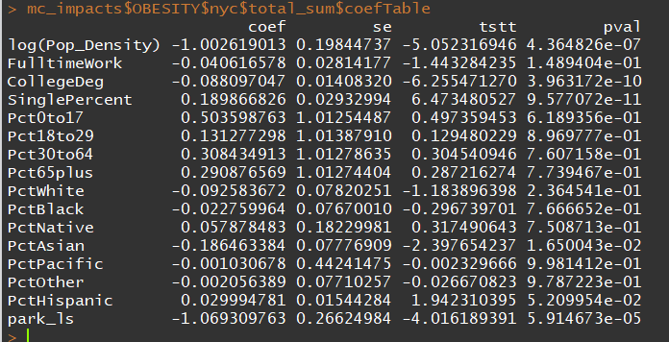

NYC Physical Activity (Sedentariness) Total Impacts

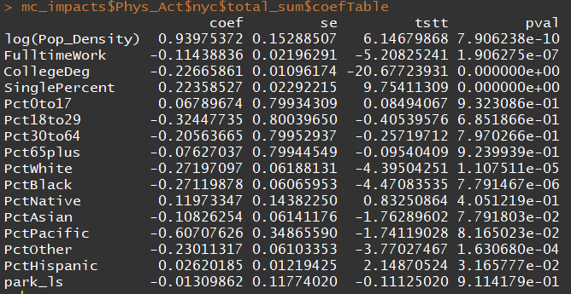

Denver Physical Activity (Sedentariness) Total Impacts

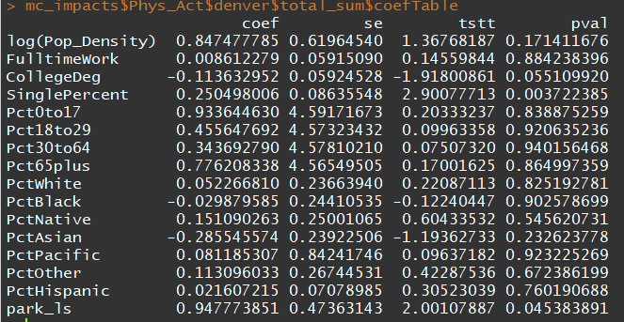

Denver Obesity Total Impacts

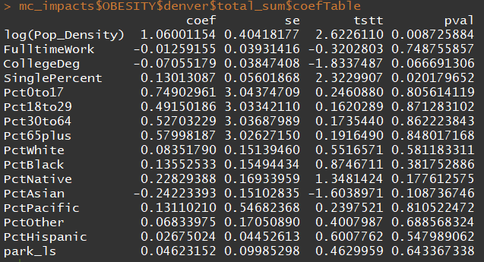

Boston Obesity Total Impacts

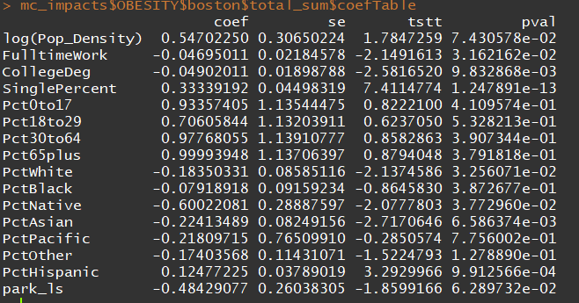

Boston Physical Activity

