Tuning R0­ to death data between 1st March and 1st April, since the surge in cases appears to start around March, and control measures were introduced in early April. I make the following assumptions:

1. Number of infectious on 1st March
   * The mean reported daily infectious in Dhaka (based on 62% cases being in dhaka) over the four days leading up to and including 1st March was 286
   * This may be around 10% of the true number of daily cases
   * Since individuals stay infectious for more than a day the total infectious on 1st March will be higher than 286*10. I assumed 4 times higher, since we expect infectiousness for around 8 days and for individuals to be on average 4 days in (so will already have used up around half of infectiousness).
   * This leads to an estimate of 11451 infectious on 1st March (but also considered 50% higher and lower than this; 5726 to 17177)
2. Number incubating on 1st March
   * I assumed that there are the same number of individuals incubating as infectious on 1st March
3. I looked at initial immunities of 0% (worst case scenario) and 50% (best case scenario)
4. Distribution of cases and immune individuals among households:
   * I assumed that every infectious individual is in a different household from every other infectious individual
   * I assumed that half of incubating individuals are in the same household as an infectious, and that the other half were in non-infectious households
   * Immune individuals are randomly distributed among households

Estimates of R0 for different numbers of infecteds and percentage immune are as follows:

|  |  |  |
| --- | --- | --- |
| **Initial infected** | **Immunity (%)** | **R0** |
| 5726 | 0 | 3.3 |
| 11451 | 0 | 2.7 |
| 17177 | 0 | 2.3 |
| 5726 | 25 | 4.4 |
| 11451 | 25 | 3.5 |
| 17177 | 25 | 3.0 |
| 5726 | 50 | 6.5 |
| 11451 | 50 | 5.2 |
| 17177 | 50 | 4.3 |

Values range from 2.3-6.5 with best guess being around 3.5.

Plot for the highlighted intermediate scenario, illustrating match between model and data:

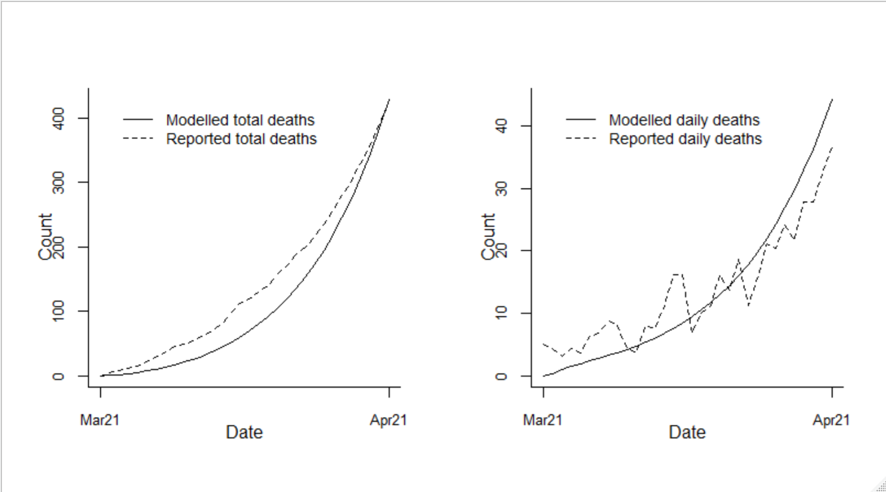

R0 estimates are based on the cumulative deaths match between model and data on 1st April. Note the resulting fit to the whole cumulative death curve looks better for the largest number of initial infecteds – e.g. with 25% immune:

