# Potential impact and cost-effectiveness of interventions to mitigate COVID-19 in Bangladesh

### Summary Report 29 June 2020

* Since the introduction of SARS-CoV-2 to Bangladesh, the disease has spread widely. Lockdown measures, introduced in late March and extended beyond EID, reduced transmission and delayed the epidemic. However, sustaining physical distancing is not considered feasible in Bangladesh given the large precarious population and risks of food insecurity.
* Relaxing lockdown is expected to lead to rapid epidemic growth that will overwhelm the health system, causing thousands of deaths and billions of dollars in healthcare costs across Greater Dhaka over the next quarter unless aggressive interventions are pursued.
* We find that two interventions 1) syndromic surveillance by *community support teams* (CST) to assist early isolation and quarantine of people showing signs of illness together with those in their household; and 2) mandatory use of *face masks* in public places to minimize the spread of infection, could in combination be extremely beneficial in limiting the health and economic consequences of COVID-19 in Bangladesh.
* CSTs and face masks each have potential to prevent between 20,000 to 40,000 deaths over the next year in Greater Dhaka depending upon their implementation and community-wide adherence. When deployed together, they could act synergistically in preventing over 70,000 deaths compared to the unmitigated epidemic.
* These public health interventions are relatively low cost ($3 million USD to maintain CST across Greater Dhaka for six months and reusable cloth face masks cost approximately $1.2 each). Their widespread implementation is predicted to be extremely cost-effective, saving around $9,000 USD for *each* death averted versus an unmitigated epidemic, with a 1,500% return on investment in CST and free mask provision, in addition to the thousands of lives saved.
* Our estimates of their impacts have considerable uncertainty associated with the feasibility, uptake and efficacy of these interventions, that depend critically on local development and implementation. However, the large community-based health worker network in Bangladesh, capacity for mass production of face masks and pilot testing all indicate the clear potential of these interventions to reduce the catastrophic impacts of the epidemic and suggest that rapid roll out is warranted.

**Background**

The COVID-19 pandemic has caused hundreds of thousands of deaths in high-income countries (HICs) around the world and is now posing a severe threat to Low- and Middle-Income Countries (LMICs). Interventions that have been developed and applied in many high-income countries are not suitable in the context of many LMICs. For example, interventions such as lockdown, rapidly exacerbate poverty, particularly for day laborers, with catastrophic consequences for food security, while others such as physical distancing are not practical in crowded informal settlements. More high-tech strategies like app-based and laboratory-supported contact tracing may not easily translate to settings with more limited infrastructure (e.g. poor smartphone penetration) and capabilities (e.g. lab testing, biosafety, and information management capacity). More generally, the wider social and economic consequences of interventions trade off against their impact on controlling disease. Hence, there is an urgent need for the development and implementation of contextually appropriate interventions that take into account the needs of the population that they target. We investigated the potential impact of contextually appropriate non-pharmaceutical intervention strategies to mitigate the consequences of COVID-19 in Bangladesh.

**Methods**

We developed a deterministic SEIR model, with compartments for progressive severity of disease including pre- and asymptomatic infection. The model was initially developed as an interactive epidemiological teaching tool to explore interventions, parameters and uncertainty (<https://rabies.shinyapps.io/Dhaka_covid19/> ). We used a simplified non-age structured model, given the high degree of intergenerational mixing in Bangladesh, and we implemented a range of interventions within this model based on discussions with policy-makers and stakeholders. We calibrated our model against time-varying estimates of Rt inferred from reported COVID-19 deaths (<https://mrc-ide.github.io/global-lmic-reports/BGD/>). Death data was taken from the European Centre for Disease Prevention and Control public repository (<https://opendata.ecdc.europa.eu>). The model is written in R and accessible from our Github repository.

In our calibrated model we assumed the first imported case in Dhaka occured on February 6th and that lockdown began from March 26th. We reduced the initial Rt from approximately 2.8 to 1.2, under lockdown assuming that transmission outside of households was reduced by 95% for those adhering to physical distancing measures, but that secondary attack rates within households were unchanged. We assumed that 5% of the population were exempt from lockdown and were required to continue their work outside their household, and a further ten percent of the population was noncompliant with lockdown. We also assumed that over time adherence to these physical distancing measures declined at a rate of 0.025, with lockdown extending beyond EID (May 29th) and activity beginning to resume in June. We apply our model to the Greater Metropolitan Area of Dhaka which has a population of ~21 million.

We model both the scaling up of community support teams (CST) who support the isolation and quarantine of persons showing symptoms of COVID-19 together with their families and the mandatory use of face coverings in public places from mid-June 2020. We assume that each intervention takes a week to scale up to the population, that community health workers identify and support 80% of symptomatic people to isolate at home with their families for 14 days, that mask wearing reduces transmission outside of the household by 40% and that 80% of people wear masks in public. Cost assumptions associated with each intervention are shown in Table 1.

**Table 1. Cost assumptions for healthcare and interventions to mitigate COVID-19**

|  |  |  |
| --- | --- | --- |
| **Item** | **Components** | **Cost assumption (USD)** |
| Hospital care | Hospital beds and associated care for severely ill COVID-19 patients including ICU, mechanical ventilation, oxygen etc. | $200/day/patient at baseline, $50 under low cost scenario |
| Community Support Team package | The CST package covers community health worker training and equipment ($200/ person) and monthly running costs ($240) covering honorarium, phone credit, PPE for activities and management. | $200/ volunteer trained, $240/ month/ volunteer for running costs. Assume 1 person covers 20 households per day with 5 persons per household. 2000 volunteers able to cover the entire Dhaka population during peak (3 months). If epidemic contained costs may reduce as not all CSTs required. |
| Masks | Free re-usable cloth masks provided population in Greater Dhaka, and mask wearing promoted through a public awareness campaign | $1.2/ mask with 2 masks/ person for the entire population or 1 mask for 50% of the population (low cost), plus media campaign ($150k). |

**Results**

Under our assumptions, the modeled trajectory of the epidemic was consistent with a recently published age-structured explicit SEIR model fitted to death data (<https://mrc-ide.github.io/global-lmic-reports/BGD/>) and qualitatively similar to confirmed cases and deaths from Bangladesh, which suggests that less than 20% of deaths due to COVID-19 are recorded as such, and less than 3% of cases are confirmed.

Upon releasing lockdown measures, an epidemic is predicted to unfold rapidly over the next three months, resulting in thousands of deaths and over $3 billion in healthcare costs for severely ill people (Figure 1). We estimate that to establish CSTs to cover at least 80% of the Dhaka population would cost around $400,000 USD, and a further $450,000/ month to run, coming to approximately $1.7 million for a 3-month period or $3 million if extended over 6 months. A public information campaign to support mask wearing together with provision of 2 masks to the entire population of Dhaka is estimated to cost approximately $50.5 million, whereas provision of a single re-usable mask to 50% of the Dhaka population would cost approximately $13 million. Mandatory masks and CST responses are each expected to reduce mortality by around 10%, preventing 24,000 and 34,000 deaths respectively, with corresponding reductions in healthcare costs. The costs of these interventions are each less than the healthcare costs under the unmitigated epidemic resulting in cost savings per death averted.

Combined use of both CST and masks is predicted to reduce mortality by 25%, preventing over 70,000 deaths and saving over $9,000 per death averted. The investment required to roll out these interventions together would potentially give a return of over 1,500% when considering the healthcare costs saved (Table 2).

**Figure 1. Comparison of daily deaths under unmitigated epidemic (red), compulsory mask use (grey solid), community support teams (CST, grey dashed) and synergistic use of both interventions (black).**

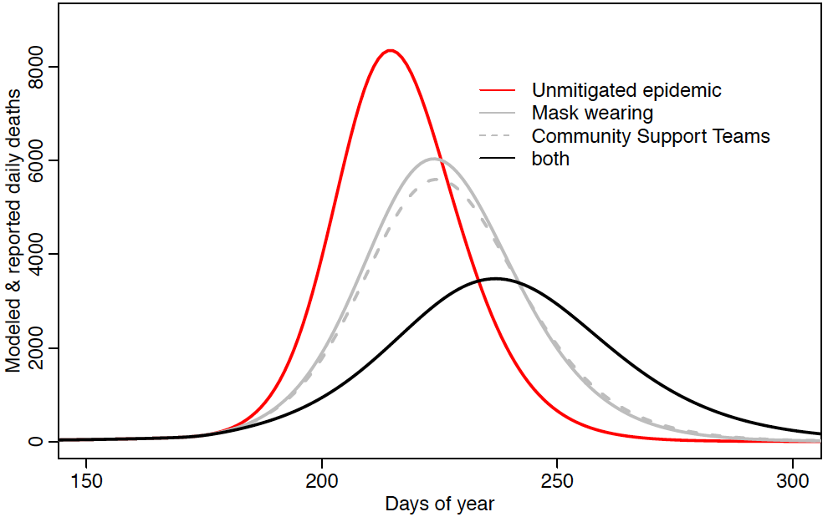

**Table 2. Impact of interventions in terms of reduced mortality, healthcare costs and return on investment, considering a range of low and high healthcare and intervention costs.**

|  |  |  |  |
| --- | --- | --- | --- |
| **Scenario** | **Deaths prevented** | **Healthcare costs in USD (low cost)** | **% return on investment (range)** |
| Unmitigated epidemic | NA | $3.18B ($0.79B) | NA |
| Masks | 24,000 | $2.9B ($0.72B) | 550% (135 - 2,150) |
| CST | 34,700 | $2.78B ($0.70B) | 12,700% (3,200 - 22,700) |
| CST & masks | 72,800 | $2.36B ($0.59B) | 1,500% (380 - 5,700) |

**Discussion**

The efficacy of face masks has yet to be accurately quantified in terms of source control (reducing transmission from infected persons who wear masks to those they come into contact with) and will be affected by both the quality of the mask and the adherence of the wearer. The costs we explore here are based on crude assumptions for mask purchase and costs of training and rollout of CST in Dhaka where there is already a large community health worker workforce that can be mobilized. However, we do not include food packages or additional support for vulnerable communities. We present relative differences under higher and low cost packages for delivery of CST and free masks to Greater Dhaka (Table 1). We also envision that investment in advocacy to encourage mask wearing and support the role of CSTs could greatly improve the impacts of these interventions on mitigating the epidemic. In the low cost mask scenario we assume just 1 re-usable mask is provided to 50% of the population, thereby assuming that higher income households are able to purchase their own masks and that households generally prioritize mask wearing and re-use to those who are active outside of the household. More generally, mass sensitization is considered crucial to ensure community engagement and buy-in. We also don’t consider the potential for exacerbated mortality with hospital capacity being exceeded. The relatively limited availability of hospital beds, oxygen and ventilators, as well as the dangers posed to the healthcare workforce, could greatly increase the health, societal and economic costs of the epidemics. Moreover, healthcare capacity is likely to be worse outside the capital and particularly in vulnerable refugee populations with potentially more catastrophic consequences.

Overall, there is considerable uncertainty in both the efficacy of these interventions and the costs involved that are not presented here (it is possible to explore the epidemiological uncertainty associated with the model parameterization via our Shiny app - (<https://rabies.shinyapps.io/Dhaka_covid19/> where further modeling limitations are also discussed). Nonetheless, under all scenarios, the reduced deaths and the relatively low cost of the interventions compared to the catastrophic health care costs mean that these interventions are expected to remain extremely good value for money and critically have a chance of averting an unmitigated public health disaster. Monitoring and evaluation of these interventions will be essential to determine their impacts, and adaptive learning to improve deployment, optimize mask demand and potentially reduce costs should be considered integral to these interventions, especially given the potential to expand these approaches beyond core areas of Dhaka and Chittagong. More generally, these interventions should be aggressively and urgently deployed, with aggressive mask promotion, distribution and community engagement. Once underway the epidemic is expected to spread rapidly and overwhelm the healthsystem within days, therefore time is of the essence to prevent this public health disaster.