1. Site Logo

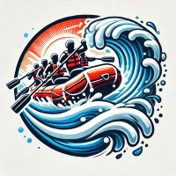

1. Color labels

* primary-color: --oxford-blue: #091C2Fff;
* secondary-color: --cinnabar: #FC4A2Dff;
* accent1-color: --baby-powder: #F9FCFAff;
* accent2-color: --process-cyan: #19B8EEff;
* optional-color: --fire-engine-red: #D31818ff;

1. Font labels
   * heading-font: Jura - Designed by Daniel Johnson, Cyreal
   * text-font: Condiment - Designed by Sudtipos
2. https://coolors.co/091c2f-fc4a2d-f9fcfa-d31818-19b8ee