[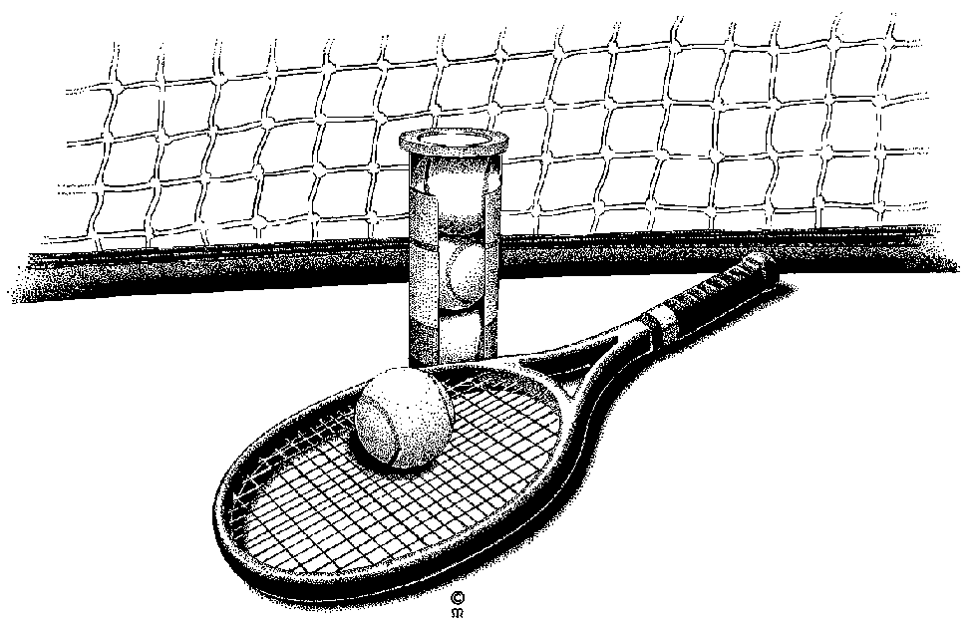](http://www.google.com/url?sa=i&rct=j&q=&esrc=s&source=images&cd=&cad=rja&uact=8&ved=0CAcQjRw&url=http://vintagetennis.com.au/coaching/private/&ei=IZ2QVcr1NJCKyATEvIDYDQ&bvm=bv.96783405,d.cGU&psig=AFQjCNF1VD2-E5ExGz7-vDpUJUiTKgiGYg&ust=1435627115556076)

5th ANNUAL MONTICELLO YOUTH TENNIS TOURNAMENT

**Events**

Boys JV Boys Varsity Girls JV Girls Varsity

**Dates and Start Times**

1. Singles on Monday, July 22 (8:00 am) B. Doubles on Tuesday, July 23 (8:00 am)

**Fees/Information**

$20 entry fee for each event you enter. Please provide a can of tennis balls as well. For any additional tourney information and updates please follow us @rousslangtennis and visit Lotustechnical.com. **All proceeds will be put directly back into the Monticello Tennis Program.**

**Location**

The tournament will be held at the Monticello High School courts at 5225 School Blvd, Monticello, MN 55362. Depending on the number of entrants, some matches might be played at the Monticello Middle School Courts.

_ _ _ _ _ _ _ _ _ _ _ _ _ _ _ _ _ _ _ _ _ _ _ _ _ _ _ _ _ _ _ _ _ _ _ _ _ _ _ _ _ _ _ _ _ _ _ _ _ _ _ _ _ _ _ _

(TO ENTER, complete and return bottom of form below, and have it to us by Friday, July 12th, 2019.

**REGISTRATION FORM**

NAME(S):___________________________________________________________________________

PHONE #:___________________________________________________________________________

ADDRESS:__________________________________________________________________________STATE/ZIP:_________________________________________________________________________

EVENT(S):__________________________________________________________________________

EMAIL ADDRESS FOR UPDATES:_____________________________________________________ CAN WE TEXT YOU UPDATES: Yes / NO

Circle your T-shirt size (men’s sizes): small medium large X-large

Most recent position held on tennis team: __________________________________________________

FEE(S): $______________ (make checks out and mail to: Brian Rousslang, 3638 WOODSIDE DR MONTICELLO, MN 55362. **(NO REFUNDS)**

Please have a parent or guardian sign below as a “waiver” for any possible injuries that might occur: **X**_________________________________________________________

For any questions please contact:

Brian Rousslang at 612-481-9955; [brousslang@lotustechnical.com](mailto:brousslang@lotustechnical.com)

or Ryan Kadelbach at 320-282-3270