**Preface**

We would like to thank HUTECH International Training Institute, Faculty of Information Technology, University of Technology Ho Chi Minh City (HUTECH) for creating favorable conditions for us to study and implement this project.

Our team would like to express our deep gratitude to Mr. Truong Ba Phuc for guiding our team to complete this project. Thanks to the online meetings and the teacher's suggestions, helped our group complete the specialized this project.

With limited knowledge, our project will have shortcomings. My team is looking forward to the teacher's comments to make our project better.

**Introduction**

Currently, society has gradually developed to a new step that is technology 4.0, where technology will take care of almost everything and here too, we want to create a website that supports users to advertise. Promote products, sell products, manage products, manage employees

Contents

**List of symbols, abbreviations** 2

**Chapter 1. OVERVIEW OF SHOPPING WEBSITE** 3

**1.1** **Contents of the website** 3

**1.2** **Application of the website** 3

**Chapter 2. SOME SUPPORT KNOWLEDGE** 3

**2.1 Programming languages** 3

***2.1.1 HTML (Hypertext Markup Language)*** 3

***2.1.2 CSS (Cascading Style Sheets)*** 4

***2.1.3 Javascript*** 5

**2.1.4 Nodejs** 5

**2.1.5 MSSQL** 5

**Chapter 3. SHOPPING WEBSITE APPLICATION DEVELOPMENT** 7

**3.1 Survey the shopping website** 7

**3.2 Analyze the requirements for the shopping website** 7

**3.3 Analyze the shopping website** 8

*3.3.4 Event stream* 9

**3.4 Design of the shopping website** 11

*3.4.1 Convert ER model into relational model* 11

# **List of symbols, abbreviations**

|  |  |
| --- | --- |
| Symbols, abbreviations | Explanation |
| HTML | Hypertext Markup Language |
| CSS | Cascading Style Sheets |
| URL | Uniform Resource Locator |
| HTTP | Hypertext Transfer Protocol |
| API | Application Programming Interface |
| RPC | Remote Procedure Call |

# **Chapter 1. OVERVIEW OF SHOPPING WEBSITE**

## **Contents of the website**

* Website is a sales website, where the store can promote or sell directly through the website
* As for employees, shop owners can manage their own employees.

## **Application of the website**

Guest

* Registration
* Login

User ( after login )

* Add to cart
* Buy product

Staff – Admin

* Add – edit product
* Add – edit admin
* Add – edit user

# **Chapter 2. SOME SUPPORT KNOWLEDGE**

## **2.1 Programming languages**

In order to build an application or a website, it is first necessary to use the appropriate programming languages. And in the first part of this project, the programming languages chosen by our group include HTML, CSS, JavaScript, Nodejs , MySQL .

### ***2.1.1 HTML (Hypertext Markup Language)***

HTML or Hypertext Markup Language is a markup language that defines the structure of your content. For example, content can be organized into paragraphs, ordered lists, or unordered lists, along with pictures, videos, and tables. HTML uses “tag” to create headings, paragraphs, underline words, and more. HTML declared in the main tag pair is <html></html> and the websites will divide into two parts.

Here in an example of simple HTML file to illustrate:

<html>

<head>

<title>This is a title</title>

</head>

<body>

<div>

<p>Hello world!</p>

</div>

</body>

</html>

The <head> tag will be used to store the information about the website and the <body> tag will contain the structure and contents of the website. In the <head> here we have <title> tag which will show us the title of the website. In <body> tag we have <div> tag to wrap of other tags and in here we use it to wrap <p> or paragraph tag.

### ***2.1.2 CSS (Cascading Style Sheets)***

CSS or Cascading Style Sheets is a simple design language intended to be used as a part of HTML. CSS handles the look and feel of a website. By using CSS, you can control from the color of the text, the size of fonts, what background images or colors are used to create animations, making variants display for different devices and screen sizes with responsive design.

There are three ways to add CSS to HTML documents:

Inline – by using the style attribute inside each HTML elements.

<h1 style="color: blue;">A Blue Heading</h1>

Internal – by using <style></style> element in the <head><head> section.

<head>

<style>

body {background-color: blue;}

h1 {color: blue;}

p {color: red;}

</style>

</head>

External – by using <link> element to link to an external CSS file or .css extension at the end of the file and put it in <head> section.

<head>

<link rel="stylesheet" href="styles.css">

</head>

### ***2.1.3 Javascript***

JavaScript is a scripting or programming language that allows you to implement complex features on web pages. With JavaScript, you can make an HTML web page more dynamic, attractive and perform more functions. JavaScript allows you to create animate effects, control multimedia, get the data from the back-end, create 3D objects with the help of libraries, or build an entirely new website. You can add JavaScript external file to your project by using the <script> tag. Here is an example:

<script src="myscripts.js"></script>

JavaScript can be inserted in the <head> or body> tag and the "src" attribute specifies where the external script file is located.

### **2.1.4 Nodejs**

* Node.js is an open source server environment
* Node.js is free
* Node.js runs on various platforms (Windows, Linux, Unix, Mac OS X, etc.)
* Node.js uses JavaScript on the server

### **2.1.5 MYSQL**

MySQL is a relational database management system (RDBMS) developed by Oracle that is based on structured query language (SQL).

# **Chapter 3. SHOPPING WEBSITE APPLICATION DEVELOPMENT**

## **3.1 Survey the shopping website**

According to statistics obtained from 55% of online shop owners participating in the evaluation, the website ranked on facebook accounted for 51% and e-commerce platforms accounted for 20%. To help you easily visualize the e-commerce market, let's take a look at the statistical images below. The first requirement is that users can register for an account and use that account to exchange information directly with other accounts.

40% of online shops increased compared to 2014, most of which were groups with revenue of less than 200 million VND (72%).

7% of online shops grew over 30% of the plan with 2014, most of which were groups with revenue of over 500 million VND (68%).

## **3.2 Analyze the requirements for the shopping website**

These are some features the system needs:

* + Sign up and login for guest
  + Add to cart + pay product ( after login success )
  + Add – Delete – Edit : User , Product , Admin

## **3.3 Analyze the shopping website**

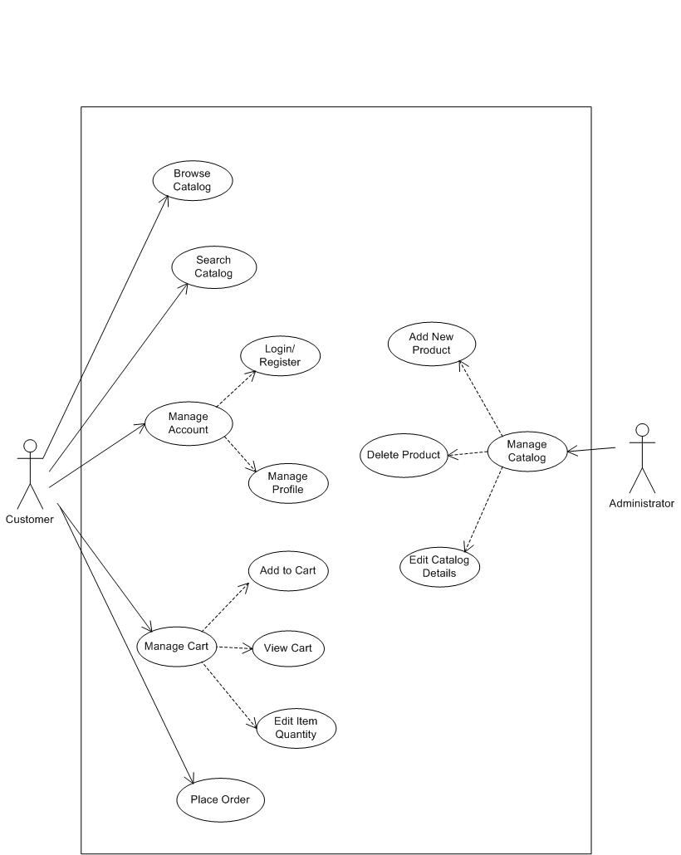

Picture 1 . Use case

Functional description:  
For Guest

* Register: register a new user and the condition is that the username is not available.
* Login: login with the username registered on the system

For user

* Update information: after login, users can update their information.
* Payment
* Buy history

For Admin – Staff

* Management product , user , admin , buy history

*3.1 Entity relationship model*

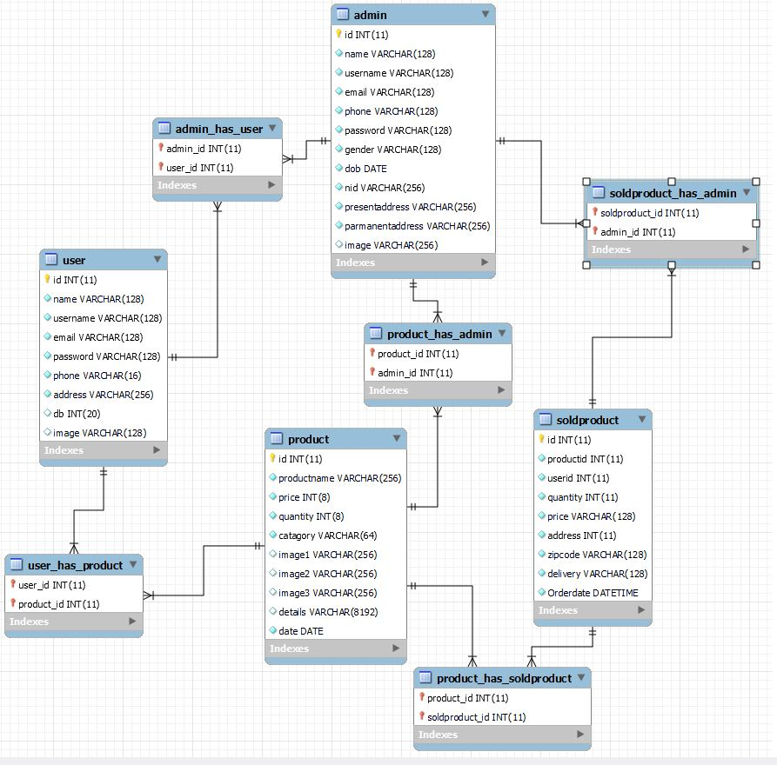

Picture 3.ERD - Entity relationship model

### *3.3.4 Event stream*

3.3.4.1 Login

|  |  |
| --- | --- |
| Use Case Name | Login |
| Actor | Guest |
| Trigger | User click “Login” button |
| Basic flow:   1. You will move to Login page 2. Input information 3. Successful login, back to home page | |
| Exception flow:   * 1. Login failed, request to login again. | |

3.3.4.2 Register

|  |  |
| --- | --- |
| Use Case Name | Register |
| Actor | Guest |
| Trigger | User click “Sign up” |
| Basic flow:   1. You will move to Login page 2. Input information 3. Successful sign up, back to home page | |
| Exception flow:   * 1. Register failed, request to register again. | |

3.3.4.3 User management information

|  |  |
| --- | --- |
| Use Case Name | User management information |
| Actor | User |
| Trigger | User click “Edit Profile” button |
| Basic flow:   1. Move to update information page 2. Edit information 3. Click Update 4. Back to profile page | |
| Exception flow:   * 1. Update failed , request update again | |

3.3.4.5 Add to cart

|  |  |
| --- | --- |
| Use Case Name | Chat |
| Actor | User |
| Trigger | Click buy now at product user want |
| Basic flow:   1. Move to add to cart page 2. Click add to cart button 3. Return main page | |

3.3.4.6 Paymant

|  |  |
| --- | --- |
| Use Case Name | Payment |
| Actor | User |
| Trigger | Click icon cart |
|  | |
|  | |

## **3.4 Design of the shopping website**

### *3.4.1 Convert ER model into relational model*