Music Mobile App

Software Architecture Document

Version 2.0

Revision History

| **Date** | **Version** | **Description** | **Author** |
| --- | --- | --- | --- |
| 08/12/2022 | 1.0 | Initial version | Nguyễn Phước Gia Huy  Vũ Đình Duy Khánh  Trần Thị Tuyết Nhung  Phạm Trần Minh Ngọc  Trịnh Thế Sơn |
| 26/12/2022 | 2.0 | Fill section 5 and 6 | Trịnh Thế Sơn |
| 26/12/2022 | 2.1 | Update <<include>> and <<extend>> relationship in Use-Case model | Phạm Trần Minh Ngọc |
|  |  |  |  |

Table of Contents

**1. Introduction** **4**

1.1 Purpose 4

1.2 Scope 4

1.3 Definitions, Acronyms, Abbreviations 4

1.4 Overview 4

**2. Architectural Goals and Constraints** **4**

**3. Use-Case Model** **4**

**4. Logical View** **5**

4.1 Component: Authentication 6

4.2 Component: Searching 7

4.3 Component: Post (Song) 8

4.4 Component: Manage homepage 9

4.5 Component: Play music 10

4.6 Component: Playlist 10

4.7 Component: Manage Account 11

4.8 Component: Manage Song 12

**5. Deployment** **14**

**6. Implementation View** **14**

Software Architecture Document

# Introduction

## Purpose

This document provides a comprehensive architecture overview of the system, using a number of different architectural views to depict different aspects of the system. It is intended to capture and convey the significant architectural decisions which have been made on the system.

## Scope

This document is an architectural overview of the Music Mobile App. This app hosts online songs that allow everyone to listen, download music,..

This document describes the current architecture structure of our app and is intended to be read by future developers who will join the project, build and interface their own website of this project.

## Definitions, Acronyms, Abbreviations

There are some acronyms and abbreviations we use in this document:

GUI: Graphical user interface - interact with user interface by interface.

## Overview

This document includes the description of the software architecture and components of the app.

Some diagram:

* Use-Case diagram
* Architecture diagram
* Package diagram
* Class diagram

# Architectural Goals and Constraints

There are some key requirements and system constraint:

* Data persistence will be addressed using relational databases.
* All performance requirements, as stipulated in the Vision Document.

# Use-Case Model

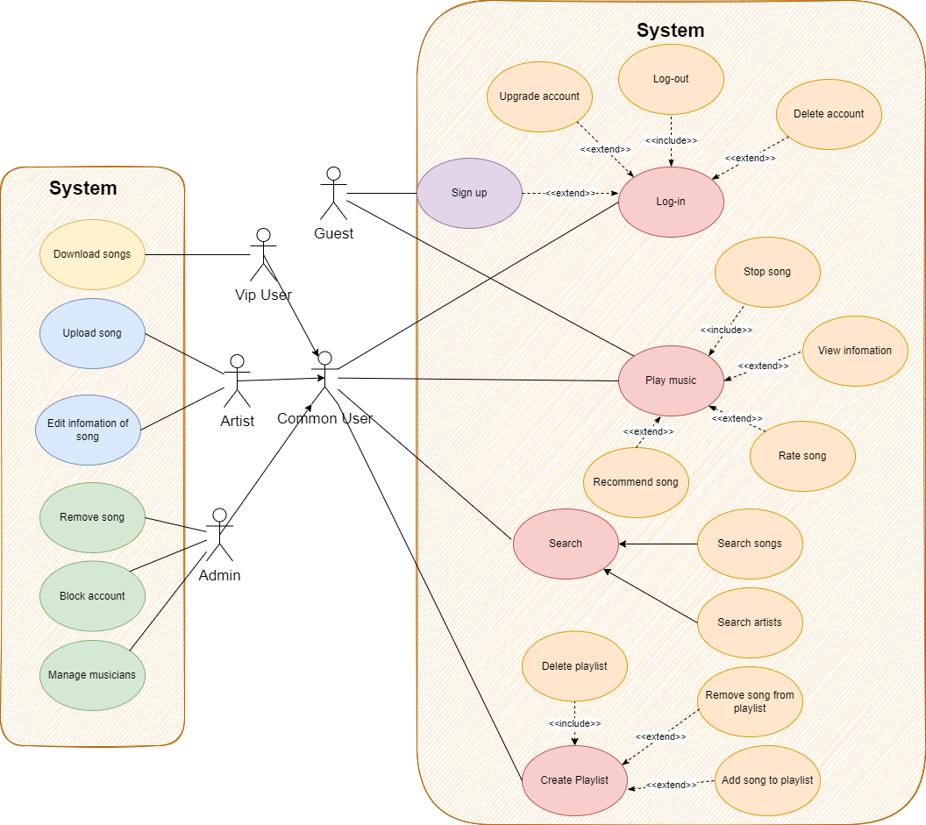

# Logical View

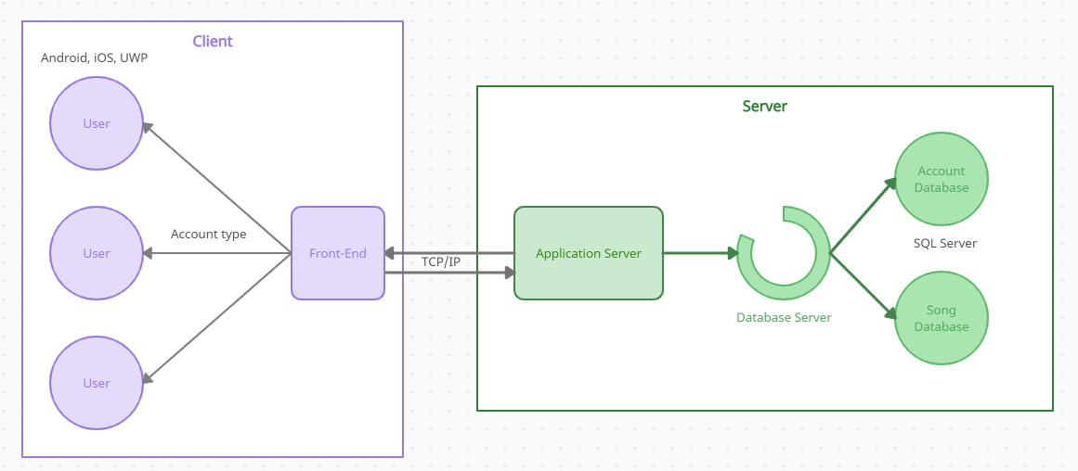

The server will store information about user accounts and songs on the SQL server.

When the client sends a request for information to the server, the server processes the information and then sends a response back to the client via TCP/IP protocol.

Clients will be authorized to use the software according to their account type, each account type will be able to use different features.

The software will be used on platforms: Android, iOS, UWP

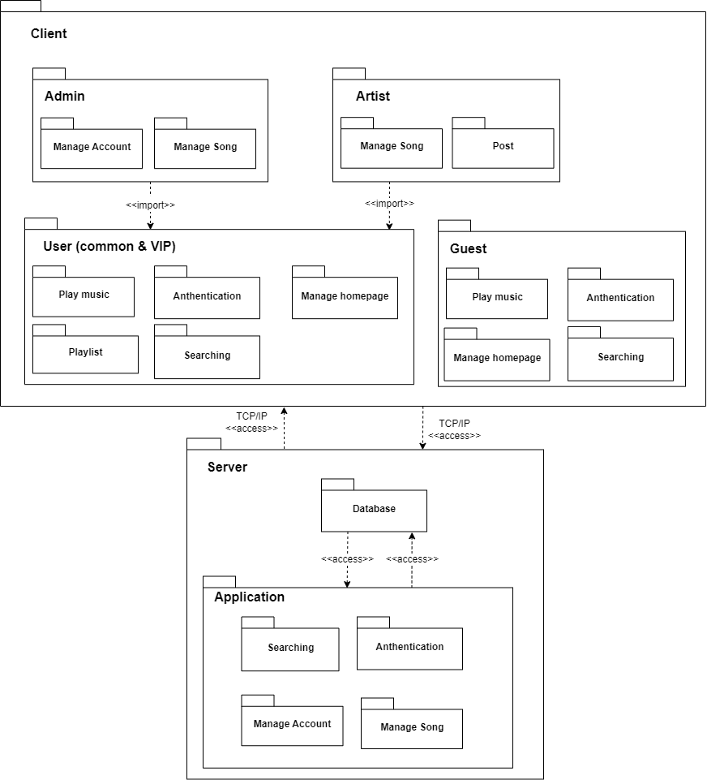

## Component: Authentication

Brief description: This component provides a method to help the user login or register an account. Users can login with an available account or create a new account with email, password, name, date of birth, username and choose user type.

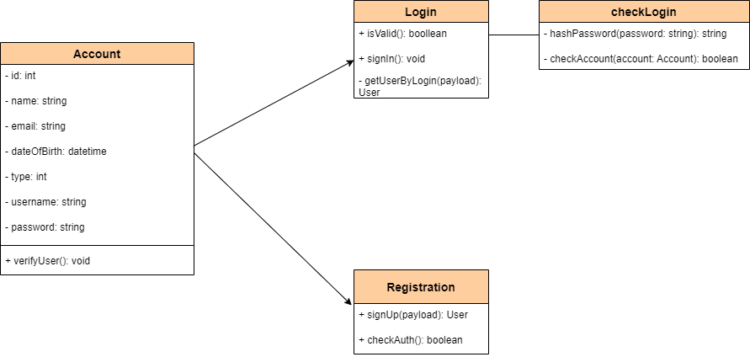

| **Class** | **Explain** |
| --- | --- |
| Account | This item contains the info of the account (ID, Use name, Email, …) and if we change the information in the app by using its operation, it will also change in the database. |
| Login | This activity will allow the guest, user, admin, artist login account to music mobile app. We also check that the username already exists, if not, return an error immediately. To check the password, we compare between the user's password entered and that user's password stored in the database using the MD-5. If the password is correct, continue. |
| Registration | This activity will allow the guest register account. We will check if that username already exists in the database, if not, we will add that user. Here I use MD-5 to hash the password and then save it to the database. |
| checkLogin | This activity will help the system check the validity of password and account. |

## Component: Searching

Brief description: This component provides the service to help users find matching songs and artists on the system.

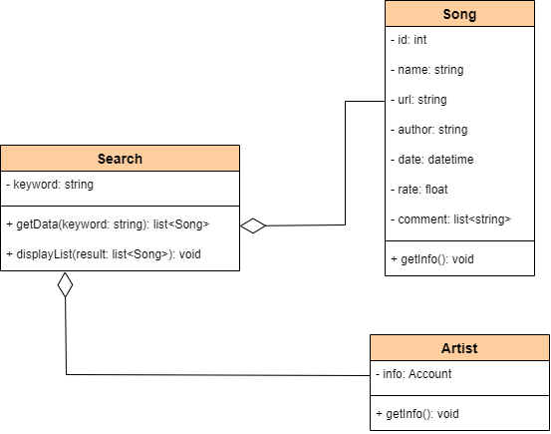

| **Class** | **Explain** |
| --- | --- |
| Search | This activity will find the required songs and artists based on the search keyword. It will return a list of matching songs and artists. |
| Song | This item contains the info of the songs(name, url, author, …) and artists can post it on the page. And if we change the information in the app by using its operation, it will also change in the database. |
| Artist | This item contains info of the artist. It shows information about the Artist. |

## Component: Post (Song)

Brief description: This component provides the service to help artists upload their song to the system.

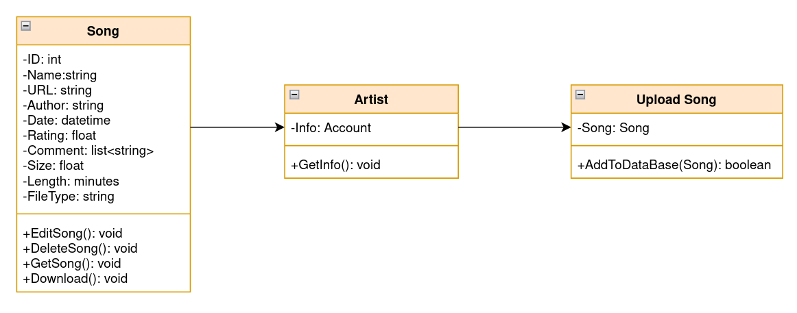

| **Class** | **Explain** |
| --- | --- |
| Upload Song | Upload song to database |
| Song | This item contains the info of the songs(name, url, author, …) and artists can post it on the page. And if we change the information in the app by using its operation, it will also change in the database. |
| Artist | This item contains info of the artist. It shows information about the Artist. |

## Component: Manage homepage

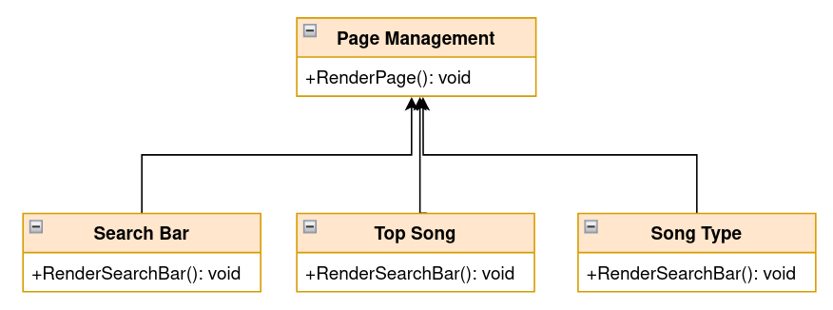

| **Class** | **Explain** |
| --- | --- |
| Page Management | Management component of the screen, render screen when user click on it. |
|  |  |

## Component: Play music

Brief description: At the Play Music page, the selected song will be played, the next songs will be played after the previous song ends.

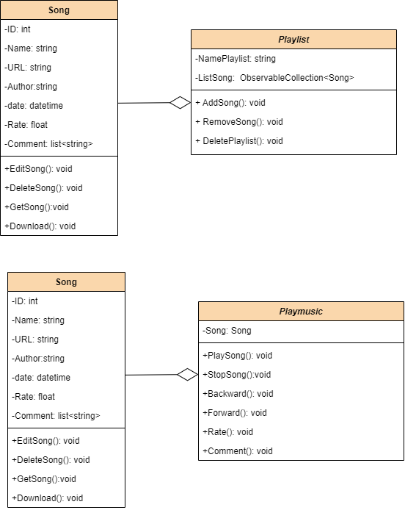

| **Class** | **Explain** |
| --- | --- |
| Playmusic | Users can stop, play next, go back to the previous song, go to the next song, rate the song, comment on the song through the Play Song, Stop Song, Backward, Forward, Rate controls, Comment - Rate: users rate the song from 1 to 5 stars. |
| Song | This item contains the info of the songs(name, url, author, …) and artists can post it on the page. And if we change the information in the app by using its operation, it will also change in the database. |

## Component: Playlist

Brief description: At the Playlist page, users can choose the songs included in the playlist to play that song, the next songs will be played after the previous song ends.



| **Class** | **Explain** |
| --- | --- |
| Playlist | The user can add new songs to Playlist, remove songs from Playlist and even delete Playlist through various means through Add Song, Remove Song, Delete Playlist controls. |
| Song | This item contains the info of the songs(name, url, author, …) and artists can post it on the page. And if we change the information in the app by using its operation, it will also change in the database. |

## Component: Manage Account

Brief description: This component provides a method to help Admin manage a list of accounts, with some basic tools like view, edit(update) and delete accounts.

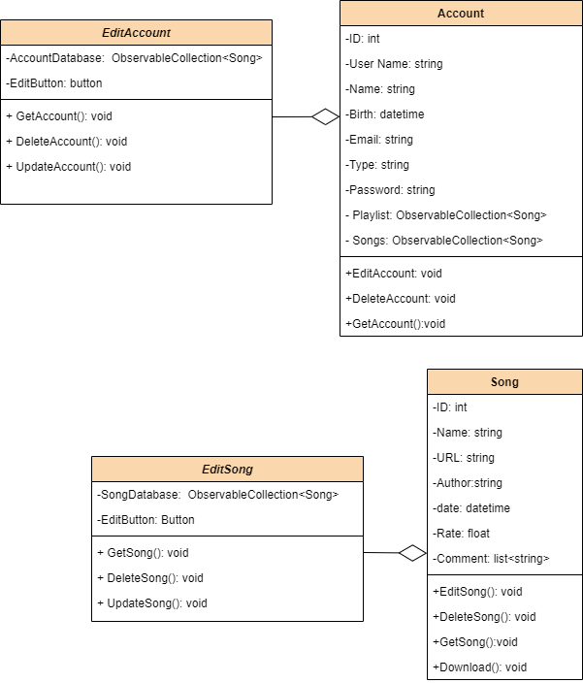

| **Class** | **Explain** |
| --- | --- |
| EditAccount | This activity will allow the Admins to manage all accounts in this app, by clicking the edit button in the account screen. |
| Account | This item contains the info of the account (ID, Use name, Email, …) and if we change the information in the app by using its operation, it will also change in the database. |

## Component: Manage Song

Brief description: This component provides a method to help Admin and Artist manage a list of songs, with some basic tools like view, edit(update) and delete song.



| **Class** | **Explain** |
| --- | --- |
| Search | By clicking the edit button in the account screen,this activity will allow Admins to manage all songs in this app and Artists to manage their own songs with few basic functions like view information and change it,... |
| Song | This item contains the info of the songs(name, url, author, …) and artists can post it on the page. And if we change the information in the app by using its operation, it will also change in the database. |

# Deployment

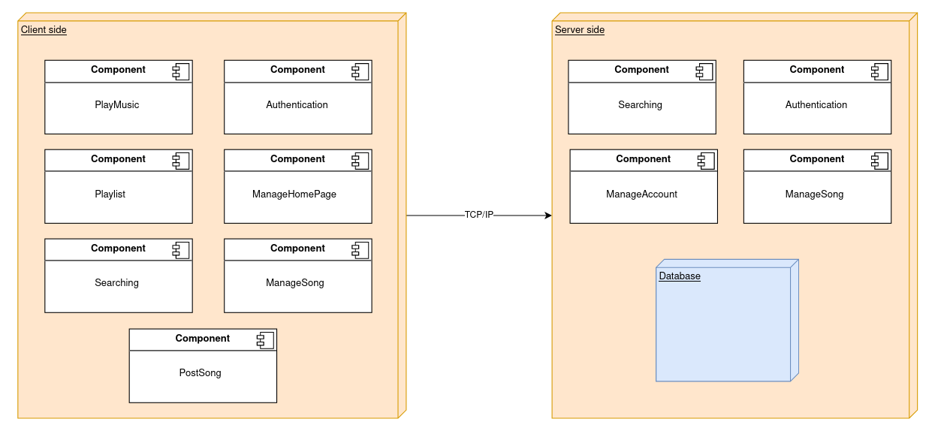Client: is a mobile device connected to the internet to access application components.

Server: execute query requests from the clients, then process and queries the database to respond to the clients.

Database: store and sync user’s data, song.

# Implementation View

Client folder:

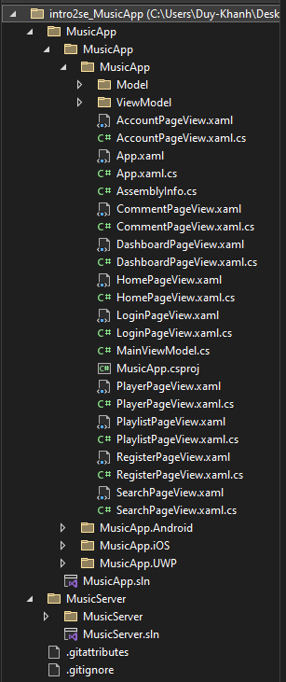

Server folder:

**