Automation Flow
This document describes the compare_file_refs automation at a high level. It focuses on the business flow, system handoffs, and exception paths rather than code-level implementation.
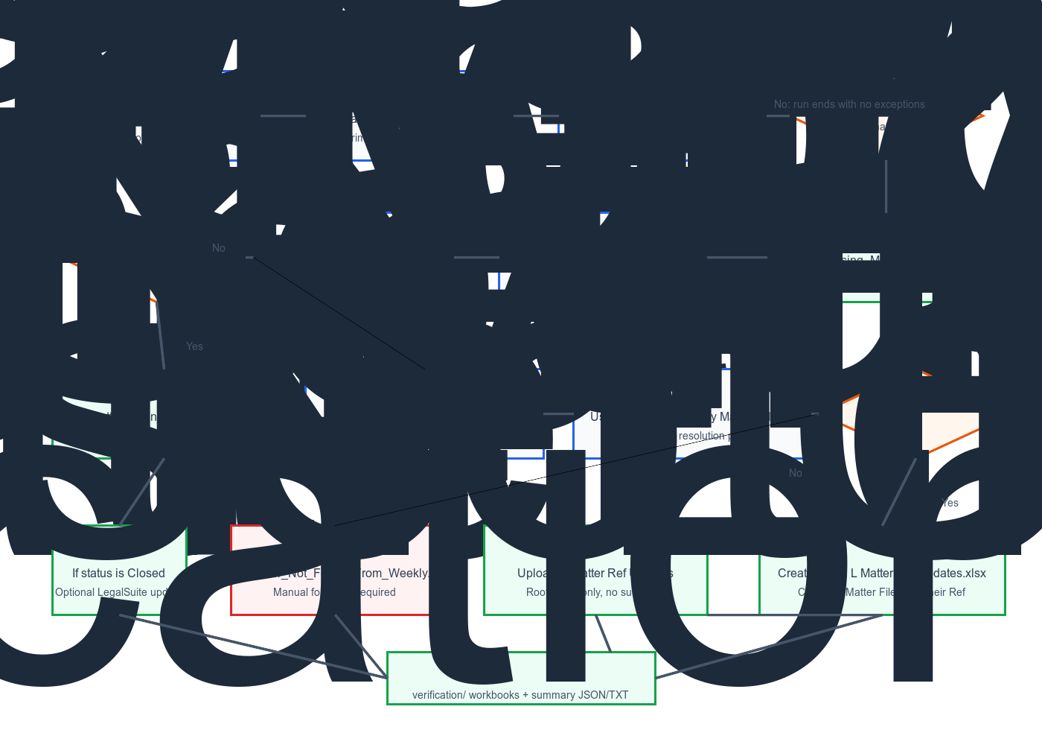
Figure 1: High-level reconciliation and exception-management flow.

Purpose
The automation reconciles LegalSuite matters against Standard Bank source files, identifies exceptions, investigates weekly-balancing anomalies, prepares correction files, and optionally closes matters in LegalSuite when the weekly status supports closure.

Main Systems
- LegalSuite: source of matter records, including Matter File Ref, Their Ref, and current matter state.
- FTP: source of claim and weekly files, and destination for the matter-ref correction workbook.
- Claim Amount File: daily file used for the primary comparison against LegalSuite matter refs.
- Weekly Balancing File: operational status source used to resolve missing refs and identify closure actions.
- Verification Outputs: audit artifacts showing what the automation concluded and what files were produced.

End-to-End Flow
Collect the matter list from LegalSuite or from a CSV input.
Download the current Standard Bank claim amount file from FTP.
Compare LegalSuite Matter File Ref values with claim file File Ref values.
Write the missing refs to an exception workbook.
If exceptions exist, download the current weekly balancing file.
Search weekly balancing by File Ref.
If still not found, search weekly balancing by LegalSuite Their Ref against the weekly Matter column.
Create downstream outputs based on what is found and what status is returned.
Upload the matter-ref correction file to FTP when a weekly mismatch is confirmed.
Optionally update LegalSuite for matters whose weekly status is Closed.
Create verification workbooks and run summaries.

Decision Paths

Direct Match In Claim File
If the LegalSuite matter ref exists in the claim file, the record is considered reconciled and no exception action is needed.

Missing From Claim File, Found In Weekly By File Ref
If the matter is missing from the claim file but appears in weekly balancing under the same File Ref, the weekly status is used for downstream handling.

Missing From Claim File, Resolved By Their Ref
If the matter cannot be found in weekly balancing by File Ref, the automation fetches the LegalSuite matter, reads Their Ref, and searches the weekly Matter column using that value.
A successful match means the weekly record exists but is carrying the wrong file reference. The automation then creates Panel L Matter Ref Updates.xlsx with Matter File Ref from LegalSuite and Their Ref as the account number used to locate the weekly row.
That workbook is uploaded to the FTP folder Matter Ref Updates itself, not to a subfolder.

Missing From Claim File, Not Found In Weekly At All
If the matter cannot be found in weekly balancing by either File Ref or Their Ref, it remains unresolved for the run and is written to the not-found output for manual follow-up.

Status Handling
- If the weekly status is open or live-type, the matter generally remains live in LegalSuite.
- If the weekly status is closed, the automation can optionally trigger the LegalSuite closure flow.

Operational Outputs
- Report (SUP).xlsx
- Missing_Matter_File_Ref.xlsx
- Matter_Found_From_Weekly.xlsx
- Matter_Not_Found_From_Weekly.xlsx
- Panel L Matter Ref Updates.xlsx

Verification Outputs
- verification/ copies of generated workbooks
- verification_summary.json
- verification_summary.txt

Control Principles
- Prefer direct reconciliation first.
- Use weekly balancing as the primary exception-resolution source.
- Use Their Ref as the fallback key when File Ref fails.
- Do not close matters simply because they are absent from the claim file.
- Keep an audit trail for every significant result.

