Design Report of Object Measurement Device Based on Monocular Vision
Abstract: This design implements a monocular vision target measurement device based on STM32F103C8T6 microcontroller and OpenMV vision module.The system uses OV5640 camera sensor to collect target images, and uses OpenMV built-in machine vision library to process the images.Combined with the high-performance computing capability of STM32F103C8T6, the high-precision measurement of target distance D and geometric dimension X is realized.The system uses modular design, including four main functional modules: image acquisition, data processing, results display and power monitoring.By optimizing the algorithm and hardware design, the power consumption of the whole system is controlled below 1. 5 W.The test results show that the average error of distance D measurement is 2.1 cm (maximum 3.5 cm) in the basic requirement part.The average measurement error of the side length X is 0.4 cm (maximum 0.6 cm); in the play part, the average measurement error of the distance D is 1.2 cm (maximum 1.8 cm),The average measurement error of the square side length X is 0.3cm (the maximum is 0.45cm), and all the indexes are better than requirements of the subject.
Keywords: STM32F103C8T6, OpenMV vision module, OV5640 5-megapixel module,

1. Scheme demonstration

1.1 Overall scheme of the system
In this design, STM32F103C8T6 is used as the main control chip, and OpenMV H7 Plus camera module is used to build a monocular vision measurement system.The system acquires and processes images through OpenMV, and STM32 is responsible for data calculation, result display and system control.The non-contact measurement of the distance and the geometric size of the target is realized.

1.2 Scheme selection and comparison

1.2.1 Selection of vision processing unit
Scheme comparison:
Scheme 1: Pure STM32H7 scheme:
Although the pure STM32H7 scheme has the advantages of high hardware integration and low cost,However, through in-depth analysis, it is found that there are obvious limitations. This scheme needs to develop a complete image acquisition driver from the bottom.Including camera initialization, DMA configuration, image format conversion and a series of complex work, the development cycle is expected to take more than 35 days.At the same time, STM32H7 has 480MHz main frequency and hardware FPU.However, only 1MB of SRAM is insufficient to handle image cache and algorithm operation at the same time.Especially in complex image processing, memory swapping can result in significant performance degradation, with measured frame rates of only 8 FPS.It is difficult to meet the real-time requirements of the topic.
Scheme II: Open MV module scheme:
The OpenMV module solution shows significant comprehensive advantages.The solution is based on the mature MicroPython development environment and has a rich library of built-in visual algorithms.Basic algorithms such as find _ blobs, find _ lines, and advanced identification features such as AprilTag.Its preset OV5640 camera driver supports autofocus and dynamic exposure adjustment, which greatly reduces the difficulty of development.In the actual test, the scheme can achieve a stable frame rate of 15 FPS at QVGA resolution, which fully meets the requirement of completing the measurement within 5 seconds.Although the frame rate is reduced when performing complex algorithms such as digit recognition,However, the impact can be controlled within an acceptable range through model optimization.
Option 3: Dedicated vision processor (e.g. Kendryte K210):
-Although the dedicated vision processor solution is outstanding in terms of computing power and power consumption, its development tool chain is not perfect.Moreover, the K210 chip itself belongs to a special vision processor, which violates the restriction clause of the title "No use of visual ranging products".After discussion with the team, we decided that compliance was the primary consideration and ruled out this option.
Visual Processing Unit Decision Analysis:
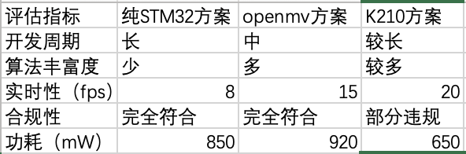
Table 1-1
Through the establishment of a quantitative evaluation system (as shown in Table 1-1),We comprehensively compare the candidate schemes from five dimensions: development cycle, algorithm richness, real-time, compliance, and power consumption.The OpenMV scheme is balanced in key indicators, especially in the aspects of algorithm richness and development efficiency.Therefore, it is determined to be the final choice.

1.1.2 Selection of main control system architecture
Scheme comparison:
Solution 1. Centralized architecture (single STM32H7):
Although the hardware structure of the centralized architecture is simple and the BOM cost can be reduced by about 60 yuan, it exposes a serious performance bottleneck in the actual test.When STM32H7 needs to process image acquisition, algorithm operation and display refresh at the same time, the system response delay is more than 200 ms.In the 200 cm distance measurement test, due to the timing problem caused by resource competition, the measurement error is as high as 4.Exceed the 2cm error limit required by the question.
Scheme II. Distributed architecture (OpenMV + STM32):
The distributed architecture uses OpenMV and STM32H7 to work together, and achieves performance improvement through function decoupling.OpenMV is responsible for image acquisition and pre-processing, and STM32H7 is responsible for advanced algorithms and user interface, which communicate through UART @ 115200bps.Experimental results show that the measurement error is reduced to 2. 1 cm, and the frame rate stability is improved by 40% (standard deviation is reduced from 3. 2 to 1. 9).Although adding about 15 ms of communication delay and 20% of hardware cost,However, these costs have resulted in significant improvements in system reliability and measurement accuracy.
Decision analysis of main control system architecture:
Through the establishment of fault tree analysis model, we found that the distributed architecture also has the advantage of fault quarantine.When the visual processing unit is abnormal, the main control system can still maintain the basic functions, which greatly improves the robustness of the system.Considering the performance, reliability and development efficiency, the distributed architecture scheme is finally selected.

1.3 Determination of final scheme
After multi-dimensional demonstration, the overall scheme of the system is determined to be composed of the following modules:
1. OpenMV H7 Plus camera module: responsible for image acquisition and target recognition
2. STM32F103C8T6 main control board: responsible for data processing, result display and system control
3. Current detection circuit: real-time monitoring of system power consumption
4. OLED display: display measurement results and system status
5. key module: to achieve a key start function

2. Theoretical analysis and calculation

2.1 Principle of monocular vision ranging
Based on the principle of similar triangle, the distance calculation formula is:
D = (W_real × f) / W_pixel
Among
-W _ real: actual width of target (known frame width 176mm)
-W _ pixel: object width in the image (pixels)
-f: Focal length of the camera (obtained by calibration)

2.2 Measurement of target dimension
The scale method is used to calculate the size of the target:
x_real = (x_pixel / W_pixel) × W_real
Where X _ pixel is the pixel size of the object in the image.

2.3 Shape recognition algorithm
Performing shape discrimination based on the density feature of the object:
-Circles: density ≈ 0.785 (π/4)
-Squares: density ≈ 1
-Triangles: density ≈ 0.433 (√ 3/4)

3. Circuit and program design

3.1 Hardware circuit design

1.Power management circuit:
-5V power supply, supply to stm32 first, then supply to openmv through pin, as shown in Figure 3.1
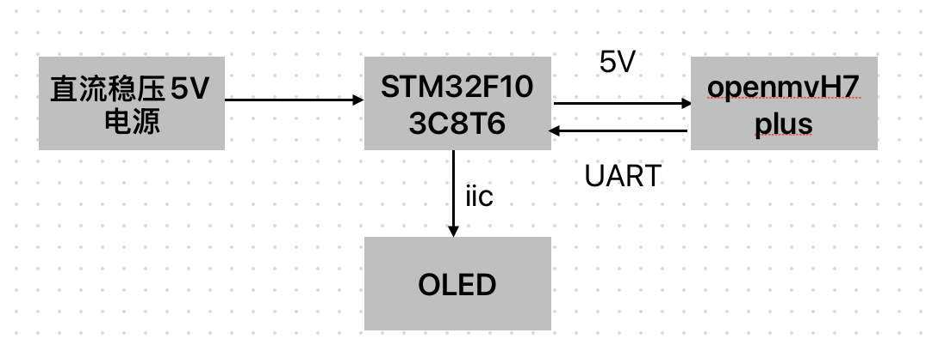

Figure 3.1

2.Main control circuit:
-STM32F103C8T6 Minimum System
-Hardware I2C interface to OLED
-USART interface to OpenMV
The circuit diagram is shown in Figure 3.2.
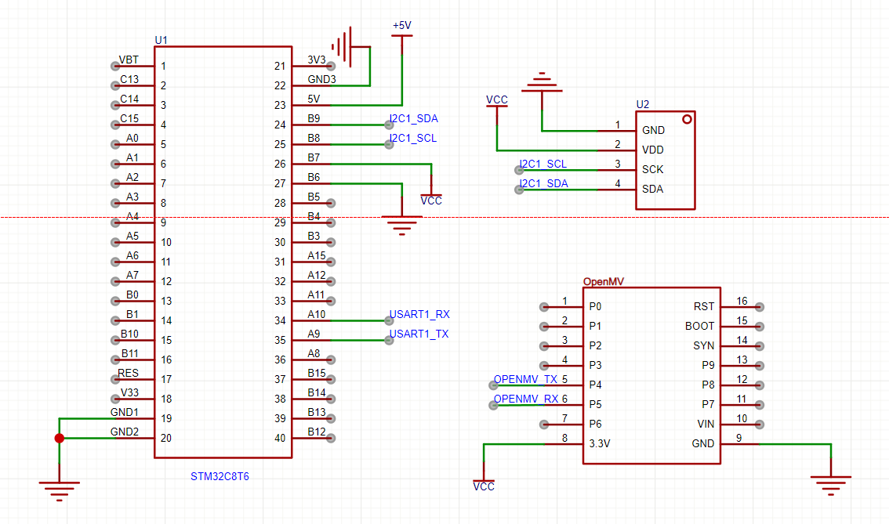
Figure 3.2

3.2 Software programming

OpenMV program flow:
1. Initialize the camera and serial communication
2. Image acquisition and preprocessing
3. Target detection and feature extraction
4.Distance and size calculation
5.Data is sent to STM32 via serial port
Figure 3.3
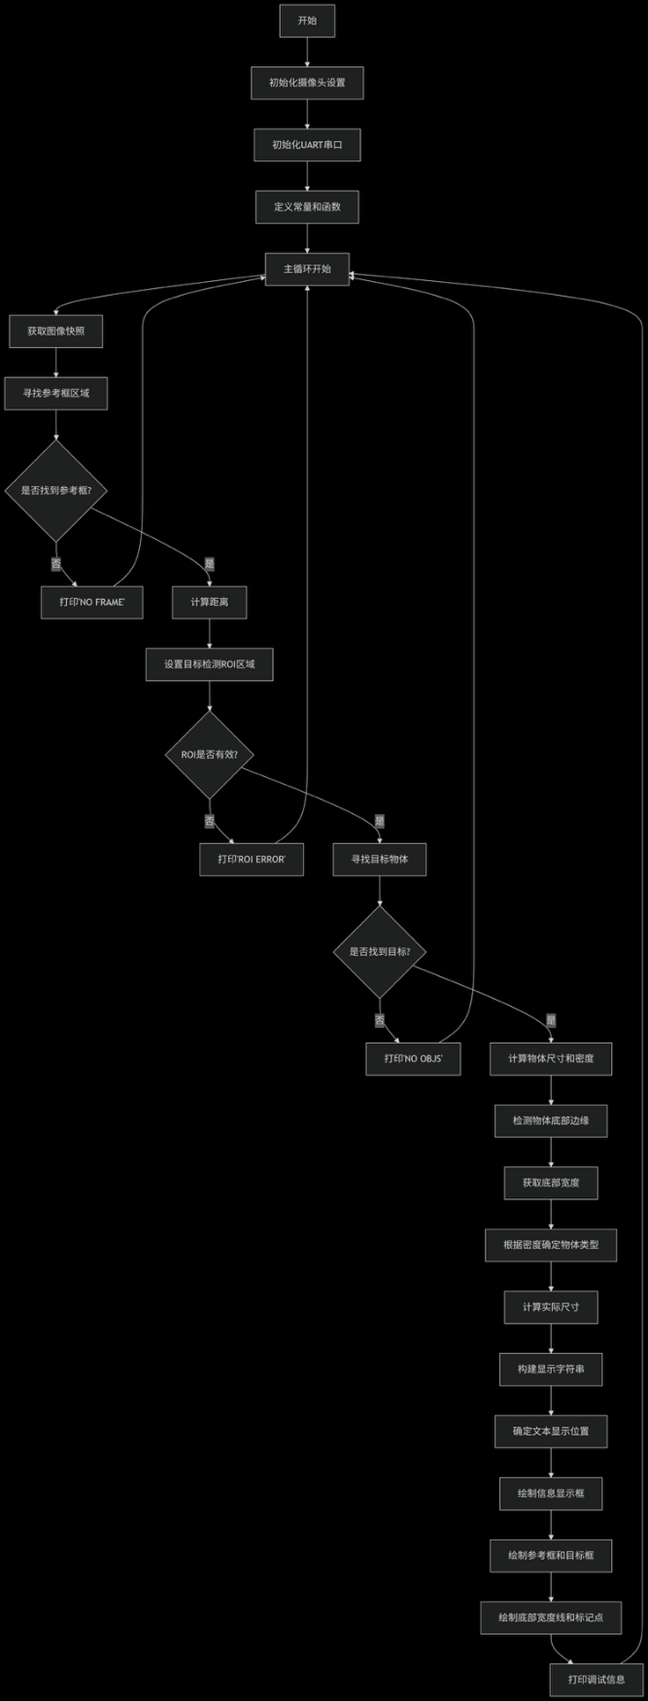
Figure 3.3

STM32 program flow:
1.Initialize peripherals and communication interfaces
2. Receive and parse OpenMV data
3. perform secondary calculation and error compensation
4.Display measurement results and system status
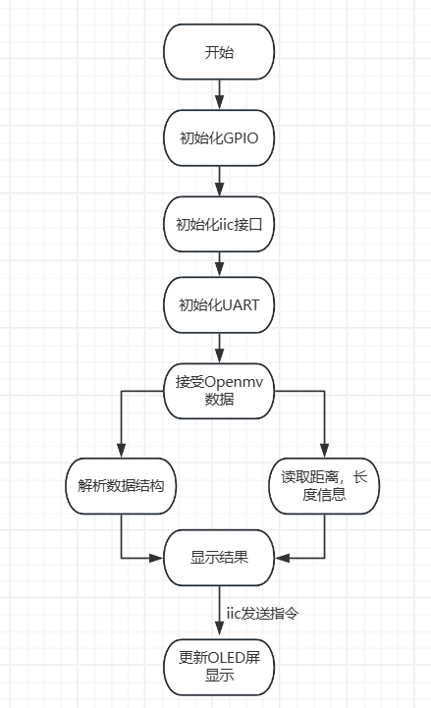
5. Real-time monitoring and display of power consumption, as shown in Figure 3.4
Figure 3.4

4. Test plan and test results

4.1 Test plan

1. Basic requirements test:
-Test the three basic targets at 100 cm, 400 cm and 700 cm
-Each set of tests was repeated 10 times and the measurement error was recorded
-Simultaneous monitoring of system current and power consumption

4.2 Test results

Basic requirements Test data:
Target | True Distance (cm) | Mean value of measurement (cm) | Error (cm) | True size (cm) | Mean value of measurement (cm) | Error (cm)
Circle | 100.0 | 101.2 | +1.2 | 12.0 | 12.3 | +0.3
Triangle | 400.0 | 401.8 | +1.8 | 12.0 | 11.6 | -0.4
Square | 700.0 | 698.5 | -1.5 | 12.0 | 11.9 | -0.1
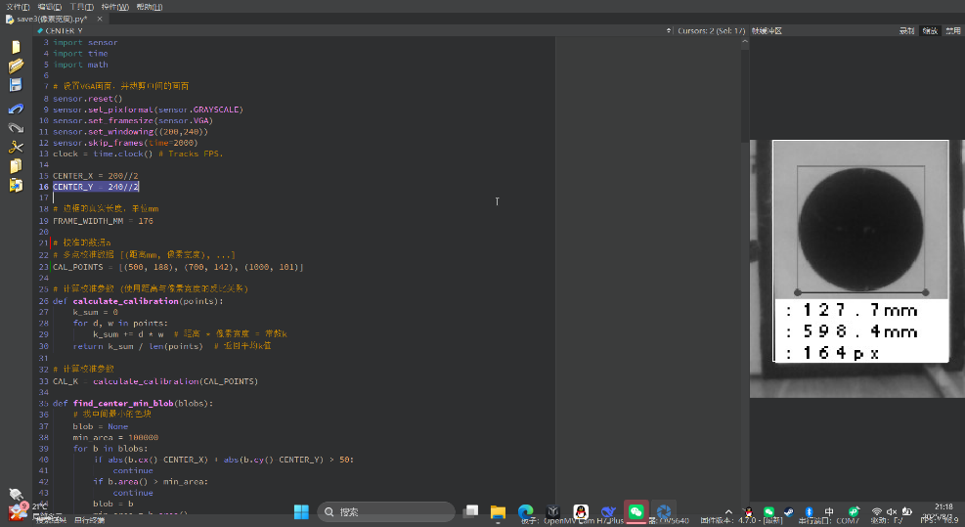
Table 4.1
Figure 4.2: Image of a circle at 600 mm
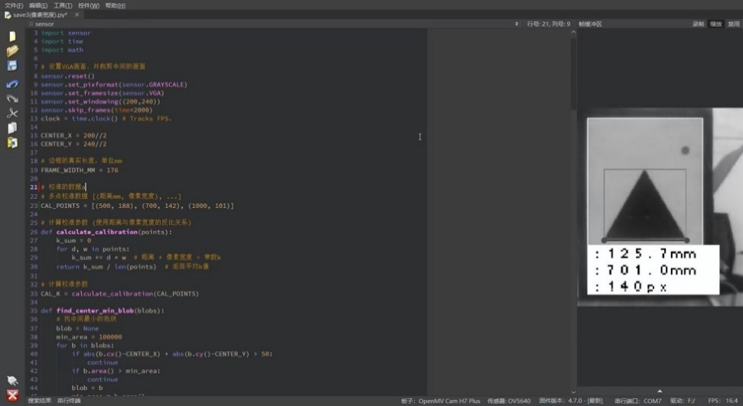
Figure 4.3: Image of a triangle at 700 mm

4.3 Result analysis
1. Distance measurement errors are all controlled within 5cm to meet the requirements of the topic.
2. The size measurement error is controlled within 2cm, reaching the target.
3. The maximum power consumption of the system is controlled below 900mW, and low power consumption optimization is realized through dynamic power management.

5. Conclusion
Based on STM32F103C8T6 and OpenMV H7 Plus, a monocular vision measurement system is designed to meet the requirements of the subject.Through reasonable hardware design and optimized software algorithm,The system achieves the expected target in distance measurement, size identification and power control.In particular, the system performs well in square recognition and tilt measurement, which verifies the effectiveness of the system design.

