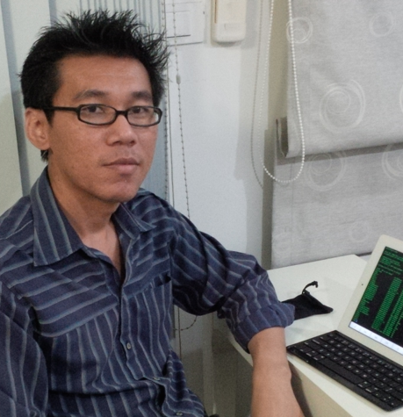
Mr.Nukoon Phimsen
Tel : 029547300 ext 591, Mobile : 087-0056680
Email : s0013254@gmail.com, nukoon.phi@dpu.ac.th
73/283 Pruksa Village 28 Moo 5 Saothonghin
Bangyai Nonthaburi Thailand 11140

Education

- M.Eng. in Electrical Engineering (Telecommunication), June 2009 – June 2011, Kasetsart University (KU)
- B.Eng in Computer Engineering, June 1997- June 2000, King Mongkut's Institute of Technology Ladkrabang (KMITL)

Summary

My primary worked on education in Computer Engineering field. My primary responsibility is lecture, the secondary responsibility is Faculty of Engineering IT infrastructure development to support faculty staff and master degree student research. I also join to University computer center to improvement network infrastructure for a year. My concurrent worked are infrastructure deployment and consultant on several industry including hospital, GAS factory, and Hosting provider. I love to learn new technology and product, so any new product and technology I believe I can handle it.

Certificate

- Cisco Certified Network Associate (CCNA)
- Cisco Certified Academy Instructor (CCAI)
- IBDN Design and Engineering Installation

Application and Language Skill

Programming : Java, C, Java Script, C#, PHP, Node.JS, Python, Lua, VB, Java Servlet, ASP.NET, Dynamic Web Application, Web Services, JSON, SOAP, XML
Database : MySQL, MS SQL, Oracle, DB2, Postgres
Platform and Experience: Linux, Mac OS X, Windows, Solaris, UNIX, Cisco IOS, Active Directory, Hadoop, OpenStack IaaS Cloud, DEIS PaaS Cloud, Docker, CoreOS, Vagrant, Arduino, Internet of Things, Firewall, VPN, IPv6, Embedded System, TCP/IP Internetworking, VMWare, Aruba, RADIUS, Cloud Computing, Arduino, Raspberry Pi, NodeRed
Development tool : Eclipse, Visual Studio, NetBean IDE, Xcode, IAR
Documentation : UML, Visio, MS Office, Power Point, Keynote, Pages, Microsoft Project, Producteev
Communication Language : English (good read and write, fair speak) , Thai (Native)

Work Experiences (Permanent)

1. Dhurakij Pundit University from Jun. 2001 - Now
- Lecture (Bachelor Degree) in Digital, C Programming, Cisco Networking Academy Program, Microprocessor, Switching and Computer Interface, Data Communication, Computer Networks, Computer Network Laboratory, System Administration.
- Lecture (Master Degree) in Wireless Sensor Network, Internet of Things, Enterprise Network. Cloud Computing.
- Deployment Cloud and Hadoop for master degree student research.
- Design and implement Faculty of Engineering network infrastructure and services for faculty staff.
- Cooperate with Computer Centre to improvement Cisco devices configuration.

2. Embedded System Lab, KMITL From Jun. 2000 – May 2001
- Develop network equipment (Router) from traditional PC with embedded Linux by developing solid-state storage ISA card (extension from my Senior project) to store embedded Linux and routing software.
- Network System Administrator and join to develop some part in another projects.

Work Experiences (Contract)

1. Ayuttaya Industrial Gasses Thailand Co.,Ltd. from Mar. 2012 - Now
- Design and implement network infrastructure.
- Design and Implement Active Directory Service Infrastructure.
- Implement secure plant network and VPN access.
- Design and Implement private plant network to partner (Praxair).
- IT Infrastructure consultant

2. Praxair Thailand Limited from Nov. from 2010 – Jun. 2015
- Design and Implement network infrastructure for VoIP service between Bangplee HQ to all branches and International sites that deploy multi-vender - 3Com Switch, Avaya VoIP, and Cisco Router.
- DR Sites design and deployment with VMWare ESXi infrastructure.
- Server virtualization migration.
- Windows Active Directory Service Deployment.
- DB2, Oracle, MSSQL administrator.
- IT infrastructure consultant.

3. Galya Hospital from Apr. 2009 to Now
- Design and implement network infrastructure for HA-Firewall.
- Consultant for improvement network operation.

4. Srithanya Hospital from Nov. 2008 – Now
- Design and implement network infrastructure.
- Consultant for advance network operation task, such as network security policy, traffic policy, traffic log.
- Design and Deployment Active Directory Service.
- Deployment Zimbra for intranet collaboration services.
- Implement online report for OPD data with ASP.NET web application.
- Deployment Server Visualization with VMWare ESXi.
- Deployment Unifi WiFi Controller with Ubiquiti AP.

5. DLF (Delifrance) Thailand co.,Ltd. From Apr. 2007 – Dec. 2009
- Design and Implement IT infrastructure for HQ office.
- Maintenance POS outlets for each braches.

6. Wireless One co.,Ltd. From Jan. 2004 – Apr. 2005
- Design and Implement Services, Architecture and Technology to integrate with AIS (Mobile operator in Thailand) SMS and MMS services.
- Most of services designed and implement with J2EE architecture, used Servlets technology to provided mobile web services (SOAP) called Camera Observer Service.

7. Nirvana Certified Computer Training School. From Mar. 2003 – Dec. 2006
- Create CCNA certification training course to train worker to take CCNA certificate in 5 days.

Work Experiences (Project)

1. National Health Security Office (NHSO) within Dec. 2014 – Mar. 2015
- Implement Free WiFi Hotspot System with FreeRADIUS integrated to Aruba Wireless Controller.

2. Thai Business Hosting within Apr. - Dec. 2014
- Design and Implement Security Solution for hosting services.
- Deployment VMWare infrastructure for optimize performance and security.
- Deployment VEEAM for VM guest backup.

3. P and J company group within May 2013
- Design and Implement network infrastructure.
- Deployment Active Directory Service Infrastructure.
- Design and Implement computer networking among company within company group.

4. Thanyaburi Technical College within Apr. – May 2008
- Re-design and improvement network infrastructure to increase security and performance.
- Implement network infrastructure to support new security requirements.

5. Minibea Factory within Feb. – Nov. 2006
- Design and implement networked embedded system (RS-485) to collect measured data from industrial measurement equipment and send the data to PC.

6. Ongkarak Nuclear Research Center, Office of Atom for Peace within Jul. – Nov.2005
- Design and implement network infrastructure to cooperate Cisco devices and Checkpoint Firewall 1.

7. Thai Copper Factory within Aug. – Dec. 2002
- Design and Implement software and hardware system to integrated to truck weigh equipment for automate tracking in/out copper material using proximity card.

