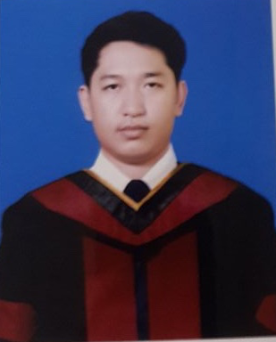
Sompong Rummaroj
272 Soi 32, Citizens 1 line Rd. Tel#: 087-937-8597
Bangsue Khet Bang Sue, Bangkok, 10800 E-mail: ce16.engineering @gmail.com

EDUCATION
2009 - 2015 Dhurakij Pundit University Bachelor of Engineering (Computer Engineering) GPA : 2.24

2007 - 2008 Ayutthaya technical college Major Communication Electronic
GPA : 2.42
EXPERIENCE
INTERNSHIP
- Studied and Developed Web Application (MVC) using PHP, HTML, CSS, Javascript, jQuery, SQL, Bootstrap framework, Laravel framework during the part 2-3 years. In the future, will gain more knowledge in Angular js, Node js, Express js, and datase in Mongo DB, oracle.
- Studied and Developed Android Application (MVC) using Java Object Oriented Programming with designed UI, UX of Android for the part 1-2 years.
- Studied and Developed IOS Application (MVC) using Objective-c, Swift for the part 1-2 years.
- Designed RESTful APIs (JSON) for Application Android, IOS, Web Service etc. using JSON which developed.
- Assemble Computer Pc and fixed Notebook with maintain the Computer system in the organization.
PROJECTS
- http://www.recyclevendingmachine.com (Web Application)
      - BarcodeScanning (Android Application)
      - Took data from RESTful APIs (JSON) showed in Android and other projects.
      - Took data from RESTful APIs (JSON) showed in IOS and other projects.
References (VDO Link Project Presented)
- https://drive.google.com/file/d/0B8TZ7y2S5DuqUXpsUTZfUjFDdWc/view?pref=2&pli=1
Job Position:
- Web Application Developer
- PHP Developer
- Front End Developer
- Full Stack JavaScript
- Android Developer
- IOS Developer

SKILLS
Programming/Languages:
Java, C, C#, PHP, MYSQL, HTML, Javascript, jQuery, Objective-c, Swift, Bootstrap framework, Laravel framework, etc.
API: JSON, XML.
Database: MySQL, Sqlite.
Design & IDE Tools: Android Studio, Sublime Text, Xcode, Visual Studio, Navicat, Sketch, Adobe Photoshop CC 2015, Adobe Dreamweaver CC 2015, etc.
REFERENCES
References will be sent on request

