RESUME  CHUKIAT JEARJESDAKUL  35/137 MOO 1, SEEVALEE VILLAGE, SOI 5/3, RATCHAPRUEK RD.  BANGKHUNKONG, BANGKRUAY, NONTHABURI 11130  TEL: 02-878-6137 CELL: 081-925-9090  CHUKIAT_TOR@HOTMAIL.COM | 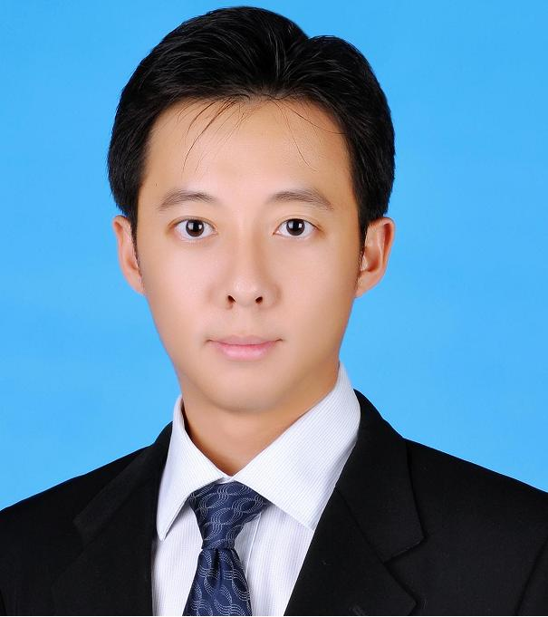
PERSONAL DETAIL
- Age: 40 (Date of birth: May 16, 1976), Male
- Marital Status: Married
- Height: 176 cm, Weight: 73 kg., Excellent health

EDUCATION
Master of Science in Economics, Kasetsart University, Bangkok, 2001
Bachelor of Engineering in Electronics, King Mongkut’s Institute of Technology Ladkrabang, 1996

BUSINESS EXPERIENCE
Area Director (Thailand, Malaysia, Singapore, India and Australia) for Retail Business and Managing Director, Wincor Nixdorf (Thailand) www.wincor-nixdorf.com
October 2014 - Present

- Responsible for Financial P&L for Retail business in the area (Thailand, Malaysia, Singapore, India and Australia). Business Size 50M USD. Reporting to VP Retail Business APAC.
- Manage Sales team of each country in the area.
- Grow Revenue /Profit and Business Development for Retail in the area.
- Responsible for Financial P&L for the entire business in Thailand (Banking, Retail and Services). Business Size 45M USD. Reporting to President Asia Pacific.
- Ensure the company achieve the target of revenue, EBITA, SG&A, Operating Cash Flow, Inventory, AR, etc
- People Management covering Sales, Operation, Services, Finance, Commercial, HR for 300+ staffs organization.
- Business and Strategy Development for both Banking and Retail Business.
- Board of Director and Country Speaker role.

Managing Director, Wincor Nixdorf (Thailand)
October 2013 – Present

- Responsible for Financial P&L for the entire business in Thailand (Banking, Retail and Services). Business Size 45M USD. Reporting to President Asia Pacific.
- Ensure the company achieve the target of revenue, EBITA, SG&A, Operating Cash Flow, Inventory, AR, etc.
- People Management covering Sales, Operation, Services, Finance, Commercial, HR for 300+ staffs organization.
- Business and Strategy Development for both Banking and Retail Business.
- Board of Director and Country Speaker role.

Achievements
- Grow the business volume 300% YOY in 2014
- Club of Excellence.

Area General Manager (Thailand/Malaysia), Wincor Nixdorf
October 2012 – September 2013

- Responsible for Financial P&L in the area (Thailand & Malaysia) for Retail Business
- Responsible for Revenue Target in the area (Thailand & Malaysia) for Retail Business
- Develops specific plans to ensure revenue growth in all company’s products, solutions and services.
- Ensure consistent, profitable growth in sales revenues through positive planning, deployment and management of sales personnel. Identifies objectives, strategies and action plans to improve short- and long-term sales and earnings.
- Country Manager & Country Speaker for Thailand. Manage all general staffs (Sales, Sales Support, Professional Services, HR, etc) in country.
- Assists sales personnel in establishing personal contact and rapport with C-level executives and decision makers.

Country Manager, IndoChina, Intermec Technologies Corporation, www.intermec.com
October 2009 – September 2012

- Country Manager responsible for Thailand, Laos, Cambodia, Myanmar and Vietnam. Report to General Manager, ASEAN.
- Manage Country Sales team including Channel Sales Managers, Enterprise Account Managers, System Engineers, Sales Support, Marketing, Post Sales Service, etc.
- Grow Country Revenue and Profit of all Intermec Product Portfolio, Grow channel partners (Value Added Distributor, Resellers, ISV, SI, Alliance) and Key Account Customer revenue.
- Build and maintain relationship with Executive customers, C Level.
- Increase market share and develop the business via Marketing, Sales Strategy, Brand Awareness, Channel Partners Program, etc.
- Collaborate cross functionally within Intermec Regionally (Product Marketing, Global Sales team, Engineering, Service, Finance, HR) in order to proceed the business.

Achievements
- Grow the business 100% in 2010 and 50+% in 2011.
- Appoint new VAD (Value Added Distributor), Grow new channel partners from 3 to 20+ partners, Build up the partner community such as ISV, SI, Telco partner.
- Successfully increase the Market Share from 20% to 50%

Territory Account Manager, Motorola Solution, Thailand, www.motorola.com
March 2008 – September 2009

- Works as Sales Manager responsible for Enterprise Mobility Business (EMB) products of Motorola in Thailand Territory.
- Handles Sales in all Key Account Customers (MNC) and Key Strategic Channel Partners.
- Achieve Country Quota and grow Motorola EMB's business.

Achievements
- Grow the business 20% in 2008 and 30% in 2009.
- Achieve the revenue target in 2008 and 2009.
- Grow Channel Partners from 20 to 30+ partners

Channel Business Manager, Intermec Technologies Corporation, www.intermec.com
January 2006 – February 2008

- Achieve annual Country Channel revenue for Thailand
- Support South Asia Sales Director with development and implementation of sales strategies for market in Thailand
- Create, develop and implement the partner channel program, ISV/SI program
- Recruit/Enable/Develop partner/channel in order to expand Thailand Market.
- Maintain the relationship with Intermec Alliance Partners such as Cisco, SAP, IBM, Oracle, etc.
- Business Development via marketing, sales strategy and partner in order to increase the revenue.
- Coordinate with regional product marketing team, field marketing team, service team.
- Identification of any potential Product Gaps in anticipating Thai accounts’ future directions and trends

Key Account Manager, Intermec Technologies Corporation : February 2004 – December 2005
- Achieve annual revenue quota set for Key Accounts in Thailand
- Develop partner/channel to expand the market and succeed in each account.
- Manage/Develop/Maintain the long term relationship directly with the key account customers in high level.
- Develop/Maintain Relationships with US & EMEA Global account teams to leverage relationships on a global basis

Some of successful Projects
- RFID Free Zone Cargo, New Bangkok International Airport
- RFID Project, Thailand Post
- Distribution Center and Store Operation System, Tesco Lotus
- Mobile Worker and 3rd Party Logistics Solution, TNT Logistics
- Route Sales Solution, Thai Nam Thip (Coca Cola)
- Warehouse Management, DHL Supply Chain Logistics
- Warehouse and Van Sales Solution, DKSH
- Presales IT Solution, Philip Morris (Thailand)
- Work in Process system, Nike Inc.
- Warehouse, Central Retail

Sales & Business Solution Manager, Application Software Div, Alcatel (Thailand),
www.alcatel.com : 40Fl, Ocean Tower II, Sukhumvit 19, Wattana, Bangkok, 2002 - 2004

- Responsible for the new services and applications for Fixed and Mobile Business in Thailand
- Selling to meet sale target and plan the marketing strategy for the relevant market
- Market activities evaluation for business development
- Build and maintain the customer relationship both low and high level and create the new opportunity for company
- Understand what customer has and what customer need, in order to deliver the best solutions which meet the customer requirement for both technical and financial.
- Manage commercial tendering information/quotation provision by Coordinate with working team in Europe and Australia.
- Product presentation to potential customer in term of Sales and Marketing
- Cooperate with Project Management Team to be success project on time

Some of successful Projects
- Intelligent Network System, TOT
- Mobile Network Expansion Phase III and IV, TA Orange
- VoIP Network with Multimedia Application, TT&T
- HutchSay Prepay Project, Hutch
- Push-To-Talk Service, Hutch
- IP Charging Gateway, AIS
- Prepaid extension project, AIS
- Local Direct Dialing (Roaming), CAT
- CDMA Network Expansion phase III, CAT
- Fraud Management System, CAT
- 3G Trial and Prepaid platform, TOT ThaiMobile
- Next Generation Network and Multimedia Application, TRUE
- Broadband TV Service, TRUE
- Push-To-Talk Service and IMS, DTAC

Sales Manager, AMR.Asia Co, Ltd., www.amrasia.com : Ayothaya Tower, Ratchadapisek Rd. Bangkok, 2001-2002
Assistant Sales Manager, AMR.Asia Co, Ltd., www.amrasia.com : 2000-2001

- Responsible for Telecom Account by focusing on CAT, TOT, SHIN, DTAC
- Selling to meet sale target and plan the marketing strategy for the relevant market.
- Build the customer relationship both low and high level especially the key customer.
- Manage proposals to customers, Prepare RFI, RFQ, RFP and bidding procedure.
- Cooperate with Project Management Team to be success project on time.

Senior Engineer, United Communication Industry Public Co, Ltd. (UCOM) Benchachinda Bldg. Vibhavadee Rangsit Rd. Bangkok, 1998-2000
Engineer, United Communication Industry Public Co, Ltd. (UCOM), 1996-1998

- Cooperate with Sales section to analyze a target market and plan the marketing strategy for the relevant market.
- Ascertain the optimal solution to be appropriate with customers’ requirement and be the technical consultant for customers.
- Manage technical proposals to customers.
- Supervise engineering system design including manpower motivation.
- Project Management to be success project on time

SPECIAL TRAINING
- Attended Target Account Selling Course (TAS), China in 2011
- Attended Channel Pro Training Course at Channel Enabler, Singapore in 2007
- Attended WCS (Winning Complex Sales) Training Course at Intermec Singapore in 2004/05
- Attended Product Training Course at Intermec Singapore in 2004/05/06/07
- Attended the Consultative Selling Training Program at Alcatel in 2003.
- Attended the Next Generation Network and Application Training Program at Alcatel University, Belgium, in 2003 for understanding the fundamental of NGN network and application.
- Attended the Introduction to Cisco Router Configuration Training Program by Cisco in 1999 for understanding how to design Router network
- Attended several engineering course at UCOM Training Center such as Transmission, Mobile network, Data Communication network, 1999

SPECIAL ACTIVITY
- Delegate Speaker (Round Table) at Supply Chain Asia @ Bangkok, January 2007
- Delegate Speaker for Asia Business Forum in Topic “RFID Development” @ Bangkok, November 2006
- Delegate Speaker at Bangkok International Logistics, September 2007
- Public Speaker in all seminar held by Intermec or Alliance Partners.
- Public Speaker in many seminar such as ICT Expo, Alcatel Seminar and TOT Seminar.
- Interview with the press for some of Alcatel’s event.

OTHER SKILLS
- LANGUAGE: Good command of English, written and spoken.
- COMPUTER SKILLS: Microsoft Office: Word, Excel, PowerPoint, Access, Visio
- PERSONALITY: Mature, Leadership, Creative, Innovative, Enthusiastic and Able to work hard under pressure

References
- Jansen Ek, Vice President & GM, Asia Pacific, Intermec Technologies Corporation. (Formerly Chief Operation Officer, ECS Holding and Vice President Asia Pacific, Silicon Graphics).
- Stuart Scott, Executive Vice President – Sales, Marketing and Product Development, SIMAT Technologies Thailand. (Formerly, Senior Director, Global Marketing, Intermec Technoglies).
- Gerard Baglieri, Vice President, Avaya USA. (Formerly Area Director, South Asia, Motorola)
- John Foragasi, Senior Director, Sales APAC, Motorola Asia Pacific.

