CURRICULUM VITAE

Name | 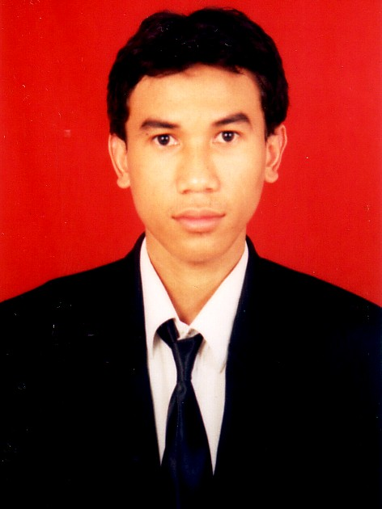  Firman Azizi
Place / Date of Birth | Selong / 19th October 1982
Address | Jl. Batu Raya No. 5 Rt. 003/007  Menteng Atas - Jakarta Selatan 12960
Country | Indonesia
Phone | +62 855 8401 604
Nationality | Indonesia
E-mail | firman01tc@gmail.com
Sex / Status | Male / Married
Year of Experience | 10 Years in IT and Telcomunication
Current Employer | PT. Ericsson Indonesia
Current Role | BSS Integration Engineer
Domain / Expertise | Charging System and PS Charging
Education | Bachelor’s Degree – Informatics Engineering

WORKING EXPERIENCE
General Overview

Period | Company | Role | Achievment
01.2013 – Now | PT. Ericsson Indonesia | BSS Service Engineer | Completed Some Projects for PT. Indosat and SingTel
01.2007 – 02.2013 | Nokia Siemens Networks – NSN Indonesia | Verification and Integration Project Leader, Verification and Integration Engineer | Completed Many Projects for Some Operators in Some Countries (APAC Region)
11.2005 – 10.2007 | PT. Siemens Indonesia | TAC2 Engineer | Completed Some Projects for PT. Indosat and PT. Telkomsel

Leadership Role Experience

Period | Company | Role | Customer | Project | Achievment
11.2012 – 01.2013 | NSN Indonesia | Verification and Integration Project Leader | Maxis Communications Bhd | SU-FU Migration (Charge@Once Select 1.7) | Completed Internal Testing
07.2010 – 02.2011 | NSN Indonesia | Verification and Integration Project Leader | SMART Philippines | Unlimited Call (Charge@Once Unified 3.0) | Successfully implemented

Overseas Working Experience (On Site)

Period | Company | Country | Customer | Project | Achievment
03.2014 – 04.2014 | PT. Ericsson Indonesia | Singapore | Singapore Telecommunication Limited | CR Project – Auto flush | Successfully implemented
08.2011 – 11.2013 | NSN Indonesia | Malaysia | DiGi Telecommunications Sdn. Bhd | Multi-Vendor Integration with ZTE | Successfully implemented
09.2010 – 07.2011 | NSN Indonesia | Philippines | SMART Communications | Unlimited Call, Sprint Project | Successfully implemented
05.2010 – 07.2010 | NSN Indonesia | Malaysia | Maxis Communications Bhd | Charge@One Select 1.7 Implementation | Successfully UAT
09.2009 – 10.2009 | NSN Indonesia | India | Vodafone India Limited | Mobile Number Portability Implementation | Successfully UAT
09.2008 – 12.2008 | NSN Indonesia | Germany | - | On Job Training for Charge@Unified | -

TRAINING
Soft Skill Training

Date | Provider | Course Name
01 – 03 Oct 2014 | Dunamis | 7 Habits of Highly Effective People
20 – 21 May 2014 | Daily Meaning | High Impact Communication

Technical Training

Date | Provider | Course Name
2007 | Siemens Training Center | CAMEL
2007 | Siemens Training Center | GSM Intro
2007 | Siemens Training Center, Poland | adapt@once 2.0 – Tariff Validator
2006 | Siemens Training Center | Enabling TAC3
2006 | Siemens Training Center, Poland | adapt@once 1.0 – Tariff Validator
2005 | Metrodata | Database Administration Fundamentals 1
2005 | Metrodata | SUN Solaris 8
2005 | Siemens Training Center | Intelligent Networks

CERTIFICATIONS

Efective Date | Expiration Date | Institution | Certificate
16.03.2015 | 16.03.2017 | Ericsson | MBC Professional – Ericsson Charging System Solution Implementation
22.12.2014 | 22.12.2016 | Ericsson | MBC Professional – Technical Solution Design

IT BACKGROUD
APPLICATION LAUNCHED in GOOGLE PLAY STORE

NAME | TYPE | CODE / LAUNCHED
Teka Teki Silang (TTS) Angka / Infinite Cross Numbers | Puzzle / Brain Game | Java / Dec 2015
Teka Teki Silang (TTS) Gambar / Infinite Fill It Ins Puzzle | Puzzle / Brain Game | Java / Mar 2016
Mencocokkan Gambar+ / Mind Matching Game | Puzzle / Mid Game | Java / May 2016

Personal Skills

Enable to work independently or as a team.
Enable to work under pressure with multiple task to meet the deadlines.
Enable to adapt in any situation.
Have strong will to learn any new things.

