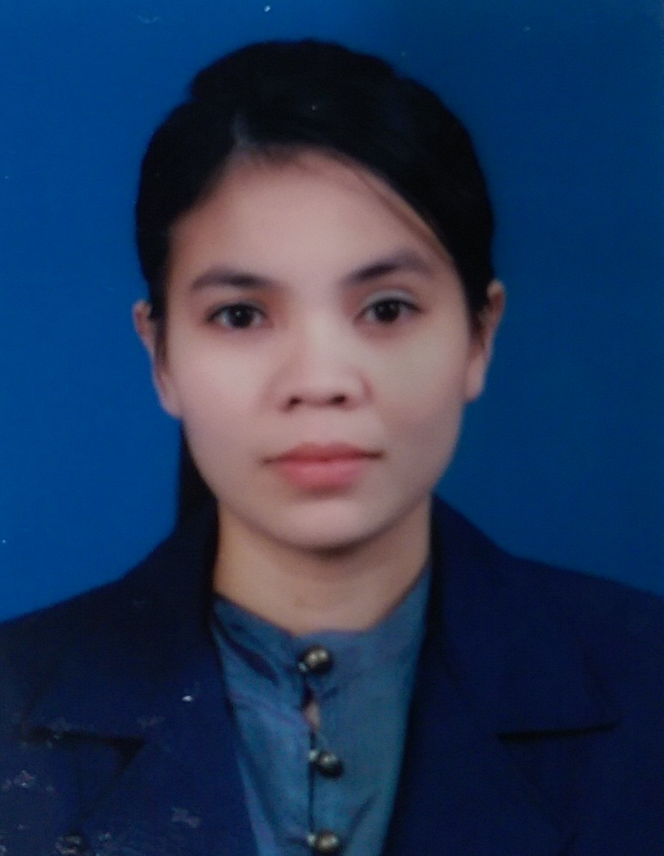
NURISUN BUERAHENG นูรีซัน บือราเฮง
Nationality: THAI  Date of Birth: July 17, 1982
Clinical Operation Manager – Hemodialysis
99/75 The Exclusive Onnut 74/3-1 Prawet, Bangkok 10250
Email: nuri_urami111@hotmail.com  (+668) 5906 - 2902

Professional Summary
Manages the overall operations for nursing services and patient care in Hemodialysis Center. Critical-thinking skills, communication skills, organizational skills, emotional stability, compassion and patience with various brand of hemodialysis machine, medical software, office suite software and spreadsheet software and paper-based.
Advance knowledge of hemodialysis equipment and procedures. Demonstrated ability to ensure provision of quality patient care in accordance with facility’s policies and procedures. Committed to maximize patient satisfaction through the delivery of passionate care in a specialized care environment. Making appropriate adjustments and modifications to the treatment plan with my core competencies are :
- Developing and maintaining effective relationships with patients and families
- Delivering safe and effective patient care with excellent problem solving skills
- Strong leadership and communication skills
Current Licenses and Certification
- Certification of Advance Dialysis Nurse Specialist from The nephrology society of Thailand 2014
- Certification in Nephrology Nursing (Dialysis Course) from Rajavithi Hospital
- Valid Registered Nursing License from Thailand Nursing and Midwifery Council
Education
2001 – 2004 | Bachelor of Nursing GPA 3.09 Prince of Songkla University – Songkhla, THAILAND
Professional Experiences
2011 - Present  Chularat 9 Hospital | Head of Hemodialysis Center (Clinical Manager)  Over 100 beds with HA Level 3 hospital. – Samutprakarn, TH  Patient Care Management  - Overseeing the entire clinical staff at Hemodialysis Center  - Make sure all Dialysis nurse follow proper protocol, and that all equipment is fully function.  - Handling patient complaints or issues, administering medications, scheduling nursing staff.  - On-duty call 24x7 for supervision support in case of emergency  Employee/Staff Management  - Provide work direction and scheduling for Dialysis Nurse and nursing assistant staff.  - Plan, Organize and Supervise and training Dialysis/Register Nurse and staff.  - Manage all staff personal human resource area such as performance evaluation, leave.  Risk Management/Quality Assurance Compliance  - Ensure compliance with standard procedure and protocol HA, ISO and JCI.  - Participate in quality assurance according to Hospital policies and procedures.  - Cooperate and assist with the internal/external audit process.  Facility/Equipment Management  - Ensure medical equipment, medical suppliers, medical inventory are maintained to provided quality care and safety. Ordering supplier when needs, accounting for medication used.  - Identified and plan prompt corrective action for any issue with hospital or equipment.  - Advance knowledge and troubleshooting skills RO Water Treatment System.
2009 – 2011  Chularat 3 Hospital | Senior Dialysis Nurse at Hemodialysis Center  Over 100 beds with HA Level 3 hospital. – Samutprakarn, TH  - Perform hemodialysis treatment according to Hemodialysis Center's policies and procedures.  - Developed plan of nursing care for each treatment and altered the dialysis management, based on standing and current physician’s orders.  - Documented appropriate information in the medical record per Hospital HA, ISO, JCI requirements.  - Scheduled patients’ dialysis treatment according to availability.  - Guided and provided comprehensive nursing care to patients through the dialysis treatment.
2008 – 2009  Vibharam Hospital | Dialysis Nurse at Hemodialysis Center  A private hospital 150 beds located on Phattanakarn Rd near Suvannaphumi. – Bangkok, TH  - Prepared dialyzer and bloodlines, recording patients' medical information and vital signs  - Oversaw dialysis treatment and cannulated accesses  - Monitored patients, adjusted specialized equipment, and interpreted and recorded information  - Provided pre- and post-procedure care to patients within the Hemodialysis Unit
2005 – 2007  Songkla-  Nakarind Hospital | ICU Registered Nurse at Intensive Care Unit  Medical school of south Songkla, TH  - Apply the nursing process to care of patients admitted to ICU section.  - Provided direct patient health care, and recorded information in logs on a regular basis.  - Ensure that all monitors and alarms are set and proper working.
Computer and Dialysis Machine Skills
Operating System | Window XP, Window 7
Office Tools | Microsoft Word, Microsoft Excel, Microsoft Power Point
Tools / Utilities | Internet WWW/HTTP, Search Engine – Google, Email – Hotmail/Gmail/Outlook, Fax
Dialysis Machine |  Fresenius  Gambro  Nipro  B.Braun  Nikkiso
Additional information
 Member of Thai Nephrology Nurse Association  Has own car with driver's license.
Languages
 Thai - Native Speaker  English – Good in the written and verbal skills  Malaysia
Training
2013 | All about Quality in Dialysis | Thai Nephrology Nurse Association
2013 | 7th Meeting of the Asian Forum of CKD Initiative | The Zign Pattaya, Chonburi, TH
2013 | Nephrology Board Review Course 2013 | Pullman Hotel Bangkok
2011 | Diversities in Dialysis | The Zign Pattaya, Chonburi, TH
2009 | Pave the way to seamless in RRT patients | Thai Nephrology Nurse Association
2007 | What’s New in Cardiovascular Diseases | Faculty of Nursing, Prince of Songkhla
2007 | Holistic care for abortion | Faculty of Nursing, Prince of Songkhla
2006 | Current Practice in Respiratory Care | Faculty of Nursing, Prince of Songkhla
References
Prof. Doctor Somchai Eiam-ong ( The President of The Nephrology Society of Thailand)
Relationship : Direct Manager

