Curriculum Vitae
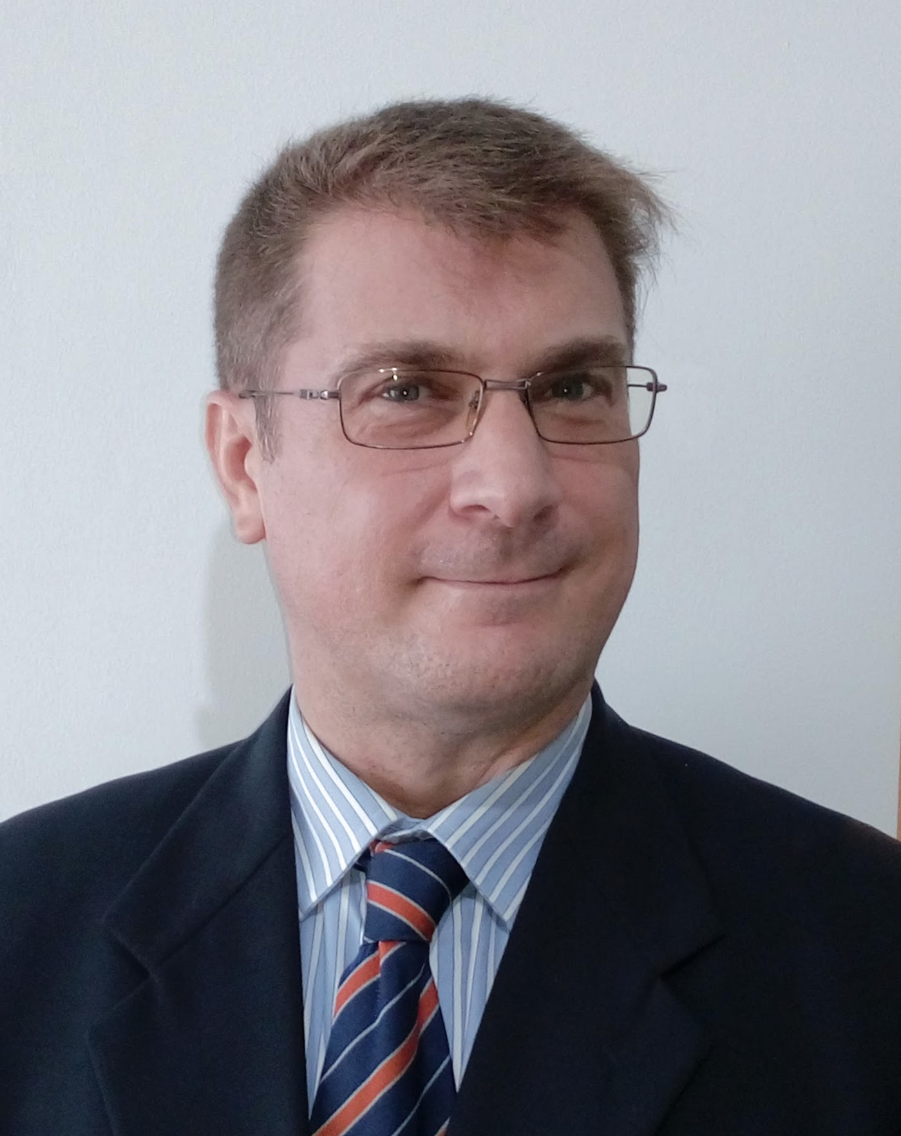 |  | Name |  | Paolo Marco Guarracino
 |  | Degree |  | Master in Economics and in Engineering
 |  | Nationality |  | Italian
 |  | Gender |  | Male
 |  | Address |  | 8, Patak Soi 20
 |  |  |  | Karon Beach, 83100 Phuket, Thailand
 |  | Telephone |  | +66 09 33485531
 |  | E-mail |  | Paolomarco.guarracino@fastwebnet.it
 |  | Skype ID |  | paologuarra
 |  | Online CV |  | www.linkedin.com/in/paolo-guarracino-1198a914
Professional Summary
I have a wide experience in Finance & Controlling that I have developed in several multinational companies. My career path crossed several industries, Telco, IT, Banking, and I was always successful in applying my methodology to improve the financial models and develop my teams.
I have a hands-on and focus-on-targets approach. I use to deal with complex scenario.
Skills Summary

FINANCE, RESOURCE MANAGEMENT, IFRS, CONTROLLING, MANAGEMENT REPORTING,
SYSTEM & TOOLS, IT SYSTEMS ROLLOUT, SAP R/3, KPI, CONSOLIDATION, DUE DILIGENCE, M&A, RISK MANAGEMENT, SOX, FINANCIAL PLANNING, COST OPTIMIZATION, MANAGEMENT CONSULTING
activities assure basis bid budget business communication contract coordination cost customer develop earned excellent execution experience flow implement improvement include interface internal leadership management matters member met performance pertaining plans preferred principles problems procedures program project proposal provide regulations reporting requirements reviews schedules senior skills subcontracts successful team understand value

Work Experience

2013 Jan -  2016 Apr |  | NTT DATA Deutschland GmbH
2013 Jan -  2016 Apr |  | Head of Corporate Controlling DACH  Achievements:  - From negative to positive Profit & Loss  - Re-organization of Controlling team  - Integration of several Legal Entity  - Implementation of BI system  Develop the Reporting and Controlling activities within the DACH region, Germany, Austria, Denmark and Romania, and in close contact with the EMEA Group. Implementation of a new Business Intelligence system based on the Board tool.  Improve Forecast accuracy and steering the Cost saving initiatives.  Develop the Finance team, both locally and remotely, coaching and levelling the tasks within the teams.  Drive the Finance and Controlling integration process of affiliated Companies of DACH region countries, including the rollout of SAP. Optimization of Treasury and Cash planning.  From Jan 2015 because of the critical situation in Austria subsidiary, I took over the local CFO that left the company, improving the Management Reporting and Internal SW Capitalization.
2012 Jan -  2012 Dec |  | NTT DATA Ha Noi – Vietnam  Finance Manager  Achievements:  - Acquisition of Vietnamese subsidiary  - Establish Management Reporting  In charge of a Merge & Acquisition project in order to acquire a subsidiary in Vietnam. Immediately after the Due Diligence I have managed all the financial and contractual aspects of this small but complex acquisition, with 36 selling shareholders: tight contract deadlines and difficulties in communication that I have successfully mitigated, also taking into account the “cultural distance” between the parties. After the completion, I have then driven the implementation of International Finance process and Reporting, designing and implementing the Management Report.
2010 Apr -  2011 Dec |  | Valueteam SpA  Business Consulting Manager  Achievements:  - Improved Controlling on Product  - Consulting on a major Italian Bank  Supporting the Controlling activities of the Finance Business Unit within Valueteam, an ICT company, with several Business Units organized on different markets.  Define and implement a new profitability model of financial SW product. Drive the capitalization of Intangible Assets, internally generated, according to IFRS rules.  Definition of new Business Plan for the next generation of a financial SW Product.  In parallel of the main controlling activity, I was asked to help on a strategic Project in a major Italian bank, Banca Mediolanum, as Responsible of Functional Analysis; the project consists in the implementation of a new Business Intelligence system, based on SAS, to implement Activity Base Costing analysis, innovative Product P&L and even Single Customer P&L.
2004 Oct -  2010 Apr |  | Nokia Siemens Networks S.p.A.  R&D Controlling Head  Achievements:  - Recover the P&L from negative to positive  - Integration of process and practices after JV  Finance & Control Responsible of all the Development Centres in Italy.  The volume of this unit is approximately 1200 headcounts with 100 Mio€ OPEX spending per year.  Managing a team composed by three employees and two consultants. Together with the institutional activities of Budgeting, Controlling, Reporting I have successfully lead my team in the complex phase of integration between Siemens and Nokia: implementation of a new accounting system, changing the process together with guarantee the SOX compliance, introduce a world-wide mode of operation instead of the local one. I have driven a specific cost optimization project on Real Estate expenses, covering all the Buildings located in North of Italy.
2000 Oct -  2004 Sep |  | Siemens S.p.A.  R&D Controller  Achievements:  - Improved Project Controlling and Reporting  Leading a group of 3 people, I was responsible of planning and tracking OPEX and CAPEX of the Research & Development of GSM/UMTS in Milan. When the Company re-organization took place, I have received also the responsibility of the Profit & Loss / Balance Sheet of the R&D area.
1997 Dec -  2000 Oct |  | Siemens ICN S.p.A.  Project Manager  Achievements:  - Implementation of timesheet system within a tight schedule  Responsible of Project Management for Telecommunication projects in the Research & Development function, in an international organization, with frequent travel abroad. In order to improve the Project Management, I have lead the implementation project of a new integrated IT System for planning, tracking, and control subsidized projects.
1997 Jul -  1997 Dec |  | Spazio ZeroUno S.p.A.  Project Manager Junior  Achievements:  - Fast acquisition of Project Management skills with training on the job.  - Excellent knowledge of MS Project  Project Management consultant assigned to the customer Italtel S.p.A., on complex Telecommunication Research & Development projects.

Education

2001  1996  1995  1988 |  | SDA Bocconi - Milano
2001  1996  1995  1988 |  | MBA – Administration & Controlling  POLITECNICO di Milano  State examination for Professional Engineering certificate  POLITECNICO di Milano  Master in Electronic Engineering – Automation  Scientific High School
Languages
Italian English French German
Native Fluent Intermediate Basic
Other courses
Economic: “ACE – Achieving Finance & Controlling Excellence”
Management: “Leading Intercultural Teams”, “Communicate”, “Team Building”, “S4 Management Learning”

Hobbies
I like technology, motorbike, swim, windsurf, diving.

