**MR. CHONG SIONG**

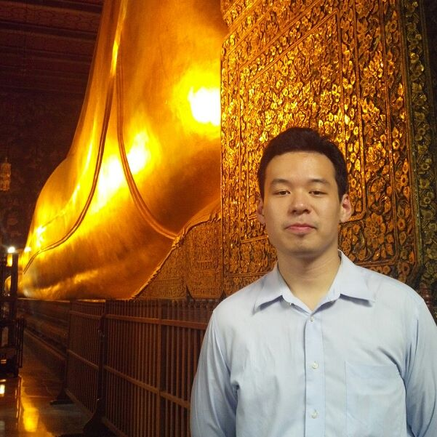

Tel: +669-10509997 (Thai Number)

Email: [chongdotcom@gmail.com](mailto:chongdotcom@gmail.com)

Address: 7 Lorong Datuk Sulaiman 8, Taman Tun Dr Ismail, 60000 Kuala Lumpur, Malaysia.

Born 16th July 1988, Chinese Malaysian

________________________________________________________________________________________

**PROFESSIONAL EXPERIENCE**

Nov 2015 – Present **Country Manager Thailand** at **EZBUY.com (65daigou.com)**

Bangkok Set up business, manage operations, marketing for the venture.

Jul 2015 – Nov 2015 **Head of Performance Marketing for Mobile, Search & Mobile App** at **Middle**

Dubai & Tehran **East Internet Group (MEIG.com)**

Oversee marketing campaigns. Hire & train marketers. Working on partnerships & open new channels to grow customer base and brand reach.

Mar 2015 – Jul 2015 **Marketing Director, Asia** at **Easy Taxi (Rocket Internet SE)**

Singapore Oversaw campaigns for Email Marketing and Social Media. Pitched and closed marketing partnerships with major brands for countries under Asian cluster.

Jul 2014 – Mar 2015 **Global SEM & Google Products Manager** at **Easy Taxi (Rocket Internet SE)**

Singapore Managed Google Search Ads, Display Ads, and Mobile Ads. Also work with other search engines such as Bing, Naver, & Daum. Familiar with AdX, AdJust tracking solutions. Developed strategies, processes, tools, and performance & analytical reports, to streamline all marketing activities.

Jun 2013 – Jul 2014 **SEM Manager for Malaysia** at **Lazada Group (Rocket Internet SE)**

Bangkok Advised and also QC-ed Indonesia, Philippines and Singapore ventures.

Familiar with the technical workings of Adwords, Bing, Google Analytics, Google Adwords Editor, Adobe Adlens (Efficient Frontier), Webtrekk and running analysis on campaigns. Gained many insights on the “Dos and Don’ts” of digital marketing.

Jan 2012 - May 2013 **Day Trader**

Kuala Lumpur Speculating on KLSE and Foreign Exchange. Made a lot of money, and lost even more. Published technical and fundamental analysis of the stock market online.

Jul 2011 - Aug 2011 **Intern** at **Maestro Capital Sdn Bhd**

Kuala Lumpur Assist the main partners in analysis on the market as well as preparing pitch packets. Handled projects in the Investor Services industry, and assisted in analysis by pouring through financial data in annual reports of all listed companies in Malaysia.

Nov 2010 - Jun 2011 **Cofounder** at **Buzztreats.com**

Kuala Lumpur Started a group buying site, which targeted the same clientele as other daily deals website such as Groupon. The main dealmaker amongst the partners. Successfully worked together with a number of local and international companies.

Aug 2010 - Oct 2010 **Relationship Marketing Executive** at **Standard Chartered Bank Malaysia**

Kuala Lumpur Gained many clients through aggressive cold-calling and follow-up. Recognized as the top acquisitions executive. Improved workplace efficiency and coached colleagues.

**EDUCATION**

**University of Nottingham, 2010 -** BA (Hons) Finance, Accounting & Management. Minoring in Marketing Studies. Graduated 2nd Class Upper (2-1)

**SMK Taman Tun Dr Ismail, 2005 -** SPM examinations (O Levels Equivalent), 5A1s

**LANGUAGES**

Native in English & Malay; Conversable in Chinese; Learning Thai