# WHO I AM CONTACT

I am **Rami CHELLALI.** I am a Frontend Developer & Graphic Designer. Currently live and work in Bangkok, Thailand. I’ve a Master’s degree in Computer Science & MBA in Marketing Management**.** Also I’m a Social Media Guru & do SEO works.

(+66)095.560.33.74

Line id: ramos.nihonto [chellali.rami@gmail.com](mailto:chellali.rami@gmail.com) Bangkok - Thailand

# EDUCATION EXPERIENCE

2014

Team Leader / Frontend Developer

Team Leader Frontend Developer and SEO **From** Oct14 **To** Present [www.softcontrol.net](http://www.softcontrol.net/)

2013 Full Stack Developer Frontend and Backend Developer

**From** Nov’13 **To** Sept14 [www.ze.co.th](http://www.ze.co.th/)

Training in a Competency Based Approach

International Institute of management

Dec’12

# 2012

MBA Training Manager

International Institute of management

**From** Sept’11 **To** Dec’12

Director of Studies, Education and Pedagogy

Master’s Degree in Computer Science

Bejaia University

**From** Sept’08 **To** Jul’11 [Major: Network and

Distributed Systems]

CISCO CCNA 4

Graduated with Honors

**From** Jan’10 ToJun’11

MBA in Marketing Management

Paris Graduated School of Management

**From** Nov’09 **To** Dec’10

# 2011

2010

International Institute of management

**From** Jun’12 **To** Aug’12

Math Teacher

Individual courses (High school level)

**From** Sept’10 **To** Jun’11 Freelance Job

Full Stack Web Developer

Graphic & Web Designer Social Media Manager SEO

**From** Jun’11 **To** Present

Bachelor in Computer Science

Bejaia University

**From** Sept’05 **To** Jul’08

# SKILLS

2008

Internship

(Software Developer)

Transit Agency Guesmia and Co

**From** Apr’08 **To** Jun’08

85%

Front-End (Html5, CSS3, JavaScript, Responsive, Sass, Gulp, Node.JS, Angular.JS)

75%

Adobe Creative Suit (Photoshop, Illustrator, InDesign, Fireworks)

65%

PhP, WordPress, Joomla, YII (Install, conﬁgure customize)

60%

Project Management, Team leading

# LANGUAGES

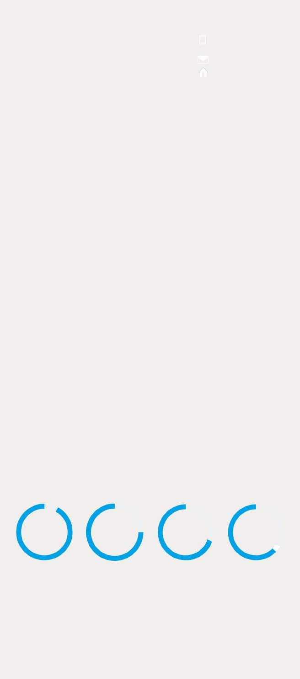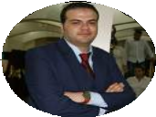

English French

Arabic

Thai (basic)

# HOBBIES & ACTIVITIES

Open source enthusiastic, music addict, sport passionate, android admirer, traveler, adventurous