**RIDHO RUDIANSYAH MARBUN**

JL. Hangtuah Dusun IX Desa Tj. Rejo Kec. Percut Sei Tuan Deli Serdang

Sumatera Utara - Indonesia

ridhorudiansyah21@gmail.com

+6281375510481

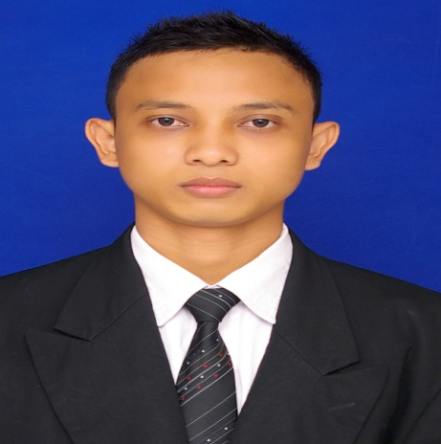

**Career objective**

To be an electromedical engineering in a Multinational company

**Education**

Diploma (D3) of Medical Engineering in Yayasan Binalita Sudama Medan (2007 – 2010),

Cumlaude with GPA 3.33

**Work Experience**

Field Service Engineering in PT. Murti Indah Sentosa (Supplier of medical, hospital and dental equipment) Oktober 18th, 2010 – April 16th, 2016

* Installation, rapairing and maintenance of product unit (Radiology, ICU, Cardiac, Physiotherapy, etc)
* Installation, and maintenance network of medical equipment, Picture Archiving and Communication (PACS) System, Radiology Information System (RIS) and Hospital Information System (HIS)
* Maintaining good relationships with customer

**Skill**

Cumputer skill

* Office
* Networking
* Repairing (Hardware – Software)

Language

* Bahasa Indonesia
* English