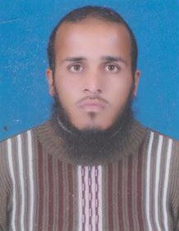**Zahid Ullah**

Resume

Address: Village Mirdil Banda, P.O Jahangiri Banda Tehsil Takhti Nasrati Distt Karak

Contact: +92-345-3045594

E-mail: zahidullah594@gmail.com

## dabbi **OBJECTIVE**

## To seek challenging position in an organization with an aim to contribute positively towards its objectives to the best knwoledge abilities and skills and to serve with honestly intergrity and diligence with the firm belief that the entity growth and success would be my own.

## dabbi **PERSONAL INFORMATION**

* Father’s Name : Muhammad Zarin
* Date of Birth : 08-04-1990
* CNIC : 14203-1184723-1
* Religion : Islam
* Marital Status : single
* Gender : Male
* Nationality : Pakistani

dabbi **ACADEMIC QUALIFICATION**

* B.Com (Hons) Gomal University D.I Khan
* D.Com Tehcnical Board peshawar
* Matric Kohat Board
* DIT Trade Testing Board Peshawar

dabbi **COMPUTER & OTHER SKILLS**

* **Basic Computer Applications**
* **Internet Browsing**

dabbi **LANGUAGES**

* English
* Urdu
* Pashto

dabbi **REFERENCE**

* Should be furnished on demand.