BioCube
Testing the sensors
This project was done on a Rasperry Pi using Rasperian - commands may differ if on a different operating system
This project will also be using the Arduino Uno R3 model
Moisture Sensor(MH-Sensor-Series Flying-Fish)
This code will read in moisture on a scale from 0 - 100. 100 = pure water, 0 = dry air:

void setup() {
Serial.begin(9600);
}
void loop() {
float sensorValue = analogRead(A2);
float voltage = -(((sensorValue - 520) / 2)-100);
Serial.println(voltage);
delay(500);
}

VCC = 3.3V
GND = Ground
AO (analog output) = A2

Temperature/Pressure Sensor (BMP180)
Connect wires from:
3v(on sensor) to 3.3v on arduino
GND to GND
SCL to A5 (analog input slot 5)
SDA to A4
Download arduino library from https://github.com/adafruit/Adafruit-BMP085-Library.git
Rename the zip file to: Adafruit_BMP085
Open command prompt and run the following command:
sudo mv /home/pi/Downloads/Adafruit_BMP085 /usr/share/arduino/libraries
Open the arduino IDE and enter the following code:

#include <Wire.h>
#include <Adafruit_BMP085.h>

Adafruit_BMP085 bmp;
float temp;
int Pressure;
void setup() {
Serial.begin(9600);
bmp.begin();
}
void loop() {
temp=bmp.readTemperature();
Pressure=bmp.readPressure();
Serial.println(temp);
Serial.println(Pressure);
delay(500);
}

Open the serial monitor from the Sketch tab in the IDE and make sure that it displays the pressure and temperature every half a second.

Creating the core programs
The core program is a python script that is the brain of the operation. It will control what sensor is active at certain times. It is also what will be storing the information to see if any changes need to happen.
Open a python script (if you do not have python installed see a tutorial on how to download python (I am using python 2.7))
First type in the following code (this code is the beginning of the core code, although :

Import serial

Ser = serial.Serial(“/dev/ttyACM0”, 9600)
ser.write(‘1’)
Temp = (ser.readline())
print(float(int(temp,16))/10)

First we need to import serial - this is so we can communicate with the arduino through a serial connection (usb).
Ser = serial.Serial() is used to tell the program that we will be communicated through a serial connection - in the parenthesis you name what port you are using and the baud.
ser.write(‘1’) is used to write to the arduino the character one. We will be using this to call a specific function in the arduino code.
Temp = str(ser.readline()) sets the variable “temp” equal to the string from the input buffer
printf(float(int(temp,16))/10) is used to convert the hex value from the arduino back into a float value
Next is the Arduino code
Type in the following code(this will only work if you followed the previous steps on testing sensors)
First download the time library ( we will be using this later in the tutorial, but I did it now).
You can download this library from here: http://www.meccanismocomplesso.org/wp-content/uploads/2016/02/Time.zip
Go to the destination it was downloaded from and extract it the run the following command in the command promt: sudo mv /home/pi/Downloads/Time /usr/share/arduino/libraries
Now type in the following code:
#include <stdlib.h>
#include <string.h>
#include <Time.h>
#include <TimeLib.h>
#include <Wire.h>
#include <Adafruit_BMP085.h>
//create an object of adafruit to use sensors
Adafruit_BMP085 bmp;
int temp = 0;
int check;

void setup(){
//Set listening frequency
Serial.begin(9600);
//setting up bmp library
bmp.begin();
pinMode(13,OUTPUT); // test
}

int findtemperature(){
int temp;

//read value from sensor - get info from pressure/temperature sensor
temp = bmp.readTemperature() * 10;
return temp;
}

void loop(){
while(1) // continously execute
{
// read command from pi - check for number from raspberry pi, get next sensor info
check = Serial.read();

// temperature info block
if(check=='1'){
temp = findtemperature();
//Serial.write(temp, DEC); //Displays on the arduino screen

Serial.flush();

//send hex info - sends the hex version of the statement to the raspberyy pi
Serial.println(temp,HEX);

Serial.flush();

// check for execute - makes sure the code executes based off of the flashing of an led
digitalWrite(13, HIGH);

check = '0';
}
The code explained:
This code will send data through the USB in HEXadecimal - It is configured to do so only when the Raspberry pi first sends it the CHARACTER: 1. (NOT AN INTEGER).
This is used so we can include more functions later on with strings instead of just a character (this is so it makes more sense). Thus when the Raspberry pi sends the character 1 through the serial port specified into the arduino and the arduino will read it into an integer and this program will check to see if that variable is equal to a certain character and if it is - it will run certain commands (this is what the if() statement does).
within the if statement we set the variable “temp” equal to a function that is called earlier in the program called findtemperature.
This function does not require any parameters but sets a variable within the function equal to “bmp.findTemperature”. This is a function from the BMP library we installed earlier.
This essentially goes to the sensor and reads its input and converts it to a float value with one decimal in Celsius.
To remove the decimal (because we cannot transfer a float between the arduino and raspberry pi) we multiply it by 10. We then simply return the value back to the main function and it is equal to our original variable “temp”.
Serial.flush() is a function used to clear the buffer in the serial port. If this is not used the arduino will at times return random values and characters and mess up your values. Thus we use it before and after sending data (to make sure the buffer is clear in the future).
serial.println(temp,HEX) function - this simply sends the data from the variable “temp” to the raspberry pi in hexadecimal. We then set the variable used originally to check what character the raspberry pi sent back to ‘0’. Otherwise it would still equal ‘1’ and infinitely run and find the temperature forever. At the end of the function we also have it set so that a led plugged into pin13 will turn on - telling us that the arduino code was executed. (this was and can be used to trouble-shoot issues with the code on either end and help find where the issue is taking place in either code).

Let’s test it
Upload the arduino code into the arduino and give it a second to load everything. Then save and run the python code - you should get a value that reads something like “22.6”. That is the current temperature in Celsius.
Now that this works we can move onto creating functions to lower the amount of code in the future.

Making Functions and simplifying the code (for future use)
We could just rewrite our previous code for every sensor we add, although this creates an issue of memory on the arduino and speed on the raspberry pi. It also makes the code much longer and more confusing. So we will be adding functions to do the work for us and use less code and make the program run faster.
Our first method of tackling this problem was a complete conversion to and from hex using functions to communicate from and to the arduino although there was an issue with this method. We consistently had the problem of trying to convert an entire block of a hex string to a ascii string.
The simplest way to do so, which we did not realize at the time, would be to send each character over individually and convert it from hex to ascii. By doing this, instead of trying to convert it all together would be simpler because we would have the option of doing hex → int → char. Which is the inverse of what we did to send the text over initially, char → int → hex.

#Python - Failed Method
#Requires to many steps to make it viable, one could separate it into blocks of 4 characters using a for loop and convert it back to ascii one at a time
#Or a person could pass an entire array and cycle through it with a for loop
def convertToHex(string):
converted = ''
for c in string:
converted += hex(ord(c))
return converted

#Newer Method
def convertToHex(string):
converted = []
for c in string:
converted += [hex(ord(c))]
return converted

//Arduino
String HexToAscii(hex){
int arrLen = sizeof(hex) / sizeOf(char);
for(i = 0; i < arrLen; i++){
text += (char) hex[i];
}
}

Or the simpler method
#Python - Pass each character one at a time
def convertToHex(string):
converted = ''
for c in string:
Serial.write( hex(ord(c)))

//Arduino
String HexToAscii():
String text = “”;
//So long as there is input, take the next character
while(Serial.available() > 0){
//Get character
String hex = Serial.read();
text = text + (char)numHex;
return text;
}
Another option is the use of strtol(string str, char** endptr, int base) which can convert a string into a numerical value of the desired base. The first parameter of str is the text in which you want to change to a numerical value.
strtol (Str str, char *endptr, int base);

When we realized we could send strings over using Serial.readString(), we began using that and terminated our hex to ascii functions. The getData function remains though, now using the direct name of the sensor as to probe for data from the arduino. The use of a direct name in place of the prior “(char) int” makes the code more legible and easier to debug. As of now, a person does not need to map each “(char) int” to the intended action but instead can now use the name of the sensor as the method of calling the function.

#Python
def getData(command):
#command = convertToHex(command)
#print(command)
ser.write(command)
temp = ser.readline()
#print(temp)
# (convert to ((float ( convert from hex to int )) / 10) temperature in celcius
#temp = float(int(temp,16))/10
return float(temp)/10
To now read the info, the Serial.readString() is used. This takes the data directly from the input buffer in String form and assigns it to check. This is how we removed the hex to ascii functions entirely.
//Arduino
//Get data from input buffer - Sent by Pi
String check = Serial.readString();

Reading all three sensors
Now that we can read temperature we will adapt our python code and arduino code to check for temperature, pressure and moisture. To do this we will just add functions in the arduino program and call them in the python program.
First call for two new integers, one for moisture and one for pressure before the setup function:
Int pressure;
Int moisture;
go to the arduino program and go right below the temperature function and create two functions:
Int findPressure(){}
Int findMoisture(){}
then go down to the loop where we check to see what the input is from the raspberry pi.
Create another if statement to check for the string “pressure” and another if statement to check for “moisture”:
If (check == “pressure”){}
if(check == “moisture”){}
In the pressure if statement lets set the integer pressure equal to the function (the function will not need any parameters:
Pressure = findPressure();
Then clear the buffer with the flush function
Serial.flush();
Then send the data to the raspberry pi:
Serial.println(pressure);
Clear the buffer again just to be safe in the future;
Now we will write the function findPressure()
In this function we will first need to call for an integer named pressure:
Int pressure;
Set this variable equal to the sensor reading of pressure:
Pressure = bmp.readPressure();
Then return the pressure variable back to the main loop:
Return pressure;
For the moisture if statement just copy and paste the pressure if statement and change all the words “pressure” to “moisture”:
if(check==”moisture”){
Moisture = findMoisture();
Serial.flush();
Serial.println(moisture);
Serial.flush();
}
Now we will move to the python program
Above the getData for temperature add a while loop that will loop infinitely - this is to constantly check all of the conditions:
while(1):
Then simply type in the following commands to request for data from the arduino:
Pressure = getData(“pressure”)
Print “pressure:”, pressure
Moisture = getData(“moisture”)
Print “moisture”, moisture
To get the temperature to print right after it is requested and received type in the following directly below the temperature = getData(“temperature”):
Print “Temperature:”, temperature
Now upload the arduino program into the arduino and connect the moisture sensor with the same wire configuration as we used in the test for the sensor. Run the python program and you should get results that should look like:
Temperature: 72.3
Pressure: 27589.0
Moisture: 2.0

Setting up 2nd arduino to change conditions
Here we will be setting up a second arduino so that if we want specific conditions we can change them with things such as heaters or coolers.
First we need to find the port that is being used by the second arduino.
Plug in the second arduino and in the IDE go to the Tools tab and on the Serial Port you should see two ports that are options. Use the port that wasn’t the first arduino.
Just like the first arduino we need to set up in the python program that we are going to write to this serial port so create a variable named ser2 and set it equal to the port just like we did with the first arduino:
ser2 = serial.Serial(“/dev/ttyACM1”, 9600)
Under the getData function for temp create and if statement and check for a condition. Since my room is currently at 71 degrees F I set my condition to check if temp is higher than 75 degrees:
Temperature = getData(“temperature”)
if(temperature > 75):
ser2.write(“high”)
Else:
ser2.write(“low”)
This will simply check if the temperature is above or below 75 degrees, if it is above it will send the string “high” to the second arduino, if it is below 75 degrees it will send the string “low” to the arduino.
Now we will move to the arduino code. Because this is a test we will just plug a led in pin 13 on the arduino to check if the arduino is reading “high” or “low”
Our code will look like this (Next Page):

#include <stdlib.h>
#include <string.h>

String check;

void setup(){
Serial.begin(9600);
pinMode(13,OUTPUT);
}
void loop(){
while(1){
check = String(Serial.readString());

if(check == "high"){
digitalWrite(13,HIGH);
check = "none";
}

if(check == "low"){
digitalWrite(13,LOW);
check = "none";
}

}
}

In this code we use pretty much all the same concepts as the first arduino code so I will not go in depth with any of the serial functions or libraries.
In the void loop(){} we are simply checking if the input from the raspberry pi was high or low and if it high then the led that we plugged in will turn on until the sensor on the first arduino reads that the condition has changed, then the raspberry pi will send the string “low” telling the second arduino to turn the led off for the time being.

Defining Classes and Objects
class Sensor:
def __init__ (self, name):
self.name = name;
self.value = 0;
self.array = [0] * 5;
self.averageVal = 0;

def addValue(self, number):
self.value = number
self.arrayValue()

def arrayValue(self):
self.array.pop(0)
self.array.append(self.value)

def average(self):
total = 0;
for x in self.array:
total += x;
self.averageVal = total / len(self.array);
return float("%.3f" % self.averageVal)

def stats(self):
return self.name+":"+" "+str(self.value)

For the following steps, we created a class called Sensor as to organize and control variables more easily. Prior, each sensor would use multiple individual variables and would have to be named differently for each Sensor. The use of a Class allows for Objects to be created. Each Object represents a unique and independent Sensor. Objects are derived from a Class, and Objects of the same Class can contain the same variables. Variables can be Class Variables which are globally shared (none being used here) or variables can be Instance Variables which are locally stored within the Object. Instance Variables can be duplicated throughout the Objects without affecting one another. Class Variables, if changed in Object, will change for all other Objects derived from the same Class.

Objects from Classes contain “ self ” variables. self variables are representative of the Object. This is the equivalent of saying - You are holding a piece of paper. You are self, and the piece of paper is the instance object. If a friend of yours also was holding a piece of paper, your paper would be different from his paper. But when I address you, by saying “your paper” in code it would be “self.paper” and when i say “your paper ” to your friend, in code it would be written “self.paper” - Even though they both use the same variables, self represents the Object we are speaking to. So the instance of the paper depends on which person we are speaking to. The same works in this code. By declaring temperature = Sensor(“Temperature”) and pressure = Sensor(“Pressure”), we are creating two different sensors, both having their own unique values but executing the same code. If i assign temperature.num the value of 5 “temperature.num = 5” and pressure the value of 10 “pressure.num = 10,” temperature.num would be 5 and pressure.num would be 10. But to temperature, when calling the variable it would not appear as temperature.num = 5 rather it would be self.num = 5. Because to temperature, itself has the value 5. And to pressure.num, pressure.num itself has the value of 10. That is a heavily repetitive long winded explanation of a recurring event in the code below. The Objects of the Class Sensor use self to call instance variables. So self.name is an instance variable relative only to the object it was created in. temperature.name would be “temperature” because the instance variable only refers to itself. pressure.name would be “pressure” because the self.name is referring to the pressure object in this instance and not the temperature object.

def __init__(self) will automatically execute each time a new object is created from the class. self will always represent the object as the first parameter. It is not possible to have a function in an object of a class that does not have at least one parameter reserved for “self.” In the example below __init__ holds two parameters: the first for the instance object itself, and the second for the “name” of the instance object. Parameters declared during the __init__ function must be included in the parameters of the class when it is being assigned. ex: moisture = Sensor(name). Although it appears the only parameter is “name,” the object declaration counts as the first parameter (self) and “name” is the second parameter being declared. All variables within the __init__ function are declared and initialized when the function __init__ is first executed.

Objects deriving from Classes inherit the functions and variables of the Parent Class. This means all the functions in Sensor, will be carried over to objects derived from Sensor, such as temperature and pressure. So addValue(n) would be referred to as name.addValue(n), name being the object that is derived from the Sensor Class. And getInfo would be name.getInfo(). getInfo only accepts self as a parameter and does not need any additional input to make it work. getValue will return the name and value of the sensor for a print statement.

Class Sensor is the class that is being used to define all the objects we are using for the sensors.
class Sensor:

The following functions are all functions of the class Sensor, and use the information of the given object when executing.

__init__ automatically executes when the object is first declared but still needs the name of the sensor as to meet the second parameter requirement. ex: moisture = Sensor(“Moisture”);

//Automatically executes when an object is declared
def __init__ (self, name):
//All variables below are created by this function

Here, self.name is declared and initialized using the second parameter being assigned as name

self.name = name;

Here self.value is being initialized to 0, no real purpose

self.value = 0;

Here self.array is being initialized to be able to hold only 5 numbers at a time, this is done for the average later on. In the average, the current length we are using is 5 characters only, if you so choose, you can change the value here and the rest of the code will change to match this change on its own

self.array = [0] * 5;

No real purpose for declaring averageVal as 0. Just for legibility.

self.averageVal = 0;

Sets the last value of addValue to the number in the parameter and calls the arrayValue function.

def addValue(self, number):
self.value = number
self.arrayValue()

arrayValue removes the oldest or the variable at the front and appends on the newest variable, which is “self.value”

def arrayValue(self):
self.array.pop(0) // removes oldest
self.array.append(self.value) //adds newest

Calculates the average of the array in the object. It does so by taking the total length of the array and going through each number in the array adding them together. It takes the total and divides it by the length ( total / len(array) ) to get the average temperature over the past 5 intervals.

def average(self):
total = 0;
for x in self.array:
total += x;
self.averageVal = total / len(self.array);
return float("%.3f" % self.averageVal)

Returns the name and last known value to be printed out by a print statement.
def getInfo(self):
return self.name+":"+" "+str(self.value)

Setting up the LCD screen
The original intent of the LCD screen is to take information from the input arduino and transfer it to the raspberry pi and then send the data to the output arduino and then display it from there. This did not work however due to time - it turns out that displaying data to the lcd takes a LONG TIME. I assume this is due to the many pins that data is going through for it to display on the lcd and the program will not move on until the data was displayed properly. What would happen is that the data would be sent for all three sensor from the input arduino so fast that by the time the data for temperature was being displayed - the input arduino would already be on the next cycle calculated temperature again. This would then result in an output that would look like this:

So we took an alternative route and now display the data directly off of the input arduino
Connect: pin 11 of the LCD display (D4) > pin 9 of the Arduino (PWM)
Connect: pin 12 of the LCD display (D5) > pin 10 of the Arduino (PWM)
Connect: pin 13 of the LCD display (D6) > pin 11 of the Arduino (PWM)
Connect: pin 14 of the LCD display (D7) > pin 12 of the Arduino (PWM)
This is the schematic:
o right before it is sent to the raspberry pi. So here is what we did:
First we connected the wires to where they need to go:
Connect: GND row (min) on breadboard > pin 1 on LCD (VSS)
Connect: +5v row (plus) on breadboard > pin 2 on LCD (VDD)
Connect: +5v row (plus) on breadboard > pin 15 on LCD (A)
Connect: GND row (min) on breadboard > pin 16 on LCD (K)
If the arduino is o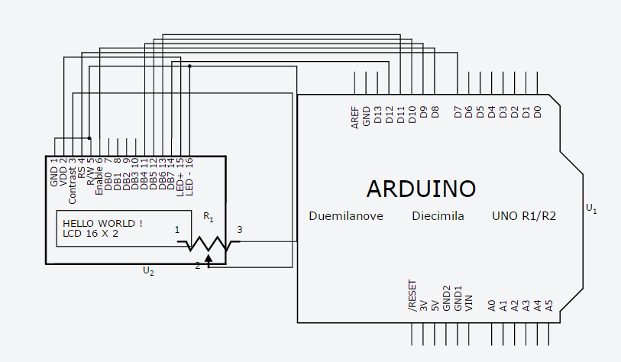n the backlight should turn on on the lcd screen
Connect: first pin of a 50 ohm potentiometer > GND of the breadboard
Connect: middle pin of the potmeter > pin 3 of the LCD display (VO)
Connect: pin 4 of the LCD display (RS) > pin 7 of the Arduino
Connect: pin 5 of the LCD display (RW) > GND row of the breadboard
Connect: pin 6 of the LCD display (E) > pin 8 of the Arduino (PWM)
If there is power the lcd should display some white boxes - if you cannot see them then change the value on the potentiometer until they are white.
Now we will move to the code:
First we need to include the library for the lcd:
#include <LiquidCrystal.h>
LiquidCrystal lcd(7,8,9,10,11,12);
This second line of code is used to tell the arduino where the lcd screen is hooked up to so that it knows where to send the data when it is going to use it.
Now we will move to the void setup(){} function and type the following to set up the lcd screen:
lcd.begin();
lcd.begin(16,2);
lcd.setCursor(0,0);
lcd.blink();
lcd.write(“READY”);
To explain - the lcd.begin functions do exactly what they sounds like - tell the arduino that the lcd should turn on. The second begin function has the parameters of 16 and 2. These are positional parameters telling the arduino that the lcd screen can only hold a max of 16 characters per row and the lcd screen has 2 rows.
lcd.setCurstor(0,0); puts the cursor on the first position on the first row.
lcd.blink() is not needed but helps determine what the lcd screen is doing - it makes the cursor blink.
Lastly lcd.write(“READY”) sends the string “READY” to the lcd screen and will display READY
Upload the code and wait - check to make sure that the lcd screen says “READY” - if it doesn’t then check the code AND the wiring, if a cord is not plugged in all the way or in the wrong spot it can ruin everything.
Now to the actual code in the program.
What we chose to do was to display the data on the lcd screen after the if statement was called and the variable was found, although if you wanted to make the code simpler you could create a function with the same content - which I might do later on, but will not explain it in this. So the code that I am using will look like this (I will use temperature for the example, but for the other three sensors it is a simple copy and paste with changing one of the print statements.
If (check == “temperature”){
Temp = findtemperature(check);
lcd.clear();
lcd.print(temperature: “);
delay(5);
lcd.setCursor(0,1);
lcd.print(((((float) temp /10) * 9 / 5) + 32));
Serial.flush();
Serial.println(temp);
Serial.flush();
Check = “0”;
}
NOTE: the lcd.print(temp) statement with all the calculations is used to convert the Celsius that the sensor reads to fahrenheit (because I know fahrenheit more than I know celsius and it makes it easier to read to me)
lcd.clear() is a function that resets the lcd screen completely and sets the cursor to the position (0,0)
Another note is that positions work like this (column, row) so the position (0,1) would be the way left on the bottom row.
lcd.print(“temperature: “) simply prints that string to the lcd
Delays are used due to the length of time it takes for the arduino to send information to the lcd and for the lcd to display the information. If there is no delays here then there is a very high potential that the program will have the same errors as it did when we tried to display the data on the output arduino.
lcd.setCursor(0,1) sets the cursor on the bottom row so that the numbers are on the bottom row
lcd.print(temp) is used to print the data - we use print here instead or write since we dealing with integer and float values instead of a string.
In the end the complete arduino code at this point looks like this:
#include <stdlib.h>
#include <string.h>
#include <Time.h>
#include <TimeLib.h>
#include <Wire.h>
#include <Adafruit_BMP085.h>
#include <LiquidCrystal.h>
LiquidCrystal lcd(7,8,9,10,11,12);
//create an object of adafruit to use sensors
Adafruit_BMP085 bmp;
int temp = 0;
int pressure = 0;
int moisture = 0;
String check;
//check = 0;

void setup(){

//Set listening frequency
Serial.begin(9600);
//setting up bmp library
bmp.begin();
lcd.begin(16,2);
lcd.setCursor(0,0);
lcd.blink();
lcd.write("READY");
}
int findtemperature(String check){
int temp;
//read value from sensor - get info from pressure/temperature sensor
temp = bmp.readTemperature() * 10;
//lcdwrite(check, temp);
return temp;
}
int findpressure(){
int pressure;
pressure=bmp.readPressure();
return pressure;
}
int findmoisture(){
float sensorValue = analogRead(A2);
float moisture = sensorValue;
return moisture;
}
void loop(){
while(1) // continously execute
{
//String check;
check = String(Serial.readString());
Serial.flush();
// read command from pi - check for number from raspberry pi, get next sensor info
//String check = String(Serial.readString());

// temperature info block
if(check == "temperature"){
temp = findtemperature(check);
//Serial.write(temp, DEC); //Displays on the arduino screen
lcd.clear();
lcd.print("temperature: ");
delay(5);
lcd.setCursor(0,1);
lcd.print(((((float) temp/10)* 9 / 5) + 32));
Serial.flush();
//send hex info - sends the hex version of the statement to the raspberyy pi
Serial.println(temp);
Serial.flush();
// check for execute - makes sure the code executes based off of the flashing of an led
check = "0";
}
if(check == "pressure"){

pressure = findpressure();
lcd.clear();
lcd.print("Pressure: ");
delay(5);
lcd.setCursor(0,1);
lcd.print(pressure);
Serial.flush();
Serial.println(pressure);
Serial.flush();
check = "0";
}

if(check == "moisture"){
moisture = findmoisture();
lcd.clear();
lcd.print("Moisture: ");
delay(5);
lcd.setCursor(0,1);
lcd.print(moisture);
Serial.flush();
Serial.println(moisture);
Serial.flush();
check = "0";
}
}
}

Creating the BioCube’s Cube
For the beginning parts we used a 3D printer - although you do not need one - we just use it to make the overall appearance better and more flush.
The 3D designs are what we will begin with.
First we made a 3D print out of the LCD cover - here are the dimensions of the print:
NOTE: you will want to make more clearance otherwise you will be sanding for a while (just add 1mm to each side)
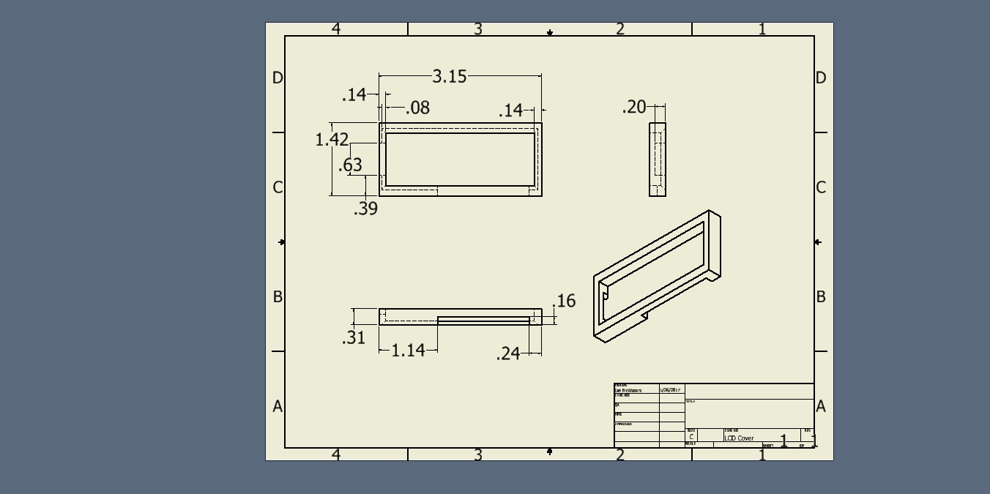Fron
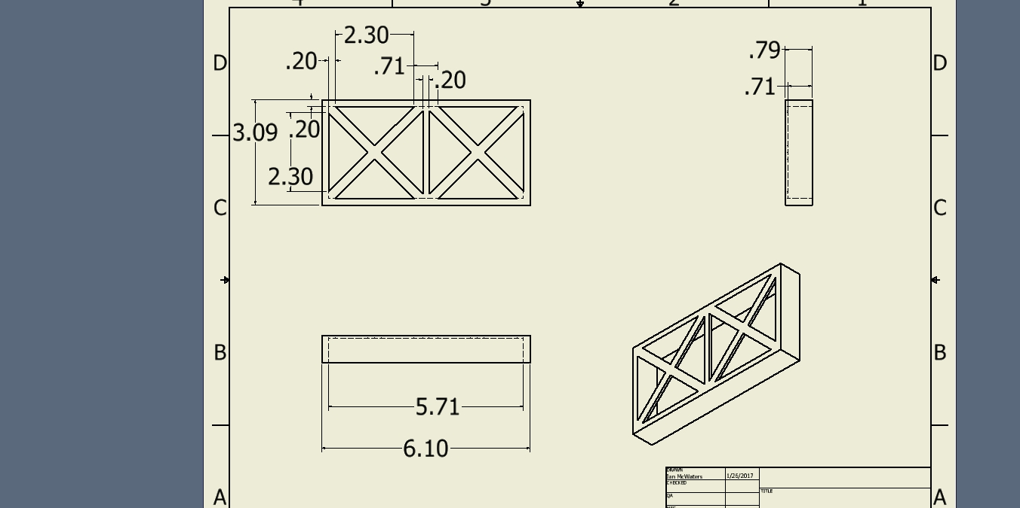

The next sections are the sides of the box. The box uses interior walls made of plexiglass on 5 sides. On the outside of the plexiglass is wood, acting as an insulator as to control the temperature more. On the bottom of the box is where the electronics such as the raspberry pi and arduinos will be stored. The bottom of the box is detachable as to access electronics. Inside the box are two hollow poles sticking up, these are connected to the bottom of the box will be used for heating the entirety of the box. On the Front, a slot is cut out to display the lcd screen. On the Back a slot is cut out for the fan. The fan will intake air and push it through the box out of a slot cut out on the right side.
Front
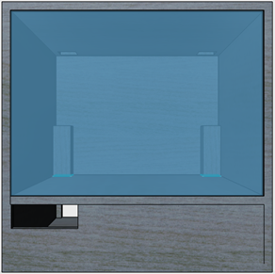
Right
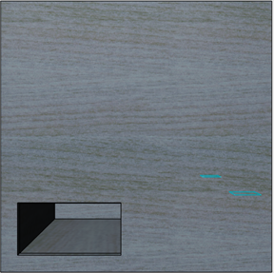

Back
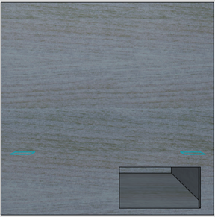
Left

Top - you will need to cut holes in the top, we do not include these because they will be the size of your heat sinks you decide to use for the thermoelectric cooling modules.
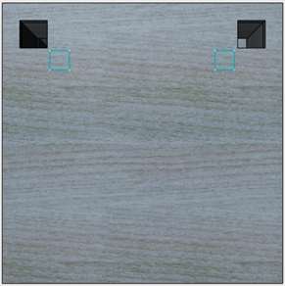
Bottom
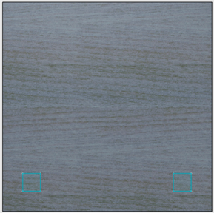
Inside

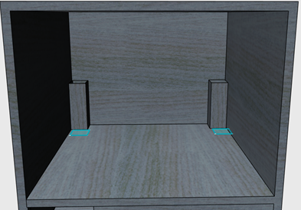

Building The Box
During the time we were building the box, we did not have the proper tools for it. For a saw, we used the wood cutter on a multitool. To start the cuts, we used a dremel and a drill bit. At times we tried using a cutter on the demel as well, the results were less than satisfactory and the side effects of it were too problematic. The dremel we had, was high speed-low torque and we kept it at the lowest setting possible which only made matters worst. When uses a cutting edge on the dremel, the lines were very jagged, took some time to even start the cut, the cutting edge radius was not large enough to cut through all the wood and the dremel would get heat up to a point where wearing work gloves was not enough to allows us to handle it and we would throw it in a freezer for forty minutes. So following this,we started using a drill bit. We would drill a hole using the dremel and then continue widening the hole by moving the drill bit around inside of the hole. Once the hole was wide enough to fit the wood cutter in, we began hacking away at the wood with it. This was overall more effective than cutting the wood using the cutting edge on the dremel. In the process of cutting the wood, the wood cutter would become really hot. When stuck in water, it would steam, and when placed on a person’s skin would brand them speaking strictly from experience. After the cut was made, we would switch over to a grinder head for the dremel to smooth it the cuts we have just made and cut away any of the remaining wood in the slot. Majority of the cuts were made this way. Afterwards the placement of the power supply and desired hole for the exhaust of it were measured out, using a breadboard as a unit of measurement. The holes for the exhaust was made the same way we would to start a cut. Drill out the hole using a drill bit and then proceed to widen the hole by moving the same drill bit around in the hole. At one point we tried to use a different tool that seemed to be more well designed for the job to make things faster. We later learned the tool was a metal grinder, and that would start a fire immediately after using. But it was fine, because this all happened in our dorm, where there are no clear rules online or in the student handbook that said we could not use power tools or start fires. The only rules that came close to it, was no open flame, no vandalizing, and no threatening other people with dangerous objects. None of which we violated, because the fire extinguished itself. Anything beyond that, we plead ignorance as there were no rules mentioned in an easily accessible way nor were did the housing contracts require us to know of any such rules. We pulled half of the charred smoking metal grinder out from the hole and pushed the other half all the way through. The wood around the area is now charred and black. At that moment we remembered the two things a teacher told us “You are going to start a fire with that power supply” and when we asked the teacher about using power tools in the dorms, the teacher responded with “Don’t get caught.” Once all the holes were made, we secured in the power supply and started plugging all the wires in (explained in the next section), started up the fans and plugged what we needed to into the breadboards. Once that was done, we threw a lid over the top, and let it run to see if any problems came out of it. Several hours later, there was wisps of smoke coming out of the lid, upon removing the lid, smoke poured out from the breadboard, apparently 12 volts into a breadboard with multiple electronics drawing electricity out of it would cause the plastic to melt and the metal to brown. After doing some math we needed a 10 gauge wire, about 17 times as thick as the wire we were using before, to prevent the problem from happening again. The 10 gauge wire was too thick to plug directly into the 12 volt slot of the power supply, so the dremel with a cutting head was used to thin down the copper wire until it would fit.

Electronics In The Base
The green wire on the P1 connector, is the receiver wire. By taking a male to male wire and connecting the green wire slot on the P1 to a ground (black wire) slot, all the slots on the P1 power supply will be charged with a voltage. A switch is used on the front end of our box to connect the receiver (green) wire and the adjacent black wire. Red wires on the P1 connector represent 5 volts, orange 12 volts, blue to be determined at a future date. Heating Cooling units have been attached to the the top of the box along with heat sinks attached to both sides. Heat sinks have been connected using thermal conductive paste on the center and super glue on the sides of the heat sink (Top side only). On the bottom of the heating cooling units, heat sinks have been attached using thermal conductive glue, regular glue will not properly conduct heat through it and out to the heat sink. The heating side faces upwards away from the plant on the top side with the heatsink attached to it. Wires are being run up the back left corner of the cube to power on the heating-cooling units as well as the fans above the the heatsinks attached to the heating cooling units. 3D printed rails sit beneath the heat sink on the interior of the box helping hold the heating cooling unit in place along with a screw going through wood into the side of the heat sink to keep it in place. A switch has been installed, this allows the Raspberry Pi(s) to communicate with one another as well as the internet. The switch has two soldered on wires, connect to the pins of where you would plug in power supply. This is to get around needing to use a plug in place of using our already installed power supply. The switch, Pi(s) and the arduinos have all been installed onto the box. The Pi(s) being in a case, were super glued directly to the bottom of the box. But the arduinos with exposed pins were super glued to foam first, and than onto the bottom of the box. The same has been done for the switch. An ethernet cable has been connected with a keystone and has been slotted into the box facing outward, so it can be connected to the internet. The lcd screen has been mounted on the front of the box where it will display the information about the internals of the BioCube. A wire on the lcd screen tends to come loose, so we will probably super glue them all together soon to prevent it from continuing to happen. Lights have been installed on the inner top of the box in strips, following a pattern of one blue for every four reds on each strip. A total of five strips are being used. The lights are powered on using a 12 volt power supply on the positive end of light and ground on any of the remaining three places, R/G/B. All lights power on accordingly, and are connected to one another with wires stemming from the first light. If one Light strip were to come undone, all following light strips will fail, but all light strips prior will continue to function. The reflective sides of the box effectively send light at all angles all over the box, effectively there is no wrong place to place the plant at the moment. A hollow tube has been installed, going through lid of the box. The tube is meant to water the plants, and will have small slits cut into it to release water. The tube extends from an Arizona jug filled with water and exits back into the handle of the jug. The top of the Arizona jug was cut off to be able to fit the water pump into it. On one end of the tube, there is a water pump, submerged, pushing water through the tubes. The water pump is hooked up to a 12 volt supply. Because our water pump is pushing the water against the force of gravity, the pump is using 12 volts in place of 5 volts. Tape is currently connecting two tubes together, a mistake was made and to remedy it the use of tape and super glue to connect them back together has been used. Hinges have been attached to the lid from the back of the box to make lifting the lid easier to lift up and place back down. Short-wide cylinder pegs have been 3D printed to suspend the box above the ground. This is due to the power supply exhaust being on the bottom of the box and needing to push out the hot air unrestricted. Wires are currently having a tendency to fall out of the P1 power connector, use of super glue is currently being considered, other methods may be used. A solution will be used at a later date.

