ANTHROPOMETRIC CORRELATES OF HAND GRIP STRENGTH AMONG FEMALE NURSING STUDENTS

¹Adebisi I. Hammed, M Sc. & ²Oghumu S. Nicholas, M Sc.
¹Department of Human Kinetics and Sports Science, University of Benin, Benin City, Nigeria
²Department of Physiotherapy, School of Post-graduate Studies, University of Lagos, Nigeria
Email address for correspondence: aiadebisi@yahoo.com

Abstract: Nursing profession entails some skills or procedures that require the use of high grip strength. This study investigated anthropometric correlates of hand grip strength (HGS) among female nursing students. A total of 145 female nursing students participated in this study. Electronic handgrip dynamometer was used to measure HGS in kg, body height and body weight were measured with a wall–mounted stadiometer in meters and bathroom weighing scale in kg respectively. Participants were then categorized into four groups as underweight BMI ≤18.5 kg/m², normal weight BMI 18.5-24.9 kg/m², overweight BMI 24.9-29.9 kg/m² and obesity BMI ≥ 30.0 kg/m². Relationship between HGS and anthropometric parameters (body height, body weight, BMI and handedness) was analyzed using Pearson’s Product Moment Correlation. Then, differences in HGS across categories of BMI were analyzed using one way analysis of variance. The outcome of this study indicated that of all the anthropometric parameters correlated, only body height relates poorly and insignificantly (p> 0.05) with HGS. However, body weight, BMI and handedness were all found to associate positively and significantly (p<0.05) with HGS. This study therefore concluded that the most important determinants of HGS among female nursing students are body weight, BMI and handedness and thus, should be taken into consideration in nursing training and practice.
Keywords: Anthropometric parameters, handgrip strength and female nursing students

INTRODUCTION
The nursing profession entails execution of some skills or procedures that require high physical body strength and involving the use of handgrip. This is because hand functionality is considered to be vital in most of the tasks involving upper limb. Handgrip strength (HGS) has long been thought of as a possible predictor of overall body strength (Smith, Smith, Martin, Henry, Weeks, & Bryant, 2006). HGS is a physiological variable that is affected by a number of factors including age, gender, handedness, body height and body weight among others (Baskaran, Arindam, Chandan & Bidhan, 2010). HGS, a form of isometric (static contraction) test is a reliable clinical measure that could be used to assess the physical fitness and nutritional status of an individual. It is the most common assessment method to measure the upper extremity muscle strength. The term HGS refers to the force of hand grasp and is usually measured isometrically using a dynamometer held in the participant’s hand which is squeezed as hard as possible. The high physical demands associated with lifting, bathing, weighing, undressing/dressing, repositioning, making an occupied bed, changing absorbent pad when bed is occupied, feeding a bed-ridden patient (frequent part of nursing care in any patient environment) and transferring patients who are getting heavier are probably the main reasons of high HGS demand among practicing and training nurses. In the past, nursing schools taught that body mechanics (i.e., specialized positioning of the caregiver’s body) could protect against injury during manual handling procedures. However, research has shown that body mechanics alone is not protective without body strength (Nelson, Motaki & Menzel, 2009; Kneafsey, 2000).
Muscle strength is impaired in overweight or obese persons and this impairment may be a consequence of both sedentary lifestyle and low physical fitness. Moreover, reduced muscular strength has been found to associate with low body weight and poor nutritional status. However, most prior studies have attempted to associate HGS with some anthropometric variables to predict the outcome of the former (Mandahawi, Imrhan, Al-Shobaki & Sarder, 2008). It has been affirmed that factors such as gender, age, height, weight, and handedness affect HGS performance (Deepak, Laxmikant & Rasika, 2014; Liao, 2014). In 2007, Visnapuu and Jurimae submitted that body weight and stature (body height) are primary indicators of human growth, and concluded that there are highly significant relationships between maximal HGS of the dominant hand and general anthropometric variables in all age groups. In effect, many HGS studies in young healthy adults have revealed that body height, body weight, body mass index (BMI), hand length and grip span are positively associated with HGS (Vaz, Hunsberger & Diffey, 2002). It has also been reported that physical performance has a strong association with body strength, shape, size, form and structure of an individual (Foo, 2007). In addition, Das and Dutta (2015) reported a significant positive correlation between BMI and HGS and handgrip endurance in different weight groups among apparently healthy males and females. In 2014, Bansode, Borse and Yadav found a significant positive relationship of dominant hand’s grip strength with age, body height, body weight, BMI and hand span of dominant hand in adult males and females. Meanwhile, Lee, Kim, Paik, Jang, Chang, Baek and Gong (2012) concluded that HGS is mainly influenced by age and height in both men and women, and additionally by BMI in men only among Koreans. Furthermore, Gunther, Burger and Rickert (2008) stated that among anthropometric variables, grip strength was correlated best with height in both gender, and weight was associated in men, but not in women among Caucasians. However, Silventoinen, Magnusson and Tynelius (2008) established positive association between HGS and height, weight, and BMI in both sexes in a study among Swedish population.
Several studies have been conducted to bring forth the relationship of anthropometric parameters with HGS. Nevertheless, it is also worth noting that measurements of anthropometric parameters are never the same across individuals and communities in the same country and neither are they the same across countries. For this reason, the relationship of anthropometric parameters with HGS may not be the same as found elsewhere. This study was therefore, aims at investigating the association of HGS with anthropometric parameters among female nursing students.
Research hypotheses
The following hypotheses were formulated and tested at 0.05 alpha level
- There will be no significant relationship between body height and HGS among female nursing students.
- Body weight would have no significant association with HGS among female nursing students.
- There will be no significant relationship between BMI and HGS among female nursing students.
- Hand dominance (handedness) would not significantly correlate with HGS among female nursing students.
- Categories of BMI will not significantly influence HGS among female nursing students.
METHODS
Research design
This study is a correlational survey design of anthropometric correlates of HGS among female nursing students.
Population
The population for this study included female nursing students between the biological ages of 18 to 35 years from three nursing schools in the 2015/2016 academic session in Oyo State, Nigeria.
Sample size and sampling technique
A total of one hundred and forty five (145) female nursing students participated in this study. They were recruited using proportionate random sampling technique. However, participants with any joint problems of hand, wrist and elbow, history of fracture, neurological disorder, and deformities of upper limb were excluded from the study.
Data collection procedure
The study received ethical approval from Research Ethics Committee of University of Benin for permission to conduct this study and the subjects were then recruited consecutively. HGS was measured using a Camry Electronic Hand Dynamometer (Model: EH101). It comes with dual scale readout of forces in kilograms and pounds. However all readings were recorded in kilograms in the present study. To standardize the test, the following guidelines were established; the arm positioning followed the American Society of Hand Therapists guidelines, with the subject comfortably seated with the shoulder slightly forward and the elbow flexed at a 90° angle. The forearm and wrist were in a neutral position. Three maximum efforts were performed alternately for each arm, with three-second contractions and ten-second rest periods between the attempts. The best of three attempts was recorded. The following test instructions were provided: “you must squeeze the handle as hard as possible keeping both your body and arm in position”. The same tone was used during the briefings, and no verbal encouragement was offered. The instrument calibration was assessed periodically throughout the study. Also, hand dominance (the one which is preferred for daily activities such as writing and eating) were recorded.
The standing heights were measured using a stadiometer. Each participant was assessed while in good standing posture on the foot resting on the device with minimal clothing without shoes but with the head facing forward in front font position. The subjects also had the shoulders relaxed, arms hanging loosely on both sides, palms facing forward, feet together and knees straight. The height for each participant was taken when the movable headboard was lowered to touch the crown of the head. The measurements were taken to the nearest 0.1cm. The calibrated weighing scale was used to measure body weight and was checked for zero balance before each use. Participants were instructed to empty their pockets and remove shoes and any apparel that could interfere with weight measurements. They then stood on the scale looking straight ahead, relaxed and remained motionless without leaning on any object or the wall. Weight measurements were taken when the scale stabilized and recorded to the nearest 0.1kg while protecting the confidentiality of the participants’ values. BMI was then calculated using the formula weight (kg)/height (m) ². According to World Health Organization classification of BMI, participants were then categorized into four groups as underweight BMI ≤18.5 kg/m², normal weight BMI 18.5-24.9 kg/m², overweight BMI 24.9-29.9 kg/m² and obesity BMI ≥ 30.0 kg/m².
Data analysis procedure
The data obtained from this study were analyzed using descriptive and inferential statistics. Anthropometric profile of participants was summarized using mean and standard deviation. Relationship of HGS with BMI, body weight, body height, and handedness were analyzed using Pearson Product Moment Correlation. Then, differences in HGS across categories of BMI were analyzed using one way analysis of variance. All inferential analyses were performed at 0.05 alpha levels using the Statistical Package for the Social Sciences (SPSS) version 20.0.
RESULTS
The results are presented in Tables 1-4.
The results show the mean and standard deviation values for the body height (BH), body weight (BW), body mass index (BMI), dominant handgrip strength (DHGS) and non dominant handgrip strength (NDHGS) are 1.60±0.60m, 55.77±4.86kg, 21.94±2.39kg/m², 11.10±1.73 and 10.85±1.70 respectively as shown in Table 1 and Figure 1. The descriptive statistics showing the mean, standard deviation and standard error values for BMI categories are as shown in Table 2 and Figure 2. The correlations of anthropometric parameters with HGS are showed in Table 3, while Table 4 is the ANOVA summary table for differences in HGS across classes of BMI.
Table 1: Descriptive statistics for total samples (N=145)
 | Minimum | Maximum | Mean | Std. Deviation
Age | 16.00 | 25.00 | 19.55 | 1.98
BH | 1.48 | 1.72 | 1.60 | .06
BW | 46.00 | 67.00 | 55.77 | 4.86
BMI | 16.63 | 30.18 | 21.94 | 2.39
DHGS | 7.60 | 14.20 | 11.10 | 1.73
NDHGS | 7.20 | 14.00 | 10.85 | 1.70
BH-body height, BW-body weight, BMI-body mass index, DHGS- dominant handgrip strength, NDHGS non dominant handgrip strength
Table 2: Descriptive statistics for BMI categories
 | N | Mean | Std. Deviation | Std. Error
Underweight | 3 | 17.19 | .70 | .40
Normal weight | 126 | 21.48 | 1.72 | .15
Overweight | 15 | 26.20 | 1.12 | .29
Obesity | 1 | 30.18 | - | -
Total | 145 | 21.94 | 2.39 | .20

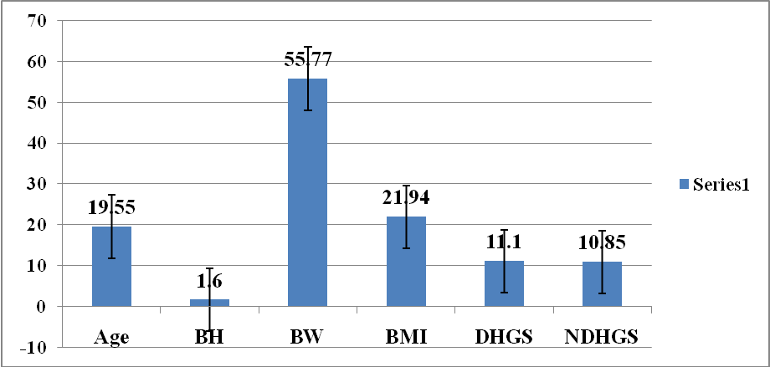
BH-body height, BW-body weight, BMI-body mass index, DHGS- dominant handgrip strength, NDHGS non dominant handgrip strength
Figure 1: Graphical representation showing the mean and standard error values of the studied parameters

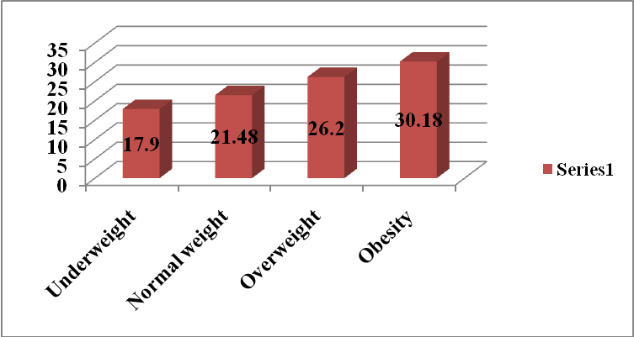
Figure 2: Graphical representation showing the mean values of BMI categories

Table 3: Correlations of participants’ anthropometric parameters with HGS
 | Age | BH | BW | BMI | DHGS | NDHGS
Age | 1 | .062 | .176* | .117 | .291** | .319**
Age |  | .455 | .034 | .162 | .000 | .000
BH | .062 | 1 | .143 | -.578** | -.125 | -.160
BH | .455 |  | .086 | .000 | .134 | .054
BW | .176* | .143 | 1 | .722** | .279** | .280**
BW | .034 | .086 |  | .000 | .001 | .001
BMI | .117 | -.578** | .722** | 1 | .316** | .340**
BMI | .162 | .000 | .000 |  | .000 | .000
DHGS | .291** | -.125 | .279** | .316** | 1 | .949**
DHGS | .000 | .134 | .001 | .000 |  | .000
NDHGS | .319** | -.160 | .280** | .340** | .949** | 1
NDHGS | .000 | .054 | .001 | .000 | .000
BH-body height, BW-body weight, BMI-body mass index, DHGS- dominant handgrip strength, NDHGS non dominant handgrip strength
** Correlation is significant at 0.01 level (2-tailed)
*Correlation is significant at 0.05 level (2-tailed)
Table 4: ANOVA summary table for differences in HGS across categories of BMI
 | Sum of Squares | Df | Mean Square | F | Sig.
Between Groups | 434.995 | 3 | 144.998 | 52.875 | .000
Within Groups | 386.662 | 141 | 2.742
Total | 821.656 | 144

Hypotheses testing

Hypothesis 1
There will be no significant relationship between body height and HGS among female nursing students.
It was observed from this study that a disproportionate (DHGS, r=-.125; NDHGS, r=-.160) and insignificant (p>0.05) relationship exists between body height and HGS and therefore, H_{O} was retained. This implies that height is not a predictor of HGS among female nursing students and any relationship noticed can be attributed to chance factor.
Hypothesis 2
Body weight would have no significant association with HGS among female nursing students.
Findings from this study however indicated that there is proportionate (DHGS, r=.279; NDHGS, r=.280) and significant (p<0.05) relationship between body weight and HGS; hence the H_{O} was rejected. This implies that being weighty does influence HGS among female nursing students.
Hypothesis 3
There will be no significant relationship between BMI and HGS among female nursing students.
This study showed that BMI is a proportionate (DHGS, r=.316; NDHGS, r=.340) and significant (p<0.05) correlate of HGS and therefore the H_{O} was rejected. This is an indication that BMI is a determinant of HGS among female nursing students.
Hypothesis 4
Hand dominance (handedness) would not significantly correlate with HGS among female nursing students.
It was observed from this study that a proportionate (r=.947) and significant (p<0.05) difference exists between DHGS and NDHGS. Therefore, H_{O} was rejected, implying that handedness is a determinant of HGS among female nursing students.
Hypothesis 5
Categories of BMI will not significantly influence HGS among female nursing students.
It was observed from this study that significant difference (p<0.05) exists in HGS across categories of BMI. Hence, H_{O} was rejected, implying that differences across BMI categories do predict HGS among female nursing students.
DISCUSSION OF FINDINGS
The principal outcome of this study indicated that of all the anthropometric parameters investigated only body height was not significantly correlated with HGS. Factors such as body weight, BMI and handedness associated proportionately and significantly with HGS. Body height was found in this study to have a disproportionate and insignificant relationship with HGS. This is in contrast to the study of Visnapuu and Jurimae (2007) and Lee, Kim, Paik, Jang, Chang, Baek and Gong (2012) that indicated body height as a primary indicator of human growth and highly significantly associated with HGS in all age groups. This contrasting finding might not be unconnected to variation in study methodology including subject characteristics, differences in measuring instruments of HGS etc. Therefore, according to this study being taller is not a predictor of better HGS and vice versa.
Contrarily to body height, body weight was found to have a significant and proportionate relationship with HGS, indicating that being weighty does influence HGS among female nursing students. This might be as a result of higher percentage of skeletal muscle mass but not percentage fat mass which can largely be responsible for body heaviness thereby resulting in better or higher HGS. This by implication means that nursing students who are weighty are at advantage because weighing, transferring and repositioning of heavy patients demand high HGS among practicing and training nurses. Previous studies have reported similar findings that body weight influences HGS among young individuals (Deepak, Laxmikant & Rasika, 2014; Visnapuu & Jurimae, 2007; Bansode, Borses & Yadav, 2014). In contrast, the study of Gunlter, Burger and Rickert (2008) showed that HGS correlated best with body height in both gender and body weight was correlated in men, but not in women with HGS among Caucasians. This contrasting finding could simply be as a result of subject characteristics of being black individuals.
This study also suggests that BMI influences HGS. Related studies showed that low BMI is associated with poor HGS and vice versa (Vas, Hunsberger & Diffey, 2002; Das & Dulta, 2015). The finding of this study could simply reflect the sexual dimorphism, due to the action of sex steroid hormones that is, female gender as the root of initial episode of low BMI simply because of large percentage of fat mass (adiposity). The implication of this is that having higher BMI could be an advantage for nursing students in the proper execution of some skills requiring the use of the hand and involving physical demands. However, a significant difference was found to exist between BMI categories, This imply that overweight category is associated with better HGS than normal weight and underweight categories, and underweight category is associated with having poorer HGS than normal weight or overweight categories. Handedness was found to relate positively and significantly to HGS in this study. This might not be a surprise because the constant use of a particular hand tends to be stronger according to the principle of reversibility (use it or lose it). This finding is supported by the findings of Baskaram, Arindam, Chandam and Bidhan (2010) who reported that HGS is affected by handedness and Visnapuu and Jurimae (2007) who concluded that dominant hand is significantly and proportionately related to HGS.
CONCLUSIONS
Body height cannot determine HGS. However, body weight, BMI and handedness are good predictors of HGS among female nursing students.
It is expected that findings of this study:
- May be useful in the screening of training and practicing nurses
- May also be useful in the process of sports talent identification in sports that involve the use of handgrip.
- Might also serve as an objective marker of physical fitness.
From the result of this study, it is highly recommended that body weight, BMI and handedness should be taken into consideration in nursing training and practice.

REFERENCES
Bansode, D.G., Borse, L. J. &Yadav, R. (2014). Study of correlation between dominant hand’s grip strength and some physical factors in adult males and females. International Journal of Pharma Research and Health Sciences, 2 (4), 316-323.

Baskaran C., Arindam, G., Chandan, P. & Bidhan, C. (2010). Anthropometric traits predict hand grip strength in healthy normal. Springer Journal of Hand & Microsurgery, 2(2):58 - 61.
Bohannon, R.W., Peolsson, A., Massy-Westropp, N., Desrosiers, J. & Bear- Lehman, J. (2006). Reference values for adult grip strength measured with a Jamar dynamometer: A descriptive meta-analysis. Physiotherapy, 92, 11-5.
Chandrasekaran, B., Ghosh, A. & Prasad, C. (2010). Age and anthropometric traits predict handgrip strength in healthynormals. J Hand Microsurg, 2, 58-61.
Das, A. & Dutta, M. (2015). Correlation between body mass index and handgrip strength and handgrip endurance among young healthy adults. Journal of Evidence based Medicine and Healthcare, 2, 3995-4001.
Deepak, G.B., Laxmikant, J.B. & Rasika, D.Y. (2014). Study of correlation between dominant hand’s grip strength and some physical factors in adult males and females. Int J Pharm Res Health Sci., 2(4), 316–23.
Foo, L.H. (2007). Influence of body composition, muscle strength, diet and physical activity on total body and forearm bone mass in Chinese adolescent girls. Br J Nutr, 98(6), 1281-1287.
Günther, C.M., Bürger, A. & Rickert, M. (2008).Grip strength in healthy caucasian adults: Reference values. J Hand Surg Am, 33, 558-65.
Hossain, M.G., Zyroul, R. & Pereira, B.P. (2012).Multiple regression analysis of factors influencing dominant hand grip strength in an adult Malaysian population. J Hand SurgEur, 37, 65-70.
Kneafsey, R. (2000). The effect of occupational socialization on nurses’ patient handling practices. J ClinNurs, 9, 585–593.
Lee, J.E., Kim, K.W., Paik, N., Jang, H.C., Chang, C. B., Baek, G. H. & Gong, H.S. (2012). Evaluation of factors influencing grip strength in elderly Koreans. Journal of Bone Metabolism, 19(2), 103-110.
Liao, K.H. (2014). Experimental study on gender differences in hands and sequence of force application on grip and hand-grip control. Int J Occup Saf Ergon., 20(1), 77–90.
Mandahawi, N., Imrhan, S., Al-Shobaki, S. & Sarder, B. (2008). Hand anthropometry survey for the Jordanian population. International Journal of Industrial Ergonomics, 38(11–12), 966–76.
Nelson, A., Motaki, K & Menzel, N. (2009). The Illustrated Guide to Safe Patient Handling and Movement, Springer Publishing.
Roberts, H.C. (2012). The Epidemiology of Grip Strength of Older People in a Range of Healthcare Setting. University of Southampton Research Repository ePrintsSotonhttp://eprint.soton.ac.uk
Silventoinen, K., Magnusson, P.K. & Tynelius, P. (2008). Heritability of body size and muscle strength in young adulthood: A study of one million Swedish men. Genet Epidemiol, 32, 341-9.
Smith, T., Smith, S., Martin, M., Henry, R., Weeks, S. & Bryant, A. (2006). Strength in Relation to Overall Strength and Functional Capacity in Very Old and Oldest Old Females. The Haworth Press Inc., 63-78.
Vaz M., Hunsberger, S. & Diffey, B. (2002).Prediction equations for handgrip strength in healthy male and female subjects encompassing a wide age range. Ann Hum Biol., 29, 131-141.
Visnapuu, M. & Jurimae, T. (2007). Handgrip strength and hand dimensions in young handball and basketball players. J Strength Cond Res., 21(3), 923–9.

