环境：

CentOS 7+

1. 安装fpm打包环境

yum install ruby-devel gcc make rpm-build rubygems

gem sources --add https://gems.ruby-china.com/ --remove https://rubygems.org/

gem install --no-ri --no-rdoc fpm

1. nginx 编译打包rpm包
2. 下载nginx源码包

wget http://nginx.org/download/nginx-1.16.0.tar.gz

1. 编译安装

[root@localhost nginx-1.16.0]# ./configure --user=www --group=www --prefix=/usr/local/webserver/nginx --with-http_stub_status_module --with-http_ssl_module --with-http_v2_module --with-http_sub_module --with-http_gzip_static_module --with-http_realip_module

make

make install

不要执行nginx –t 不然会生成一大堆文件

mkdir /data0/fpm

cd /data0/fpm

fpm --prefix=/usr/local/webserver/nginx -C /usr/local/webserver/nginx --config-files /usr/local/webserver/nginx/conf --iteration 1 --rpm-dist el7 -n nginx -v 1.16.0 -s dir -t rpm -p rpms -d glibc -d keyutils-libs -d krb5-libs -d libcom_err -d libselinux -d openssl-libs -d pcre -d zlib

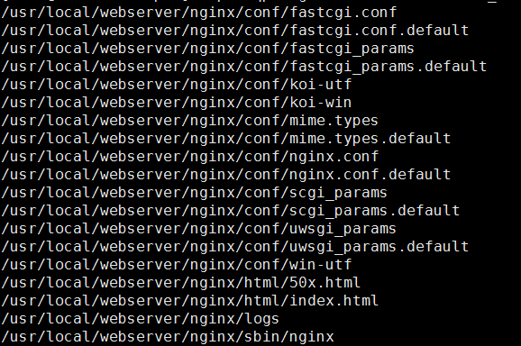

Cache 版nginx打包

cd nginx-1.16.0

wget <http://labs.frickle.com/files/ngx_cache_purge-2.3.tar.gz>

tar xf ngx_cache_purge-2.3.tar.gz

./configure --user=www --group=www --prefix=/usr/local/webserver/nginx --with-http_stub_status_module --with-http_ssl_module --with-http_v2_module --with-http_sub_module --with-http_gzip_static_module --with-http_realip_module --add-module=./ngx_cache_purge-2.3

fpm --prefix=/usr/local/webserver/nginx -C /usr/local/webserver/nginx --config-files /usr/local/webserver/nginx/conf --iteration 1 --rpm-dist el7 -n nginx-cache -v 1.16.0 -s dir -t rpm -p rpms -d glibc -d keyutils-libs -d krb5-libs -d libcom_err -d libselinux -d openssl-libs -d pcre -d zlib

1. php-fpm编译打包 rpm 包

安装依赖

yum install –y libXpm-devel libpng-devel libjpeg-devel bzip2 bzip2-devel libxml2-devel freetype-devel gmp-devel

编译

./configure --prefix=/usr/local/webserver/php \

--enable-opcache \

--disable-debug \

--with-pic \

--disable-rpath \

--with-bz2 \

--without-gdbm \

--with-gettext \

--with-gmp \

--enable-mbregex \

--enable-mbstring \

--with-iconv \

--with-openssl \

--with-zlib \

--with-layout=GNU \

--enable-exif \

--enable-ftp \

--enable-sockets \

--enable-sysvsem \

--enable-sysvshm \

--enable-sysvmsg \

--enable-shmop \

--enable-calendar \

--enable-xml \

--with-pear \

--enable-fpm \

--with-pdo-mysql \

--with-curl \

--with-gd \

--with-freetype-dir \

--with-mysqli \

--enable-soap \

--enable-bcmath \

--with-jpeg-dir=/usr \

--with-xpm-dir=/usr \

--with-png-dir=/usr \

--with-libdir=lib64 \

--with-fpm-user=www \

--with-fpm-group=www

make && make install

pecl install redis # 安装redis 扩展

fpm --prefix=/usr/local/webserver/php -C /usr/local/webserver/php --config-files /usr/local/webserver/php/etc --iteration 1 --rpm-dist el7 -n php -v 7.3.6 -s dir -t rpm -p rpms -d bzip2-libs -d cyrus-sasl-lib -d freetype -d glibc -d gmp -d keyutils-libs -d krb5-libs -d libcom_err -d libcurl -d libidn -d libjpeg-turbo -d libpng -d libselinux -d libssh2 -d libtool-ltdl -d libX11 -d libXau -d libxcb -d libxml2 -d libXpm -d openldap -d openssl-libs -d pcre -d xz-libs -d zlib -d libmcrypt

php.ini 在源码包里面

会告诉你php.ini 应该放的位置

[root@localhost php-7.3.6]# /usr/local/webserver/php/bin/php -r 'phpinfo();' | grep 'php.ini'

Configuration File (php.ini) Path => /usr/local/webserver/php/etc

安装zip扩展的话

1. mysql编译打包 rpm 包
2. 下载源码包

https://www.percona.com/downloads/Percona-Server-5.7/Percona-Server-5.7.26-29/source/tarball/percona-server-5.7.26-29.tar.gz

1. 安装依赖

yum install -y cmake \

libaio-devel \

zlib-devel \

openssl-devel \

systemtap \

readline-devel \

ncurses-devel \

make \

gcc \

gcc-c++ \

automake \

autoconf \

1. 编译参数

cmake ./ \

-DWITH_BOOST=/usr/local/boost \

-DCMAKE_INSTALL_PREFIX=/usr/local/webserver/mysql \

-DWITH_PARTITION_STORAGE_ENGINE=1 \

-DWITH_INNOBASE_STORAGE_ENGINE=1 \

-DWITH_ARCHIVE_STORAGE_ENGINE=1 \

-DWITH_BLACKHOLE_STORAGE_ENGINE=1 \

-DWITH_CSV_STORAGE_ENGINE=1 \

-DWITH_HEAP_STORAGE_ENGINE=1 \

-DWITH_MYISAM_STORAGE_ENGINE=1 \

-DWITH_MYISAMMRG_STORAGE_ENGINE=1 \

-DWITH_ZLIB=bundled \

-DENABLED_LOCAL_INFILE=1 \

-DDEFAULT_CHARSET=utf8 \

-DDEFAULT_COLLATION=utf8_general_ci \

-DEXTRA_CHARSETS=gbk,gb2312,utf8,ascii \

-DWITH_DEBUG=0 \

-DWITH_EMBEDDED_SERVER=1 \

-DWITH_EDITLINE=bundled