Assignment 3
- Determine virtual memory characteristics
Strategy:
Define an integer array for simulate pages. Access pages and detect page fault. When a page fault happens, trace back the pages in order to get other page faults. Using these patterns, to determine which replacement algorithm is being used.
Experiment result:
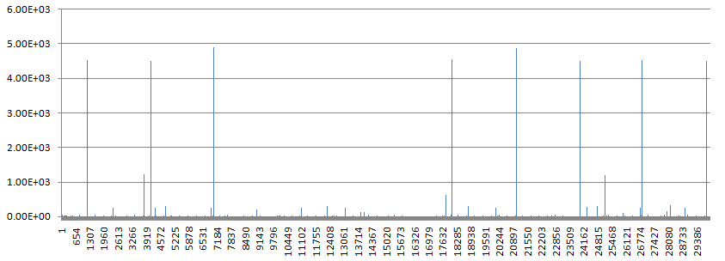
Figure 1 Page fault
According to investigation, we can conclude that the page replacement is not FIFO, and it is likely Second-Chance algorithm.
- Determine file system characteristics
  - Seek time for the local disk on linux-lab machines.
Strategy:
Create a file with a mount of bytes, reposition the offset of the file and measure the time.
Experiment result:
 | Offset = 1/8 | Offset = 1/4 | Offset = 1/3 | Offset = 1/2
File size = 100000 bytes | 13 usec | 1 | 1 | 2
File size = 200000 bytes | 2 | 2 | 2 | 2
File size = 300000 bytes | 2 | 1 | 2 | 2
File size = 400000 bytes | 2 | 1 | 1 | 2

  - Disk bandwidth for the local disk on linux-lab machines.
Strategy:
Create an empty file, write amount of bytes into the file, and measure the time that used. According the definition of disk bandwidth, calculate the value equals TRANSFERRED_BYTES / TIME.
Experiment result:
Disk Bandwidth = 8.366766e+02 (byte/sec)

