

The study of Beng Mealea heritage site for revising tentative list and  
preparing final official listing as an extension for  
the World Heritage site of Angkor

By

Mr. Sitta Kongsasana  
56056960

Submitted to  
Professor John H. Stubbs

The Final Report of  
265436 World Heritage Studies  
DOCTOR OF PHILOSOPHY

Program of Architectural Heritage Management and Tourism  
(International Program)

Graduate School  
SILPAKORN UNIVERSITY  
2014

The study of Beng Mealea heritage site for revising tentative list and preparing final official listing as an extension for the World Heritage site of Angkor

Introduction

This report is a part of a primary study of Beng Mealea heritage site for revising tentative list and preparing final official listing as an extension for the World Heritage site of Angkor. This is not an inclusive manual or a genuine document for Beng Mealea as a World Heritage nomination dossier, but it will give a general framework, some useful advises and recommendations in order to start the nomination process. The study comprises of four main parts which are a technical description of the Beng Mealea, challenges and opportunities, advisory for preparing World Heritage Nomination and a list of actions recommended for the improved protection, display and maintenance of Beng Mealea heritage site. The next parts are main contents of this report which will be analyzed and discussed further as following;

1. A technical description of the Beng Mealea
   1. Location

Situated at the foothills east of Phnom Kulen (mountain), on the national highway 64 to Kor Ker, the Beng Mealea heritage site is located 40 km east of the main group of temples at [Angkor](http://en.wikipedia.org/wiki/Angkor) and 77 km from [Siem Reap](http://en.wikipedia.org/wiki/Siem_Reap) by road. The location was geographical significant as a cross road or a junction point of the great system of ancient highways that tied together the provinces of the Classical Khmer Empire; the East-West major axis (arteries) joining the Angkor and the Prah khan of Kampong Savi via Beng Mealea (100 km); the North-East road linked Beng Mealea to Wat Phu, via Kor Ker (210 km); the South-west road connecting Beng Mealea to the Great Lake -Tonle Sap (40 km)1 (Figure 01). Also the North-West road heading to Kulen Mountain2 which probably related to stone’s transportation from major quarries. Its geographical coordinates (the latitude and longitude coordinates) is now marked at N [13°28'35" E 104°14'18".](http://tools.wmflabs.org/geohack/geohack.php?pagename=Beng_Mealea&params=13_28_35_N_104_14_18_E_type:landmark_region:KH_source:kolossus-dewiki) 4

* 1. Brief history

A mystical, isolated and forgotten Khmer temple, covered by a bunch of vines and mosses, partly embraced by roots and big trees in the jungle with mostly un-restored and in a fairly ruined state, Beng Mealea literally means "lotus pond" (translated from the Khmer language) (Figure 02) is considered to be one of the most significant temples in ancient temple-towns of the Angkorian period (Khmer classical age from 9 th-13th centuries) outside the center of Angkor. (Figure 03) It was one of the Khmer monuments/buildings (e.g. Temple complexes, Temple d’etapes, Fire Shrines, bridges) located along the East Royal Road (Figure 04), which the Temples d’etapes and Fire Shrines are located approximately every 15 km between Beng Mealea and Preah Khan of Kompong Svay (Figure 05).5 Since no inscriptions have been found here and no other that mention it, the builder and the purpose for building this holy complex are still unknown.6 However, with several comparative studies on art, architecture and decoration style by experts7, the assumption tend to accept that it was built around middle of the 12th century, in the reign of

o

Suryavarman II (1113-1145/50 A.D.) - the builder of Angkor Wat. But also, some believe it built after Angkor Wat in the reign of Dharanindravarman II (1150-? A.D.) - The builder of Preah Khan of Kompong Svay, who was a Buddhist father of Jayavarman VII (1118-1218/20 A.D.) - The great Khmer temple’s builders - including Tha Phrom, Preah Khan, Banteay Chhmar and Bayon.9 With the use of the magnetic susceptibility technique on the sandstone blocks in Beng Mealea site, suggested that it was constructed during the same period as Pr. Thommanon and Pr. Chau Say Tevoda, that is, in the early Angkor Wat Period.10 The religious (or believe) history is also unclear, but only left the carvings and decoration revealing a mix legends of Hinduism (Vishnu and Shiva) and Buddhism without any apparent traces of iconoclasm.11 12 Also, the reason for abandonment this major temple-town outside the center of Angkor for more than 850 years is still unknown and be debatable among scholars .

The forgotten Beng Mealea scared town was brought back to life in late 18th century by the drawing of French explorer and artist, Louis Delaporte (1842-1925 A.D.), which gave the overall bird’s eyes view of its temple complex (Figure 06) following by expenditures of researchers to discover the hidden site in the early 19th century. Unfortunately, those valuable missions to investigate the lost temple-town were interrupted by the Khmer Rouge period (1975-1979) and up until late 1990’s. As its strategic and hidden location, the Khmer Rouge guerrillas occupied the place as a stronghold, laying a number of landmines around the temple area which had caused deaths or injuries for a lot of their enemies, or even those locals who lived nearby and also lived, worked and played in the area. This dangerous situation had not encouraged people to come and visit the site. However, the site was added to the [UNESCO](http://en.wikipedia.org/wiki/UNESCO) [World Heritage](http://en.wikipedia.org/wiki/World_Heritage) Tentative List on September 1, 1992 in the Cultural category (with other eight tentative-list heritage sites14, and the inscription of Angkor Archaeological Park). Until, at the end of 2003, Beng Mealea site was officially reopened to visitors after the painstaking and time consuming task to clearing the land mines.15 It has been under the protection and management of the Authority for the Protection and Management of Angkor and the Region of Siem Reap (APSARA) since the time it was reopened. Inside the main temple complex, which largely collapsed, there is a network of wooden elevated walkway (partly and originally constructed for the filming of Jean-Jacques Annaud's Two Brothers (2004) and extended more linkage by APSARA later), to facilitate access to the ruined central sanctuary area.16 17(Figure 07) Also, before entering the site, visitor has to buy 5 US$ ticket for admission (not included in Angkor Pass ticket) (Figure 08) and accesses the site from southern side, crosses the moat, passes a large cruciform terrace and walks toward the main temple at the center area on the southern causeway. (Figure 09, 10)

Today, with the dramatically increasing in the number of visitors to Angkor region average 25% growth in numbers every year and expected to attract four million tourists in 2014, a better paved road condition leading to the site, the continued promotion of its adventurous and exotic experience for visitation, Beng Mealea is now becoming one of a popular remote temple site outside the World Heritage Zone of Angkor Archeological Park. With hundreds visiting daily in the peak season (November to March)19 (Figure 11) Thus, without the proper conservation and management policies and plans, this heritage site (which is also a potential heritage tourism destination) might be questionable for its ability to succeed the sustainability in protecting, conserving and managing its significances and OUV of Beng Mealea heritage site in the future.

* 1. The characters of Beng Mealea

Beng Mealea heritage site was one of the lost Khmer temple-city locating outside the Angkor ancient city center to the east. According to the images obtaining from LiDAR technology in 2012 at Beng Mealea (Figure 12), presented the archaeological landscape beneath forest cover, they provide vivid evidences of the existing pattern of “Urban temple” in the form of formal spaces divided into regular “Orthogonal city blocks” by the road grid and pond arrangements which each block furnished with a number of elevated occupation mounds and excavated

ponds (Figure 13, 14). This pattern is remarkably similar to the urban patterns within the

22

moats of several major temple sites in the Angkor region such as Angkor Wat and Preah Khan (Figure 15). The main temple complex located at the center of the city, oriented to the east. It is surrounded by a moat of 1,025m by 875m and 45m wide with the natural waterway (from Kulen Mountain) bounded to the site in the north and linked with a large baray in the east (with a small island containing a shrine in its center) by the causeway on east-west axis which is one of four paved walkways lead by cruciform terraces to the temple’s entrances at the cardinal points 23 (Figure 16). There is Pr. Kansaeng in Beng Mealea site which is one of five temples known as “Fire Shrines” along the East Royal Road, situated along the western causeway of Beng Mealea temple complex, unlike other four Fire Shrines which are located along the eastern causeway in the temple complexes. Therefore, it is suggested that worshipers might accessed to the Beng Mealea temple complex from the west side that is also the direction to the capital city Angkor24 (Figure 17).

Interestingly, Beng Mealea’s design and decoration have revealed its characters which influenced by a mixture of three styles in Angkorian period - late Baphuon style, Angkor Wat style and early Bayon style. For the architectural planning and construction of the main temple complex, its planning is a type of so-called “flat temple”25 and it often described as a “flat”version of Angkor Wat (or Angkor of the East) which they have shared something in common or alike such as; both planed with three concentric enclosures, each one set back slightly to the west, with the central shrine at the intersection of the temple axes (Beng - Mealea is flat type temple, no temple mountain like Angkor Wat, that are now all collapsed);26 the third enclosure (the outside galleries) is supported by a single wall and a row of pillars and the second galleries supported by two walls (like the Angkor)27; two libraries (or shrines?) located to the north and south of the cruciform galleries which had the same layout as the one found in Angkor Wat temple (Figure 18). In addition the quality of temple’s construction was in high building standard and craftsmanship like Angkor Wat such as; the thinness and precision of the joints between the large sandstones blocks (from the south-eastern foot of Phanom Kulen quarries a few kilometers away like other Khmer building in the Angkor area) which were used in Angkor Wat and Wat Athevea constructed in the Angkor Wat Period (Figure 19, 20); elaborated

30

corbelling vaulting (Figure 21), and half-vault techniques that work as a kind of buttressing. Moreover, other influences or styles on architectural planning and construction of Beng Mealea such as the two bridges (elevated causeway) supported by small columns that linked two libraries (or shrines?) and the cruciform gallery at the east together were very similar to a long elevated walkway approaching Baphuon temple (late Baphuon style) (Figure 22); the central section (a single sanctuary with, to the east, a large chamber connecting it to the first enclosure) as well as the location of the second enclosure that built very close to the first enclosure, strongly evoke the layout used later by Jayavarman VII at Ta Prohm and Preah Khan temple (early Bayon style) ;

the two large galleried structures that fill (probably additional parts later) the space between the second and outer enclosures on the south side, might reflected the idea of “filling up the vacuum” by sanctuaries in the available space of the enclosures like Ta Prohm, Preah Khan, and

32

Bayon temple.

For the decoration of Beng Mealea, from the research of Jean V. Boisselier (1952) which conducted the comparative studies in decorations between Beng Mealea and some other related temples, generally concluded that most of its decoration elements were more influenced by the early Bayon style than the Angkor Wat style.33 Also its decoration still represented the mixture of the styles and believes (Hinduism and Buddhism) through its sophisticated decoration elements such as; the intricate Naga balustrades which each one was carved out from an one- pieced, continuous in-length sand stone (Figure 23); the lintels and pediments’ stone craving with the images and stories related to Hinduism or Buddhism (Figure 24); Ancient stone craving of “Devatas” (when in standing position) or “Apsaras” (when in dancing position)34 with an unusual representation of Apsara, cupping one breast, at the southeast corner pavilion of the outer enclosure (Figure 25).

As a result of no obvious traces of iconoclasm, the unsafe and inconvenient accessibility to the site which discouraged the looters in the past and also no scientific research or restoration projects of the temple and surrounding landscape in full scale, then several authentic architectural and decoration elements are still intact to the site, even though some are looted by thieves or retrieved and transferred to the rescue statuary at Angkor Conservatories such as lion statues and many statues (or parts) of Shiva and Vishnu35 (Figure 26).

Many visitors had expressed their adventurous feelings and senses of discovering and exploring experiences like “the Indiana Jones” for finding the lost treasures in the ruined temple embedding in a tranquil jungle 36 (Figure 27). Nowadays, not so many tourists daily come to visit the place. They usually come to the site as small groups, not large groups. No or very little numbers of locals or children approaching tourists for money or selling souvenirs. Most of them who found near the heritage property are very friendly and behave politely to the visitors. Some of them are also local guides for the visitors in small groups, or search for their daily food from the forest and the ponds, and also local children have use this site as a “heritage playground” near their residences as well (Figure 28). Thus, Beng Mealea has a unique sense of place that is quite different from others heritage places in Angkor which normally are more crowded with tourists and have a little or no signs of locals who purposefully use the site only for their commercial and tourism-serviced benefits near the main temple complex.

* 1. Recommended size, shape and zoning of heritage site

In order to propose the size and shape of Beng Mealea’s boundaries for starting the inscription process of the World Heritage List, this report has considered and followed various documents on principles and guidelines relating heritage boundaries’ designation such as; Operational Guidelines for the implementation of World Heritage Convention (2013), Preparing World Heritage Nomination (2011), The Banteay Srei Parvis Project (2009), Format for the Nomination of Properties for Inscription on the World Heritage List (2005) and Royal Decree establishing Protected Cultural Zones in Siem Reap/Angkor Region and Guidelines for their Management (1994). Also, some geographical information pertaining the physical features, land uses and activities at Beng Mealea and its vicinity from a site visit (on January 5th, 2014) and other sources (especially, interpretations of aerial images from Google maps and airborne laser scanning (LiDAR) and pictures taken from a slide presentation on “Angkor Urbanism” by Dr. Christophe Pottier37. However, this suggested size and shape of heritage site at Beng Mealea is only a tentative scheme, which must be clarified and corrected later by various stakeholders in the process of actual nomination or conducting the conservation and management plan.

From this point, the proposed shape and size are not yet exactly determined, but only a rough- sketched area will be present here (Figure 29). Normally, in the World Heritage nomination process, it requires the state party to define two boundaries which are the nominated property and buffer zone. However, for this report, there are four suggested zones that require to be assigned in order to establish the effective protection of Beng Mealea heritage site and its surrounding as a whole; which are Zone 1) The Monumental Site(s); Zone 2) - The Buffer Zones; Zone 3) - The Heritage Transition Zone; Zone 4) - The Protected Cultural Landscape Zones. There is worth to note that Zone 3 and Zone 4 are also parts of Zone 2 - The Buffer Zone, but they are separately defined since they have different regulations and controls. At this stage, only an approximate size of the Monumental site zone will be proposed in the area of approximately three sq.km. Each zone will have different levels of protection and development involving the decision-making process by various stakeholders as following;

Zone 1) The Monumental Site is the area (or boundary) proposed for the property that must encompass all the attributes and features that convey its potential Outstanding Universal Value of Beng Mealea, which deserves the highest level of protection. Any actions or changes upon this zone should be followed the future master plan framework and supported by strong integrative research evidences. For Beng Mealea, this area includes the main temple’s compound, structures and landscape area within the surrounding moats and some of the natural watercourse way in the north; the large eastern baray, embankments and a small island with a shrine in its center40, the areas between the surrounding moats and the baray linked together by the eastern alley and Pr.Chrei, one of the Temple d’etape (resembling temples) along the East Royal Road, situated south of Beng Mealea’s east barray.41 It is note-worthy that this zone might be extended or appointed to cover more areas in the future, if new archeological sites will be found and clearly proved their direct relationships with the significances, the Outstanding Universal Value (OUV), or enhancing the additional knowledge of Beng Mealea site (such as sand stone quarries, historic building remains, or ancient trails).

Zone 2) - The Buffer Zones are those clearly delineated area(s) outside a world heritage property, adjoining the monument sites which have complementary legal and/or customary restrictions placed on their uses and development to give an added layer of protection, conservation and management to the heritage properties. It does not form part of the World Heritage property, but assist in protecting the immediate setting of the property contributing to safeguard authenticity and integrity.43 For Beng Maelea, most of its buffer zones are rice paddies, green groves and domestic/agricultural-related buildings. The non-appropriated uses and development must be controlled and monitored by the acceptable degree from stakeholders, especially the locals and the heritage management team, which will enriching the surrounding to support more on the heritage significance (also OUV) of Beng Mealea.

Zone 3) The Heritage Transition Zone is assigned for the alteration areas before/after the visitors’ entering/leaving the heritage site. For Beng Mealea, the adjacent area outside the monument site, all along the moat in the south side including a part of the East Royal Road, is appointed to be the Heritage Transition Zone. Since Beng Mealea location is quite far from Siem Reap (also Angkor Archeological Park), potentially situated as a junction for traveling around this area and also the visitors use this area to enter or leave the site and locals use it to facilitate the tourist at present (some of them also inhabit in or adjacent to the area), then this zone should prepared to be a reception area for the visitors, an appropriate tourism-based commercial area for the locals and gives an addition buffer tool to protect the heritage site.

Zone 4) The Protected Cultural Landscape Zones are those areas in the landscape reflecting the “combined works of man and nature” that need to be protected in order to maintain the authenticity in location/setting (also in spirit and feeling) and safeguarded the integrity (wholeness and intactness) of the surrounding areas of the heritage places. For Beng Maelea, conserving its cultural landscape around the heritage site would be beneficial for protecting visual quality of its setting and landscape; for interpretation programs revealing the close relationship between the site, the surrounding (landscape) and the Khmer people in the past. Some of its protected cultural landscape zones might have been already coincided with the buffer zones such as rice fields, green groves; however, more focusing on sensitive areas which are possibly changed rapidly by human intervention in the landscape like greenways, water ways and road-sided corridor.

* 1. Proposed site recognition

In the World Heritage nomination process, a state party who is responsible for the nomination needs to define the definition of its heritage property for recognition based on the formal definitions in the World Heritage Convention (WHC). This will help to categorize the nominated property into one of three definitions (cultural, natural, and mixed heritage) which will involve or influence on the selection of World Heritage criteria for the nominated heritage property.44

For Beng Mealea, this report proposes the definition of the site as “cultural heritage” rather than “natural” or “mixed” property. Since the site is obviously dominated by man-made creations that were applied in the landscape. It has the main temple complex, its related structures and the modified landscape such as (lotus) ponds, moats, a baray which reflected human wisdoms and believes through the temple-town planning, the hydrological engineering and the design, construction and decoration of ancient Khmer civilization in Angkorian period. Furthermore, the cultural heritage category had already been proposed for Beng Mealea to the former tentative list in 1992. Without further scientific evidences, this heritage should still has more cultural values than natural values which need to justify inscription under cultural criteria (criteria I-VI)

The WHC also classified four types of cultural property which are monuments, groups of buildings, sites and cultural landscape.45 For the former tentative list in 1992, Beng Mealea is considered as a monument which only focused on its main temple complex. However, this heritage place is increasing its significances. The images from LiDAR clearly revealed the typical urban pattern of Angkorian temple-town which dominated by the central temple, causeways on north-south and east-west axes, road grid and ponds arrangements and the large baray. Also Beng Mealea was a “hydraulic city” which depended on water management from a stream in the north linked directly from Phnom Kulen to the moat, the baray and a number of ponds in the site. Moreover, as Beng Mealea lost in the jungle for hundred years, vegetations (like big trees, herbs, lotuses) are becoming more important to the site as well. There should be more researches beyond the already known information of the site (such as the archeological surveys, the forest and vegetation studies, water flows and hydraulic studies, and etc.) which will emphasize more on the significant of its site.

Thus, for this report, Beng Mealea has been proposed to be a cultural property which recognized as a heritage site, not just only as a stand-alone monument, which will reveals works of man or the combined works of nature and man including the areas of archaeological sites which are of Outstanding Universal Value from the historical, aesthetic, ethnological or anthropological point of view.

1. Challenges and opportunities

In order to revise tentative list and preparing Beng Mealea to the nomination process as an extension to the Angkor World Heritage Site. Some challenges and opportunities might be considered to the process and also for its conservation and management in developing country like Cambodia as following;47

Challenges

* Lack of researches, inventories and documentations - there are quite a few, not up-to- date or not comprehensive existing researches and inventories related to the knowledge of the property in order to support the defining and understanding of its values for a nomination process, especially on identifying and defining potential Outstanding Universal Value (OUV).
* No comprehensive master plan for protection and management system - even though, the site has been in jurisdiction of APSARA since it reopened to the public in 2003, there is still no comprehensive master plan for protection and management system of Beng Mealea, which is required in the process of nomination (or even more important after the inscription in World Heritage List). The protection of its heritage property is insufficient and no selection of appropriate conservation approach or techniques to be conducted for the heritage property which will accelerates the deterioration to its property by the environment, especially the climate change. Also, the existing management of the site is still ineffective, no proactive management approach. Mainly only concern on entrance fees collection, but has limited staffs to secure and maintenance a very large and unexplored site and inadequate facilities to support visitors’ safety and convenient. These might not ensure the effectiveness conservation and management of heritage property, particularly after the influx of visitors to the site in the future.
* Lack of funding and/or human resources - since Cambodia has a rich array of Khmer heritages throughout the country, together with the tight budgets and a lack of human resources, these do not allow all, or even large portion, of heritage resources to be conserved. Most of its resources (also the international aids) have primarily concentrated on the heritage places in

Angkor Archaeological Park, not on those that are in remote areas, like Beng Mealea. Besides, the shortage of local experts and craftsmen in many fields such as, monumental conservation, archaeology, community development, tourism, urban planning or forestry49 has been impeded the protection, conservation and management of the heritage sites toward sustainable approach.

* Looting, vandalism and irresponsible visitors - there are various negative impacts caused by human intervention to the heritage site of Beng Mealea as following;
* Looting - although there are several international and national measures which Cambodia government is obligated to prevent and fight against looting50, but locally the heritage properties are still stolen, excavated or illicitly traffic from many of those remote heritage places. For Ben Mealea, since it was long hidden in the jungle, and unsafe by the landmines, the heritage stealing in the site was discouraged. However, after it has been officially opened to the public in 2003, a more convenient road was built to access the site, and also with its ineffectiveness in site management, these encourage thefts to steal precious heritage property which cause damages to irreplaceable archaeological sites such as the Apsara or female Devata’s face looting between 2006-2007 (Figure 30) 51
* Vandalism and irresponsible visitors - vandals of heritage sites are not only including those who detach ornaments for profit, but also the irresponsible (thoughtless) visitors who intentionally or unintentionally damage the sites such as erosion or wear and tear by visitors, using the beautifully sculpted blocks fallen off un-restored temple as stepping stones for exciting and potentially dangerous climbing52, breaking the parts of the heritage, writing on the surfaces, and etc. (Figure 31)
* Lack of social wills on heritage conservation - due to the poverty, most of the local people in less developed countries like Cambodia where health care, food and education are usually deficient; they seem to be aware more on their economic rather than the value of their heritage conservation. Some of them might only get involve in heritage for its economic benefits, not the appreciation of its significances. However, from top-down perspective, if the authorities or who have full responsibilities for protecting and managing the heritage properties do not encourage local people to take part in the heritage and conservation process, there is usually less participation of the locals in the process. Thus, the way that APSARA manages Beng Mealea by giving full concessions to private company for managing the site alone will also dampen the active involvement of the locals, especially those who live nearby the heritage sites.

Opportunities

* The strategic location of Beng Mealea - it situated in a strategic point connecting together other heritage places both in the past and at present. It locates outside the area of Angkor Park, far from a crowded city of Siem Reap and also surrounded by a remote landscape setting which is still be authentic and intact (but fragile) more like the ancient Khmer landscape. This might support more comprehensive site interpretation of Beng Mealea including its heritage properties and its setting (e.g. rice paddies, Phnom Kulen Mountain, quarries, creeks, and vegetation).
* The high authenticity and integrity of its property - the site had been lost in the jungle for many years, and no major restoration procedures have been applied to the site. Most of its ruins are still intact to its places revealing its authenticity as a whole which will support its OUV in nomination process. Also, the sense of “Ruins in the jungle” or “Indiana Jones’ experience” might help to determine the appropriate approach for conserving the spirits of Beng Melea; unlike many heritage places that have “too much conservation” on the site, and then lost their uniqueness and the exotic senses of place.
* The availability of international expertise networks and financial aids - since 1990s, there are unprecedented influx of several international assistance, more than 20 countries have together donated millions of dollars, and set up a number of working teams (under an administrative body, created by UNESCO, the International Coordinating Committee for Safeguarding and Development of Angkor (ICC)) to help safeguard the temple and its heritage properties. Also APSARA Authority, a Cambodian-run management body , is expected to act as an organizational bridge between the attendant international community and the domestic government. In the near future, after the withdraw of ICC, APSARA is strongly hoped to be self­funded, independent and autonomous Cambodian management authority filling the gap left by those withdrawing international partners.54 More and more restoration projects on heritage worksites are joint projects of APSARA with other international experts’ teams. Most of the collaborated projects are responsible for APSARA to pay the local and technical workers salaries and purchasing of all equipment available in the county, on the other hand, those international assistant parties are responsible for providing technical consultants and the necessary equipments and materials bought outside the country.55 Also, later on, there are more collaborative projects and grants on those intangible heritage (not only principally related to the tangible heritage like architectural and archaeological heritage properties), especially in order to reduce poverty and increase the quality of life of the locals who are living in or nearby the heritage properties.
* The potential of community involvement in heritage protection and management - Beng Mealea site is located quite far from Angkor Park in remote area, surrounded by scattering villages in the rural landscape. Some locals who live nearby the site are already associate with site in some extents in their everyday life, for instance; working as local guides or security guards; go to the forest and ponds for hunting, fish catching and finding raw materials for food and also a playground for children. Thus, there is an excellent opportunity for APSARA and its assistant partners to take a further step toward sustainable heritage management and tourism for a developing country like Cambodia, in order to protect and manage the heritage effectively together with alleviating poverty and improving the quality of life for the locals by various bottom-up approaches in cultural heritage tourism such as Community-Based Tourism (CBT), Community-Involvement Tourism (CIT), Pro-Poor Tourism (PPT), Voluntary Tourism (VT) or many forms of Responsible Tourism (RT). These methods will encourage local involvements and participations for the sustainable protection and management of heritage site in the future and also conforming to one of the World Heritage Strategic Objectives (5Cs) that needs to “Enhance the role of communities in the implementation of the world heritage conservation”56
* The opportunities for extending the World Heritage List of Angkor Archaeological Park -more and more evidences to support that past prosperities of the Khmer civilization are not only confined within the Angkor Park area. The Greater Angkor Project, an international collaboration of the University of Sydney (Australia), APSARA Authority and the EFEO (Ecole Franqaise d'Extreme Orient), has demonstrated that the famous temples of Angkor were surrounded by vast suburbs integrated by a road and canal network within a vast low-density urban complex which extends far beyond the walled enclosure of Angkor Thom, and is integrated with the sprawling outer suburbs and their network of road embankments and canals. This is called Greater Angkor, covering about 1000 sq km and containing as many as 750,000 people at its peak in the 12th century.57 Linking the central area of Ancient Angkor with those related heritage places outside will be more clearly comprehend the “big picture” of the glory of Ancient Khmer Kingdom. Also the World Heritage Committee tends to support the ideas of linking those already separated inscribed World Heritage Places on the List together into one World Heritage serial listing in order to reduce the amount of World Heritage listings, while not reducing the actual number of protected sites under the World Heritage Convention believing that the measure will not reduce the cultural/natural significance of each individual site nor diminish the prestige value of the listings. Thus, Beng Mealea,which has already been in Tentative List since 1992 (needs to be revised and resubmitted every ten years), and also has several things in common, closely associates with the Classical Angkorian period, should be nominated as an extension of the Angkor Archaeological Park in the future.

1. Advisory for preparing World Heritage Nomination

The overview of the World Heritage nomination process is summarized in the diagram (Figure 32), alongside the different responsibilities of the State Party and World Heritage Committee. For each State Party, it has critical responsibilities to the World Heritage Convention which cover three key areas; preparation of Tentative List, preparation of nominations and effective management of properties that are inscribed to protect, conserve and manage their Outstanding Universal Values.59 It suggests that “preparation” stages are very crucial for both Tentative List and actual World Heritage nomination process which all occur before the properties inscribed.

Preparing a World Heritage nomination can be one of the most satisfying and rewarding of experiences for those involved which developing a World Heritage nomination involves an expedition that takes time (usually at least two years’ work, or more), budgets, and effort. Being well prepared and organized for developing a nomination will keep the time, cost and effort to a minimum.60 Then, a successful World Heritage nomination requires careful preparation. This report will advise four aspects concerning the preparation Beng Mealea for World Heritage nomination as an extension of the World Heritage site of Angkor as following:

• Gathering existing information on the property - the relevant information that already exists on the property will help with the nomination. Several cases shown that the World Heritage Committee has referred or deferred nominations because of a lack of researches, evidences or supporting information to verify its values. Bringing together all the material that is often scattered in many different places - in the case of cultural properties, such as oral history, published archaeological evidence, conservation history, tourism data, planning regulations and etc. for most properties, there is usually a need to undertake some sort of research either because none exists or the supplement or update what has already been achieved. As a preliminary to a nomination it is helpful to assemble what is known and whether work is needed on researches, inventories, documentations for completing nomination format, and stakeholder analysis.61

For Beng Mealea, there should be more update researches and inventories to be conducted, particularly those related to archaeology investigations of the main temple and its surrounding landscape in the Monumental site zone (with some in Buffer Zones). Also those researches and inventories relating people (software) that associate with the heritage site (such as the APSARA international expert teams (if any), the site management staffs, the visitors, and the locals who live nearby the site) should be carried out for supporting the information of the site involvement of the stakeholders. It might be useful to start with the results from the latest full-scale architectural and measurement surveys research on Beng Mealea monuments which started from September 2009 by JAPAN-APSARA Safeguarding Angkor (JASA) and several collaborative teams for conducting the measurement survey of the entire temple complex and making precise drawing to replace those that are less accurate. They also plan to continue this measurement survey and expand this study by analysis of the design plan and extended to the surrounding areas of the main temple complex.62

• Setting up and resourcing the nomination team - a team approach is undoubtedly necessary for a complex task like preparing a World Heritage nomination. It should be involved the range of key stakeholders and experts which formed a good, focused and well-resourced team that can greatly help nomination. The following are summarized key tips for structuring a team working on the nomination;63

* Compile a list of key supporters or stakeholders (e.g. site owner / manager, State Party, national heritage agencies, local authorities, local communities, indigenous populations, tourism operators, universities and experts);
* Check that the range of knowledge and expertise within the team reflects the range of values, ideally have some understanding of the property in an international context, and have useful networks for obtaining wider advice;
* Be flexible about team membership to take account of the possibility of emerging interests, however it is preferable to retain a continuing editor;
* Consider creating a small core team to work on the nomination itself, and a larger reference group (advisory panel) to support the work;
* Ensure that the team is clearly led, has the right membership, has a clear task, and has a clear and realistic work plan with milestones.
* Possible long-term and ongoing role for the nomination team after inscription in protection, conservation and management of the heritage property.

The nomination team and process will need adequate resources and funding to support the work. Early in the process, the level of resources and funding should be estimated, and sources identified and confirmed to provide this support. The main sources of funding are possibly to be provided within the State Party. Some cases might be able to seek assistant from International Assistant from the World Heritage Fund for preparatory assistance as well.64

For Beng Mealea, APSARA should take a leading role in setting up the nomination team and support the financial resource for the preparation of World Heritage nomination. International Coordinating Committee for Safeguarding and Development of Angkor (ICC) and academic experts should be strongly involved in technical and expertise aspects of protection, conservation and management the property. The site managers or representatives from Angkor Archaeological Park should join the team for sharing its experiences on protection and management the Angkor

Park, which will be beneficial for Beng Mealea’s nomination as an extension of the World Heritage Park of Angkor. Also, the local representatives from villages or communities around the site should take part in the core team or a reference group (Advisory panel) to support the work.

* Participation of local people and other stakeholders - In order to develop a shared understanding and responsibility between the nominated property and its stakeholders following the Operational Guidelines of World Heritage, the locals and other stakeholders (e.g. site managers, local and regional governments, NGOs and other interested parties), local people need to participate in the process at certain degree; from the start, all the way through the preparation of a nomination, also continue after the nomination and inscription as a part of the ongoing management of the property.65

For Beng Mealea, besides the local representatives from villages or communities near the heritage site will take the positions in the nomination’s core working team or an advisory panel, the local people in general should also be able to participate in the process as well. Particularly, the locals who live in the Heritage Transition Zone, the Buffer Zone and The Protected Cultural Landscape Zones, which will be affected (both positively and negatively) after the heritage site has been inscribed.

* Staging the preparation of a nomination and suggested key stages - at this stage, a latest official nomination format (see the Operational Guideline, Annex), which the World Heritage Committee has approved for the World Heritage Nomination, must always be followed when submitting a nomination. It includes a commentary on what is require in each section which helps to guide the State Party along the nomination process.66 The official format encompasses two parts which are executive summary and the content of properties for inscription on the World Heritage List. The later part, the main body of the World Heritage nomination dossier, comprises of nine sections; 1) Identification of the property, 2) Description of property, history and development, 3) Justification for inscription, 4) State of conservation and factors affecting the property, 5) Protection and management of the property, 6) Monitoring, 7) Documentation, 8) Contact information of responsible authorities, and 9) Signature on the behalf of the State Party.61

Normally it is helpful to address the nomination as at least a two-stage process. The first stage is a core part of the nomination emphasizing on why the property has potential Outstanding Universal Value (OUV) and how it is to be sustained (the 3rd 4th 5th 6th section of the nomination format - 3) Justification for inscription 4) State of conservation and factors affecting the property, 5) Protection and management of the property, 6) Monitoring). It divided into three main parts; identify the potential OUV of the property; ensure that this is justified through a comparative analysis; make sure adequate protection, conservation and management is provided. The second stage is the writing nomination dossier that should be started as after the first stage. By attempting to write the nomination before the OUV has been defined can lead to too much emphasis being given to description and history, and insufficient emphasis to the core part of the nomination.68

For this report, only the core part of the nomination (the first stage) will be briefly presented, due to the limitation of back up information or not sufficient existing and relevant comprehensive researches. Then the further comprehensive guidelines or advices for conducting this section can be found in “The Preparing World Heritage Nomination (2012)”, chapter 3 - defining and understanding property and chapter 4 - writing and preparing the nomination file.

As mention earlier, the core contents of the nomination process consisting of three sections which have to be defined. In order to nominate Beng Mealea as an extension of Angkor World Heritage property, this report will advice key stages related to the central of nomination as following:

1. Identifying and defining potential Outstanding Universal Value (OUV) - the first key stage is a fundamental part of the nomination dossier which should be carried out as an early task in developing a nomination is demonstrating why a property should be considered to be so significant internationally (not only nationally or locally) or has OUV as to justify recognition on the World Heritage List.69 Identifying and defining values is a mixture of knowledge and methodology. It is usually helpful to structure this process initially to bring out as far as possible all the values of the property, with a view to establishing which of these might provide the basis for supporting a World Heritage nomination. This definition of values should eventually be set out in a relatively short text which will form part of the Statement of Outstanding Universal Value (SOUV) for the nomination which should set out some contents such as an evocation of the property and what it consists of - a word picture for those who do not know it, its character and especially for cultural properties, its meaning and ’stories’ associated with it; why the property could be considered to be of potential OUV and a summary of the attributes that convey the potential Outstanding Universal Value of the property. So as to understand more on the OUV, one can study further in ICOMOS publishing “What is OUV? Defining the Outstanding Universal Value of cultural World Heritage Properties (2008)”71

Generally, there are three foundations (pillars) of within the World Heritage Convention that all three must be in place for a property to be judged as of Outstanding Universal Value. These three pillars are “Property meets one or more World Heritage criteria”, “Property meets the condition of integrity and authenticity” and “Property meets the requirements for protection and management” (Figure 33)12 which will be discussed more as following:

1.1 Checking potential Outstanding Universal Value against World Heritage criteria and identifying appropriate criteria - ten criteria for World Heritage inscription identified in the Operational Guidelines (Paragraph 77). Criteria (i) to (vi) relate to cultural properties, and are therefore assessed by ICOMOS, and the remaining criteria (vii) to (x) relate to natural properties and are assessed by IUCN. While many properties may only meet some natural or cultural criteria, mixed properties will meet some natural as well as some cultural criteria. Nominations of mixed properties are evaluated by both IUCN and ICOMOS.73

There should be a clear and logical connection between the Statement of Outstanding Universal Value and selection of criteria. Only one criterion needs to be satisfied for a property to be inscribed on the World Heritage List (although in the case of criterion (vi), the Committee considers that it should preferably be used in conjunction with other criteria). There is no necessity in trying to nominate a property under as many criteria as possible if they are not well supported by the research and documentation of specific value and attributes which including weakly argued criteria does not help a nomination. In addition, using many criteria can have implications for the amount of research needed to support the property, for the comparative analysis, for boundaries and other aspects of the nomination.74 Also there might be burden on too many criteria to be maintained if the nomination has been inscribed later.

For Beng Mealea, only the criteria (iv) has been used in the previous Tentative List in 1992 which had been followed the criteria (iv) of 1983 stated “Be an outstanding example of a type of building or architectural ensemble which illustrates a significant state in history". It has been changed in some parts (focusing more on technological ensemble and landscape) in the present criteria (iv) of 2005 stated “Be an outstanding example of a type of building or architectural or technological ensemble or landscape which illustrates (a) significant stage(s) in human history.” However, this report suggests that the criteria (iv) is still be able to apply to Beng Mealea for nomination. Because, it represents various significant value of this heritage site in classical Angkorian Period such as; it is an outstanding example of the “hydraulic city” and “Angkorian temple-town” revealing the existing pattern of “Urban temple” landscape in the form of formal spaces divided into regular “Orthogonal city blocks” by the road grid and pond arrangements which each block furnished with a number of elevated occupation mounds and excavated ponds; its design and decoration have shown a mixture in characters which influenced by three styles in Angkorian period - late Baphuon style, Angkor Wat style and early Bayon style; the main temple represents the planning type of so- called “flat temple” which often described as a “flat”version of Angkor Wat; the stone construction techniques were equivalent in high building standard and craftsmanship of Angkor Wat, and etc.

Regarding extensions, the same criteria should be justified for the original nomination and the proposed extension. For a small extension, the proposed area might amplify some of the attributes of the original nomination but not all of them, although it might be concluded that the original criteria are still valid as the overall spread of attributes is still sufficient for justification. Also, different or new attributes might also be identified within the proposed extension but they should bear the same values as those already recognized as outstanding. 6

Since the World Heritage Site of Angkor has been inscribed by criteria (i,ii,iii,iv),77 the nomination of Beng Mealea as an extension of the Angkor Archaeological Park should select one or more criteria that are synchronize with the World Heritage of Angkor’s criteria (i,ii,iii,iv). Thus, the selection of the criteria (iv) for Beng Mealea nomination is appropriate and coordinate with Angkor. The other criteria (i, ii, iii) might be added up to the process of nomination, if there are sufficient supported evidences from more comprehensive researches and inventories that will be carried on later in an actual nomination process.

1.2 Assessing authenticity and integrity - two of the other important requirements specified in the Operational Guidelines related to the authenticity and integrity of the nominated property.

- Authenticity - based on the Nara Meeting of 1994 and the Operational Guideline (paragraph 82), Authenticity is about the link between attributes and potential Outstanding Universal Value which that link needs to be truthfully expressed so that the attributes can fully convey the value

of the property (required only cultural and mixed property). The Operational Guideline (paragraph 79-86) also suggest the following types of attribute might be considered as conveying or expressing OUV; form and design; material and substance; use and function; traditions, technique and management system; location and setting; language and other forms of intangible heritage; and spirit and feeling. It is noteworthy, in the case of the case of archaeological sites, authenticity is judged according to the ability of the archaeological remains to truthfully convey their meaning. However, it can be compromised if the attributes are weak - communities create thrive, building collapse, tradition disappear, and so on. In many cases, conjectural

reconstruction or reconstruction of incomplete buildings and structures can also impact on their

80

ability to truthfully convey meaning.

- Integrity - it is a measure of the completeness or intactness of the attributes that convey OUV which a clear understanding of the potential OUV is required before it is possible to consider the integrity of the property. There three key words that need to be assessed; Wholeness - all the necessary attributes are within the property; Intactness - all the necessary attributes are still present - none are lost or have been significantly damaged or have decayed. Absence of threats -none of the attributes are threatened by development, deterioration or neglect.

From the current state of knowledge relating Beng Mealea, its authenticity has been expressed OUV through some types of remaining attributes such as; form and design; materials and substance; location and setting. But since it has been long abandoned and ruined for hundreds of year, many attributes are weak or not so well in conveying potential OUV such as; the use and function; traditions, techniques and management systems; language and other forms of intangible heritage; spirit and feeling which can be compromised and defined more later on.

Since the Beng Mealea’s site and the main temple complex have not been fully investigated or restored, almost all of the ruins’ features still intact on their places and many of them are unexplored, then most of the necessary attributes are within the property (wholeness) and still present-none are lost or have been significant damaged (even some of them are moved to the rescue statuary at Angkor Conservatories). However, the unprotected attributes and features, which are left un-restored and exposed to the weather condition, might be threatened by deterioration, looting or vandalism causing the lost of integrity to Beng Mealea in the future.

1.3 The requirements for protection and management - this section should set out how the

requirements for protection and management will be met, in order to ensure that the Outstanding Universal Value of the property is maintained over time. It should include both details of an overall framework for protection and management, and the identification of specific long term expectations for the protection of the property. This section should summarize information that may be included in more detail in section 5 - Protection and management of the property of the nomination document (and also potentially in sections 4 - State of conservation and factors

affecting the property and section 6 - Monitoring), and should not reproduce the level of detail

81

included in those sections.

For Beng Mealea, ideally, the APSARA should take leading role in conducting the protection and management master plan with the support of the comprehensive site investigations and researches before the nomination process which will be useful for this required section (also section 4 and 6). Working together with ICC-Angkor (International Coordinating Committee for the Safeguarding and Development of the Historic Site of Angkor) will help to ensure the coordination of the successive scientific, restoration and conservation related projects, executed

by the Royal Cambodian Government (through APSARA) and its international partners, and also

82

contributes to the overall management of the property and its sustainable development.

1. Ensuring that the identification of the potential OUV of the property is justified through a comparative analysis - The purpose of this key stage, the comparative analysis, is to show that there is room on the List using existing thematic studies and, in the case of serial properties, the justification for the selection of the component parts. The property should be compared with similar properties, whether on the World Heritage List or not. The comparison should outline the similarities the nominated property has with other properties and the reasons that make the nominated property stand out. The comparative analysis should aim to explain the importance of the nominated property both in its national and international context (see Paragraph 132 of the

83

Operational Guidelines).

For Beng Mealea, the comparative analysis mainly should be carried out with the heritage sites in the Angkorian Period, particularly, the late Baphuon style, the Angkor Wat style and the early Bayon style. The Angkor Wat temple complex, as a prototype or sharing the most of similarity, should be closely analyzed and compared with Beng Mealea linking together with one of the most significant temple in Angkor Archaeological Park. Also those historic buildings and structures along the East Royal Road should be included in the study as well. These will strongly support the rational nomination of Beng Mealea as an extension of the World Heritage Park of Angkor.

1. *Make sure adequate protection, conservation and management are provided -* this key stage encompasses three sections in the official World heritage nomination dossier including Section 4 - State of conservation and factors affecting the property, Section 5 - Protection and management of the property, and Section 6 - Monitoring.

The present states of conservation-threats to or pressures on the potential OUV of the nominated property are an important consideration in the assessments process. The Operational Guidelines mention four such factors - development, environmental, natural disasters and visitors/ tourism, are the major threats or pressures. Accordingly, the information provided about the state of conservation of the nominated property should be realistic, supported by evidence, and not

84

overstated on the one hand or understated on the other.

For protection and management, this section of the nomination is intended to provide a clear picture of the legislative, regulatory, contractual, planning, institutional and/or traditional measures (see Paragraph 132 of the Operational Guidelines) and the management plan or other management system (Paragraphs 108-18 of the Operational Guidelines) that is in place to protect and manage the property as required by the World Heritage Convention. It should deal with policy aspects, legal status and protective measures and with the practicalities of day-to-day administration and management. Nominated properties should have good legal and/or traditional protection. Ideally the property should have the best available protection in a given jurisdiction and context (both in the property and its buffer zone), and sometimes this will include layers of legislative and other protection working together successfully. Whether adequate protection is in place needs to be examined very early in the nomination process, because developing such protection may take considerable time (e.g. preparing new legislation), and this timing could impact on the timetable for the overall nomination process.86 Ensuring that the value, authenticity and integrity of the property are sustained for the future through managing the attributes, Nominated properties should demonstrate that they have an adequate management plan or documented management system to define their management arrangements. If neither of these is in place, it is important to set realistic timeframes for their development, and this may impact on the nomination timetable. Suitable management arrangements should also exist for the buffer zone and the setting for the property. A nomination for a property which does not have satisfactory management at the time of nomination may struggle to achieve World Heritage

inscription.87

For monitoring, as an integral part of good management, monitoring will give an indication about the current situation of the property, its state of conservation and its likely future. Monitoring provides valuable information for the property manager - it can show that protection, conservation and management are achieving their goals or that changes need to be made. Monitoring of a World Heritage property should focus on Outstanding Universal Value, including integrity, protection and management, and authenticity for cultural properties. Again, the Statement of Outstanding Universal Value is a key reference for monitoring. The World Heritage system also includes formal Periodic Reporting whereby inscribed properties are subject to monitoring reports every six years (see Operational Guidelines, V). A well-developed monitoring system for a property will help with Periodic Reporting. An important issue is who undertakes monitoring as this can influence the real or apparent credibility of the monitoring

results. In general, monitoring will have greater credibility if undertaken in a transparent way by

88

relevant experts who are independent.

For Beng Mealea, at the national level, several laws and legislations for protecting the national heritage of Cambodia in general which also applied with Beng Mealea site as well such as the Royal Decree on the creation of the APSARA National Authority (1995), the Law on the protection of Cultural Heritage (1996). Also, there should be more specific laws and legislative regulations for protecting Beng Mealea in the future, as same as the Angkor Archaeological Park which protected by the Royal Decree on the Zoning of the Region of Siem Reap/ Angkor (1994)

89

and the No. 70 SSR government Decision (2004) providing for land-use in the Angkor Park.

As mention earlier in 1.3, carrying out the specific protection and management master plan is required in early stage and can be beneficial for the World Heritage nomination process of Beng Mealea. It might be useful to link or apply those protection and management plans related to Angkor Archaeological Park and other pertaining areas such as the Angkor Management Plan (AMP); the Community Development Participation Project (CDPP) - a bilateral cooperation with the Government of New Zealand; the Heritage Management Framework composed of a Tourism Management Plan and a Risk map on monuments and natural resources - a multilateral cooperation the Government of Australia and UNESCO),90 with Beng Mealea’s master plan for creating relevant relationship between Angkor Park and Beng Mealea in nomination process as an extension.

1. A list of actions recommended for the improved protection, display and maintenance of Beng Mealea heritage site.

As Beng Mealea aims to be inscribed as an extension of the World Heritage Park of Angkor, it should adopt the current 5Cs Strategic Objectives - Credibility, Conservation, Capacity building, Communication and Communities (see Paragraph 26 of the Operational Guidelines)91 in order to facilitate the implementation of the World Heritage Convention as its framework for protection and management in the future. Several actions are recommended for the improved protection, display and maintenance of Beng Melea in order to safeguard OUV and meet the World Heritage requirements which are listed as following:

* Conduct the conservation and management master plan for Beng Mealea - with the purpose of guiding the conservation and management approach and preparing Beng Mealea for the nomination process in the future, there should be a specific formulation of the conservation and management master plan as a principle tool of the site to identify, protect, conserve, present and transmit its cultural heritage of OUV to future generations and also conforms to the mission of the World Heritage Convention. A multidisciplinary and sustainable approach should been adopted the strategies and actions for the conservation, restoration and management master plan of Beng Mealea including appropriate use, legal and institutional framework, conservation and documentation, maintenance and monitoring, visitation and interpretation, research and excavations, facilities, services and infrastructures, public awareness, education and community

92

participation and also investments, marketing and funding.

* Increasing the knowledge of the property - more comprehensive investigations, up-dated researches, inventories or technical studies of Beng Mealea should be conducted in order to gain deeper and broader knowledge of the property within its property and its seting before the nomination. The main temple complex and its surrounding landscape in the monumental zone are the major focusing areas of those studies. Such technical studies and investigations are the archaeological surveys searching for the original form and historical development phases of the place, the studies on structural stability of the temple complex, the hydrological system studies,

93

the arboriculture/ forest studies to study the life span and conservation of trees and etc. Moreover the stakeholder analysis should be performed in order to understand who needs to involve in the nomination, including who lives or has direct relationships with the property and also what are the social, economic, and political realities of property.94 With the results from these further researches and investigation will be beneficial for both before and during the time when carrying out the conservation and management plans for Beng mealea.

* Setting up the Beng Mealea’s site management team and legal framework - to facilitate efficiently implement the conservation and management plan and support the World Heritage nomination process, there are necessary to establish the site management team of Beng Mealea to take a primary responsibility in operation and decision making for sustainable protecting and managing (planning-operating-maintenance-monitoring) the heritage site and also working together with other supportive parties. Since its location is separated far-off from Angkor Park and local people who live around the site still use it for their daily-life purposes, APSARA should take an opportunity to differ management scenarios toward a more decentralized approach in management system which reimaging the APSARA from a single all-powerful institution to a more hybrid institution with joint management which share responsibility more widely. In addition, there should be a working group to establish the framework for laws, regulations or other measures (both legislative or customary methods or controlled or incentive measures) to protect its OUV and ensures the effectiveness of the master plan’s implementation.
* Appropriate conservation and restoration - the main temple complex and physical attributes in the landscape should be decided by experts and specialists using reliable scientific methods to what extent should a suitable and acceptable degree of intervention be applied for conserving and restoring Beng Mealea. The selected conservation and restoration actions or techniques are supposed to protect its OUV, particularly preserving the authenticity, integrity and also the sense of exploring or adventure of the site.
* Strengthening the collaboration from stakeholders - there should be more intensive collaboration in conservation and management process among stakeholders Beng Mealea heritage site including the involvement of APSARA Authorities, other national authorities, international/local organization and supportive partners, and other interested groups. Moreover, encouraging involvement or participation of local people will create the shared responsibilities (with respect and daily care) between the heritage site and the locals (as the true custodians of the heritage place)95 which will follow the required strategies of the UNESCO World Heritage Convention toward sustainability that emphasizes on the 5Cs - Communities - “enhancing the role of communities in the implementation of the World Heritage Convention ”.96
* Introducing the Capacity-Building or training strategy to Beng Mealea site - since human resources and people-centered approach are crucial for the sustainable development, the Capacity-Building or training strategy as a third strategy of 5Cs Strategic Objectives for World Heritage Convention aiming to strengthen knowledge, abilities, skills and behavior of people with direct responsibilities for heritage conservation and management is also importance for the process as well. Not only the practitioners or institutions related to the field should participate in the actions of this strategies, but also the communities and networks (including local communities living on or near properties as well as the larger networks the nurture them). For Beng Mealea site, it should be appointed as a new on-site training unit, a research worksite, or an “outdoor-class room” in conservation and management heritage site for the target groups of this strategy such as international / domestic practitioners or students in relating fields such as Archaeology, Heritage sciences and engineering, Art and Architecture, Arboriculture and Forest studies, Cultural heritage tourism and etc. Also the locals should have opportunities to participate in various skill trainings for conservation and management of Beng Mealea, for instance, the local tour guides (including youths, adults and elders), the skill craftsmen for conservation, or local entrepreneurs for cultural heritage tourism.
* Establishing visitation management and interpretation plan for Beng Mealea - the visitation management should balance the needs to fulfill visitation’s experiences of visitors along with providing appropriated development for facilities, service infrastructure and the need to protect the significance and OUV of the place considering the limits of negative impacts from visitors, the caring capacity and the effectiveness in restoration and maintenance of the heritage site. For the interpretation plan, it should consider to reinterpret and introduce the new presentation to the main temple complex (in cooperated with the restoration) which still safeguard the spirit of exploration and adventure (but also safe and secure for visitor) of the site. Furthermore, a new interpretation and presentation programs should be carried out in the surrounding landscape and setting (both inside the monumental site zone and outside areas) in order to open up the new understanding of the property as a whole. There are some suggested actions for interpretation and presentation actions for Beng Mealea as following;
* The restorations of ancient road grid networks and (lotus) pond arrangements with introducing on-site signage, walkways and observation areas.
* The revitalization of hydrological system of the site to understand the relationship between the main temple complex, the ponds arrangement, the east baray, the moats and also the natural waterways that link the site and outside areas, particularly, the sacred Phnom Kulen mountain.
* The construction of interpretation and visitor-welcoming center in the Heritage Transition Zone which will introduce some necessary information related to Beng Mealea and providing facilities for the visitors before/after visiting the site. The design of the new structure should enrich the heritage values, be compatible with the site context and requires minimum maintenance. For case studies of appropriate design in Cambodia such as the welcome and Visitor Centers of Banteay Srei temple and the visitor center at Preah Khan temple.
* The landscape interpretation in the Buffer Zones and the Protected Cultural Landscape Zone should be introduced in order to support the reimaging the relationship between the temple town of Beng Mealea and the surrounding ancient landscape, for examples; protected views of Phnom Kulen mountain and the rice paddies, natural water ways around the site; Facilitate the on-site interpretation units of the ancient stone quarries at the foot of Phnom Kulen mountain and along the waterways that believed to be the pathways to transport the stones in the past; Introducing the heritage walking trails around the site connecting several heritages places in order to tell stories of Beng Mealea and its associations more thoroughly and comprehensively.

Conclusion

As mention earlier, this report is only preliminary study of Beng Mealea heritage site for revising tentative list and preparing final official listing as an extension for the World Heritage site of Angkor. With the limitation of resources in conducting this report, several issues and a lot of information related to Beng Mealea and the World Heritage Nomination process have to be investigatedby more careful involvement from many stakeholders in the study for actual nomination. However, this report might contribute some primary notations and recommendations to the authorities or to whom that are responsible for nomination Beng Mealea as the extension of Angkor Park in World Heritage List which will broaden the comprehension of Angkor Civilization in the near future.

References

Archaeological Survey of India. (2008). Conservation and restoration project of Ta Prohm Temple in Cambodia (Online). In, Activity reports for the 15th Plenary Session meeting of the International Co-Ordinating Committee for the Safeguarding and and Development of the Historic Site of Angkor, Siem Reap, 1 December 2008. Available [http://unesdoc.unesco.org/images/0021/002164/216480e.pdf.](http://unesdoc.unesco.org/images/0021/002164/216480e.pdf) Retrieved: 2014­02-28.

Authority for the Protection and Management of Angkor and the Region of Siem Reap. (2002). Resoration work sites (Online). In Yashodhara no.6, January-June 2002. Available:

[http://www.autoriteapsara.org/en/apsara/about apsara/publication/yashodhara/yashodhara 6.html.](http://www.autoriteapsara.org/en/apsara/about_apsara/publication/yashodhara/yashodhara_6.html) Retrieved: 2014-02-28.

Authority for the Protection and Management of Angkor and the Region of Siem Reap. (2005, updated 2013).

The fight against looting (Online). Available:

[http://www.autoriteapsara.org/en/apsara/about apsara/police/looting.htm.](http://www.autoriteapsara.org/en/apsara/about_apsara/police/looting.htm)Retrieved: 2014-02-26.

Boisselier Jean. V. (1952). Ben Mala et la chronologie des monuments du style d'Ankor Vat. In: Bulletin de I'Ecole frangaise d'Extreme-Orient. Tome 46N1, 1952. Available:

[http://www.persee.fr/web/revues/home/prescript/article/befeo 0336-1519 1952 num 46 1 5162.](http://www.persee.fr/web/revues/home/prescript/article/befeo_0336-1519_1952_num_46_1_5162) Retrieved: 2014-02-23.

Bogart,W.V.D. (2004). A piligrimage to Beng Mealea: The sacred dwelling place of the Neak Ta (Online).

Available: [http://www.earthportals.com/Portal Messenger/stonesinsky12.html.](http://www.earthportals.com/Portal_Messenger/stonesinsky12.html) Retrieved: 2014-02-26. Coe, M.D. (2004). Angkor and the Khmer civilization. London: Thames&Hudson.

Davis, K. (2008). Death of an angel antiquities: theft at Beng Mealea Cambodian temple (Online). Available: [http://www.devata.org/death-of-an-angel-antiquities-theft-at-beng-mealea-cambodian-](http://www.devata.org/death-of-an-angel-antiquities-theft-at-beng-mealea-cambodian-temple/%23.UzG2I_mSwYk) [temple/#.UzG2I mSwYk.](http://www.devata.org/death-of-an-angel-antiquities-theft-at-beng-mealea-cambodian-temple/%23.UzG2I_mSwYk) Retrieved: 2014-02-26.

Evans, D.H., et al. (2013). Uncovering archaeological landscapes at Angkor using Lidar. In PNAS 2013 ; published ahead of print July 11, 2013, doi:10.1073/pnas.1306539110 . Available:

[http://www.pnas.org/content/earlv/2013/07/10/1306539110.full.pdf+html?with-ds=ves.](http://www.pnas.org/content/early/2013/07/10/1306539110.full.pdf+html?with-ds=yes) Retrieved: 2014­02-24.

Evans, D. and Hanus, K. (2013). 2012 LiDAR survey over Angkor, Phnom Kulen and Koh Ker. In World Heritage Magazine (issue 68), June 2013, pp.63. Available:

[http://unesdoc.unesco.org/images/0022/002209/220956e.pdf.](http://unesdoc.unesco.org/images/0022/002209/220956e.pdf) . Retrieved: 2014-02-22.

Freeman, M. and Jacques, C. (2013). Ancient Angkor Book Guide. Bangkok: River Book.

GeoHack. (2014). Beng Mealea (online). Available:

[http://tools.wmflabs.org/geohack/geohack.php?pagename=Beng Mealea&params=13 28 35 N 104 14 1](http://tools.wmflabs.org/geohack/geohack.php?pagename=Beng_Mealea&params=13_28_35_N_104_14_18_E_type:landmark_region:KH_source:kolossus-dewiki) [8 E type:landmark region:KH source:kolossus-dewiki.](http://tools.wmflabs.org/geohack/geohack.php?pagename=Beng_Mealea&params=13_28_35_N_104_14_18_E_type:landmark_region:KH_source:kolossus-dewiki) Retrieved: 2014-02-23.

Heritage Policy and Architectural Protection Section. (2008). “Tentative list and World Heritage status”. Wexford: Heritage Policy and Architectural Protection Section. Available:

[http://www.worldheritageireland.ie/fileadmin/user upload/documents/Tentative list review research doc](http://www.worldheritageireland.ie/fileadmin/user_upload/documents/Tentative_list_review_research_document_-_public_version.pdf) [ument - public version.pdf](http://www.worldheritageireland.ie/fileadmin/user_upload/documents/Tentative_list_review_research_document_-_public_version.pdf) Retrieved: 2014-02-27.

International Council on Monuments and Sites (ed.). (2008). What is OUV? Defining the Outstanding Universal Value of cultural World Heritage properties. Berlin: Hendrik BaBler Verlag.

International Institution of Asian Studies. (2013). Greater Angkor: The growth and demise of a giant low-density, agrarian city (Online). Available: [http://www.iias.nl/event/greater-angkor-growth-and-demise-giant-low-](http://www.iias.nl/event/greater-angkor-growth-and-demise-giant-low-density-agrarian-city) [density-agrarian-city.](http://www.iias.nl/event/greater-angkor-growth-and-demise-giant-low-density-agrarian-city) Retrieved: 2014-02-26 Lonely Planet. (2014). Beng Mealea: Lonely Planet review (Online). Available:

[http://www.lonelyplanet.com/cambodia/temples-of-angkor/sights/other/beng-mealea#ixzz2wHqRqkLd.](http://www.lonelyplanet.com/cambodia/temples-of-angkor/sights/other/beng-mealea%23ixzz2wHqRqkLd) Retrieved: 2014-02-26.

Nakagawa, T. (2009).Research on the Koh Ker and Beng Mealea monuments (Online). In, Activity reports for the 16th Plenary Session meeting of the International Co-Ordinating Committee for the Safeguarding and and Development of the Historic Site of Angkor, Siem Reap, 15 December 2009. Available: [http://unesdoc.unesco.org/images/0021/002164/216483E.pdf.](http://unesdoc.unesco.org/images/0021/002164/216483E.pdf) . Retrieved: 2014-02-28. pp.8 Palumbo, G. and Atzori, A. (eds.). (2014). Qusayr’ Amra site management plan. Amman: World Monument Fu nd.

Available: whc.unesco.org/download.cfm?id document=127108. Retrieved: 2014-02-28 Peace of Angkor Tour. (2013). Beng Mealea (Online). Available: [http ://www.peaceofangkorphoto. com/beng-](http://www.peaceofangkorphoto.com/beng-mealea.html) [mealea.html.](http://www.peaceofangkorphoto.com/beng-mealea.html) Retrieved: 2014-02-24.

Petrotchenko, M. (2012). Focusing on the Angkor Temples: The guidebook (2nd edition). Babgkok: Amarin Printing and Publishing.

Pottier, C. (2014). Angkor Urbanism. In a special lecture at Faculty of Architecture, Silpakorn University, Bangkok, Thailand on Febuary,10th 2014.

Timothy, D.J. and Nyaupane, G.P. (eds.). (2009). Protecting the past: Challenges and opportunities. In cultural

heritage and tourism in developing world: A regional perspective (Online). London: Routledge. pp.20-40.

Traveling Solemates. (2013). Beng Mealea: The ultimate Indiana Jones experience (online). Available:

[http://www.travelingsolemates.com/beng-mealea-the-ultimate-indiana-iones-experience/.](http://www.travelingsolemates.com/beng-mealea-the-ultimate-indiana-jones-experience/) Retrieved: 2014­02-24.

TripAdvisor. (2014). Beng Mealea (Online). Available: [http://th.tripadvisor.com/Attraction Review-g293939-](http://th.tripadvisor.com/Attraction_Review-g293939-d655155-Reviews-Beng_Mealea-Cambodia.html) [d655155-Reviews-Beng Mealea-Cambodia.html.](http://th.tripadvisor.com/Attraction_Review-g293939-d655155-Reviews-Beng_Mealea-Cambodia.html) Retrieved: 2014-02-28.

Winter, T. (2008). Post-conflict heritage and tourism in Cambodia: The burden of Angkor. In international Journal of Heritage Studies, 14:6. Available:

[http://www.tandfonline.com/doi/abs/10.1080/13527250802503274#.UzC4dfmSwYk.](http://www.tandfonline.com/doi/abs/10.1080/13527250802503274%23.UzC4dfmSwYk) Retrieved: 2014-02­28 pp.524-539.

Uchida, E. and et al. (2013). Consideration of the construction period of the Khmer Temples along the East Royal Road to Preah Khan of Kompong Svay and the Provenance of sandstone blocks based on their Magnetic Susceptibility (Online). In Archaeological Discovery, Vol.1, No.2. Available: [http://dx.doi.org/10.4236/ad.2013.12004.](http://dx.doi.org/10.4236/ad.2013.12004) Retrieved: 2014-02-22. pp.42

UNESCO World Heritage Center. (2005). Format for the nomination of properties for inscription on the World Heritage List. Paris: 1 UNESCO World Heritage Center.

UNESCO World Heritage Centre. (2011). Preparing World Heritage nominations (2nd edition). Paris: UNESCO World Heritage Centre.

UNESCO World Heritage Centre. (2013-a). Angkor: Managing success (Online). Available:

[http://www.unesco.org/new/en/media-services/in-focus-articles/angkor-managing-success/.](http://www.unesco.org/new/en/media-services/in-focus-articles/angkor-managing-success/) Retrieved: 2014-02-24.

UNESCO World Heritage Centre. (2013-b). Operational guidelines for the implementation of the World Heritage Convention. Paris: UNESCO World Heritage Centre.

UNESCO World Heritage Centre. (2013-c). Managing cultural World Heritage. Paris: UNESCO World Heritage Centre.

UNESCO World Heritage Centre. (2014). World Heritage List: Angkor (Online). Available: [http://whc.unesco.org/en/list/668.](http://whc.unesco.org/en/list/668) Retrieved: 2014-02-27.

**ANNEX 1** - Figures

Figure 1- Beng Mealea at the junction point on the Royal Roads of Khmer Empire

Figure 2- Beng Mealea is situated in the jungle with mostly un-restored and in a fairly ruined state

Figure 3- Beng Mealea as a primary center and other major Khmer Heritage Sites in “Classical” Angkorian Period

Figure 4 - Beng Mealea with other temples on the Eastern Royal Rroads radiating from the Angkor area to Preah Khan of Kompong Svay. The numbers of temples are based on Carte Interactive des Sites Archeologiques Khmers (Cisark)

Figure 5 -The Khmer monuments distributed along on Eastern Royal Roads connecting the Central Angkor,

Beng Melea and Preah Khan of Kompong Svay. The numbers of temples are based on Carte Interactive des Sites Archeologiques Khmers (Cisark)

Figure 6 - the early 19th century drawing of Beng Mealea Temple Complex by the French explorer and artist,

Louis Delaport

Figure 7 - a network of wooden elevated walkway, partly and originally constructed for the filming of Jean- Jacques Annaud's Two Brothers (2004) and extended more linkage by APSARA later

Figure 8 - A 5 US$ ticket for Beng Mealea admission (not included in Angkor Pass ticket)

Figure 9 - The moat, the seven-heads Naga balustrades and the ancient bridge at the southern entrance

Figure 10 - The southern causeway leads to the main temple complex in the center

Figure 11 - With hundreds visiting daily to Beng Melea in the peak season (November to March)

Figure 12 - An overview of the LiDar acquisition areas in the northwest Cambodia in 2012 including Beng Mealea

Figure 13 - An image of Beng Mealea from Google and the overlay of the LiDar digital terrain model at 1-m resolution and the image from LiDar-derived hillshade model of terrain beneath the vegetation with elevation derived from the LiDar digital terrain model.

Figure 14 - The LiDar technology decoding revealed the height of trees and the level of objects (or surfaces) at ground level

Figure 15 - Shaded relief map of terrain beneath the vegetation at major temple sites in the Angkor regio n, with elevation derived from the lidar digital terrain model at 1-m resolution. Top Left: Bakong (late 9th century). Top Center: Phnom Bakheng (late 9th century). Top Right: Pre Rup (mid-10th century). Middle Left: Chau Srei Vibol (11th to 12th centuries). Middle Center: Beng Mealea (early 12th century). Middle Right: Angkor Wat (mid-12th century). Bottom Left: Preah Khan (late 12th century). Bottom Center: Ta Prohm (late 12th century). Bottom Right: Bayon (late 12th to13th centuries). Red denotes modern linear features such as roadways and canals

Figure 16 - The overall site plan of Beng Mealea.

Figure 17 - The plan of main temple complex of Beng Mealea

Figure 18 - The layouts comparison of the Angkor Wat and Beng Mealea

Figure 19 - The thinness and precision of the joints between the large sandstones blocks alike Angkor Wat

Figure 20 - The high building standard of Angkor Wat and Beng Mealea in stone blocks’ lying comparing to other temples like (Preah Khan) in later period (Bayon Style).

**ANNEX 1** - Figures (Continue)

Figure 21 - The elaborated sandstones’ corbelling vaulting of the gallery

Figure 22 - The two similar elevated walkways approaching the buildings of Baphuon temple (Baphoun style) and of Beng Mealea (Angkor Wat style)

Figure 23 - The intricate Naga balustrades which each one was carved out from a one-pieced, continuous in-length sand stone

Figure 24 - Some of the intricate lintels and fallen pediments found at Beng Mealea with the images and stories related to Hinduism.

Figure 25 - An Apsara, cupping one breast, at the southeast corner pavilion of the outer enclosure

Figure 26 - The rescue statuaries from Beng Mealea such as lion statues and many statues (or parts) of Shiva and Vishnu at Angkor Conservatories

Figure 27 - Senses of exploring and adventure like “Indiana Jones’ experiences” of Beng Mealea heritage site

Figure 28 - The symbiosis in harmony between Beng Mealea site and locals

Figure 29 - The primary map of proposed zoning for Beng Mealea

Figure 30 - The Apsara’s face looting between 2006-2007 which the photo was taken prior in 2006 (left) and another was taken later in 2007 (right).

Figure 31 - Climbing the heritage structures might be dangerous and also can harm to the property by breaking the parts of it or scratching.

Figure 32 - Summary of the different steps in the nomination process and the main responsibilities of the State Party and the UNESCO World Heritage Committee

Figure 33 - Illustration of the three foundations of Outstanding Universal Value within the World Heritage Convention

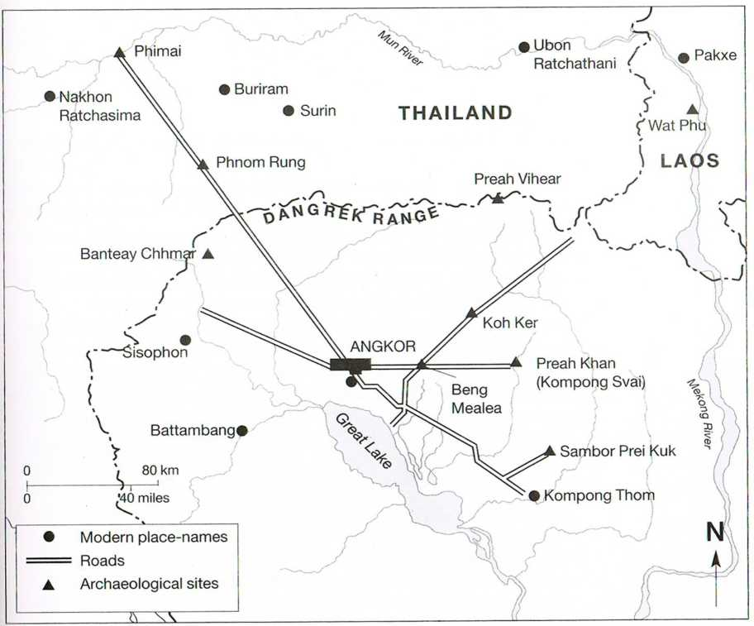

Figure 1- Beng Mealea at the junction point on the Royal Roads of Khmer Empire

Source: Coe, M.D. (2004). pp.151

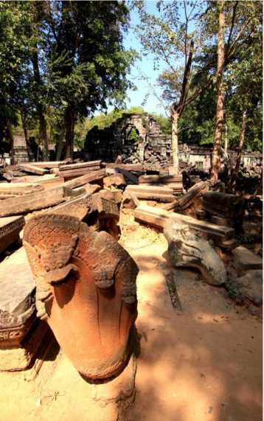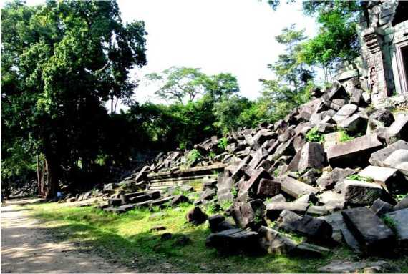

Source: Sitta Kongsasana (2014)

Figure 2- Beng Mealea is situated in the jungle with mostly un-restored and in a fairly ruined state

Source: Pari chat Promsawat (2014)

*Chao*

Figure 3 - Beng Mealea as a primary center and other major Khmer Heritage Sites in “Classical” Angkorian Period

Source: Coe, M.D. (2004). pp.98

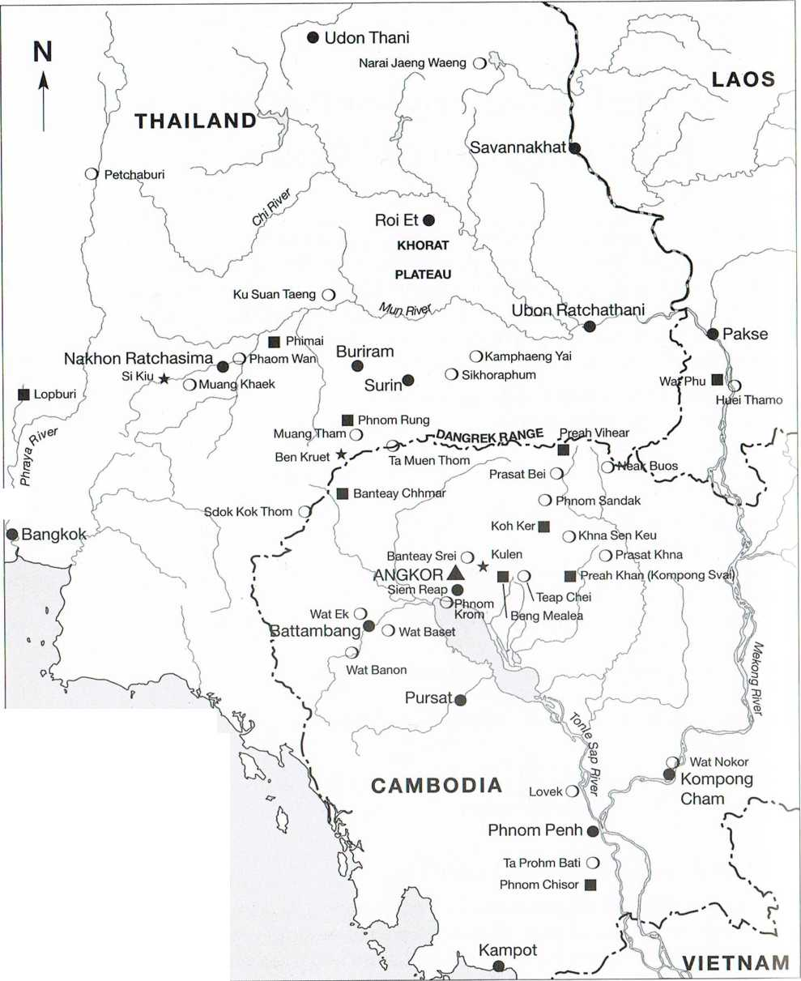

|  |  |
| --- | --- |
| ★ | Quarry |
| **o** | Secondary centre |
| ■ | Primary centre |
| A | Imperial capital |
| • | Modern place-names |
| 0 | 100 km  . i |
| 0 | 50 miles |

*Gulf of Thailand*

4 ***Phinuti***

Thailand

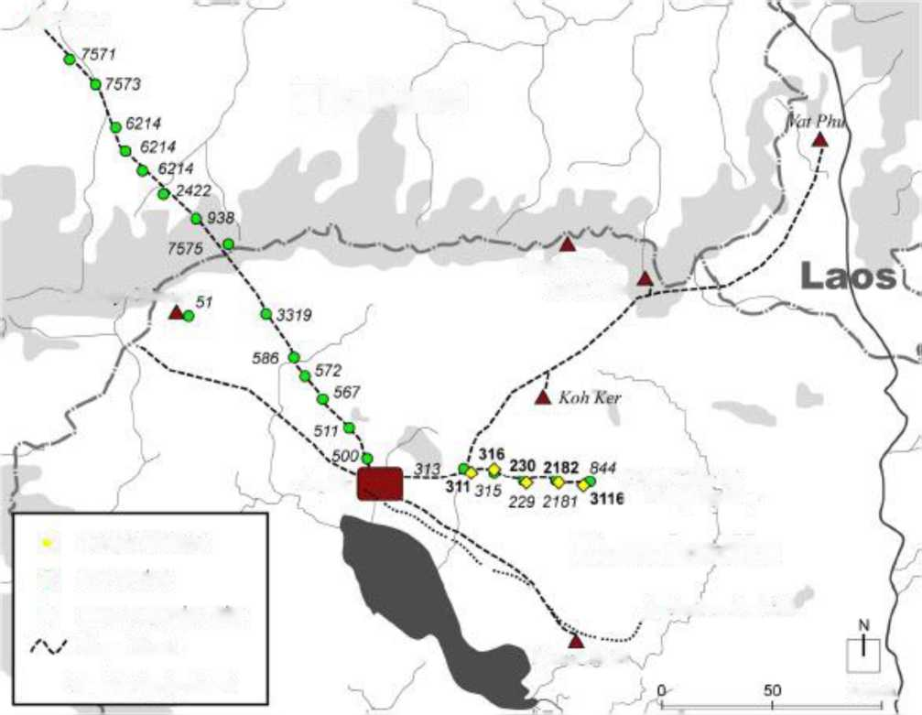

***Preah Vihear Scak Buos***

***Banteav Chnmar***

|  |  |
| --- | --- |
| o | Temple d'etape |
| © | Fire Shrine |
| ▲ | Main Angkonan Site |
|  | Royal Road |
| ♦ | Numbering by Cisark |

***Angkor***

***Preah Khan of*** i ***Kompong Svay***

Cambodia

***^ Sanihor Prei Kuk***

***Pnisat Andei***

**100 km,**

Figure 4 - Beng Mealea with other temples on the Eastern Royal Roads radiating from the Angkor area to Preah Khan of Kompong Svay. The numbers of temples are based on Carte Interactive des Sites Archeologiques Khmers (Cisark)

Source: Uchida, E. and et al. (2013). pp.38

Figure 5 -The Khmer monuments distributed along on Eastern Royal Roads connecting the Central Angkor, Beng Melea and Preah Khan of Kompong Svay. The numbers of temples are based on Carte Interactive des Sites Archeologiques Khmers (Cisark)

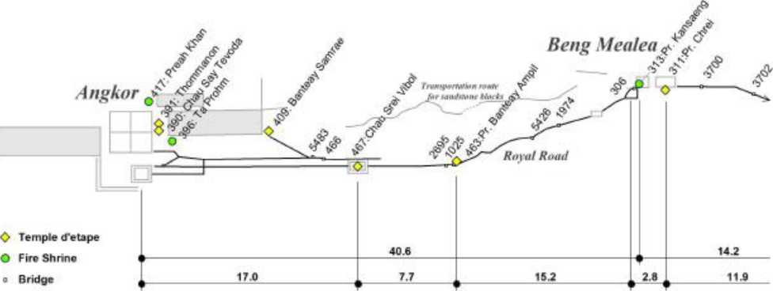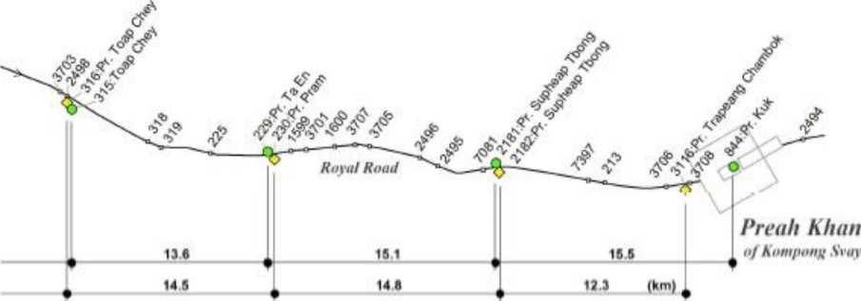

Source: Uchida, E. and et al. (2013). pp.39

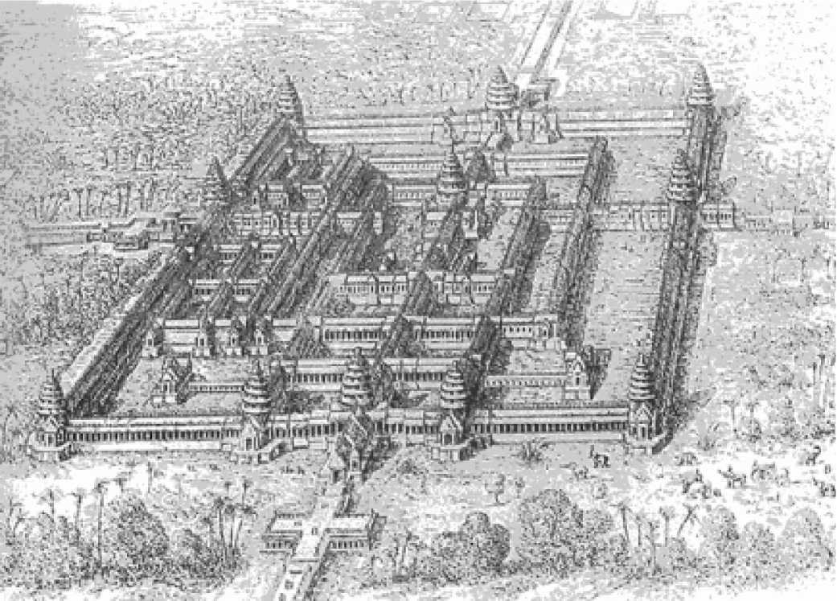

Figure 6 - The early 19th century drawing of Beng Mealea Temple Complex by the

French explorer and artist, Louis Delaport

Source: Bogart,W.V.D. (2004)

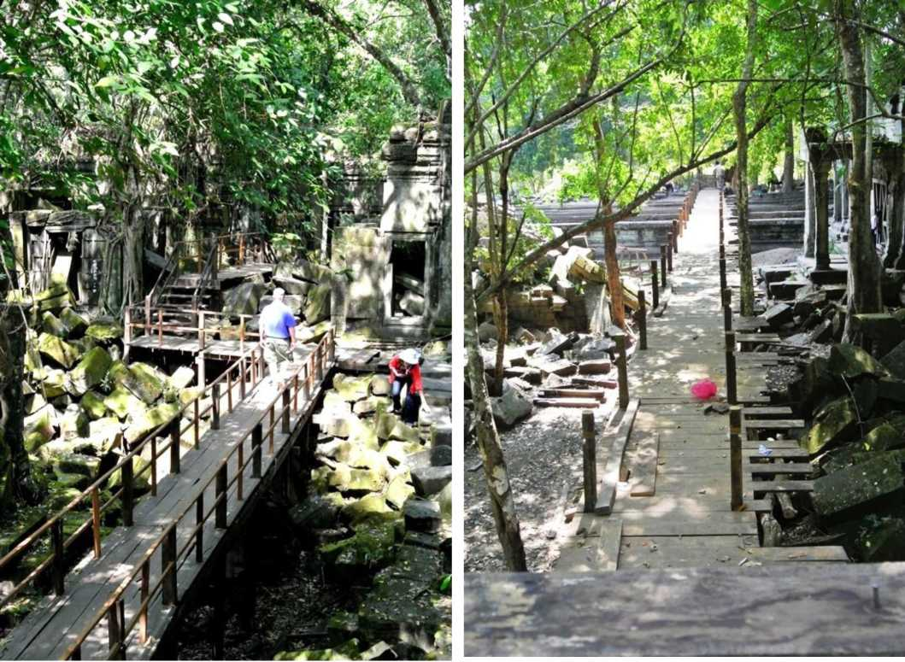

Figure 7 - The network of wooden elevated walkway, partly and originally constructed for the filming of Jean-Jacques Annaud's Two Brothers (2004) and extended more linkage by APSARA later

Source: Sitta Kongsasana (2014)

Figure 8 - A 5 US$ ticket for Beng Mealea admission (not included in Angkor Pass ticket)

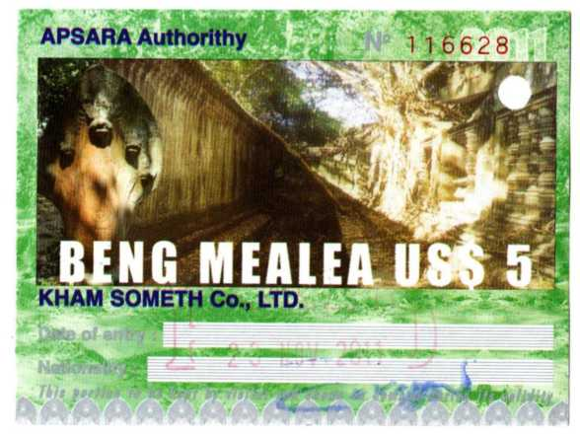

Source:

[http://ordinarvmostlv.files.wordpress.com/2012/01/beng mealea](http://ordinarymostly.files.wordpress.com/2012/01/beng_mealea_pass.jpg) [pass.jpg.](http://ordinarymostly.files.wordpress.com/2012/01/beng_mealea_pass.jpg) Retrieved: 2014-02-25

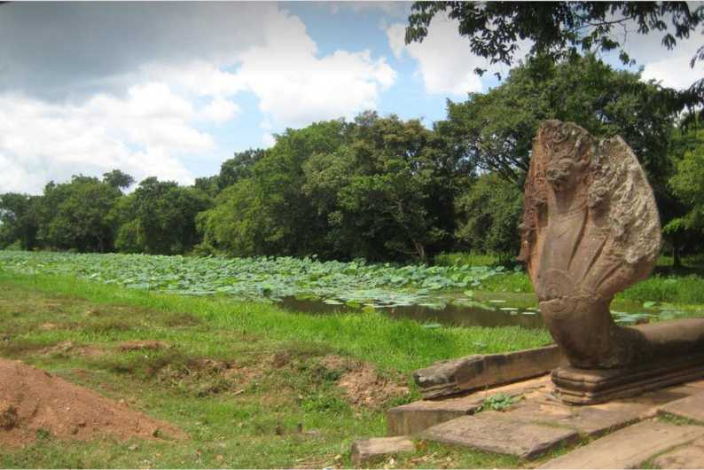

Figure 9 - The moat, the seven-heads Naga balustrades and the ancient bridge at the southern entrance

Source: [https://www.flickr.com/photos/littlecloudvskve/2997698246/in/photostream/.](https://www.flickr.com/photos/littlecloudyskye/2997698246/in/photostream/) Retrieved: 2014-02-25

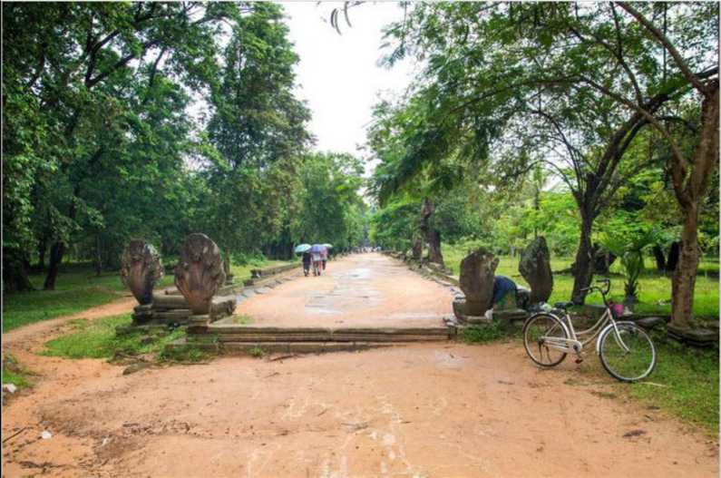

Figure 10 - The southern causeway leads to the main temple complex in the center

Source: [http://kbob.dvndns.org/pics/portfolio.aspx?co=Asia&p=Beng%20Mealea&c=Cambodia.](http://kbob.dyndns.org/pics/portfolio.aspx?co=Asia&p=Beng%20Mealea&c=Cambodia) Retrieved: 2014-02-25

Figure 11 - With hundreds visiting daily to Beng Melea in the peak season (November to March)

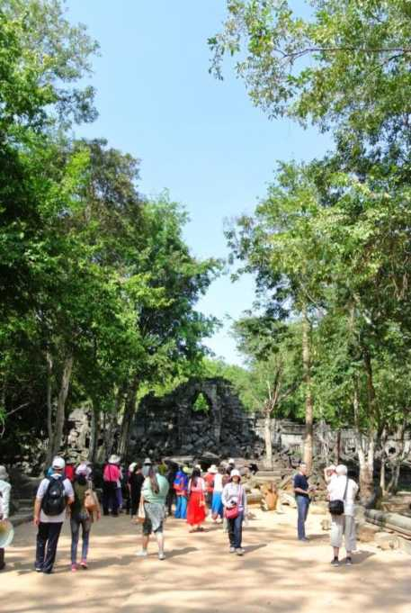

Source: Sitta Kongsasana (2014)

Figure 12 - An overview of the LiDar acquisition areas in the northwest Cambodia in 2012 including Beng Mealea

Source: [http://i2.cdn.turner.com/cnn/dam/assets/130701165349-angkor-map-guide-horizontal-gallerv.ipg.](http://i2.cdn.turner.com/cnn/dam/assets/130701165349-angkor-map-guide-horizontal-gallery.jpg) Retrieved: 2014-02-25

|KHrr1ERTflRCHflEOLrOGYjLlDflRlc;ON$.ORTIUMl

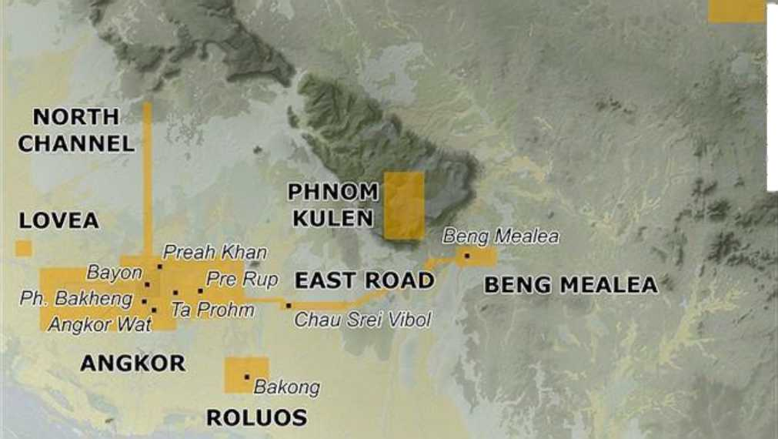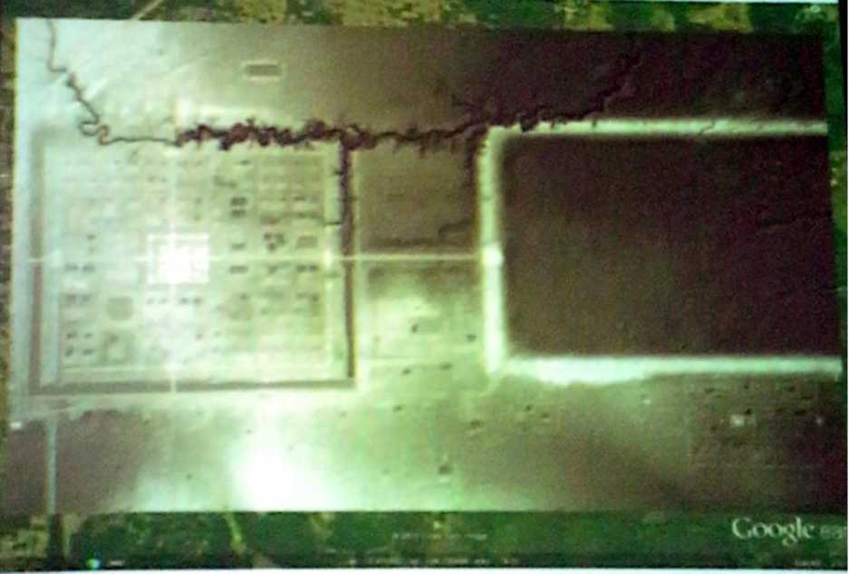

An image of Beng Mealea from Google and the overlay of the LiDar digital terrain model at 1-m resolution revealing “Orthogonal city blocks” by the road grid and pond arrangements which each block furnished with a number of elevated occupation mounds and excavated ponds surrounded by moats and linked with a large

baray and a natural waterway running from Phnom Kulen

An image of Beng Mealea from LiDar-derived hillshade model of terrain beneath the vegetation with elevation

derived from the LiDar digital terrain model.

Figure 13 - An image of Beng Mealea from Google and the overlay of the LiDar digital terrain model at 1-m resolution and the image from LiDar-derived hillshade model of terrain beneath the vegetation with elevation

derived from the LiDar digital terrain model.

Source: Pottier, C. (2014)

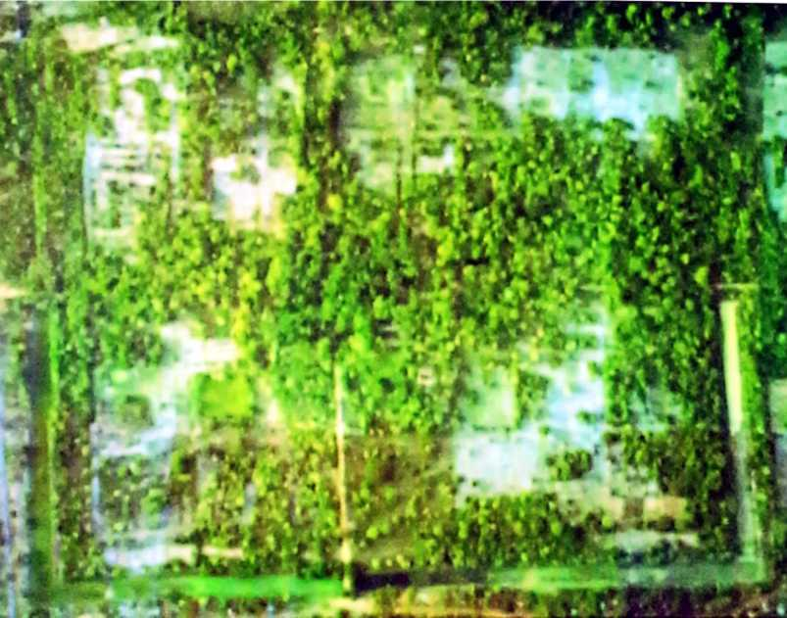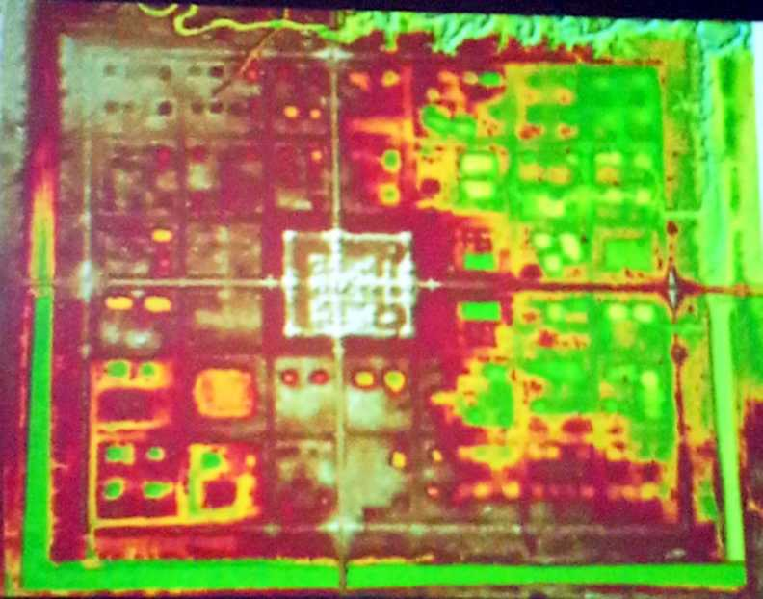

Figure 14 - The LiDar technology decoding revealed the height of trees and the level of objects

(or surfaces) at ground level

Source: Pottier, C. (2014)

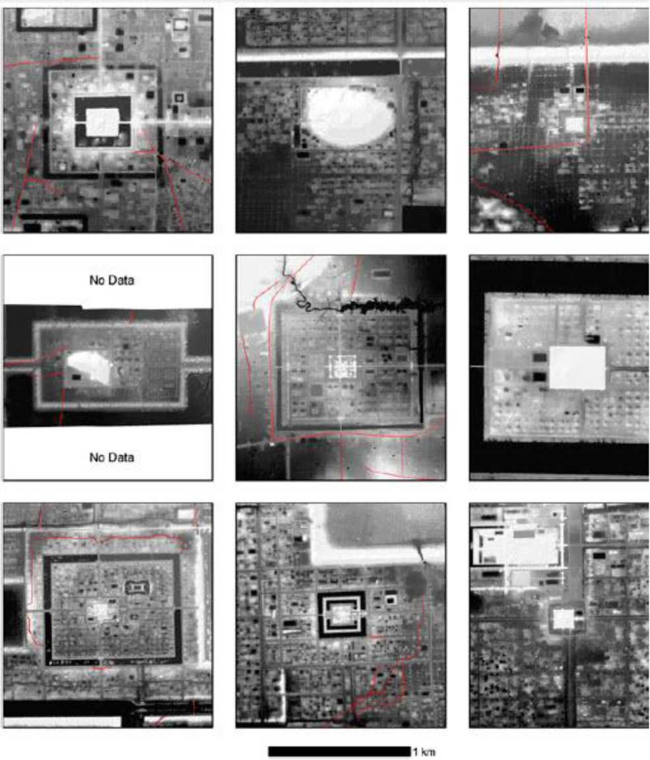

Figure 15 - Shaded relief map of terrain beneath the vegetation at major temple sites in the Angkor region, with elevation derived from the lidar digital terrain model at 1-m resolution. Top Left: Bakong (late 9th century). Top Center: Phnom Bakheng (late 9th century). Top Right: Pre Rup (mid-10th century). Middle Left: Chau Srei Vibol (11th to 12th centuries). Middle Center: Beng Mealea (early 12th century). Middle Right: Angkor Wat (mid-12th century). Bottom Left: Preah Khan (late 12th century). Bottom Center: Ta Prohm (late 12th century). Bottom Right: Bayon (late 12th to13th centuries). Red denotes modern linear

features such as roadways and canals

Source: Evans, D.H., et al. (2013).

880m'

A dharmasala or ‘house of fire’ is lo­cated on the west side of the temple.

1030m

A 500-metre long alley paved with laterite and lined with boundary stones leads to ...



□

East baray

An alley lined with naga ba­lustrades leads to the temple.

***o-***

... an imposing laterite jetty once covered by a wood pavilion whose galleries enclosed four inner court­yards. The jetty overlooked the large baray, now dry, located east of the temple.

At Beng Melea arched openings allowed water You enter ^ere to pass under the cause- on t^ie ways crossing the moat, southern side

A large cruciform terrace is found at each cardinal point but there are no traces of the enclosure which probably once connected them. An earth levy topped by a wooden palisade may have played that role in ancient times.

Figure 16 - The overall site plan of Beng Mealea. Source: Petrotchenko, M. (2012). pp.327 3rd enclosure 150m, L: 180m ,

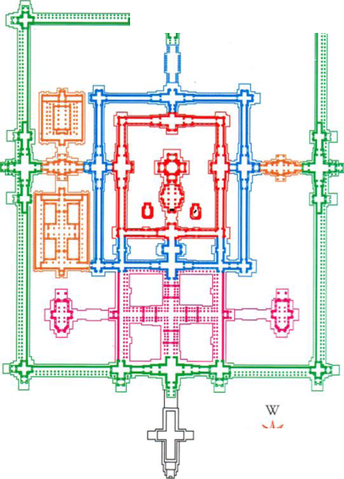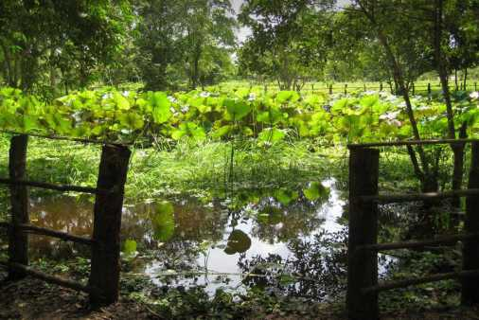

One of several lotus ponds in site of Beng Mealea.

Source: [https://www.flickr.com/photos/littlecloudvskve/2996933247/in/photostream/.](https://www.flickr.com/photos/littlecloudyskye/2996933247/in/photostream/)

Retrieved: 2014-02-18

Figure 17 - The plan of main temple complex of Beng Mealea

Source: Petrotchenko, M. (2012). pp.327

(Same scale)

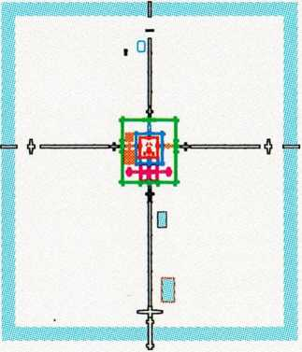

Beng Melea

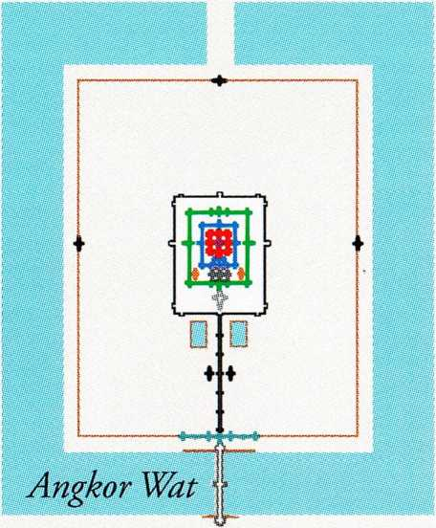

Figure 18 - The layouts comparison of the Angkor Wat and Beng Mealea

Source: Petrotchenko, M. (2012). pp.150

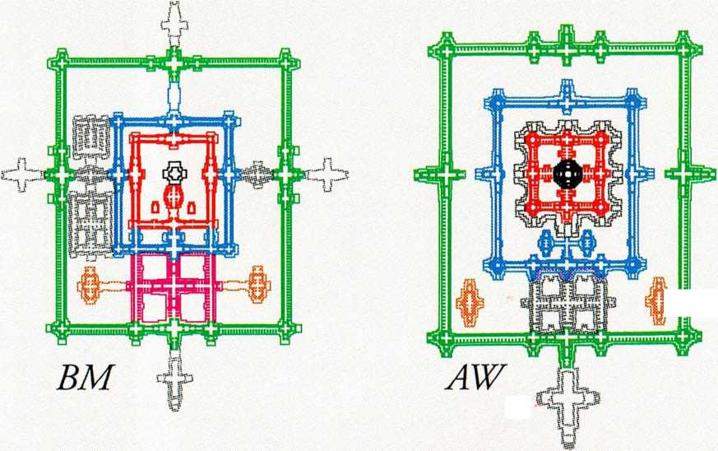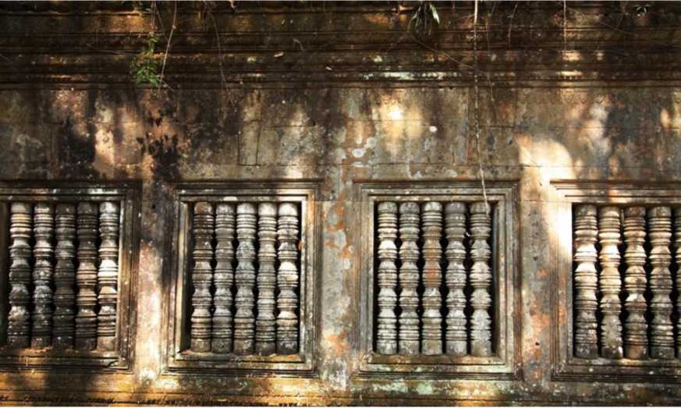

Figure 19 - The thinness and precision of the joints between the large sandstones blocks alike Angkor Wat

Source: Parichat Promsawat (2014)

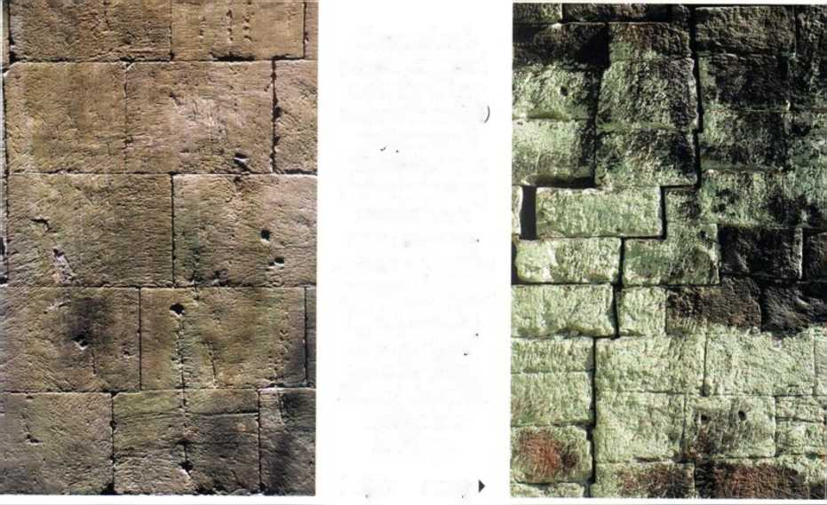

***Compared to the  
perfection attained  
at Angkor Wat or  
at Beng Melea (left  
the layavarman***

***VII temples show a  
decline in building  
standards. The  
stones are usually  
smaller and, instead  
of overlapping, stone  
blocks were often  
placed on top of  
each other (Preah***

***Khan, right), which  
weakened the***

***buildings.***

***i right***

***wrong***

Figure 20 - The high building standard of Angkor Wat and Beng Mealea in stone blocks’ lying comparing

to other temples like (Preah Khan) in later period (Bayon Style).

Source: Petrotchenko, M. (2012). pp.95

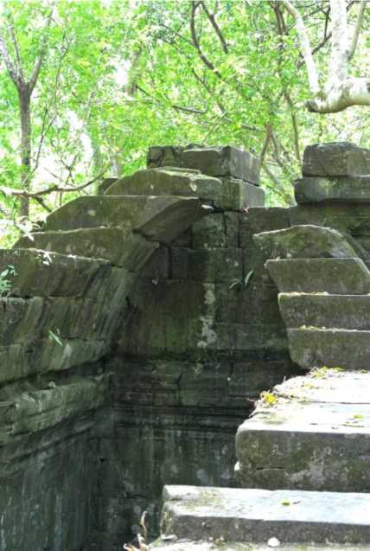

Source: Sitta Kongsasana (2014)

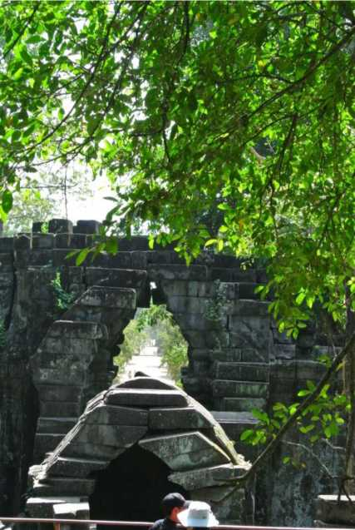

Source: Sitta Kongsasana (2014)

Figure 21 - The elaborated sandstones’ corbelling vaulting of the gallery

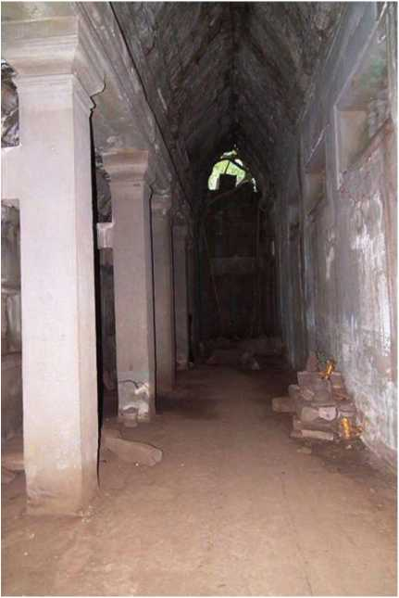

Source:

[http://upload.wikimedia.org/wikipedia/commons/thumb/c/c6/B](http://upload.wikimedia.org/wikipedia/commons/thumb/c/c6/Beng_Mealea_%E1%9E%94%E1%9F%92%E1%9E%9A%E1%9E%B6%E1%9E%9F%E1%9E%B6%E1%9E%91%E1%9E%94%E1%9E%B9%E1%9E%84%E1%9E%98%E1%9E%B6%E1%9E%9B%E1%9E%B6_%E3%83%99%E3%83%B3%E3%83%A1%E3%83%AA%E3%82%A2_DSCF4654.jpg/400px-Beng_Mealea_%E1%9E%94%E1%9F%92%E1%9E%9A%E1%9E%B6%E1%9E%9F%E1%9E%B6%E1%9E%91%E1%9E%94%E1%9E%B9%E1%9E%84%E1%9E%98%E1%9E%B6%E1%9E%9B%E1%9E%B6_%E3%83%99%E3%83%B3%E3%83%A1%E3%83%AA%E3%82%A2_DSCF4654.jpg) [eng Mealea %E1%9E%94%E1%9F%92%E1%9E%9A%E1%](http://upload.wikimedia.org/wikipedia/commons/thumb/c/c6/Beng_Mealea_%E1%9E%94%E1%9F%92%E1%9E%9A%E1%9E%B6%E1%9E%9F%E1%9E%B6%E1%9E%91%E1%9E%94%E1%9E%B9%E1%9E%84%E1%9E%98%E1%9E%B6%E1%9E%9B%E1%9E%B6_%E3%83%99%E3%83%B3%E3%83%A1%E3%83%AA%E3%82%A2_DSCF4654.jpg/400px-Beng_Mealea_%E1%9E%94%E1%9F%92%E1%9E%9A%E1%9E%B6%E1%9E%9F%E1%9E%B6%E1%9E%91%E1%9E%94%E1%9E%B9%E1%9E%84%E1%9E%98%E1%9E%B6%E1%9E%9B%E1%9E%B6_%E3%83%99%E3%83%B3%E3%83%A1%E3%83%AA%E3%82%A2_DSCF4654.jpg) [9E%B6%E 1 %9E%9F%E 1 %9E%B6%E 1 %9E%91 %E 1 %9E%](http://upload.wikimedia.org/wikipedia/commons/thumb/c/c6/Beng_Mealea_%E1%9E%94%E1%9F%92%E1%9E%9A%E1%9E%B6%E1%9E%9F%E1%9E%B6%E1%9E%91%E1%9E%94%E1%9E%B9%E1%9E%84%E1%9E%98%E1%9E%B6%E1%9E%9B%E1%9E%B6_%E3%83%99%E3%83%B3%E3%83%A1%E3%83%AA%E3%82%A2_DSCF4654.jpg/400px-Beng_Mealea_%E1%9E%94%E1%9F%92%E1%9E%9A%E1%9E%B6%E1%9E%9F%E1%9E%B6%E1%9E%91%E1%9E%94%E1%9E%B9%E1%9E%84%E1%9E%98%E1%9E%B6%E1%9E%9B%E1%9E%B6_%E3%83%99%E3%83%B3%E3%83%A1%E3%83%AA%E3%82%A2_DSCF4654.jpg) [94%E1%9E%B9%E1%9E%84%E1%9E%98%E1%9E%B6%](http://upload.wikimedia.org/wikipedia/commons/thumb/c/c6/Beng_Mealea_%E1%9E%94%E1%9F%92%E1%9E%9A%E1%9E%B6%E1%9E%9F%E1%9E%B6%E1%9E%91%E1%9E%94%E1%9E%B9%E1%9E%84%E1%9E%98%E1%9E%B6%E1%9E%9B%E1%9E%B6_%E3%83%99%E3%83%B3%E3%83%A1%E3%83%AA%E3%82%A2_DSCF4654.jpg/400px-Beng_Mealea_%E1%9E%94%E1%9F%92%E1%9E%9A%E1%9E%B6%E1%9E%9F%E1%9E%B6%E1%9E%91%E1%9E%94%E1%9E%B9%E1%9E%84%E1%9E%98%E1%9E%B6%E1%9E%9B%E1%9E%B6_%E3%83%99%E3%83%B3%E3%83%A1%E3%83%AA%E3%82%A2_DSCF4654.jpg) [E1 %9E%9B%E1 %9E%B6 %E3%83%99%E3%83%B3%E3%](http://upload.wikimedia.org/wikipedia/commons/thumb/c/c6/Beng_Mealea_%E1%9E%94%E1%9F%92%E1%9E%9A%E1%9E%B6%E1%9E%9F%E1%9E%B6%E1%9E%91%E1%9E%94%E1%9E%B9%E1%9E%84%E1%9E%98%E1%9E%B6%E1%9E%9B%E1%9E%B6_%E3%83%99%E3%83%B3%E3%83%A1%E3%83%AA%E3%82%A2_DSCF4654.jpg/400px-Beng_Mealea_%E1%9E%94%E1%9F%92%E1%9E%9A%E1%9E%B6%E1%9E%9F%E1%9E%B6%E1%9E%91%E1%9E%94%E1%9E%B9%E1%9E%84%E1%9E%98%E1%9E%B6%E1%9E%9B%E1%9E%B6_%E3%83%99%E3%83%B3%E3%83%A1%E3%83%AA%E3%82%A2_DSCF4654.jpg) [83%A1%E3%83%AA%E3%82%A2 DSCF4654.jpg/400px-](http://upload.wikimedia.org/wikipedia/commons/thumb/c/c6/Beng_Mealea_%E1%9E%94%E1%9F%92%E1%9E%9A%E1%9E%B6%E1%9E%9F%E1%9E%B6%E1%9E%91%E1%9E%94%E1%9E%B9%E1%9E%84%E1%9E%98%E1%9E%B6%E1%9E%9B%E1%9E%B6_%E3%83%99%E3%83%B3%E3%83%A1%E3%83%AA%E3%82%A2_DSCF4654.jpg/400px-Beng_Mealea_%E1%9E%94%E1%9F%92%E1%9E%9A%E1%9E%B6%E1%9E%9F%E1%9E%B6%E1%9E%91%E1%9E%94%E1%9E%B9%E1%9E%84%E1%9E%98%E1%9E%B6%E1%9E%9B%E1%9E%B6_%E3%83%99%E3%83%B3%E3%83%A1%E3%83%AA%E3%82%A2_DSCF4654.jpg) [Beng Mealea %E1%9E%94%E1%9F%92%E1%9E%9A%E1](http://upload.wikimedia.org/wikipedia/commons/thumb/c/c6/Beng_Mealea_%E1%9E%94%E1%9F%92%E1%9E%9A%E1%9E%B6%E1%9E%9F%E1%9E%B6%E1%9E%91%E1%9E%94%E1%9E%B9%E1%9E%84%E1%9E%98%E1%9E%B6%E1%9E%9B%E1%9E%B6_%E3%83%99%E3%83%B3%E3%83%A1%E3%83%AA%E3%82%A2_DSCF4654.jpg/400px-Beng_Mealea_%E1%9E%94%E1%9F%92%E1%9E%9A%E1%9E%B6%E1%9E%9F%E1%9E%B6%E1%9E%91%E1%9E%94%E1%9E%B9%E1%9E%84%E1%9E%98%E1%9E%B6%E1%9E%9B%E1%9E%B6_%E3%83%99%E3%83%B3%E3%83%A1%E3%83%AA%E3%82%A2_DSCF4654.jpg) [%9E%B6%E 1 %9E%9F%E 1 %9E%B6%E 1 %9E%91 %E 1 %9E](http://upload.wikimedia.org/wikipedia/commons/thumb/c/c6/Beng_Mealea_%E1%9E%94%E1%9F%92%E1%9E%9A%E1%9E%B6%E1%9E%9F%E1%9E%B6%E1%9E%91%E1%9E%94%E1%9E%B9%E1%9E%84%E1%9E%98%E1%9E%B6%E1%9E%9B%E1%9E%B6_%E3%83%99%E3%83%B3%E3%83%A1%E3%83%AA%E3%82%A2_DSCF4654.jpg/400px-Beng_Mealea_%E1%9E%94%E1%9F%92%E1%9E%9A%E1%9E%B6%E1%9E%9F%E1%9E%B6%E1%9E%91%E1%9E%94%E1%9E%B9%E1%9E%84%E1%9E%98%E1%9E%B6%E1%9E%9B%E1%9E%B6_%E3%83%99%E3%83%B3%E3%83%A1%E3%83%AA%E3%82%A2_DSCF4654.jpg) [%94%E1 %9E%B9%E 1 %9E%84%E 1 %9E%98%E1 %9E%B6](http://upload.wikimedia.org/wikipedia/commons/thumb/c/c6/Beng_Mealea_%E1%9E%94%E1%9F%92%E1%9E%9A%E1%9E%B6%E1%9E%9F%E1%9E%B6%E1%9E%91%E1%9E%94%E1%9E%B9%E1%9E%84%E1%9E%98%E1%9E%B6%E1%9E%9B%E1%9E%B6_%E3%83%99%E3%83%B3%E3%83%A1%E3%83%AA%E3%82%A2_DSCF4654.jpg/400px-Beng_Mealea_%E1%9E%94%E1%9F%92%E1%9E%9A%E1%9E%B6%E1%9E%9F%E1%9E%B6%E1%9E%91%E1%9E%94%E1%9E%B9%E1%9E%84%E1%9E%98%E1%9E%B6%E1%9E%9B%E1%9E%B6_%E3%83%99%E3%83%B3%E3%83%A1%E3%83%AA%E3%82%A2_DSCF4654.jpg) [%E 1 %9E%9B%E 1 %9E%B6 %E3%83%99%E3%83%B3%E3](http://upload.wikimedia.org/wikipedia/commons/thumb/c/c6/Beng_Mealea_%E1%9E%94%E1%9F%92%E1%9E%9A%E1%9E%B6%E1%9E%9F%E1%9E%B6%E1%9E%91%E1%9E%94%E1%9E%B9%E1%9E%84%E1%9E%98%E1%9E%B6%E1%9E%9B%E1%9E%B6_%E3%83%99%E3%83%B3%E3%83%A1%E3%83%AA%E3%82%A2_DSCF4654.jpg/400px-Beng_Mealea_%E1%9E%94%E1%9F%92%E1%9E%9A%E1%9E%B6%E1%9E%9F%E1%9E%B6%E1%9E%91%E1%9E%94%E1%9E%B9%E1%9E%84%E1%9E%98%E1%9E%B6%E1%9E%9B%E1%9E%B6_%E3%83%99%E3%83%B3%E3%83%A1%E3%83%AA%E3%82%A2_DSCF4654.jpg) [%83%A1%E3%83%AA%E3%82%A2 DSCF4654.jpg.](http://upload.wikimedia.org/wikipedia/commons/thumb/c/c6/Beng_Mealea_%E1%9E%94%E1%9F%92%E1%9E%9A%E1%9E%B6%E1%9E%9F%E1%9E%B6%E1%9E%91%E1%9E%94%E1%9E%B9%E1%9E%84%E1%9E%98%E1%9E%B6%E1%9E%9B%E1%9E%B6_%E3%83%99%E3%83%B3%E3%83%A1%E3%83%AA%E3%82%A2_DSCF4654.jpg/400px-Beng_Mealea_%E1%9E%94%E1%9F%92%E1%9E%9A%E1%9E%B6%E1%9E%9F%E1%9E%B6%E1%9E%91%E1%9E%94%E1%9E%B9%E1%9E%84%E1%9E%98%E1%9E%B6%E1%9E%9B%E1%9E%B6_%E3%83%99%E3%83%B3%E3%83%A1%E3%83%AA%E3%82%A2_DSCF4654.jpg)

Retrieved: 2014-02-18

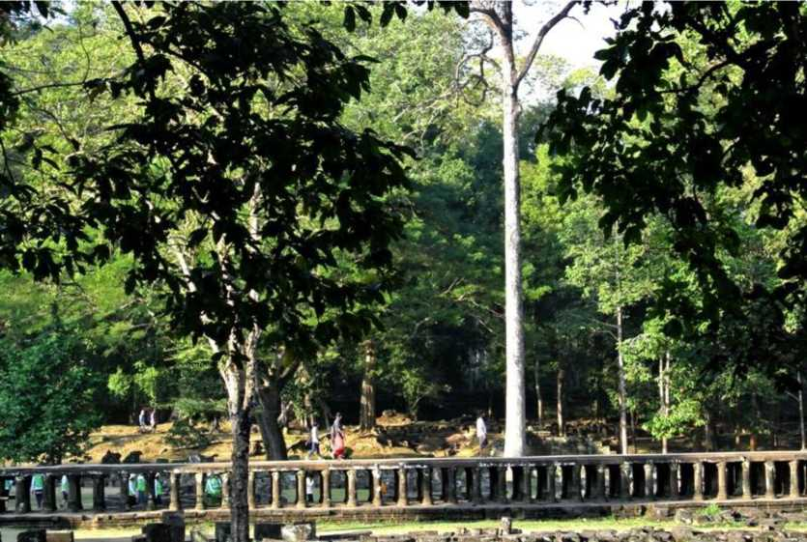

A long elevated walkway approaching Baphuon temple (late Baphuon style)

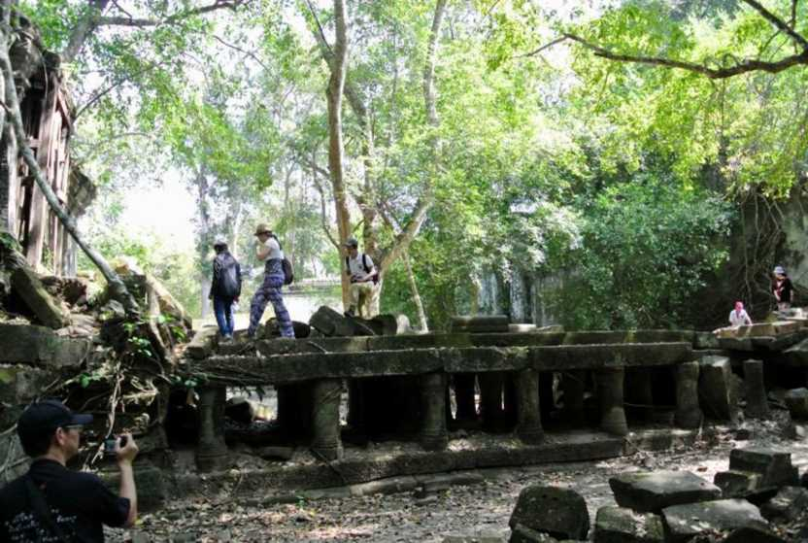

Figure 22 - The two similar elevated walkways approaching the buildings of Baphuon temple (Baphoun style) and of Beng Mealea (Angkor Wat style)

Source: Sitta Kongsasana (2014)

A bridge (elevated causeway) supported by small columns of Beng Mealea linked a library (or a shrine?) and the cruciform gallery at the east together

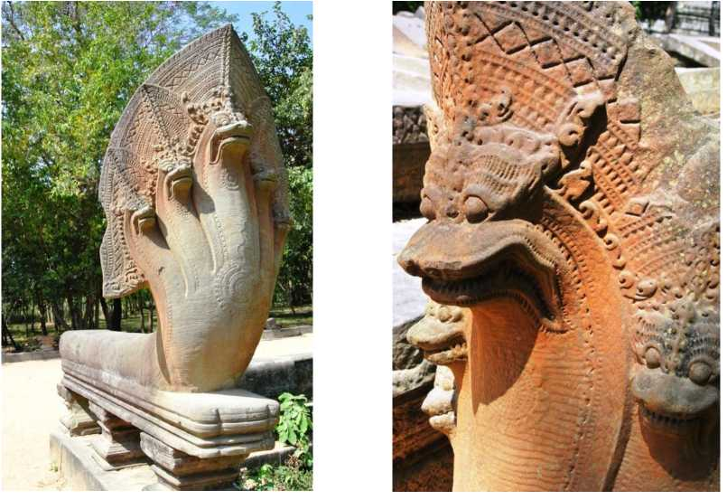

Figure 23 - The intricate Naga balustrades which each one was carved out from a

one-pieced, continuous in-length sand stone

Source: Sitta Kongsasana (2014)

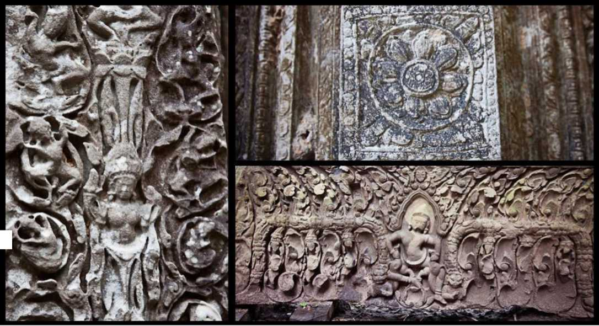

Figure 24 - Some of the intricate lintels and fallen pediments found at Beng Mealea with the images and stories

related to Hinduism.

Source: [http://www.travelingsolemates.com/wp-content/uploads/2013/05/Carvings-in-Beng-Mealea-Cambodia.ipg](http://www.travelingsolemates.com/wp-content/uploads/2013/05/Carvings-in-Beng-Mealea-Cambodia.jpg) . Retrieved: 2014-02-25

Figure 25 - An Apsara, cupping one breast, at the southeast corner pavilion of the outer enclosure

Source:

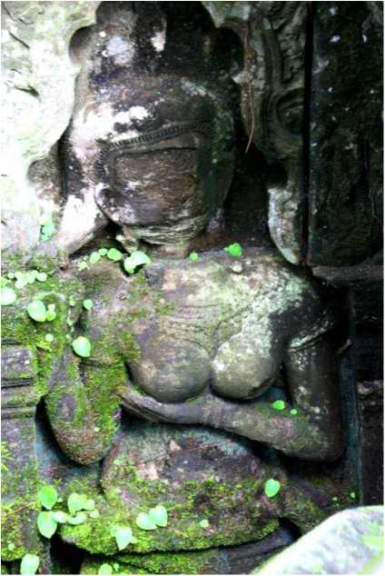

[http://dc281.4shared.com/img/qiwLzaqu/s7/13cd85](http://dc281.4shared.com/img/qiwLzaqu/s7/13cd85ab9d0/Beng_Mealea_Women_with_boob_KO.JPG) [ab9d0/Beng Mealea Women with boob KO.JPG](http://dc281.4shared.com/img/qiwLzaqu/s7/13cd85ab9d0/Beng_Mealea_Women_with_boob_KO.JPG) Retrieved: 2014-02-23

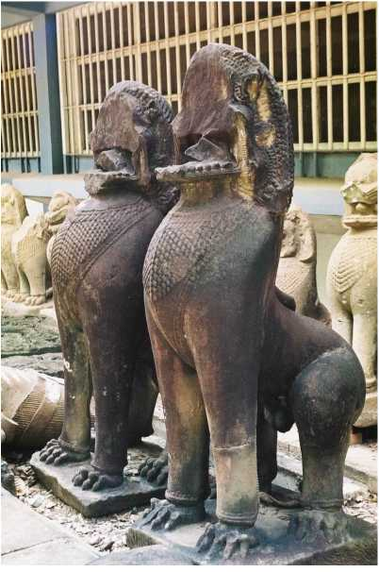

Source:

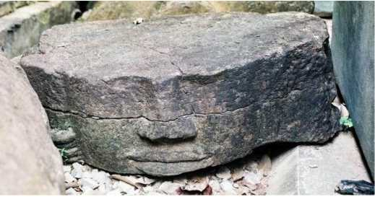

Source: [http://www.earthportals.com/Portal Messenger/bengmealea/shiva1.jpg](http://www.earthportals.com/Portal_Messenger/bengmealea/shiva1.jpg)

Retrieved: 2014-02-23

Source:

[http://www.earthportals.com/Portal](http://www.earthportals.com/Portal_Messenger/bengmealea/shiva2.jpg) [Messenger/bengmealea/ shiva2.jpg](http://www.earthportals.com/Portal_Messenger/bengmealea/shiva2.jpg) Retrieved: 2014-02-23

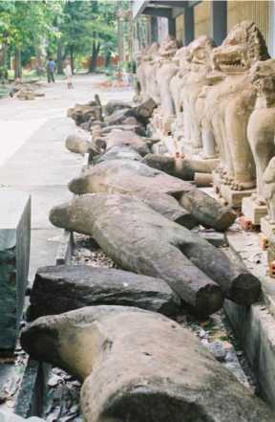

[http://www.earthportals.com/Portal](http://www.earthportals.com/Portal_Messenger/bengmealea/lion3.jpg)

[Messenger/bengmealea/lion3.jpg.](http://www.earthportals.com/Portal_Messenger/bengmealea/lion3.jpg)

Retrieved: 2014-02-23

Figure 26 - The rescue statuaries from Beng Mealea such as lion statues and many statues (or parts) of Shiva and Vishnu at Angkor Conservatories

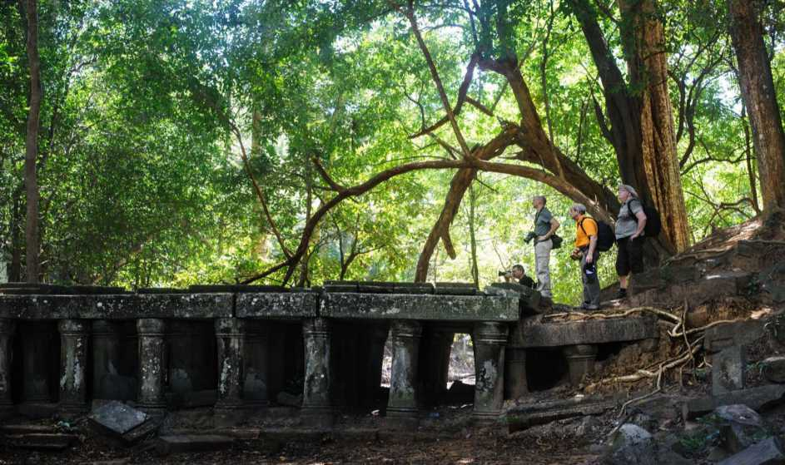

Source: [http://www.davsontheroad.be/wp-content/uploads/2012/09/DSC 0570-copv.ipg.](http://www.daysontheroad.be/wp-content/uploads/2012/09/DSC_0570-copy.jpg)

Retrieved: Retrieved: 2014-02-24

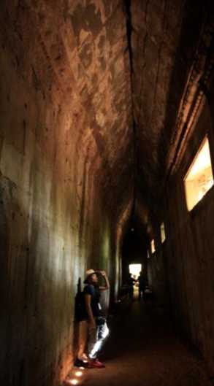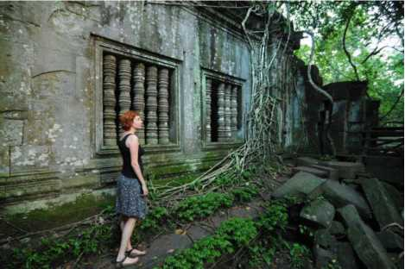

Source: [http://www.daysontheroad.be/wp-](http://www.daysontheroad.be/wp-content/uploads/2012/09/DSC_0570-copy.jpg) [content/uploads/2012/09/DSC 0570-copy.ipg.](http://www.daysontheroad.be/wp-content/uploads/2012/09/DSC_0570-copy.jpg) Retrieved:

Retrieved: 2014-02-24

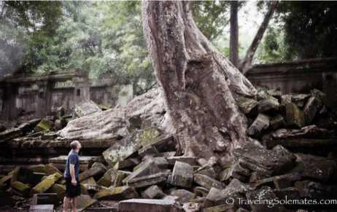

Source: [http://www.travelingsolemates.com/wp-](http://www.travelingsolemates.com/wp-content/uploads/2013/05/03_Beng-Mealea-Cambodia.jpg) [content/uploads/2013/05/03 Beng-Mealea-Cambodia.jpg.](http://www.travelingsolemates.com/wp-content/uploads/2013/05/03_Beng-Mealea-Cambodia.jpg) Retrieved:

Retrieved: 2014-02-24

Source: Sitta Kongsasana (2014)

Figure 27 - Senses of exploring and adventure like “Indiana Jones’ experiences” of Beng Mealea heritage site

Local vegetation as a source of food for locals

Children and their heritage playground

Source: Sitta Kongsasana (2014)

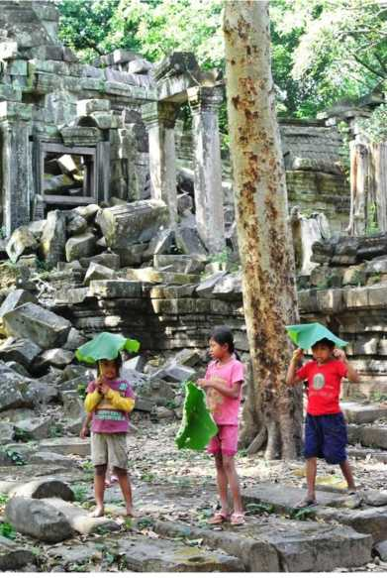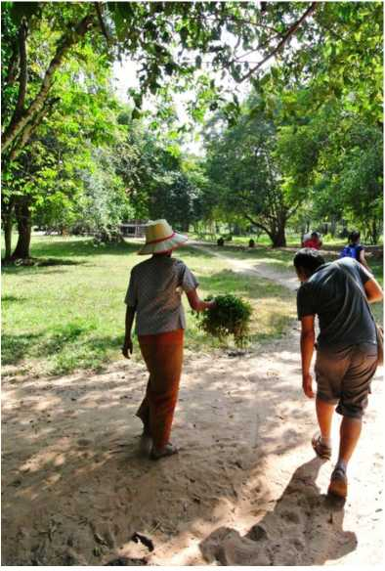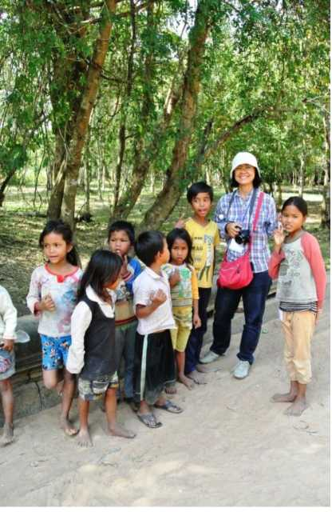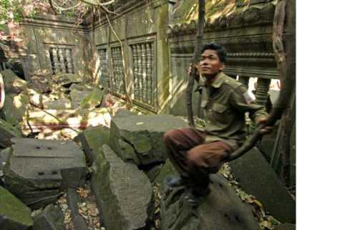

Source:

[http://www.globespots.com/pictures/asia/cambodia/beng](http://www.globespots.com/pictures/asia/cambodia/beng_mealea_8032.jpg) [mealea 8032.jpg.](http://www.globespots.com/pictures/asia/cambodia/beng_mealea_8032.jpg) Retrieved: 2014-02-25



Children were greeting the tourist with smiles

Source: Sitta Kongsasana (2014)

Source: [http://www.travelingsolemates.com/wp-](http://www.travelingsolemates.com/wp-content/uploads/2013/05/23-Children-in-Beng-Mealea-Cambodia.jpg) [content/uploads/2013/05/23-Children-in-Beng-Mealea-](http://www.travelingsolemates.com/wp-content/uploads/2013/05/23-Children-in-Beng-Mealea-Cambodia.jpg) [Cambodia.jpg.](http://www.travelingsolemates.com/wp-content/uploads/2013/05/23-Children-in-Beng-Mealea-Cambodia.jpg) Retrieved: 2014-02-25

Source: Sitta Kongsasana (2014)

Figure 28 - The symbiosis in harmony between Beng Mealea site and locals

A

To Preah Khan (Kompong

■■■

***m:.*** ™

***mm***

*$mm2*

te

PH* ‘

f,,. •

-4

&

To Kor Ker

RW

I

\ I V­i ;

jt- <Vjr ^mprm

*mp& e&rp* ■

Xg / «-A ■ , jMS rafc&toiA

-. Pnnr\m 1/ iil^n t/*

Zone 1-The Monumental Site zones



Phnom Kulen

£3!

***■ ■ .:■***

***mtmmwM&Fi***

***gM. ■ ¥£&&***

***iu>-£5***

***■fptjBpA***

Zone 2-The Buffer zones

Zone 3-The Protected Cultural Landscape zones



Ell

To Siem Reap

Zone 4-The Heritage Transition zones

Figure 29 - The primary map of proposed zoning for Beng Mealea

Source: adapted from Google map

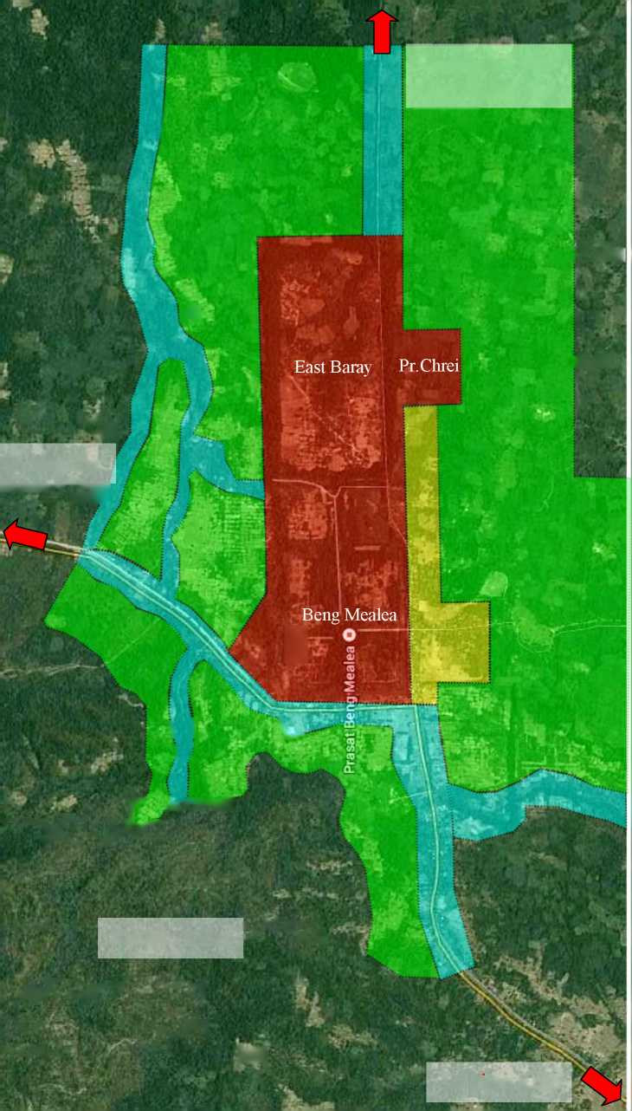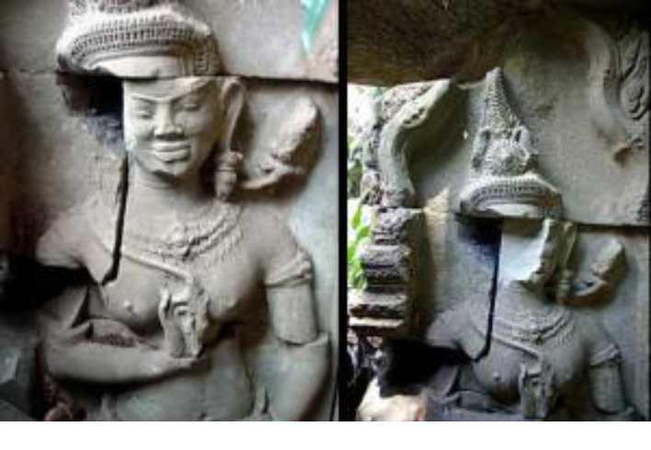

Figure 30 - the Apsara’s face looting between 2006-2007 which the photo was taken prior in 2006 (left) and another was taken later in 2007 (right). Source: [http://www.devata.org/dat-devata/uploads/2009/02/beng-melea-devata 2006-2007-](http://www.devata.org/dat-devata/uploads/2009/02/beng-melea-devata_2006-2007-300x207.jpg)

[300x207.jpg.](http://www.devata.org/dat-devata/uploads/2009/02/beng-melea-devata_2006-2007-300x207.jpg) Retrieved: 2014-02-23

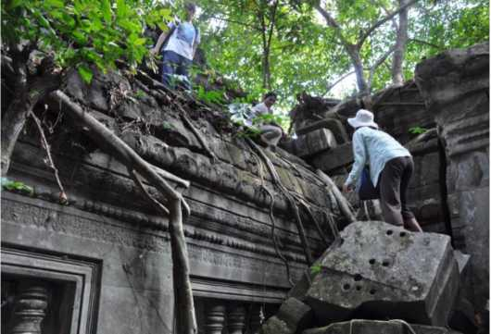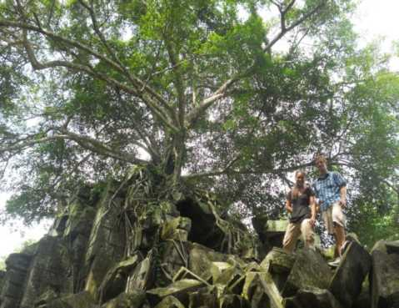

Source: [http://3.bp.blogspot.com/-](http://3.bp.blogspot.com/-DomLvFEL37w/TeUgE_PRtdI/AAAAAAAAaPI/mOe8-ej8IFM/s1600/DSC_1174.JPG) Source: [http://galvinn.files.wordpress.com/2012/07/dscn5675.ipg.](http://galvinn.files.wordpress.com/2012/07/dscn5675.jpg)

[DomLvFEL37w/TeUgE PRtdI/AAAAAAAAaPI/mOe8-](http://3.bp.blogspot.com/-DomLvFEL37w/TeUgE_PRtdI/AAAAAAAAaPI/mOe8-ej8IFM/s1600/DSC_1174.JPG) Retrieved: 2014-02-23

[ei8IFM/s1600/DSC 1174.JPG.](http://3.bp.blogspot.com/-DomLvFEL37w/TeUgE_PRtdI/AAAAAAAAaPI/mOe8-ej8IFM/s1600/DSC_1174.JPG) Retrieved: 2014-02-23

Figure 31 - Climbing the heritage structures might be dangerous and also can harm to the property by breaking the parts of it or scratching.

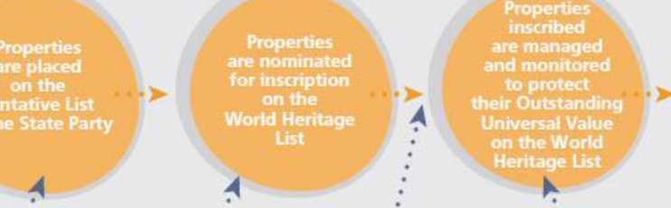

***The State Party  
decides which  
properties  
to include on its  
Tentative List***

***The State Party  
decides which  
properties on its  
Tentative List  
it will nominate  
and when for  
World Heritage  
Listing***

***The World Heritage  
Committee  
decides whether  
to inscribe  
a property on the  
World Heritage List,  
after evaluation  
of the property  
by IUCN and* / *or  
ICOMOS***

***The* State Party  
*is responsible  
for the continuing  
protection and  
effective  
management of  
the property to the  
requirements of the  
World Heritage  
Convention***

Figure 32 - Summary of the different steps in the nomination process and the main responsibilities of the State Party and the UNESCO World Heritage Committee

Source: UNESCO World Heritage Centre. (2011). pp. 17

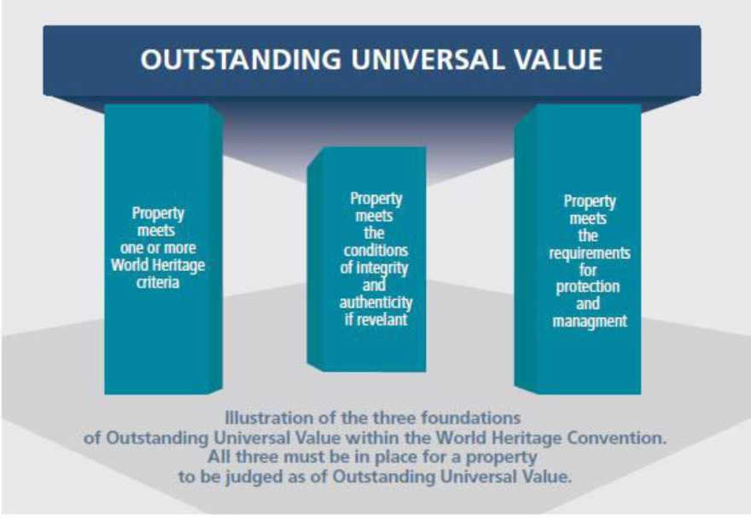

Figure 33 - Illustration of the three foundations of Outstanding Universal Value

within the World Heritage Convention

Source: UNESCO World Heritage Centre. (2011). pp. 58

Endnotes

1. Coe, D. M. (2004). Angkor and the Khmer civilization. London: Thames&Hudson. pp. 151
2. Boisselier Jean. V. (1952). Ben Mala et la chronologie des monuments du style d'Ankor Vat. In: Bulletin de l'Ecole frangaise d'Extreme-Orient. Tome 46 N 1, 1952. pp. 223-224.
3. The road had recognized by G. Groslier who wrote about Beng Mealea: "on the slopes of the foothills east Kulen, there are the remains of a paved road that I followed hundreds of meters in length, with stretches in excellent condition and, according to the natives, will lead to a small stream dry now, down to the South in the by Beng Mealea.” -Extracted from Boisselier Jean. V. (1952). pp.224
4. GeoHack. (2014). Beng Mealea (Online). Available:

[http://tools.wmflabs.org/geohack/geohack.php?pagename=Beng Mealea&params=13 28 35 N 104 14 18 Etype:](http://tools.wmflabs.org/geohack/geohack.php?pagename=Beng_Mealea&params=13_28_35_N_104_14_18_Etype:landmark_region:KH_source:kolossus-dewiki) [landmark region:KH source:kolossus-dewiki.](http://tools.wmflabs.org/geohack/geohack.php?pagename=Beng_Mealea&params=13_28_35_N_104_14_18_Etype:landmark_region:KH_source:kolossus-dewiki) Retrieved: 2014-02-23.

1. Uchida, E. and et al. (2013). Consideration of the construction period of the Khmer Temples along the East Royal Road to Preah Khan of Kompong Svay and the Provenance of sandstone blocks based on their Magnetic Susceptibility (Online). In Archaeological Discovery, Vol.1, No.2. Available: [http://dx.doi.org/10.4236/ad.2013.12004.](http://dx.doi.org/10.4236/ad.2013.12004) Retrieved: 2014-02-22. pp.42
2. Freeman, M. and Jacques, C. (2013). Ancient Angkor Book Guide. Bangkok: River Book. pp.220
3. Such as George Coedes, George Groslier, Jean V.Boisselier and Phlong Pisith.
4. Freeman, M. and Jacques, C. (2013). pp.220
5. Petrotchenko, M. (2012). Focusing on the Angkor Temples: The guidebook (2nd edition). Babgkok: Amarin Printing and Publishing. pp.31-37
6. Uchida, E. and et al. (2013). pp.42
7. Ibid., pp.326
8. Freeman, M. and Jacques, C. (2013). pp.220
9. Since the central sanctuary is totally ruined and collapsed, this led some experts to propose that it was probably destroyed in an intentional and systematic effort, during a Cham raid or during the Hindu reaction (the central sanctuary is said to have featured Buddhist pediments) - Summarized from Petrotchenko, M. (2012). pp.329
10. Nine of Cambodian heritage places is put into a tentative list on 01/09/1992; Ensemble de Banteay Chmar, Ensemble de Banteay Prei Nokor, Ensemble de Beng Mealea, Ensemble du Prah Khan de Kompong Svay, Groupe de Sambor Prei Kuk, Le site de Koh ker, Site d’Angkor Borei et Phnom Da, Site Oudong, and Site des Kulen.
11. Freeman, M. and Jacques, C. (2013). pp.326
12. Lonely Planet. (2014). Beng Mealea: Lonely Planet review (Online). Available:

[http://www.lonelyplanet.com/cambodia/temples-of-angkor/sights/other/beng-mealea#ixzz2wHaRqkLd.](http://www.lonelyplanet.com/cambodia/temples-of-angkor/sights/other/beng-mealea%23ixzz2wHqRqkLd) Retrieved: 2014-02-26.

1. Traveling Solemates. (2013). Beng Mealea: The ultimate Indiana Jones experience (Online). Available: [http://www.travelingsolemates.com/beng-mealea-the-ultimate-indiana-iones-experience/.](http://www.travelingsolemates.com/beng-mealea-the-ultimate-indiana-jones-experience/) Retrieved: 2014-02-24.
2. UNESCO World Heritage Centre. (2013-a). Angkor: Managing success (Online). Available: [http://www.unesco.org/new/en/media-services/in-focus-articles/angkor-managing-success/.](http://www.unesco.org/new/en/media-services/in-focus-articles/angkor-managing-success/) Retrieved: 2014-02-24.
3. Peace of Angkor tour.(2013). Beng Mealea (Online). Available: [http ://www.peaceofangkorphoto. com/beng-](http://www.peaceofangkorphoto.com/beng-mealea.html) [mealea.html.](http://www.peaceofangkorphoto.com/beng-mealea.html) Retrieved: 2014-02-24.
4. LiDAR (Light Detection and Ranging) survey is an airborne laser scanning that allows researchers to create very precise, detailed maps of the landscape, any structures upon it, a high-resolution and precision elevation record and also create 3D models of vegetation such as the triple canopy tropical forest covering and concealing the ground below from view. In April 2012, the first archaeological LiDAR survey in Asia and the largest archaeological LiDAR survey ever completed, 370 sq.km of LiDAR mission was undertaken in northwest of Cambodia, within the Angkor World Heritage Park, of Koh Ker, Bakong, Beng Mealea and of part of the Phnom Kulen National Park.

The results of the LiDAR acquisition have profoundly transformed the understanding of urbanism in the region of Angkor and even confirming various long-standing assumptions.

- Summarized from; Evans, D.H., et al. (2013). Uncovering archaeological landscapes at Angkor using LiDAR. In PNAS 2013 ; published ahead of print July 11, 2013, doi:10.1073/pnas.1306539110 . Available: [http://www.pnas.org/content/early/2013/07/10/1306539110.full.pdf+html?with-ds=yes.](http://www.pnas.org/content/early/2013/07/10/1306539110.full.pdf+html?with-ds=yes) Retrieved: 2014-02-24. pp.1-2 and Evans, D. and Hanus, K. (2013). 2012 LiDAR survey over Angkor, Phnom Kulen and Koh Ker. In World Heritage Magazine (issue 68), June 2013, pp.63. Available: [http://unesdoc.unesco.org/images/0022/002209/220956e.pdf.](http://unesdoc.unesco.org/images/0022/002209/220956e.pdf) . Retrieved: 2014-02-22.

1. Evans, D.H., et al. (2013). pp.2
2. Ibid., pp. 2 of the support information section.
3. Freeman, M. and Jacques, C. (2013). pp.220
4. Uchida, E. and et al. (2013). pp.41
5. Flat temple means that all the edifices were built at ground level, which was “a signature” of Jayavarman VII’s temples in Bayon Style of the Angkorian period (with the notable exception of the Bayon temple). - Summarized from Petrotchenko, M. (2012). pp.84
6. Freeman, M. and Jacques, C. (2013). pp.221
7. Petrotchenko, M. (2012). pp.83
8. Ibid., pp.221
9. Uchida, E. and et al. (2013). pp.42-43
10. Freeman, M. and Jacques, C. (2013). pp.221
11. Petrotchenko, M. (2012). pp.327
12. Ibid., pp.84
13. Boisselier Jean. V. (1952). pp.221
14. Like Angkor Wat, Beng Melea’s designers and sponsors prominently included female deities, now referred to as Devata (when standing) or Apsara (when dancing) in order to balancing mannish and feminine forces in the universe was a key component of Khmer religion - extracted from Davis, K. (2008). Death of an angel antiquities: theft at Beng Mealea Cambodian temple (Online). Available:

[http://www.devata.org/death-of-an-angel-antiquities-theft-at-beng-mealea-cambodian-temple/#.UzG2I mSwYk.](http://www.devata.org/death-of-an-angel-antiquities-theft-at-beng-mealea-cambodian-temple/%23.UzG2I_mSwYk) Retrieved: 2014-02-26. pp.2-3

1. Bogart,W.V.D. (2004). A piligrimage to Beng Mealea: The sacred dwelling place of the Neak Ta (Online). Available: [http://www.earthportals.com/Portal Messenger/stonesinsky12.html.](http://www.earthportals.com/Portal_Messenger/stonesinsky12.html) Retrieved: 2014-02-26.
2. Summarized from many comments and reviews on TripAdvisory website - TripAdvisor. (2014). Beng Mealea (Online). Available: [http://th.tripadvisor.com/Attraction Review-g293939-d655155-Reviews-Beng Mealea-](http://th.tripadvisor.com/Attraction_Review-g293939-d655155-Reviews-Beng_Mealea-Cambodia.html) [Cambodia.html.](http://th.tripadvisor.com/Attraction_Review-g293939-d655155-Reviews-Beng_Mealea-Cambodia.html) Retrieved: 2014-02-28
3. The special lecture on the title “Angkor urbanism” by Dr. Christophe Pottier of Ecole frangaise d'Extreme-Orient (EFEO) at Faculty of Architecture, Silpakorn University on February 10, 2014.
4. UNESCO World Heritage Center. (2005). Format for the nomination of properties for inscription on the World Heritage List. Paris: 38 UNESCO World Heritage Center. pp.4.
5. UNESCO World Heritage Centre. (2011). Preparing World Heritage nominations (2nd edition). Paris: UNESCO World Heritage Centre. pp.80
6. Freeman, M. and Jacques, C. (2013). pp.220
7. Uchida, E. and et al. (2013). pp.39
8. UNESCO World Heritage Centre. (2013-b). Operational guidelines for the implementation of the World Heritage Convention. Paris: UNESCO World Heritage Centre. pp.26
9. UNESCO World Heritage Centre. (2011). pp.82
10. See more on - UNESCO World Heritage Centre. (2011). Preparing World Heritage nominations (2nd edition). Paris: UNESCO World Heritage Centre. pp.19-33 and UNESCO World Heritage Centre. (2013-b). Operational guidelines for the implementation of the World Heritage Convention. Paris: UNESCO World Heritage Centre. pp.13-15.
11. UNESCO World Heritage Centre. (2011). pp.25-28
12. UNESCO World Heritage Centre. (2013-b). pp.13
13. Summarized and drew conclusion from site visits and some literatures such as; Timothy, D.J. and Nyaupane, G.P. (eds.). (2009). Protecting the past: Challenges and opportunities. In cultural heritage and tourism in developing world: A regional perspective (Online). London: Routledge. pp.20-40 and Winter, T. (2008). Post-conflict heritage and tourism in Cambodia: The burden of Angkor. In international Journal of Heritage Studies, 14:6. Available: [http://www.tandfonline.com/doi/abs/10.1080/13527250802503274#.UzC4dfmSwYk.](http://www.tandfonline.com/doi/abs/10.1080/13527250802503274%23.UzC4dfmSwYk) Retrieved: 2014-02-28 pp.524-539 and United Nations Education, Scientific and Cultural Organization. (2013). Angkor: Managing success

(Online). Available: [http://whc.unesco.org/en/news/1095.](http://whc.unesco.org/en/news/1095) Retrieved: 2014-02-28

1. Timothy, D.J. and Nyaupane, G.P. (eds.). (2009). pp.30.
2. Winter, T. (2008). pp.527
3. Authority for the Protection and Management of Angkor and the Region of Siem Reap. (2005, updated 2013).The fight against looting (Online). Available: [http://www.autoriteapsara.org/en/apsara/about apsara/police/looting.htm.](http://www.autoriteapsara.org/en/apsara/about_apsara/police/looting.htm)

Retrieved: 2014-02-26.

1. Davis, K. (2008). pp.5
2. United Nations Education, Scientific and Cultural Organization. (2013). Angkor: Managing success (Online).Available: [http://whc.unesco.org/en/news/1095.](http://whc.unesco.org/en/news/1095) Retrieved: 2014-02-28. pp.2
3. APSARA are divided into three principal departments: Culture and Monuments, Urban Development and Tourism Development. - Retrieved from Winter, T. (2008). pp.533
4. Winter, T. (2008). pp.527-528
5. Authority for the Protection and Management of Angkor and the Region of Siem Reap. (2002). Resoration work sites (Online). In Yashodhara no.6, January-June 2002.

Available: [http://www.autoriteapsara.org/en/apsara/about apsara/publication/yashodhara/yashodhara 6.html.](http://www.autoriteapsara.org/en/apsara/about_apsara/publication/yashodhara/yashodhara_6.html) Retrieved: 2014-02-28.

1. UNESCO World Heritage Centre. (2013-b). pp.7

57International Institution of Asian Studies. (2013). Greater Angkor: The growth and demise of a giant low-density, agrarian city (Online). Available: [http://www.iias.nl/event/greater-angkor-growth-and-demise-giant-low-density-](http://www.iias.nl/event/greater-angkor-growth-and-demise-giant-low-density-agrarian-city) [agrarian-city.](http://www.iias.nl/event/greater-angkor-growth-and-demise-giant-low-density-agrarian-city) Retrieved: 2014-02-26

1. Heritage Policy and Architectural Protection Section. (2008). “Tentative list and World Heritage status”.

Wexford: Heritage Policy and Architectural Protection Section. Available:

[http://www.worldheritageireland.ie/fileadmin/user upload/documents/Tentative list review research document -](http://www.worldheritageireland.ie/fileadmin/user_upload/documents/Tentative_list_review_research_document_-_public_version.pdf) [public version,pdf.](http://www.worldheritageireland.ie/fileadmin/user_upload/documents/Tentative_list_review_research_document_-_public_version.pdf) Retrieved: 2014-02-27. pp. 14

1. UNESCO World Heritage Centre. (2011). pp. 16-17
2. Ibid., pp.10
3. UNESCO World Heritage Centre. (2011). pp.51
4. Nakagawa, T. (2009).Research on the Koh Ker and Beng Mealea monuments (Online). In, Activity reports for the 16th Plenary Session meeting of the International Co-Ordinating Committee for the Safeguarding and and Development of the Historic Site of Angkor, Siem Reap, 15 December 2009. Available: [http://unesdoc.unesco.org/images/0021/002164/216483E.pdf.](http://unesdoc.unesco.org/images/0021/002164/216483E.pdf) . Retrieved: 2014-02-28. pp.8
5. Ibid., pp.52-53
6. UNESCO World Heritage Centre. (2013-b). pp.62-63.
7. UNESCO World Heritage Centre. (2011). pp.54
8. Ibid., pp.101
9. Ibid., pp.105-123
10. Ibid., pp.54-55
11. UNESCO World Heritage Centre. (2011). pp.56
12. Ibid., pp.57
13. International Council on Monuments and Sites (ed.). (2008). What is OUV? Defining the Outstanding Universal Value of cultural World Heritage properties. Berlin: Hendrik BaBler Verlag.
14. UNESCO World Heritage Centre. (2011). pp.58
15. Ibid., pp.34
16. UNESCO World Heritage Centre. (2011). pp.60
17. International Council on Monuments and Sites (ed.). (2008). pp.27-28
18. UNESCO World Heritage Centre. (2011). pp.61
19. UNESCO World Heritage Centre. (2014). World Heritage List: Angkor (Online). Available: [http://whc.unesco.org/en/list/668.](http://whc.unesco.org/en/list/668) Retrieved: 2014-02-27. pp.3-4
20. UNESCO World Heritage Centre. (2011). pp.61
21. UNESCO World Heritage Centre. (2013-b). pp.21-22.
22. UNESCO World Heritage Centre. (2011). pp.62-63
23. Ibid., pp.113
24. UNESCO World Heritage Centre. (2014). World Heritage List: Angkor (Online). Available: [http://whc.unesco.org/en/list/668.](http://whc.unesco.org/en/list/668) Retrieved: 2014-02-27.pp.4
25. UNESCO World Heritage Centre (2011). pp.114
26. Ibid., pp.87
27. Ibid., pp.117
28. UNESCO World Heritage Centre (2011). pp.87-88
29. Ibid., pp.89
30. Ibid., pp.92
31. UNESCO World Heritage Centre. (2014). pp.4
32. Ibid., pp.5
33. UNESCO World Heritage Centre. (2013-b). pp.7
34. From the example of strategies and actions in World Heritage Site Management Plan of Qusayr’ Amra heritage site in, Amman, Jordan - Palumbo, G. and Atzori, A. (eds.). (2014). Qusayr’ Amra site management plan. Amman: World Monument Fund. Available: whc.unesco.org/download.cfm?id document=127108. Retrieved: 2014-02-28
35. The suggested technical studies and investigation of Beng Mealea site are influenced by those in the conservation and restoration project of Ta Prohm Temple Complex via the close cooperation between the Archaeological Survey of India with the APSARA under the guidance of International Coordination Committee for Safeguarding the Angkor (ICC). Since both sites had been lost in the jungle for hundred years and the ruins are uniquely coexistence of the trees and the built form and integrated its site with the hydrological system. Moreover, both sites gives the sense of exploring and adventure for the visitors. Then applying some of Tha Prohm projects might be advantage to the Beng Mealea’s researches and investigations. (See more in Archaeological Survey of India. (2008).

Conservation and restoration project of Ta Prohm Temple in Cambodia (Online). In Activity reports for the 15th Plenary Session meeting of the International Co-Ordinating Committee for the Safeguarding and and Development of the Historic Site of Angkor, Siem Reap, 1 December 2008. Available [http://unesdoc.unesco.org/images/0021/002164/216480e.pdf.](http://unesdoc.unesco.org/images/0021/002164/216480e.pdf) Retrieved: 2014-02-28. pp.15)

1. UNESCO World Heritage Centre. (2011). pp.56
2. Applied from the statement by Mr. Koichhiro Matsuura, former Director-General of UNESCO in UNESCO World Heritage Centre. (2013-c). Managing cultural World Heritage. Paris: UNESCO World Heritage Centre. pp.51
3. UNESCO World Heritage Centre. (2013-b). pp.7
4. UNESCO World Heritage Centre. (2013-c). pp.50-51