# 概率论讨论

## 引言：为什么要学习概率论

## **概率的不同类型**

#### A 直观概率

这类概率是基于直观来处理和判断的。该套数学理论是有库普曼（B.O.Koopman）建立。

#### B 古典概率

事件的概率不是实验性的。是通过预先计算事件可能发生的次数与所有可能的结果形成的一个比值。

古典概率至少会遇到两个问题：（1）它不能处理实验结果不是等可能的情况；（2）它不能处理实验结果无穷大的情况。

#### C 频率作为概率的测度

#### D 基于公理化理论的概论

## **概率的误用、误算和悖论**

基于相对频率的概率是无用的。

## **Sets,Fields,And Events**

A set is a collection of objects, either concrete or abstract. A subset of a set is a collection that is contained within the larger set.

In probability theory we call set *events*.

We denote the set of all outcomes by Ω , and individual outcomes by ζ. The set is called the *sample space* of the random experiment. Certain subsets of Ω, whose probabilities we are interested in are called *events*. In particular Ω itself is called the *certain event* and the empty ϕ set is called the *null event*.

##### Set Theory

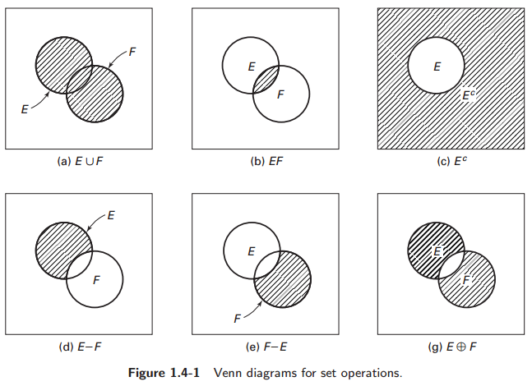

##### Sigma fields.

##### (σ代数，或者称为σ -域，可以用用来严格的定义可测集).

Consider a universal set Ω and a certain collection of subsets of Ω. Let *E* and *F* be two arbitrary subsets in this collection. This collection of subsets forms a *field M* if

1. 
2. If  and , then , and 
3. If , then 