BCG-vaccination reduces early infant mortality: an observational study in Guinea-Bissau

# Introduction

The protection provided by BCG vaccines is a complex and controversial subject. The protective effect of BCG vaccines against tuberculosis is well documented [REF] but it may also protect against other diseases such as leprosy. This is particularly relevant in low-income country where …

… something about age possible important predictor of mortality …

Using a cohort of infants (0-7 months) from Guinea-Bissau, we assess the efficacy of the BCG vaccination with respect to 6 month mortality. Since some of the infant in the cohort had received DTP injections, a secondary analysis was perform account for possible interactions between the BCG and DTP vaccine on the mortality rate.

# Methods

### Study design

This is an population-based cohort study organized as a systematic house-to-house survey. A nurse was sent to visit every household in the district ….

### Participants

Infant from 0 to 7 months old. Infant with birth trauma, severe infection or hospitalized when answering the survey were excluded. Informed consent …

### Exposure

Most infant develop a scar at the injection site after intradermal injection of the BCG vaccine. The nurse reported BCG vaccination after asking the parents and checking the presence of a scar (present, doubtful, absent). In case of disagreement (e.g. vaccinated infant according to the parent but no scar) ….

### Outcome

The primary outcome was 6 months survival from the enrolment visit. Death or emigration (i.e. right-censoring of the outcome) were identified through the national registry …

### Data processing

…

### Statistical analysis

To estimate the age specific 6 months difference in survival between BCG-vaccinated vs. non vaccinated infant, first a Cox model was used to model the hazard rate of death as a function of time since inclusion in the study (baseline hazard), age group (in month as a categorical variable) and BCG vaccination status (yes or no). The BCG vaccination effect was assumed constant for each age group and over time on the log-hazard scale. The p-value relative to the hazard ratio of BCG was used to evaluate the null hypothesis of no vaccine effect at all timepoint in all age groups. The average difference in 6 months survival had all infants been vaccinated vs. none was used to quantify the vaccine effect. The survival was estimated using an exponential approximation and the Breslow estimator of the baseline hazard.

In a sensitivity analysis, the age effect on the log-hazard was modeled in the Cox model using p-splines based on the number of days since birth instead of assuming a log-hazard specific to each month since birth.

In a secondary analysis, the age specific 6 months difference in survival between BCG-vaccinated vs. non vaccinated infant was estimated separately for infant without DTP and for infant with DTP. A Cox model including DTP vaccination status in addition to age (as a categorical variable) and BCG vaccination status, with an interaction between DTP and BCG, was fitted. Survival probabilities were estimated for each age and vaccination group using the same method as for the main analysis. P-value relative to the hazard ratio for (i) BCG among non-vaccinated DTP infants (ii) BCG among vaccinated DTP infants were use to evaluate the null hypothesis of no vaccine effect at all timepoints in all age groups among (i) non vaccinated DTP infants or (ii) vaccinated DTP infants.

The R software (R Core Team (2022) was use to implement the statistical analysis. The source code, the version of R and of related software package, can be found at <https://github.com/bozenne/article-template/tree/main>.

# Results

5274 children were included in the study. Among them 222 (4.21%) died by the end of follow-up, 2548 (48.31%) survived, and 2504 (47.48%) were lost during the follow-up period and their survival outcome was thus not know at 6 months. Lost to follow-up mainly occurred between month 4 to month 6 (figure 1). 3301 (62.59%) infants were identified as being BCG vaccinated and 1973 (37.41%) identified as not BCG vaccinated. … document possible issues with identification of BCG vaccination… . Descriptive statistics about the vaccination group can be found in table 1. In particular only 31 (1.6%) infants received DTP but not BCG.

Figure 2 shows the estimated survival curve from the Cox model for each age group and vaccination group. The difference in survival between the two groups ranged from 1.42% to 1.97%. The corresponding hazard ratio for the BCG vaccine was 0.707 [0.531;0.941] (p=0.017). A nearly identical hazard ratio(0.708) was found when modeling the age effect using splines. ….

| Variable | Level | bcg = 1 (n=3301) | bcg = 0 (n=1973) | Total (n=5274) |
| --- | --- | --- | --- | --- |
| status | dead | 125 (3.8) | 97 (4.9) | 222 (4.2) |
|  | censored | 3176 (96.2) | 1876 (95.1) | 5,052 (95.8) |
| agem | mean (sd) | 3.1 (1.7) | 1.8 (1.7) | 2.6 (1.8) |
| dtp | 1 | 2,142 (64.9) | 31 (1.6) | 2,173 (41.2) |
|  | 0 | 1159 (35.1) | 1942 (98.4) | 3,101 (58.8) |

Table 1: Demographic information

| model | OR | CI(OR) | p.value |
| --- | --- | --- | --- |
| Age (categorical) | 0.707 | 0.531;0.941 | 0.0174 |
| Age (splines) | 0.708 | 0.531;0.942 | 0.0179 |

Table 2: estimated hazard ratio by the Cox model using age in months as a categorical variable or using p-splines with age in days as continuous variable.

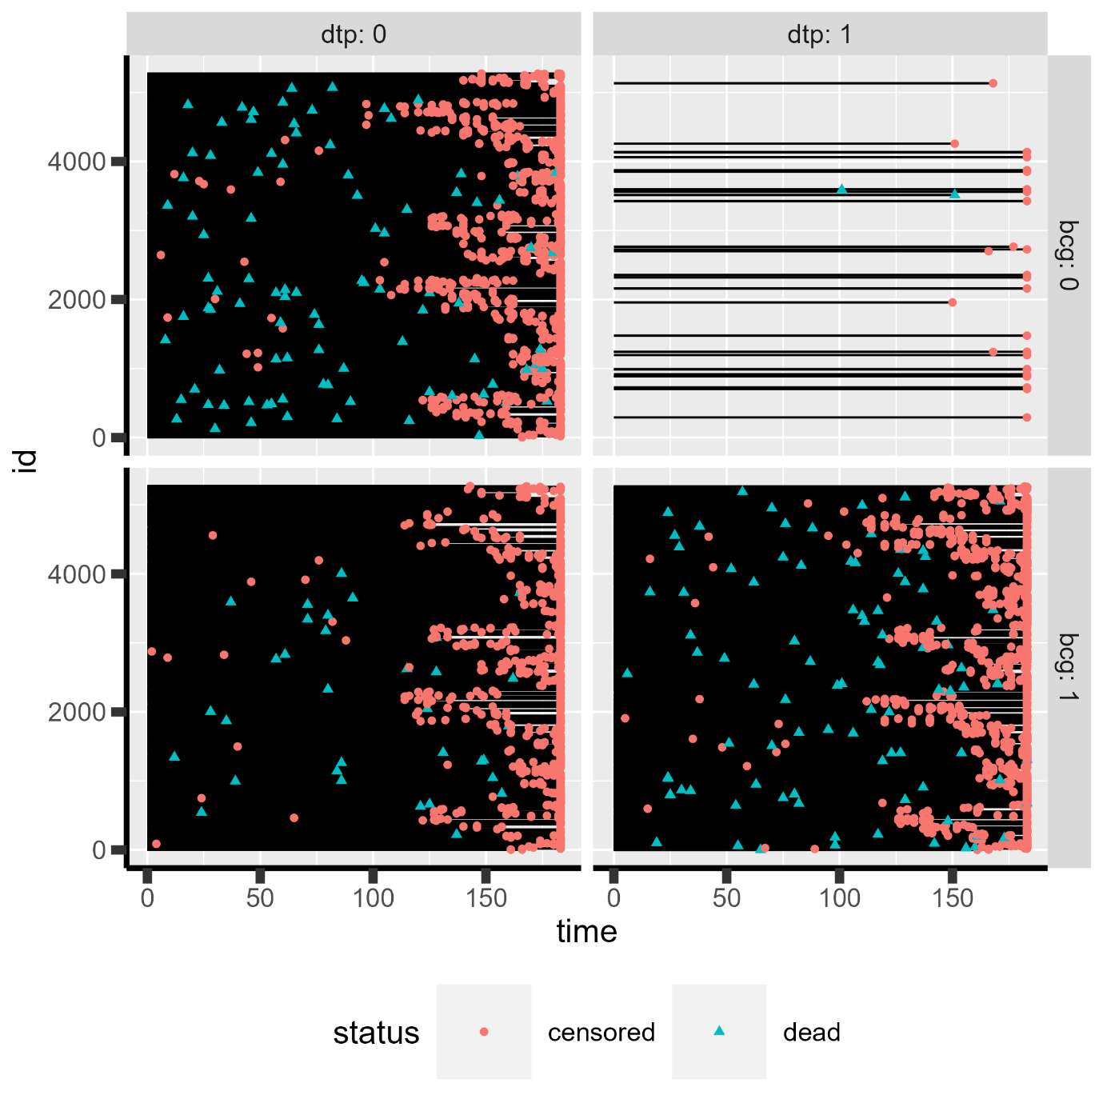

Figure 1: Survival or censoring time for each subject (y-axis) for each vaccination group.

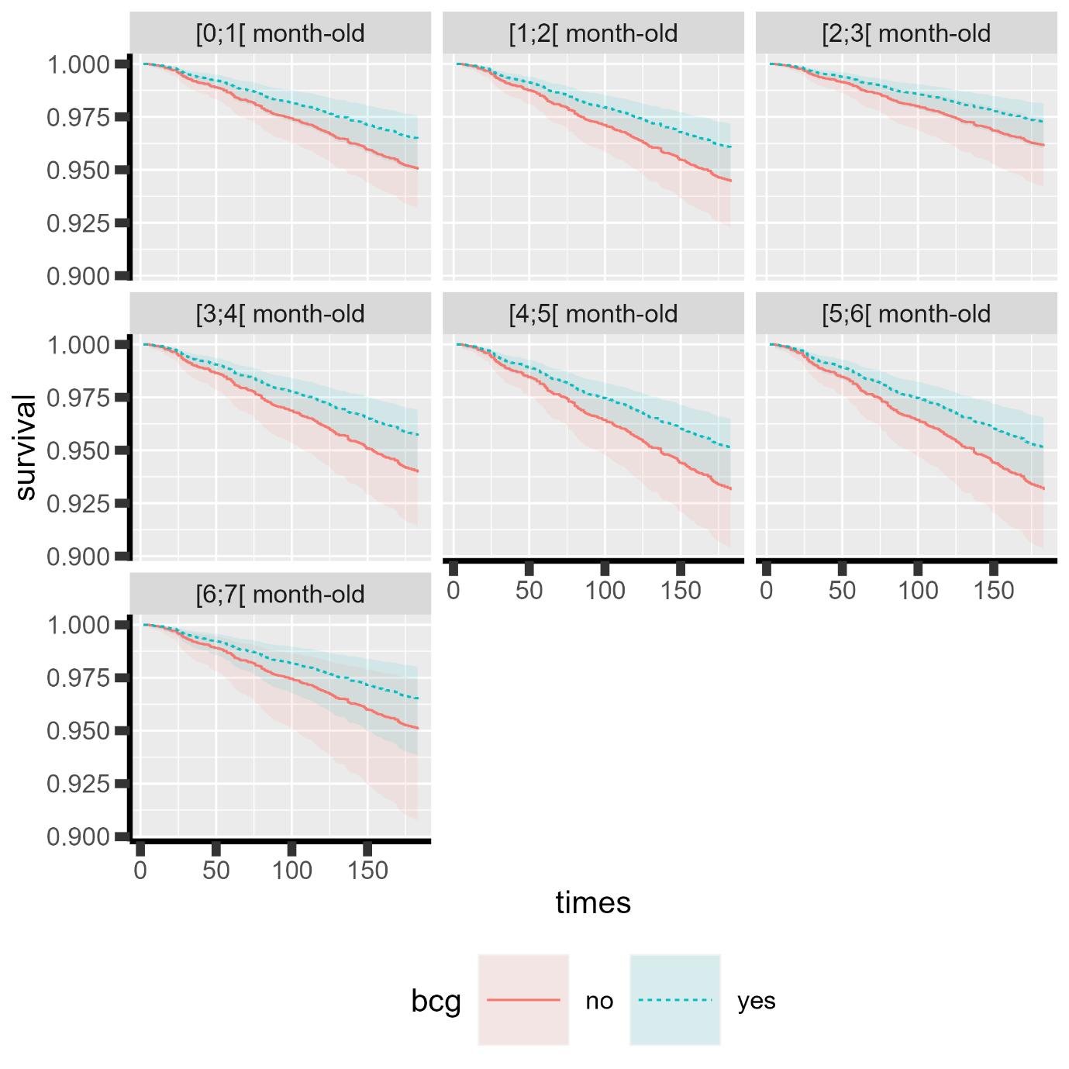

Figure 2: Estimated survival (lines) and time-specific 95% confidence intervals (shaded area) for each age group (panels) and each vaccination group (color and type of line).

# Bibliography

R Core Team (2022). R: A language and environment for statistical computing. R Foundation for Statistical Computing, Vienna, Austria. URL https://www.R-project.org/.