Exam Preparation
Test your tasks in the Judge system:
https://alpha.judge.softuni.org/contests/exam-preparation-i/4454

Sum Factorial Even Digits
Write a program that:
- Reads an integer number from the console
- Calculate sum of the factorials only on even digits of the given number
- Print the calculated sum

Example
Input | Output | Comments
4532 | 26 | First digit is 4, it is even so we calculate factorial: 4! = 4 * 3 * 2 * 1 = 24  Second digit is 5, it is odd so we skip it.  Third digit is 3, it is odd so we skip it.  Forth digit is 2, it is even so we calculate factorial: 2! = 2 * 1 = 2  Sum of factorials: 24 + 2 = 26
468 | 41064 | First digit is 4, it is even so we calculate factorial: 4! = 4 * 3 * 2 * 1 = 24  Second digit is 6, it is even so we calculate factorial:  6! = 6 * 5 * 4* 3 * 2 * 1 = 720  Third digit is 8, it is even so we calculate factorial:  8! = 8 * 7 * 6 * 5 * 4* 3 * 2 * 1 = 40320  Sum of factorials: 24 + 720 + 40320 = 41064

Middle Elements
Write a program that:
- Reads an array of integer numbers from the console, separated by single space
- Array length will always be even number.
- Calculate the average value of the elements in the middle of the array
- Print the result formatted to the second digit

Example
Input | Output | Comments
3 4 6 7 8 9 | 6.50 | Middle elements are: 6 and 7  Average value: (6 + 7) / 2 = 13 / 2 = 6.50
12 34 98 42 65 12 | 70.00 | Middle elements are: 98 and 42  Average value: (98 + 42) / 2 = 140 / 2 = 70

Unit Test Method: Center Point
Test a given method which takes in coordinates of 2 points and determines which point is closer to the center (0,0).
The method is found in the CenterPoint.cs file:
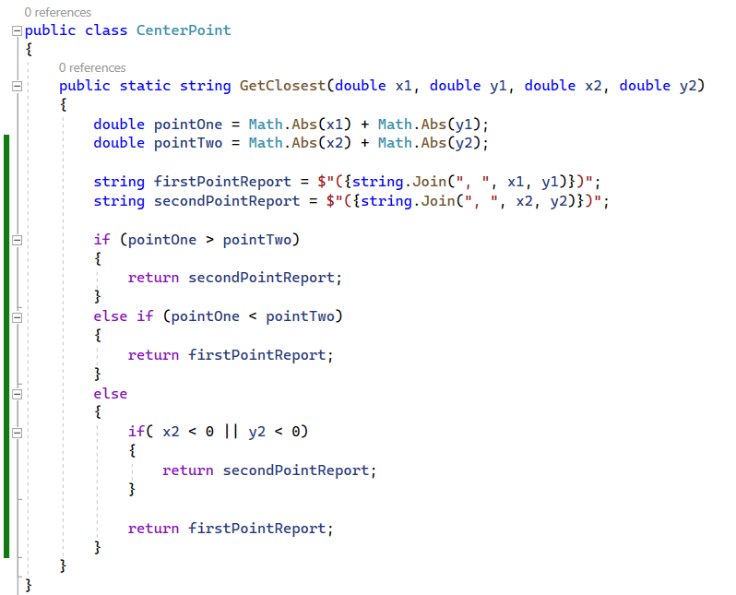
You are given a test file CenterPointTests.cs containing 5 empty tests. Implement all the unit tests:
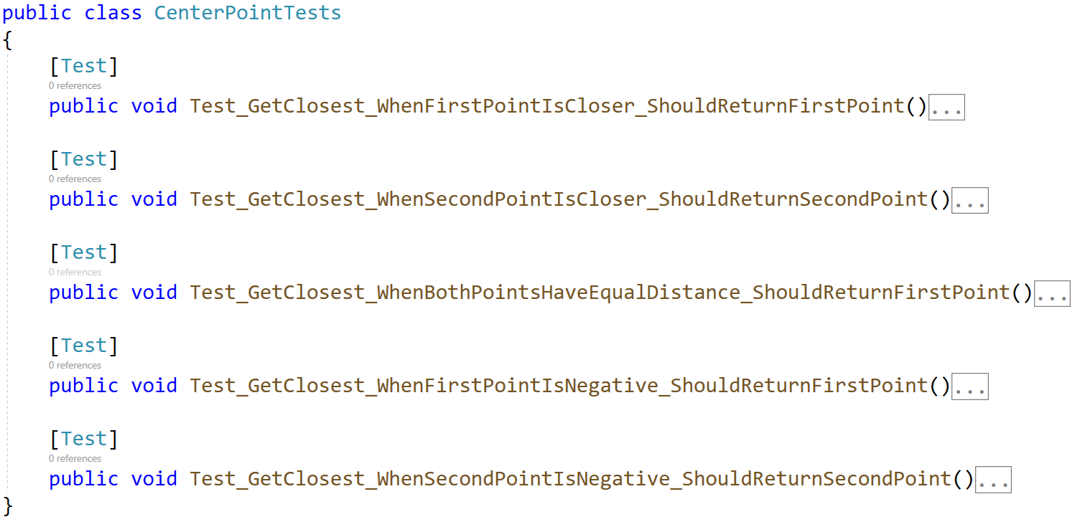
When you are ready make sure your tests run:
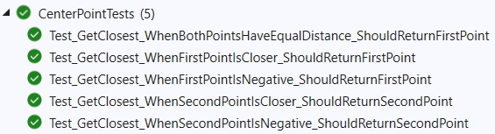
IMPORTANT: DO NOT REMOVE OR CHANGE ANY NAMESPACES AND USINGS.

Unit Test Array: Fold Array
Test a given method which takes in an integer array of 4*k integers, then folds it like shown below, and returns the sum of the upper and lower two rows (each holding 2*k integers):
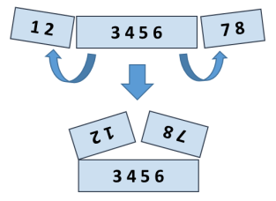
The method is found in the FoldSum.cs file:
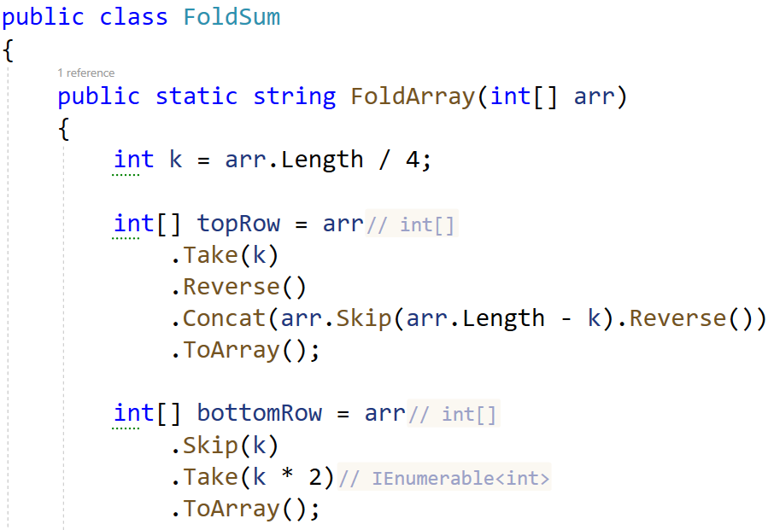
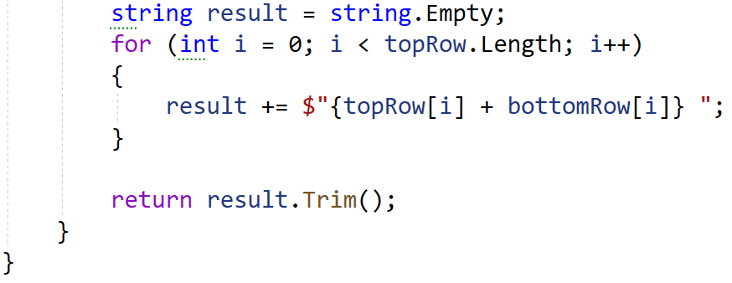
You are given a test file FoldSumTests.cs containing 5 empty test cases. Implement all the cases:
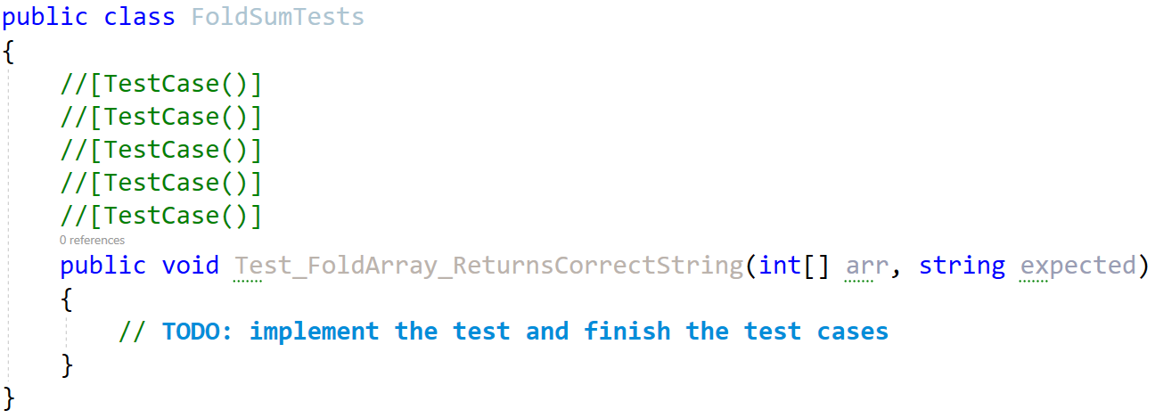
When you are ready make sure your tests run:
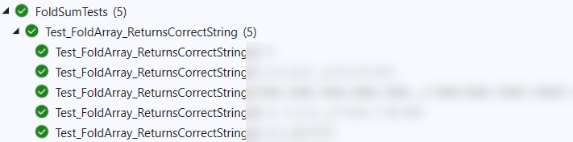
IMPORTANT: DO NOT REMOVE OR CHANGE ANY NAMESPACES AND USINGS.

