Programming Fundamentals and Unit Testing

Regular Exam – 02 November 2025
Submit your solution here:
https://alpha.judge.softuni.org/contests/programming-fundamentals-and-unit-testing-regular-exam-02-november-2023/5225

3. Unit Test Method: Prime numbers
Test a given method which takes in two integers and returns all prime numbers in the range.

Examples
Input | Output
10  1 | Start number should be bigger than end number.
1  1 | Empty string
0  1 | Empty string
1  50 | 2 3 5 7 11 13 17 19 23 29 31 37 41 43 47
2  3 | 2 3
The method is found in the PrimeNumbers.cs file:
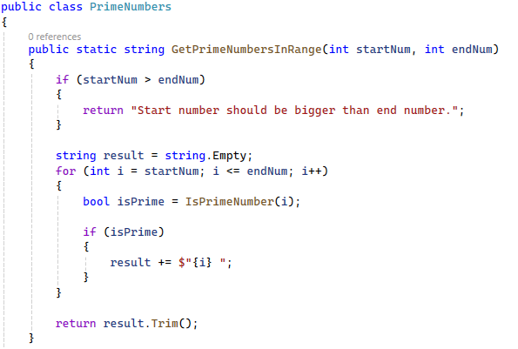
There is one helper method to verify if the number is prime or not:
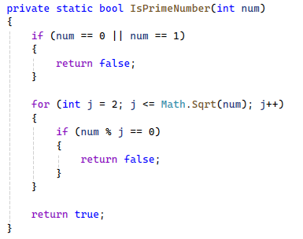
You are given a test file PrimeNumbersTests.cs containing 5 empty tests. Implement all the unit tests:
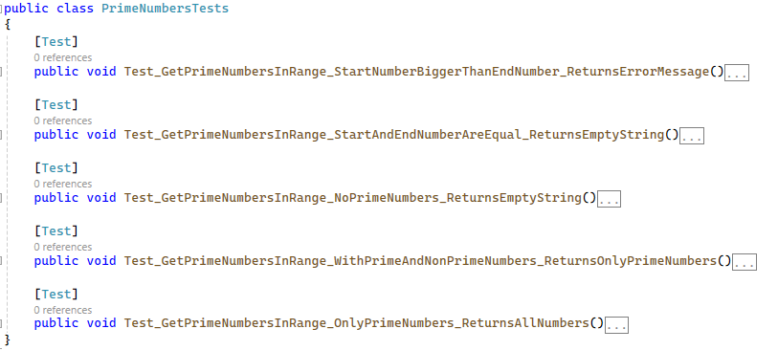
When you are ready make sure your tests run:
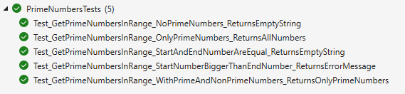
IMPORTANT: DO NOT REMOVE OR CHANGE ANY NAMESPACES AND USINGS.

