Programming Fundamentals and Unit Testing

Regular Exam – 02 November 2025
Submit your solution here:
https://alpha.judge.softuni.org/contests/programming-fundamentals-and-unit-testing-regular-exam-02-november-2023/5225

4. Unit Test List: Palindrome Finder
Test a given method which takes in a list of strings and returns a single string with space separated palindromes. The program considers every word as palindrome if can be read the same backwards as forwards.
The method is found in the PalindromeFinder.cs file:
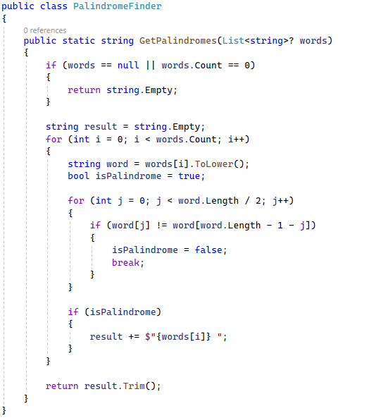
You are given a test file PalindromeFinderTests.cs containing 5 empty tests. Implement all the unit tests:
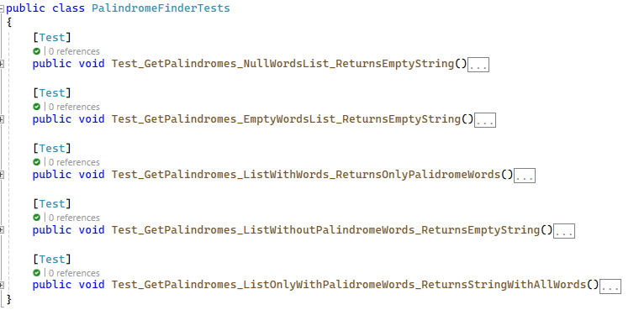
When you are ready make sure your tests run:
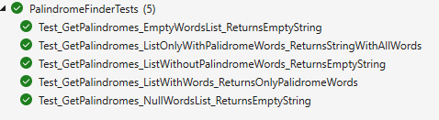

IMPORTANT: DO NOT REMOVE OR CHANGE ANY NAMESPACES AND USINGS.

