Programming Fundamentals
and Unit Testing Regular Exam - 19 October 2023

English Name of Each Digit
Write a program that:
- Reads an integer positive number from the console
- Print English name of the each digit of a given number on a separate line, starting from the last to the first digit
  - 1 -> "one"
  - 2 -> "two"
  - 3 -> "three"
  - 4 -> "four"
  - 5 -> "five"
  - 6 -> "six"
  - 7 -> "seven"
  - 8 -> "eight"
  - 9 -> "nine"

Example
Input | Output
512 | two  one  five
121 | one  two  one
1643 | three  four  six  one

Average Last Elements
Write a program that:
- Reads an array of integer numbers from the first line of the console, separated by single space
- Read an integer number N from the second line of the console
- Find average value of the last N elements in the array
- Print the average value formatted to the second decimal digit

Example
Input | Output | Comments
3 42 61 7 8 9 10 23  4 | 12.50 | Last 4 numbers in the array are: 8 9 10 23  Average value is: (8 + 9 + 10 + 23) / 4 = 12.5
12 34 98 42 65 12  3 | 39.67 | Last 3 numbers in the array are: 42 65 12  Average value is: (42 + 65 + 12) / 3 = 39.67

Unit Test Method: Extract File
Test a given method which takes in a path in the form of a string and gets the filename and file extension (if it exists).

Examples
Input | Output
C:\Users\John\Documents\example.txt | File name: example\nFile extension: txt
C:\Users\John\Documents\example | File name: example
C:\Users\John\Documents?\example.txt | File name: example\nFile extension: txt
null | Throws ArgumentNullException
(empty string) | Throws ArgumentNullException

The method is found in the ExtractFile.cs file:
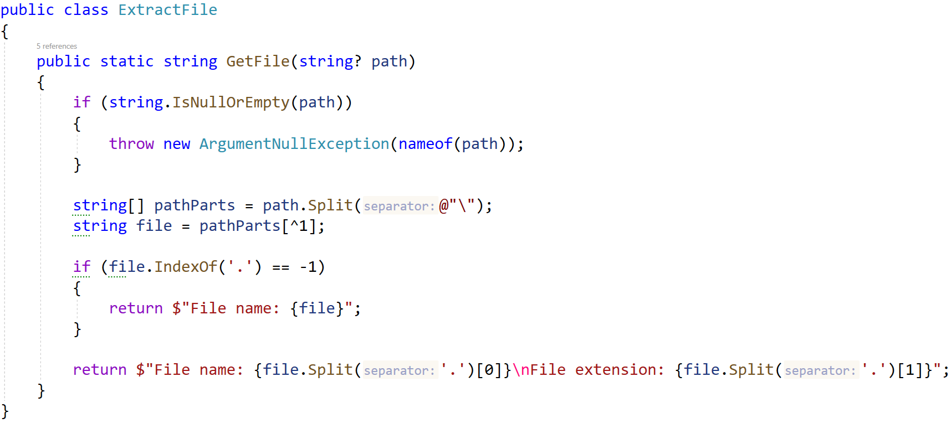
You are given a test file ExtractFileTests.cs containing 5 empty tests. Implement all the unit tests:
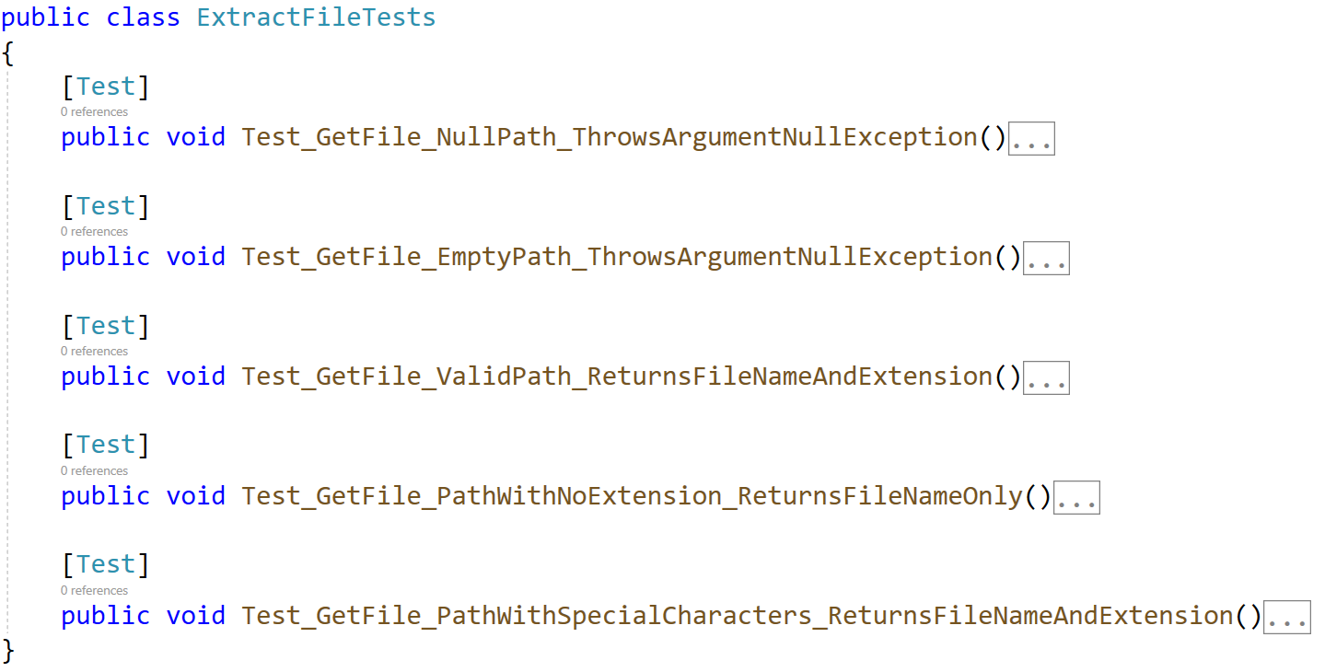
When you are ready make sure your tests run:
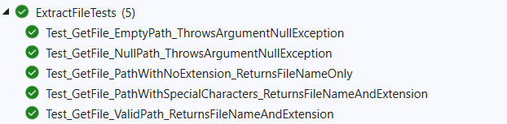
IMPORTANT: DO NOT REMOVE OR CHANGE ANY NAMESPACES AND USINGS.

Unit Test List: Drum Set
Test a given method which takes in a decimal representing money, list of integers representing quality of drums and a list of strings representing commands.
For each command each drum is hit by the number indicated. If a drum breaks (goes below or equal to zero) it must be replaced by the initial amount, then initial amount times three must be reduced from the money. If a new drum can’t be afforded it is removed from the list.
When the command "Hit it again, Gabsy!" is received, the method ends, and returns the current state of the drum set alongside the leftover money.
The method is found in the DrumSet.cs file:
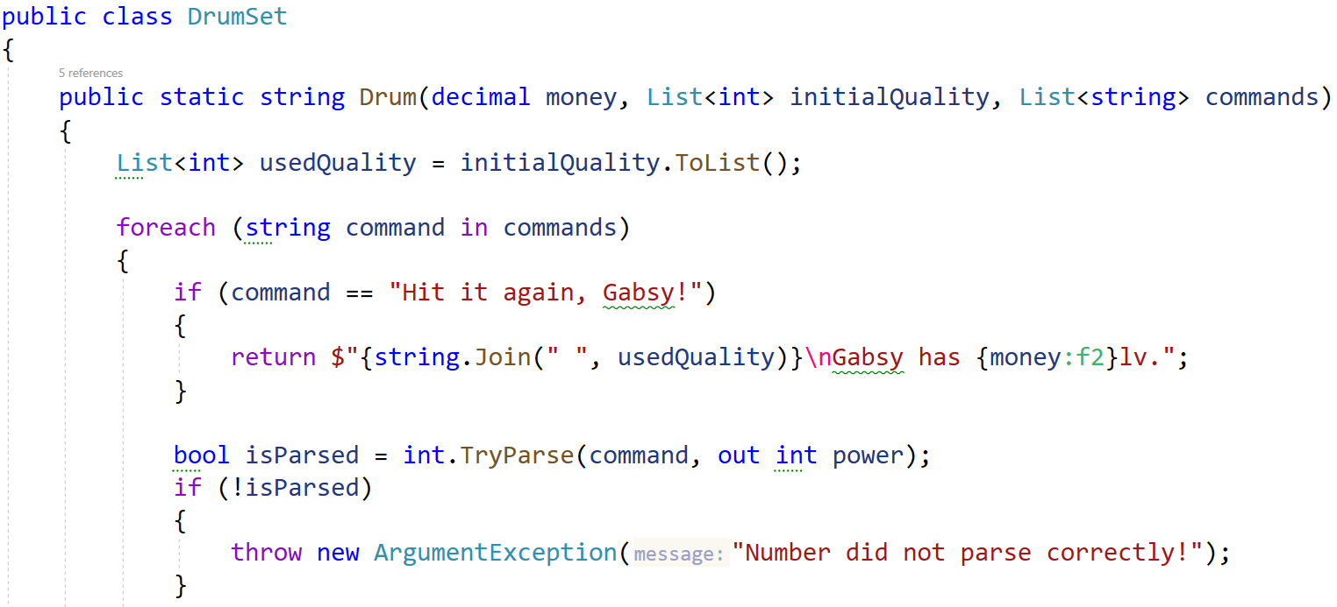
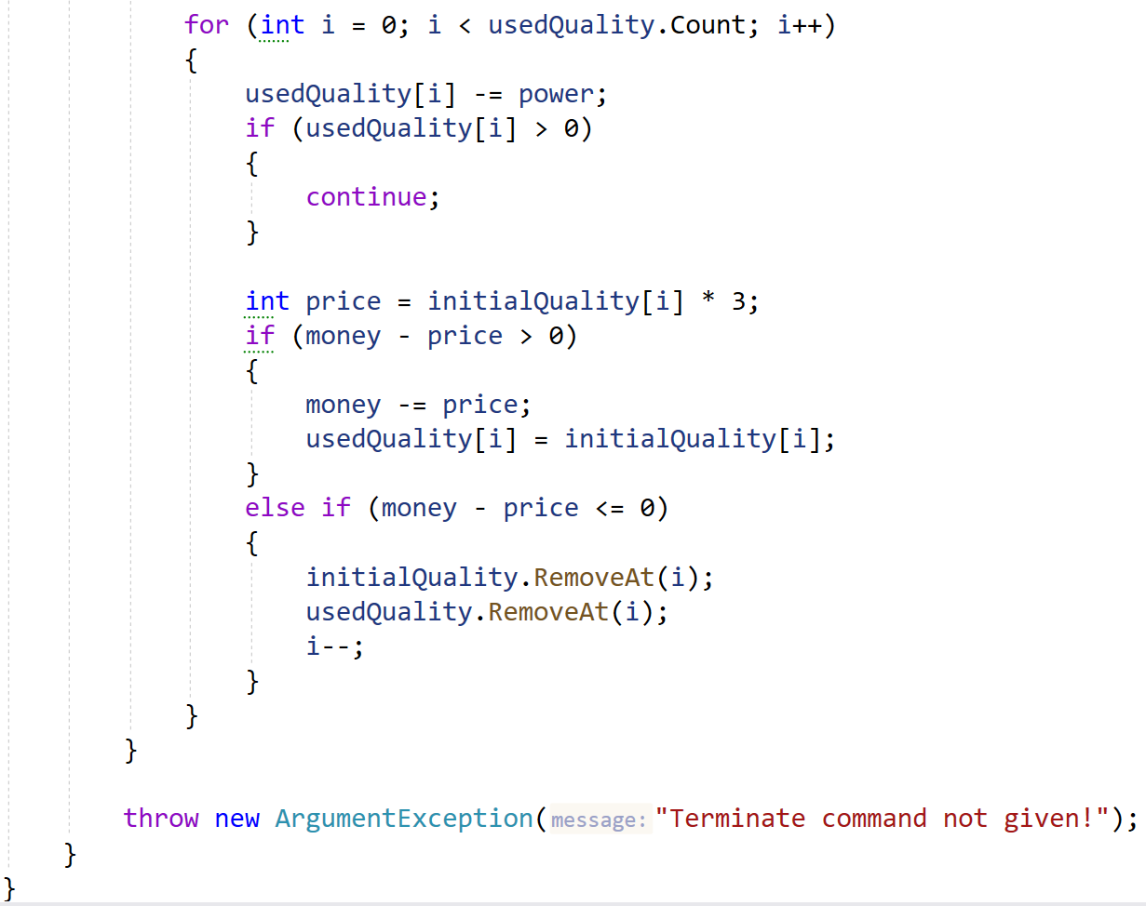
You are given a test file DrumSetTests.cs containing 5 empty tests. Implement all the unit tests:
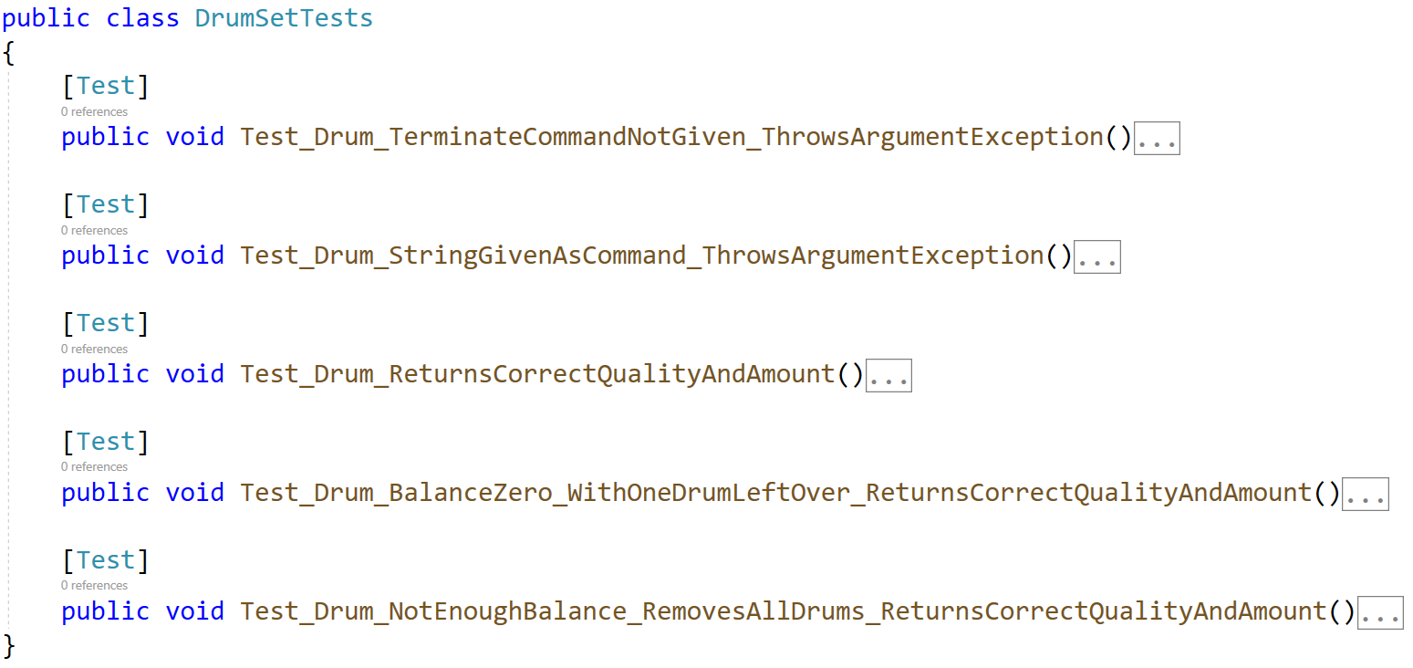
When you are ready make sure your tests run:
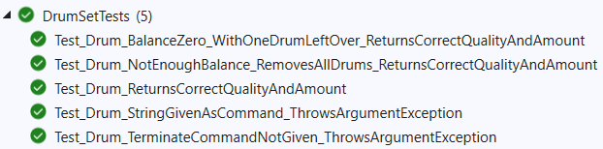
IMPORTANT: DO NOT REMOVE OR CHANGE ANY NAMESPACES AND USINGS.

